About the files

The record level .csv file has 4M rows. All the information is randomized so that the statistics are intact but all the fields of every record have been randomized so it will not match any fields of the original record. If there is a match to someone living, that is simply an unavoidable coincidence.

4,193,438 total database records of people who were vaccinated (dead and alive).

2,215,730 unique people are covered in the database.

37,285 unique people died were reported in the data and summarized in the time-series cohort analysis.

66,005 total records for those who have died (so average of less than 2 vaccination records per dead person)

The data is approximately 33% of all New Zealand vaccination records.

Only people who were vaccinated are included in the data. So you cannot use the unvaccinated as a control group.

There was a disproportionate draw on each dose (i.e., for some doses we got a greater percentage of records than other doses).

This database will not contain all records of every person who has a record, e.g., the first record to appear may be on dose 3.

Unvaccinated people never died because the database only had entries for people who received at least one vaccine.

The database is skewed over time in terms of which reports got into this database. That’s why you want to look at the death over time for a given dose and deaths per person year, and do NOT compare absolute death rates in a dose unless you are doing a time series cohort analysis where you are calculating death per person days.

Here are the counts of records for each dose in the database:

|  |  |  |  |
| --- | --- | --- | --- |
| **Dose** | **Number of records** | **Average age** | **Date of peak injection** |
| 1 | 966994 | 40 | Aug, Sept 2021 |
| 2 | 1034807 | 42 | Oct 2021 |
| 3 | 1053284 | 54 | Feb 2022 |
| 4 | 762241 | 66 | July 2022 |
| 5 | 369371 | 72 | April 2023 |
| 6 | 6633 | 69 | April 2023 |

For dose 3, the shift in ages is because the young people didn’t opt to get the shots, not because older people opted in. You cannot opt in at dose 3; you can only opt out. So the age shift simply means the people who were not as likely to die opted out. We should expect slightly lower death counts per week in Dose 3 because there are fewer people; however it’s oversampled (see number of records in the table above), so Dose 3 deaths per week should be comparable to Dose 2 deaths per week.

But this is not the case! The dose 3 and dose 4 deaths per week are 2X higher than dose 2 (300 vs. 140). Which means that people are dying at higher rates after getting these doses (the big jump is on Dose 3 causing nearly a 100% increase, and Dose 4 adds another 25%). This is why even at Dose 4 with fewer doses, the absolute death count peaks are the same.

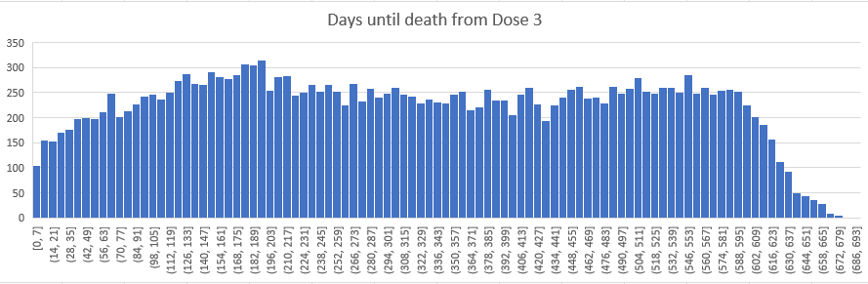

The most reliable way to analyze the data is using the time-series cohort analysis files which we’ve turned into an easy to use Excel spreadsheet found in the analysis tab.

The time series analysis is the same as the UK ONS did on their data, but with much finer granularity. Pick the file that best meets your needs.

A safe vaccine is a flat line over time. What you will find is that for Doses 1 to 3, the death rate climbs after vaccination for around 6 months. But by the time people get to Dose 4, even though they are slightly sicker (which you can see by the slightly higher baseline), there is no excess death over time like for the other doses. This can be caused by one of more of the following:

1. The people who have survived 3 shots are now pretty much immune to further shots increasing their mortality even more
2. Shot 4 is a complete dud as far as immunogenicity goes

Bottom line: people have had their risk of death progressively increased by jabs 1 to 3. After jab 3, things don’t get worse mortality wise. It is not clear when, if ever, people will return to their baseline mortality rate after getting jabbed. It seems to eventually settle slightly higher.

It would be nice to have all the records exposed. The only reason for not doing this is because the authorities don’t want people to learn the truth.

The time-series cohort analysis files are generated in less than a day no matter what the criteria is. AFAIK, no health department is interested in looking at the data.

The simplest way to see how dead the vaccines are is using the decade spreadsheet. Look at a fixed period of time that is the same for each dose (e.g., a 1 year or more window as was done in the spreadsheet). Then look at the average mortality rate over that window. The lowest mortality will be dose 4 because even though the baseline is higher, the mortality rate doesn’t climb after the jab is given like it does with doses 1 to 3.

These vaccines have killed over 1 person per 1,000 doses. There is no other way to explain this data.

The official numbers from New Zealand:

# ASMR data

](https://www.tewhatuora.govt.nz/our-health-system/data-and-statistics/mortality-web-tool/#mortality-web-tool)

So our dataset is NOT an EXACT random draw of the complete dataset as you can see by the number of records of each shot, e.g., we have more Dose 3 records than records for any other dose.

This doesn’t affect the analysis because the selection criteria was effectively random, it’s just that certain biases tended to give us more records of a particular dose.

**The single month charts tell the story very clearly that the effect is the same regardless of vaccination window**

There is a steady increase in deaths per month which levels off at month 6 (day 170) no matter when you are vaccinated. The only way this can happen is if it is the vaccines causing this, not by some background event which would shift as you shifted your observation window.

We’ll go backward from vaxxed in March 2022. Y-axis is # people who died within the 28 day bucket

# Could the rises be due to COVID?

The COVID death spike ended Aug 3, 2022.

](https://ourworldindata.org/explorers/coronavirus-data-explorer?zoomToSelection=true&time=2020-03-01..latest&uniformYAxis=0&country=~NZL&pickerSort=asc&pickerMetric=location&Metric=Cases+and+deaths&Interval=7-day+rolling+average&Relative+to+Population=true&Color+by+test+positivity=false)

Which means it wouldn’t impact shot 2, it might impact shot3 on the tail end, and it would definitely impact Shot4 in the early months.

We can’t see the “hump” caused by COVID at all.

# The official data from New Zealand on COVID deaths



This shows that nothing is happening COVID wise except in the 5 month period from 4/22 to 8/22.

This means it would affect ONLY the tail of Dose 3 (it would increase months 3 through 7 by a constant amount), but it would increase ONLY the very first month of Dose 4.

Yet the first month of Dose 4 is in the same pattern as for other months. And Dose 3 curve looks like Dose 4 curve, climbing at a constant rate for first 7 months.

In addition, if you look at the period before COVID, you see the same effect. If you limit your time window to after COVID, you see the same effect.

So the COVID explanation doesn’t fit.

In addition, a 2X increase in all-cause mortality rate is HUGE. It wasn’t COVID and it’s correlated with the vaccine. And it **monotonically kills people at a higher and higher rate for the first 6 months** from the time that person got the vaccine.

