About the record level files

The nz-record-level-data has all the records.
For convenience in using excel, I’ve split the files into files for each dose.
There is also a file contain all the records of people who have died. You can find that in the ../analysis directory.
The dose1 deaths only is simply just the death records of people who got Dose 1. The shape of the death curve in the largest two consecutive 4 week periods (7/25/21-8/21/21 and 8/22/21 until 9/18/21) is used as a control group to show whether there is a background event causing excess death.
If there is a background event causing excess death, it would shift the peaks in the “death since vaccination” curve by 1 month.
So any event significantly affecting background death rate this should be easy to see.
Show this to someone and ask: Does one graph look like a shifted version of the other graph and if so, by how much?
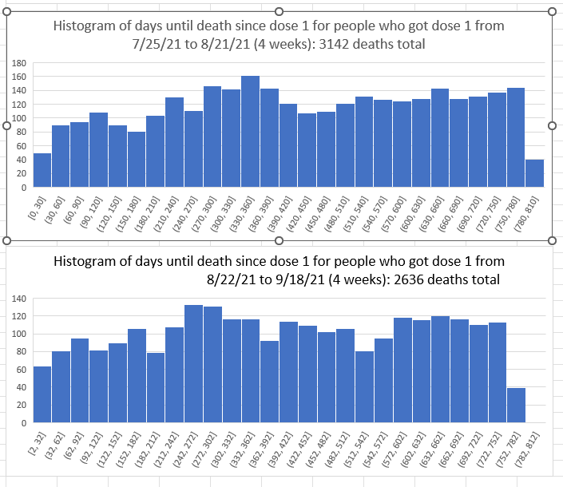

COVID deaths
There is not a major background event affecting deaths in New Zealand.
30 people died from COVID at the peak on July 25, 2022:

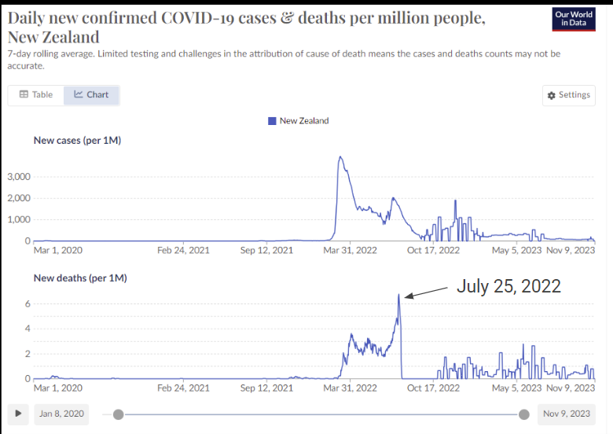
In the top histogram above, there are 353 days from the midpoint to July 25, 2022. There is a 14% increase from the previous bar.
In the bottom histogram above, there are 325 from the midpoint to July 25, 2022. There is a 10% decrease from the previous bar.
So if there was a COVID background effect on the death rate, these should have both been increases.
And if there was any other significant systemic death event in New Zealand, we would have seen it in the shift of the dose 1 curves.
So we aren’t seeing any COVID spike at all and we aren’t seeing any time shift either.

Further test: Is the death rate calculation invariant of the observation window?
Consider the following:
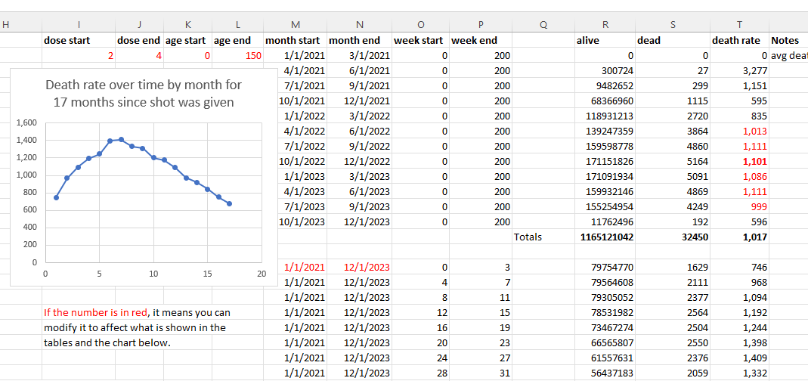

The chart is death rate (deaths per 100K person years) in the months after a dose. It goes up for 6 months and then goes back down. In other words, on average, the shots make you more and more likely to die for 6 months, than then it starts returning to normal.
But look the numbers in Red on the right. Those are completely stable. Those numbers are what happens when we do a pivot holding the other independent variable constant. So now, instead of holding the overall start/end observations dates constant, we are now changing the observation dates and looking what happens over all weeks (0 to 200) since the shot was given. We see that the numbers are flat, just as we expected. The fact that these numbers are flat for 6 consecutive months as we shift the observation window is very strong evidence that there isn’t a background effect. If there was, the values wouldn’t be the same. In other words, the effect we are observing is due to the shot, not some background effect.

