MI-06
2016 IE Strategy Memorandum

Updated on 4/18/16

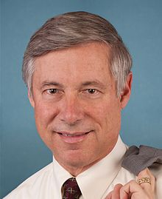

PAUL CLEMENTS FRED UPTON
CoH: $310,739.53 CoH: $1,278,074.22
Date: 4/15/16 Date: 4/15/16
Occupation: Professor/Consultant Occupation: Congressman

SECTION I: Race Overview
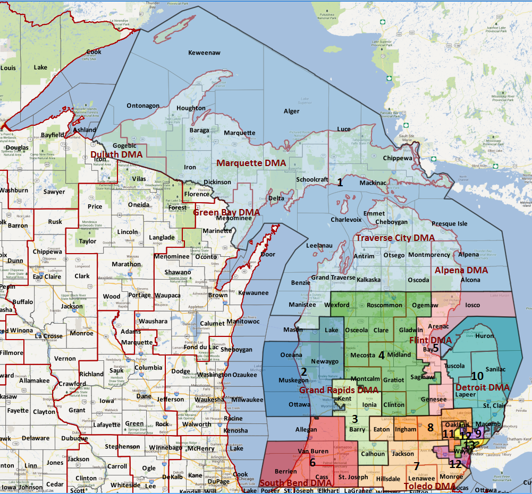

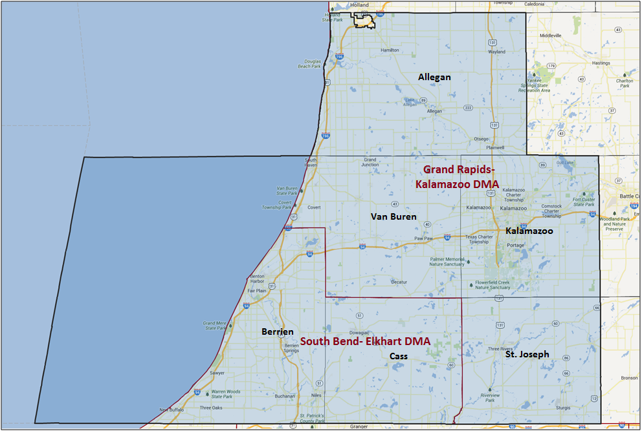

Media Market Costs

TV DMA | % of  CD | I.E.  35+ CPP | Cable CPP
GRAND RAPIDS | 70.4% | $151
SOUTH BEND | 29.6% | $54
MI-06 TOTALS: | 100.0%
Radio Landscape
None

Digital Landscape
- MI-06
  - Persuasion universe size: 35,645
  - Audience extension (key demos): Independents & Democrats
  - Weekly budget for full coverage: $9,659.83
  - Reach
    - YouTube - 337,346
    - Pandora - 192,479

Presidential Statistics
Cycle | Candidate | Party | Vote
2012 | Obama | DEM | 49.3%
2012 | Romney | REP | 50.7%
2008 | Obama | DEM | 50.4%
2008 | McCain | REP | 49.6%

Congressional Statistics
Cycle | W/L | Candidate | Party | Vote
2014 | L | CLEMENTS | DEM | 41.95%
2014 | W | UPTON | REP | 58.05%
2012 | L | O’BRIEN | DEM | 43.8%
2012 | W | UPTON | REP | 56.2%

NCEC Data
Dem Performance: 46.3%
BVAP: 7.9%
Hispanic: 2.8%
Asian: 1.1%
Total Minority: 11.8%

Critical Dates
Filing: April 19th, 2016
Primary Date: August 2nd, 2016

Summary of 2014 Cycle Spending by Outside Groups to Date

**Still determining where and how this was spent.

Campaign/Group | GRPs | Total Dollars
American Future Fund | 2,031 | $306,720
Main Street Advocacy | 1,325 | $200,000
Mayday PAC | 13,818 | $2,086,542
Good Guys v Bad Guys | GRPs | Total Dollars
Good Guys | 13,818 | $2,086,542
Bad Guys | 3,356 | $506,720

Pre-Election Day Voting

Type of  “Early Voting” | Start Date  End Date | Percent of  Vote Cast Using this Method | Brief Description  (where/how  do people vote) | Timeframe (when does the majority of voting happen)
Early Vote
Absentee Ballot/In person Absentee | Return by Election Day |  | Voters must apply for an absentee/VBM ballot via mail, online, or in person | Rolling, leaning towards closer to election day
Vote By Mail

