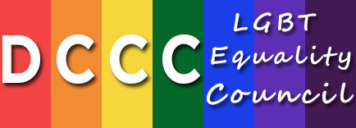
2015 – 2016 DCCC LGBT Equality Council Schedule

2015
NYC Breakfast
NYC Reception
DC Fly-in Event

2016
LA Event
Chicago Event
NYC Breakfast
NYC Reception
DC Fly-in Event

