Article
Differences in Vaccine and SARS-CoV-2 Replication Derived mRNA:
Implications for Cell Biology and Future Disease

Kevin McKernan¹*, Anthony M. Kyriakopoulos² and Peter A. McCullough^{3,}
¹ Medicinal Genomics, Beverly Mass, USA; Kevin.McKernan@medicinalgenomics.com
² Nasco A.D. Biotechnology Laboratory, 11 Sacthouri Str. 18536 Piraeus, Greece; rnd@nascoad.com
^{3.} Truth for Health Foundation, Tucson, AZ, USA; peteramccullough@gmail.com

* Correspondence: kevin.mckernan@medicinalgenomics.com
Abstract: Codon optimization describes the process used to increase protein production by use of alternative but synonymous codon changes. In SARS-CoV-2 mRNA vaccines codon optimizations can result in differential secondary conformations that inevitably affect a protein’s function with significant consequences to the cell. Importantly, when codon optimization increases the GC content of synthetic mRNAs, there can be an inevitable enrichment of G-quartets which potentially form G-quadruplex structures. The emerging G-quadruplexes are favorable binding sites of RNA binding proteins like helicases that inevitably affect epigenetic reprogramming of the cell by altering transcription, translation and replication. In this study, we performed a RNAfold analysis to investigate alterations in secondary structures of mRNAs in SARS-CoV-2 vaccines due to codon optimization. We show a significant increase in the GC content of mRNAs in vaccines as compared to native SARS-CoV-2 RNA sequences encoding the spike protein. As the GC enrichment leads to more G-quadruplex structure formations, these may contribute to potential pathological processes initiated by SARS-CoV-2 genetic vaccination.
Keywords: SARs-CoV-2; BNT162b2; mRNA-1273, quadruplex-G, codon optimization, SEB, translation error.

1. Introduction
The simplification of scientific jargon in the realm of public health can lead to the construction of a false consensus. One such over-simplification exists in our discussions surrounding the expression of SARs-CoV-2 spike protein in mRNA vaccines. This spike protein is often referred to as being bio-equivalent to the naturally expressed spike protein in SARs-CoV-2. Accordingly, it is suggested that this "may” constitute a safer immunological exposure as the rest of the genes responsible for replication of the virus are omitted. This often leads one to assume that the pathologies that arise from vaccine expressed spike protein should be a subset of those you might experience with the full-length live virus. The mRNA vaccines have the benefit of being a non-replication competent immune exposure, but are the spike proteins truly equivalent?
In this line of questioning, one must ask what is the purpose for codon optimizing a viral mRNA that is already adapted to its host? This does not come risk free. The potential dangers of codon optimization have been raised for in vivo applications [1]. Even synonymous codon changes incorporated into mRNA vaccines can alter the expected encoded protein conformation as the translation speed and efficiency can result in different protein folding. Despite identical amino acids, the altered conformation can function differently as compared to synonymous codon replacements of native mRNAs that have been put in place under the selective pressure of evolution of parasite-host adaptation. Codon optimization strategies for the development of mRNA vaccines can result in immune de-regularities, affect epi-transcriptomic regulation, and can lead to disease progression [1,2].

2. Materials and Methods
We used open source, publicly available software for every step of the analysis.

Sequences utilized
Vaccine derived mRNAs were downloaded from Dae Eun Jeong et al.
https://virological.org/t/assemblies-of-putative-sars-cov2-spike-encoding-mrna-sequences-for-vaccines-bnt-162b2-and-mrna-1273/663
Using BLAST of the Wuhan Hu-1 reference sequence against the vaccine derived RNAs, we extracted the Wuhan Hu-1 spike sequence. Query13637:21560-25382 NC_045512.2 Severe acute respiratory syndrome coronavirus 2 isolate Wuhan-Hu-1, complete genome

GC content
GC content of each sequence was calculated[3]. Biologicscorp.https://www.biologicscorp.com/tools/GCContent/

RNAfold analysis
Using default conditions from a tool known as RNAfold, secondary structures were predicted[4]. http://rna.tbi.univie.ac.at/cgi-bin/RNAWebSuite/RNAfold.cgi

G4 Identification
We used QGRSMapper to calculate G4 motifs in the three mMRNA sequences.https://bioinformatics.ramapo.edu/QGRS/index.php[5]

Frameshift evaluation
We used IGV2.4.16 to visualize all 6 reading frames of the 5’ UTR[6-8].

3. Results
To address the implied equivalency of virus derived spike protein vs mRNA derived spike protein, we explore the impact of codon optimization on the secondary structure of the natural RNA encoded spike protein and compare this to the secondary structure of the mRNA vaccines. The most obvious alteration from codon optimization is the increase in the GC content of the mRNAs (Figure 1.)
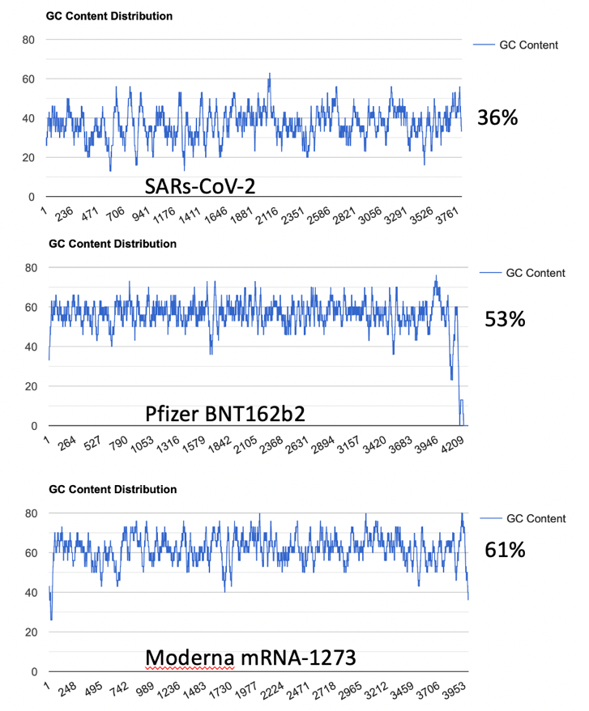
Figure 1. Top: GC content of SARs-CoV-2 Spike Protein. Middle: GC content of codon optimized Pfizer BNT162b2 vaccine. Bottom: GC content of codon optimized Moderna mRNA-1273. https://www.biologicscorp.com/tools/GCContent/

This increased GC content significantly alters mRNA secondary structure. Using RNAfold (http://rna.tbi.univie.ac.at/cgi-bin/RNAWebSuite/RNAfold.cgi) we see the changes to secondary structure in the vaccine derived mRNAs compared to the native virus (Figure 2)[4]. This is a result of codon optimization that was likely performed without the consideration of secondary structures like quadruplex G formation.

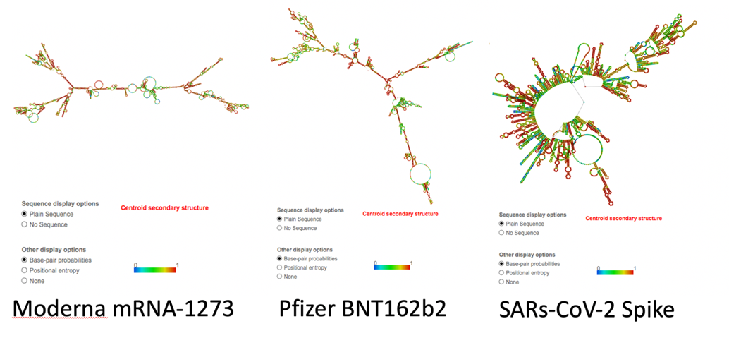
Figure 2. The three different Spike Protein Sequences (Moderna (left), Pfizer (middle), SARs-CoV-2(right)) analyzed with RNAfold.

Not only are the secondary structures of the mRNA noticeably different, of note, is the increased number of quadruplex G formations in the codon optimized mRNA vaccines (Figure 3). Quadruplex G formations (G4s) in SARs-CoV-2 are highly conserved across over 16,466 SARs-CoV-2 genome sequences [9]. They are believed to play a critical role in transcription and translation of SARs-CoV-2 peptides [10-12]. G4 formations in the RNA sequence for nucleocapsid protein have been proposed as attractive drug targets to eliminate nucleocapsid expression. This is achieved by using compounds that stabilize quadruplex G formations [13].
G4s are also implicated in recruiting viral SARs Unique Domain (SUD) of Nsp3 [14]. While the mRNA vaccines do not encode this non-structural protein, an increasing number of breakthrough infections must consider the biology of both the virus and the non-native vaccine derived mRNA. With increased vaccination rates and continued boosters, it will be increasingly important to understand the immune status of patients expressing both mRNA-based vaccine spike proteins concurrent with viral spike protein expression.
The changes to secondary structure can be observed in the G4 formations seen in each sequence using QGRSMapper (Figure 3) [5]. Similar trends were observed using G4-iM Grinder (Personal communication Belmonte)[12].
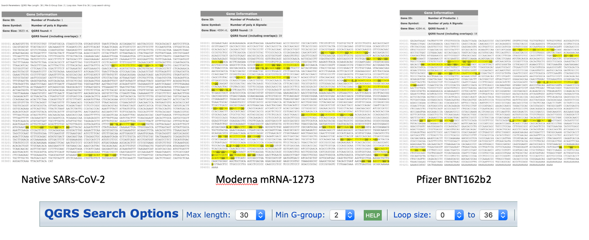
Figure 3. Three sequences analyzed with QGRSMapper. Only four G4 motifs (yellow) are identified in the Spike coding region of the virus mRNA (left). 19 G4 motifs are identified in Moderna (middle) and 9 G4 motifs are identified in Pfizer (Right).

Does the increase of 4 to 19 G4 motifs alter the translation efficiency of these proteins? Do they create truncated spike proteins not seen with the natural virus?

Fidelity of Spike protein expression
To address these questions, there is another unique feature of the mRNA vaccines that must be considered. The uracil’s in the vaccines have been replaced with N1-methylpseudouridine. The use of N1-methylpseudouridine in these mRNAs will further complicate the folding predictions as both pseudouridine (Ψ) and N1-methylpseudouridine (m1Ψ) increase base stacking, RNA stability and melting temperatures compared to uracil[15,16].

Pseudouridine is the most common RNA modification[17]. Both Ψ and m1Ψ are native nucleosides. Pseudouridine synthases (PUS1-PUS13) are responsible for converting uridine into Ψ and this conversion is very mRNA structure dependent[18,19].N1-specific pseudouridine methyltransferase converts Ψ into m1Ψ.

Methyltransferases and demethylases that govern nucleoside methylation are often biological signaling systems. It is unknown how these signaling systems will respond to molecules this densely methylated. Can biological demethylation present Ψ which has more promiscuous base pairing with G and A and is known to create errors in translation [20-22]? While the methylation of pseudouridine should reduce the base pairing promiscuity, both nucleosides have a significant impact on melting temperature of oligonucleotides and are thus less predictable than native uracil translation[16].

Subtle codon changes in the Furin clevage site (FCS) and SEB domain of the spike protein have demonstrated ribosomal pausing[23]. The double arginine residues (CGGCGG) in FCS/SEB are believed to play a role in codon CGG depletion which can create ribosomal pausing significant enough to impact proper spike protein folding. The omicron variant is notably mutated in this region (P681H, N679K).

These m1Ψ replacements are excellent for evading host RNAses but they are also implicated in Toll Like Receptor biology and this is something unique to mRNA vaccines. While m1Ψ enables slower degradation of mRNAs, it comes at the cost of camouflaging the mRNA from the immune system that targets viral RNA secondary structures [24]. Immune receptor TLR3,7,8 and RIG-1 are intimately involved in targeting such secondary structures and their response is RNA modification dependent [25]. This has been described as “reprogramming the innate immune and adaptive immune response” [26]. This may explain the increased rate of Herpes Zoster, HHV6/HHV7 (Pityriasis rosea) and Epstein-Barr reactivation post mRNA vaccination [27-32]. These reactivations are also seen with SARs-CoV-2 infection. Further investigation is required to understand if the mRNA vaccines exacerbate or curtail these reactivations.
Codon optimizations and pseudouridine replacements alter the secondary structure significantly and likely change the Toll Like Receptor activity one might find with the native virus [33]. How these receptors behave in the presence of both vaccine-derived spike mRNA and viral derived spike mRNAs is a nascent field. However, this field is of interest to many physicians concerned about chronic diseases including cancer [34,35]. Jiang et al. note that the spike protein localizes to the nucleus and significantly alters DNA damage and repair pathways via modified VDJ recombination required for adaptive immunity [36]. Many of these vaccine trials demonstrated lymophocytopenia and neutropenia 2 weeks after injection [37,38]. Down regulation of the innate immune system concurrent with reduced DNA repair may lead to carcinogenesis[39].
Notably, promiscuous bases like inosine and pseudouridine are known to stabilize quadruplex Gs [40] [41] further exacerbating the impact of G4 quartet formation with codon optimization. Less is known about m1Ψ interaction with G4’s but given it has a similar increase in Tm as Ψ, it is expected to stabilize secondary structures in RNA.
How much m1Ψ is present in these mRNAs? The only independent DNA sequence released for these mRNA vaccines were sequenced on Illumina platforms that are blind to pseudouridine [42]. The exact m1Ψ density (while reported by the manufacturers to be 100%) has not been independently sequence verified[43]. The most parsimonious synthesis approach described by Nance et al. replaces all uracil’s with m1Ψ via polymerase incorporation [24]. Such an approach may also leave the stop codons prone to pseudouracil stop codon read through described by Fernandez et al. [44] and Atkins et al[45]. Pseudouridine is also known to create ribosomal frameshifts and it is unclear if m1Ψ will exhibit similar properties. Penultimate to the ΨGA ΨGA stop codon in the BNT162b2 vaccine is an out of frame human amino acid sequence of unknown function (AAG23172.1) (Figure 4). Xia et al. also makes note that UGA stop codons are more prone to read through and +1 frameshifts suggesting these mRNA derived stop codons may not be as effective as viral derived stop codons [20].

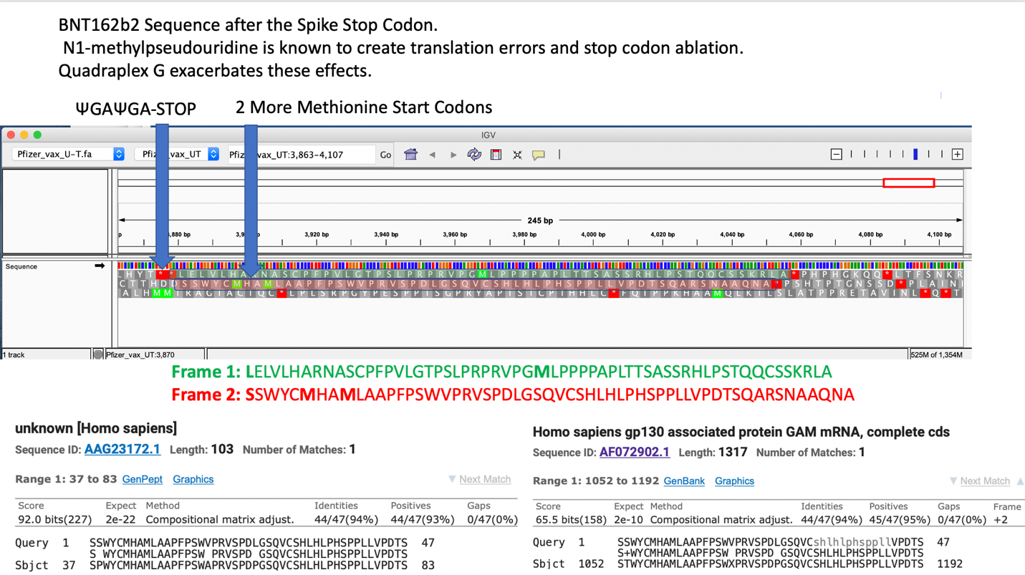

Figure 4. Top: IGV view of the BNT162b2 mRNA sequence as published by Dae-Eun Jeong et al. focused on the Amino acid sequence 3’ to the stop codon. N1-methyl Pseudouridine based Read through of this codon could lead to chimeric Spike-Human peptides (Red text). Bottom track:Read through amino acid sequence BLASTp alignment delivers a Human hit. tBLASTn of amino acid sequence had homology to human gp130.

Expression of chimeric spike-human peptides may be unique to m1Ψ based mRNA vaccination and raises concerns over immune de-regulation including autoimmunity that may develop with such chimeric inoculations.

Hypothetical viral: mRNA vaccine interactions
With any virus or vaccine that enables latent virus reactivation we must consider the case of viral recombination. Chimeric RNAs are more likely to form with mRNAs that have degenerate bases or form more stable secondary structures[46]. In this hypothetical case, a non-replicative pseudouridylated mRNA may hitchhike into a replication form via recombination with a live virus.

Relevantly, in vitro and in vivo experiments using human and mouse RNAse L chimeras, and chimeric Mouse Hepatitis Virus (coronavirus) expressing recombinant L* from Theiler's murine encephalomyelitis virus (picornavirus) showed that chimeric MHV viruses are functional. These efficiently express RNAse L inhibitors and hence interfered with prompt interferon responses[47].

This is relevant to SARs-CoV-2 as the persistence of vaccine based mRNA and spike protein is longer than initially recognize and an increasing number of breakthrough cases imply many patients are coinfected with highly homologous spike coding mRNA. The subunit 1 (S1) persists for up to 15 months post infection and is related to post-acute inflammatory sequalae presenting with neurological complications[48]. 75% of Patients with persistent RNAemia also present long COVID[49]. Autopsies have revealed replicating virus 3 months past infection and even RNA detectable 230 days after infection in one patient[50]. Chertow et al. also explored tissue specific heteroplasmy and detected viral loads in the brain but very little in the reproductive tissues. Recently, three mRNA vaccine sequences were deposited into NCBI by Castruita et al. These were detected in from plasma obtained up to 28 days after of vaccination (OK120842.1, OK128041.1, OK120840.1)[51].

The persistence of SARs-CoV-2 and vaccine derived mRNA should be considered in light of the large catalog of retroviral and non-retroviral RNA sequences abundantly integrated into mammalian DNA[52]. These inserted viral sequences exist in the form of long interspersed nuclear elements (LINEs). These LINE based retrotransposons mobilize and also transcribe human DNA not associated with the LINE sequences forming pseudogenes [53]. These can be active in disease onset including tumorigenesis [54]. As an example, the polio RNA sequences are identified with a 100 % sequence homology to human chromosomes and are associated with cancer progression[55]. These require further study to characterize the potential production of chimeric mRNAs with SARS-CoV-2 native or vaccine derived mRNAs, especially during meiotic division[56], stem cell differentiation and cancer[57].

For example, human endogenous retroviruses (HERVs) constitute the 8% of human DNA. These are mobile genetic elements related to etiopathogenesis of inflammation and neurogenerative disease[52]. Due to viral transactivation of HERVs the herpesviridae reactivation is implicated in the onset of multiple sclerosis [58]. Another example of reactivation disease is Epstein-Barr virus associated head and neck cancer. Notably, HERVs induce neurological autoimmunity by interfering with innate immunity in mice [59].

Moreover, the presence of chimeric SARS-CoV-2 mRNAs with other viral sequences has recently been reported but these events need to be carefully verified as some of the template switching aspects of current sequencing methods may create false positives [60,61]. Other studies describe a decrease in the interferon response[62,63] and emergence of Herpes zoster virus infection post SARS-CoV-2 molecular vaccination[29] [27]

It is important to understand these are not documented cases of SARs-CoV-2 viral recombination but such hypothetical cases resonate with recently published clinical data[64] and have been a suggested hypothesis for omicron variant emergence as it shares an insert with other HCoVs[65].

Likewise, virus to mRNA recombinations increase in likelihood with mRNAs that use bases that alter melting temperatures and increase stability of hybridization like Ψ and m1Ψ[66]. Notably, the natural Ψ:U ratio of mRNAs under normal conditions is markedly low (0.2-0.6 %) compared to the 100% m1Ψ substitutions in synthetic SARS-CoV-2 mRNAs[67]. RNA based Pseudouridine substitutions determine the cell’s fate and differentiation[68]. Specifically, pseudouridylations of mRNAs are subject to activity of PUS7 writer protein which is a key regulator of protein translation and determinant of stem cell growth and differentiation[68]. Dysregulation of PUS7 activity correlates with agitated protein synthesis in stem cells which leads to hematological disorders and aggressive stem cell acute myeloid leukemia[69]. Also pertinent to the detection of the SARs-CoV-2 recombination hypothesis is that many SARs-CoV-2 sequencing methods (ARTIC) rely on SARs-CoV-2 specific PCR primers that are often blind to recombination events [70]. This impacted early detection of omicron as multiple ARTIC primers were impacted by omicron mutations. Specifically amplicon 76 (which covers a part of the spike protein) is known to drop out[71]. Given the paucity of sequence information on the vaccines and the peptides expressed in-vivo with such mRNAs, further work is required to confirm pseudouridine induced promiscuous translation or viral recombination with mRNA vaccines.

Limited evidence of pure vaccine derived spike protein expression in humans

There is limited literature describing fidelity of mRNA vaccine derived spike protein expression. The best in-vivo evidence of heterogeneous translation of vaccine derived spike protein is from Figure 2C in Bansal et al. where the SDS-PAGE of vaccinated patients’ exosome-derived spike proteins exhibit broad banding patterns (Figure 5). To rule out electrophoretic artifacts from membrane derived proteins, LS/MS-MS should be performed to confirm or negate the spike translation heterogeneity. Additionally, spike proteins expressed from a DNA based plasmid in HEK293T cells described by Jiang et al. demonstrate 3 different bands on SDS-PAGE. These 3 bands represent the glycosylated, full length and fragmented spike proteins and their expression appears cell fraction dependent. DNA based expression does not contain error prone pseudouridine and one would expect more translational error from the m1Ψ mRNA-based vaccine expression systems.

In agreement with these findings, in February of 2021 the Committee for Medicinal Products for Human Use (CHMP) published a report that requested more characterization of the diverse bands observed in the in vitro translated Comirnaty mRNAs (commercial BNT162b2)[72]. This report voiced concerns over both the mRNA heterogeneity and protein heterogeneity observed with in vitro translation.

Figure 5. Reproduced from Bansal et al. and Jiang et al. Vaccine induced, exosome-derived Spike proteins exhibit broad banding patterns (left). DNA plasmid-based expression of Spike in HEK293T cells demonstrates translational heterogeneity in a cell fraction dependent manner.
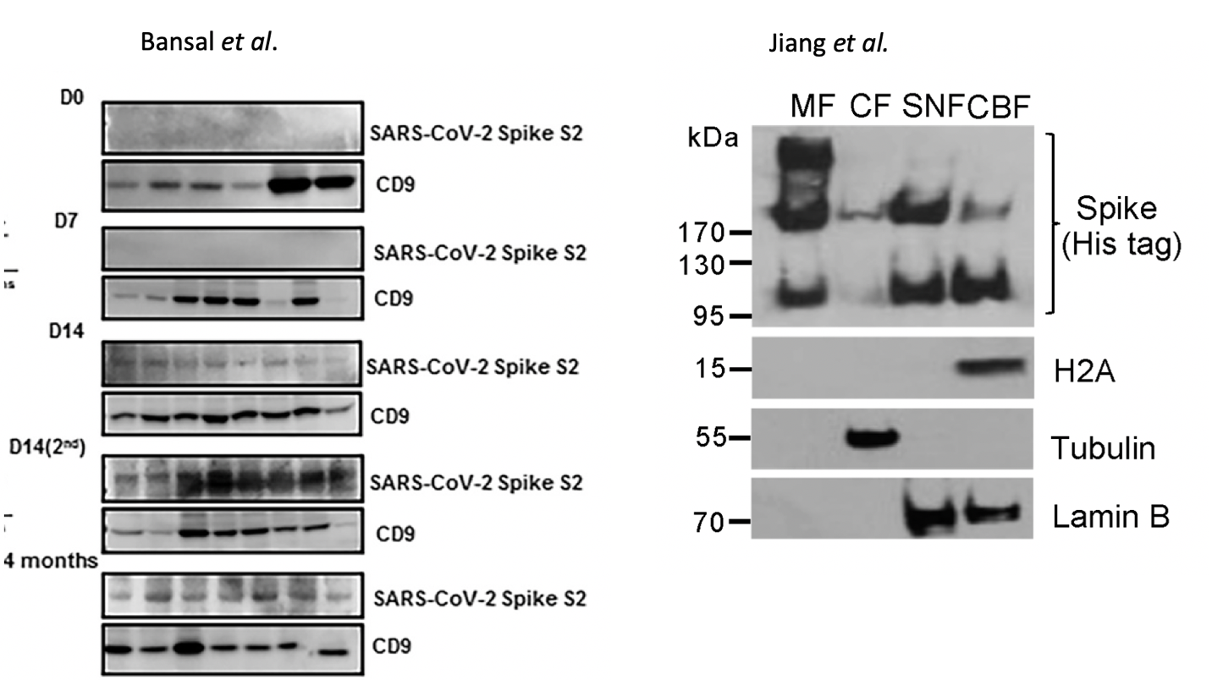

While these truncated or elongated promiscuous translation products may be rare events, this does bring to focus the question of dosage and spike protein duration with mRNA vaccines that ablate many components of the innate immune system [26].

Quantity of Spike Protein
How much spike is too much? Bansal et al note that Spike protein can be detected circulating on exosomes membranes 4 months post vaccination [73]. Virus derived Spike protein has been detected 15 months later in post-acute sequelae patients (PASC or long COVID)[48]. The vaccine programs have not existed long enough to form a valid comparison in the same tissues. Patterson has recently presented data that both the S1 and S2 segments of spike protein are recoverable from vaccinated persons many months after immunization (personal communication). mRNA detected in plasma should raise alarms given the Bansal et al. detection of circulating exosomes that contain spike protein. Do these exosomes contain any vaccine derived mRNA and can they be exhaled like other exosomes[74,75]?
mRNA based vaccination has also been shown to provide log scale higher anti-spike antibody production compared to natural infections [76]. While some imply this equates to better immunity, it likely comes at the cost of higher spike protein titers and spike protein is believed to be toxic and a potential inhibitor of DNA damage and repair [36].
Estimates of mRNA transfection efficiency have been described by Pardi et al. using a luciferase mRNA [77] transfected into mice. While this does suggest more than 1 protein is synthesized from each mRNA transfected, it is not clear this result can be superimposed onto mRNA derived spike proteins which localize to the nucleus. Quantitative measurement of spike protein expression levels of vaccinated individuals is lacking in the peer reviewed literature.

Toxicity of spike protein
There are multiple modes of spike protein toxicity. Some is attributed to spike protein induced coagulopathy and mitochondrial damage [78]. Other toxicity may be a result of Staphylococcus Enterotoxin B (SEB) sequences in the spike protein [79-84].
These SEB motifs are a 20 amino acid domain directly adjacent to the FCS. They share sequence homology to neurotoxic peptides from Cobra’s and the full proteins are classified as bioweapons [85-87]. It should be emphasized that short peptides like the SEB motif may have different properties when cloned into spike proteins and the bioweapon classification has not been applied to the SARs-CoV-2 SEB motif. This motif is unique to SARs-CoV-2 amongst coronaviruses[79,88].
Even though the SEB motif is cloned into a different amino acid context, many of the symptoms observed in SEB ingestion are similar to SARs-CoV-2 symptoms as these super antigenic peptides are known for inducing cytokine storms. Cheng et al. suggest SARs-CoV-2 SEB may be responsible for multisystem inflammatory syndrome (MIS-C). Ahanotu et al. describe the symptoms of SEB intoxication as the following
“sudden onset of fever (40-41C), chills, headache, myalgia, non-productive cough. Some patients may develop shortness of breath and chest pain. Fever may last for 2-5 days and cough may continue for up to one month. Patients also present with nausea, vomiting, and diarrhea when the toxin is swallowed.”
The conclusions of Ahanotu et al. are prescient and suggest the most likely method for delivering SEB as a bioweapon would be through the use of an aerosol.
“The use of SEB as a weapon of mass casualty is considered likely for several reasons, mainly high morbidity with ease of production and dispersion, the delayed onset of disease symptoms associated with high morbidity and low mortality and difficulty in diagnosis. Staphylococcal enterotoxin B is a superantigen capable of massive non-specific activation of the immune system. Because of the remarkable toxicity and stability, they would most likely be disseminated as an aerosol”
It is worth noting that the recently described omicron strain has multiple amino acid changes in the SEB/FCS (N679K, P681H) and these mutations may alter glycosylation and antigenicity of this motif.
Finally, the raised GC content and the amplification of G4 quartets in vaccine spike protein mRNAs over the native SARS-CoV-2 spike protein mRNA, can amplify the already established interaction of SARS-CoV-2 RNA with RNA binding proteins[11,89]. This constitutes a potential cause of interference on epi-transcriptomic regulation of RNA G4 binding proteins. This may play a major role in the potential activation or deactivation of a pathological pathway [90]. In this respect, oncogenic RNA binding proteins like the mutant variants of p53 and mdm2 can readily form RNA-Protein binding complexes at polysomes with SARS-CoV-2 vaccine mRNA potential G-quadruplexes [91,92]. The vaccine mRNAs prolong their translation due to robust capping resisting natural mRNA decay pathways. This can trigger cancer initiation and progression[34].

Conclusions
The argument that the spike proteins synthesized by codon optimized mRNAs are identical to spike protein from the virus should be cautiously examined. There are several arguments that challenge this dogma. First, the biodistribution of non-specific LNP transfection of mRNAs does not discriminate towards ACE2 or CD147 expressing cell lines as seen with the virus. Second, the mRNA that encodes spike protein is known to be different in several regards. The mRNAs are known to have a 2 Proline substitution (K986P and V987P) (Department of Health and Human Services Patent US 10,960,070B2) altering the proteins conformation. The mRNAs are known to be codon optimized thus altering their secondary structure and their quadruplex G density in the spike protein mRNA. The mRNAs are known to have N1-methylpseudourine substitutions that alter translation fidelity and Toll Like Receptor recognition. Additionally, the expression levels and duration of these mRNAs may be longer and of higher copy number in many tissues that never experience natural virus infection. In this respect, safety evaluation studies involving mass
spectrometry to identify cryptic expression of synthetic mRNA constructs and
immunoprecipitation studies to locate unfavorable RNA and DNA binding proteins involved in
epi-transcriptomic interference are urgently needed. Finally, the pharmacokinetics of injection are different than infection. 30ug- 100ug per injection (90ug-300ug for those boosted) of Spike mRNA equates to 13 Trillion to 40 Trillion mRNA molecules injected in a few seconds with each injection. The pharmacokinetics of this bolus injection differs from that of viral replication that occurs over the course of a few days. If each of these mRNAs can produce 10-100 spike proteins and you have 30-40 Trillion cells, there may be a far greater systemic quantity and a much longer duration of spike protein exposure through the vaccination route than natural infection. Boosters given more frequently than a year will lead to total body accumulation of spike protein and further heighten the risk of disease in organs such as the brain, heart, bone marrow, and immune cells and tissues. This false equivalency may lead to an under appreciation of the symptomatology of vaccine based adverse events.
It should be emphasized that these results are an in-silico hypothesis supported by the peer-reviewed literature but further work is required to better characterize the homogeneity of spike protein expression in-vivo. This work has not considered post translational modifications or the impact of the altered base pairing from N1-methylpseudouridine.
More than 20 months into this pandemic and we have millions of SARs-CoV-2 genomes sequenced. Lot to lot sequencing of the vaccines is non-existent. To this date, no raw reads for these vaccines exist in NCBI despite over a billion liability-free vaccinations. To fully understand RNA synthesis substitution errors, fragmentation errors or strandedness errors in the mRNA synthesis process, robust lot to lot sequencing should be performed and published. Given these mRNAs are prodrugs which code for a desired protein, where is the evidence that the conversion of this prodrug into a drug is of high fidelity? This seems to have been assumed as opposed to documented. This work suggests this assumption should be questioned. Public and transparent quality control of these often-mandated injections are required. This should include sequence verification and quality control of the various lots and evidence of the proteins these mRNA express in patients.

Acknowledgments. We want to thank Efres Belmonte-Reche for helpful comments. A preprint of this work was published at OSF.io[93] and on Substack[94].
Data availability. The DNA Sequence data used to support the findings of this study have been deposited in Github by Dae-Eun Jeong et al.
https://github.com/NAalytics/Assemblies-of-putative-SARS-CoV2-spike-encoding-mRNA-sequences-for-vaccines-BNT-162b2-and-mRNA-1273
Author Contributions: “Conceptualization, K.M., A.K. and P.M..; methodology, K.M., and A.K..; writing—original draft preparation, K.M.; writing—review and editing, K.M., A.K. and P.M.
Conflicts of Interest: “The authors declare no conflict of interest

References

1. Sauna, Z.E.; Kimchi-Sarfaty, C. Understanding the contribution of synonymous mutations to human disease. Nat Rev Genet 2011, 12, 683-691, doi:10.1038/nrg3051.
2. Chen, R.; Davydov, E.V.; Sirota, M.; Butte, A.J. Non-synonymous and synonymous coding SNPs show similar likelihood and effect size of human disease association. PloS one 2010, 5, e13574, doi:10.1371/journal.pone.0013574.
3. Guerra, A.P.; Calvo, E.P.; Wasserman, M.; Chaparro-Olaya, J. Production of recombinant proteins from Plasmodium falciparum in Escherichia coli. Biomedica 2016, 36, 97-108, doi:10.7705/biomedica.v36i3.3011.
4. Denman, R.B. Using RNAFOLD to predict the activity of small catalytic RNAs. BioTechniques 1993, 15, 1090-1095.
5. Kikin, O.; D'Antonio, L.; Bagga, P.S. QGRS Mapper: a web-based server for predicting G-quadruplexes in nucleotide sequences. Nucleic acids research 2006, 34, W676-682, doi:10.1093/nar/gkl253.
6. Robinson, J.T.; Thorvaldsdottir, H.; Wenger, A.M.; Zehir, A.; Mesirov, J.P. Variant Review with the Integrative Genomics Viewer. Cancer research 2017, 77, e31-e34, doi:10.1158/0008-5472.CAN-17-0337.
7. Thorvaldsdottir, H.; Robinson, J.T.; Mesirov, J.P. Integrative Genomics Viewer (IGV): high-performance genomics data visualization and exploration. Briefings in bioinformatics 2013, 14, 178-192, doi:10.1093/bib/bbs017.
8. Robinson, J.T.; Thorvaldsdottir, H.; Winckler, W.; Guttman, M.; Lander, E.S.; Getz, G.; Mesirov, J.P. Integrative genomics viewer. Nature biotechnology 2011, 29, 24-26, doi:10.1038/nbt.1754.
9. Zhang, R.; Xiao, K.; Gu, Y.; Liu, H.; Sun, X. Whole Genome Identification of Potential G-Quadruplexes and Analysis of the G-Quadruplex Binding Domain for SARS-CoV-2. Frontiers in genetics 2020, 11, 587829, doi:10.3389/fgene.2020.587829.
10. Ji, D.; Juhas, M.; Tsang, C.M.; Kwok, C.K.; Li, Y.; Zhang, Y. Discovery of G-quadruplex-forming sequences in SARS-CoV-2. Briefings in bioinformatics 2021, 22, 1150-1160, doi:10.1093/bib/bbaa114.
11. Cui, H.; Zhang, L. G-Quadruplexes Are Present in Human Coronaviruses Including SARS-CoV-2. Frontiers in microbiology 2020, 11, 567317, doi:10.3389/fmicb.2020.567317.
12. Belmonte-Reche, E.; Serrano-Chacon, I.; Gonzalez, C.; Gallo, J.; Banobre-Lopez, M. Potential G-quadruplexes and i-Motifs in the SARS-CoV-2. PloS one 2021, 16, e0250654, doi:10.1371/journal.pone.0250654.
13. Zhao, C.; Qin, G.; Niu, J.; Wang, Z.; Wang, C.; Ren, J.; Qu, X. Targeting RNA G-Quadruplex in SARS-CoV-2: A Promising Therapeutic Target for COVID-19? Angewandte Chemie 2021, 60, 432-438, doi:10.1002/anie.202011419.
14. Hognon, C.; Miclot, T.; Garci, A.I.C.; Frances-Monerris, A.; Grandemange, S.; Terenzi, A.; Marazzi, M.; Barone, G.; Monari, A. Role of RNA Guanine Quadruplexes in Favoring the Dimerization of SARS Unique Domain in Coronaviruses. J Phys Chem Lett 2020, 11, 5661-5667, doi:10.1021/acs.jpclett.0c01097.
15. Westhof, E. Pseudouridines or how to draw on weak energy differences. Biochemical and biophysical research communications 2019, 520, 702-704, doi:10.1016/j.bbrc.2019.10.009.
16. Parr, C.J.C.; Wada, S.; Kotake, K.; Kameda, S.; Matsuura, S.; Sakashita, S.; Park, S.; Sugiyama, H.; Kuang, Y.; Saito, H. N 1-Methylpseudouridine substitution enhances the performance of synthetic mRNA switches in cells. Nucleic acids research 2020, 48, e35, doi:10.1093/nar/gkaa070.
17. Levi, O.; Arava, Y.S. Pseudouridine-mediated translation control of mRNA by methionine aminoacyl tRNA synthetase. Nucleic acids research 2021, 49, 432-443, doi:10.1093/nar/gkaa1178.
18. Carlile, T.M.; Martinez, N.M.; Schaening, C.; Su, A.; Bell, T.A.; Zinshteyn, B.; Gilbert, W.V. mRNA structure determines modification by pseudouridine synthase 1. Nat Chem Biol 2019, 15, 966-974, doi:10.1038/s41589-019-0353-z.
19. Carlile, T.M.; Rojas-Duran, M.F.; Zinshteyn, B.; Shin, H.; Bartoli, K.M.; Gilbert, W.V. Pseudouridine profiling reveals regulated mRNA pseudouridylation in yeast and human cells. Nature 2014, 515, 143-146, doi:10.1038/nature13802.
20. Xia, X. Detailed Dissection and Critical Evaluation of the Pfizer/BioNTech and Moderna mRNA Vaccines. Vaccines (Basel) 2021, 9, doi:10.3390/vaccines9070734.
21. Svidritskiy, E.; Madireddy, R.; Korostelev, A.A. Structural Basis for Translation Termination on a Pseudouridylated Stop Codon. Journal of molecular biology 2016, 428, 2228-2236, doi:10.1016/j.jmb.2016.04.018.
22. Eyler, D.E.; Franco, M.K.; Batool, Z.; Wu, M.Z.; Dubuke, M.L.; Dobosz-Bartoszek, M.; Jones, J.D.; Polikanov, Y.S.; Roy, B.; Koutmou, K.S. Pseudouridinylation of mRNA coding sequences alters translation. Proceedings of the National Academy of Sciences of the United States of America 2019, 116, 23068-23074, doi:10.1073/pnas.1821754116.
23. Postnikova, O.A.; Uppal, S.; Huang, W.; Kane, M.A.; Villasmil, R.; Rogozin, I.B.; Poliakov, E.; Redmond, T.M. The Functional Consequences of the Novel Ribosomal Pausing Site in SARS-CoV-2 Spike Glycoprotein RNA. Int J Mol Sci 2021, 22, doi:10.3390/ijms22126490.
24. Nance, K.D.; Meier, J.L. Modifications in an Emergency: The Role of N1-Methylpseudouridine in COVID-19 Vaccines. ACS Cent Sci 2021, 7, 748-756, doi:10.1021/acscentsci.1c00197.
25. Kariko, K.; Ni, H.; Capodici, J.; Lamphier, M.; Weissman, D. mRNA is an endogenous ligand for Toll-like receptor 3. The Journal of biological chemistry 2004, 279, 12542-12550, doi:10.1074/jbc.M310175200.
26. Fohse. The BNT162b2 mRNA vaccine against SARS-CoV-2 reprograms both adaptive and innate immune responses. MedRXiv 2021, doi:https://doi.org/10.1101/2021.05.03.21256520.
27. Furer, V.; Zisman, D.; Elkayam, O. Comment on: Herpes zoster following BNT162b2 mRNA Covid-19 vaccination in patients with autoimmune inflammatory rheumatic diseases: a case series. Reply. Rheumatology (Oxford) 2021, doi:10.1093/rheumatology/keab702.
28. Furer, V.; Zisman, D.; Kibari, A.; Rimar, D.; Paran, Y.; Elkayam, O. Herpes zoster following BNT162b2 mRNA COVID-19 vaccination in patients with autoimmune inflammatory rheumatic diseases: a case series. Rheumatology (Oxford) 2021, 60, SI90-SI95, doi:10.1093/rheumatology/keab345.
29. Eid, E.; Abdullah, L.; Kurban, M.; Abbas, O. Herpes zoster emergence following mRNA COVID-19 vaccine. J Med Virol 2021, 93, 5231-5232, doi:10.1002/jmv.27036.
30. Veraldi, S.; Romagnuolo, M.; Benzecry, V. Pityriasis rosea-like eruption revealing COVID-19. Australas J Dermatol 2021, 62, e333-e334, doi:10.1111/ajd.13504.
31. Veraldi, S.; Spigariolo, C.B. Pityriasis rosea and COVID-19. J Med Virol 2021, 93, 4068, doi:10.1002/jmv.26679.
32. Cyrenne, B.M.; Al-Mohammedi, F.; DeKoven, J.G.; Alhusayen, R. Pityriasis rosea-like eruptions following vaccination with BNT162b2 mRNA COVID-19 Vaccine. J Eur Acad Dermatol Venereol 2021, 35, e546-e548, doi:10.1111/jdv.17342.
33. Kariko, K.; Buckstein, M.; Ni, H.; Weissman, D. Suppression of RNA recognition by Toll-like receptors: the impact of nucleoside modification and the evolutionary origin of RNA. Immunity 2005, 23, 165-175, doi:10.1016/j.immuni.2005.06.008.
34. Kyriakopoulos, A.M.; McCullough, P.A. Synthetic mRNAs; Their Analogue Caps and Contribution to Disease. Diseases 2021, 9, doi:10.3390/diseases9030057.
35. Goldman, S.; Bron, D.; Tousseyn, T.; Vierasu, I.; Dewispelaere, L.; Heimann, P.; Cogan, E.; Goldman, M. Rapid Progression of Angioimmunoblastic T Cell Lymphoma Following BNT162b2 mRNA Vaccine Booster Shot: A Case Report. Front Med (Lausanne) 2021, 8, 798095, doi:10.3389/fmed.2021.798095.
36. Jiang, H.; Mei, Y.F. SARS-CoV-2 Spike Impairs DNA Damage Repair and Inhibits V(D)J Recombination In Vitro. Viruses 2021, 13, doi:10.3390/v13102056.
37. Walsh, E.E.; Frenck, R.W., Jr.; Falsey, A.R.; Kitchin, N.; Absalon, J.; Gurtman, A.; Lockhart, S.; Neuzil, K.; Mulligan, M.J.; Bailey, R.; et al. Safety and Immunogenicity of Two RNA-Based Covid-19 Vaccine Candidates. The New England journal of medicine 2020, 383, 2439-2450, doi:10.1056/NEJMoa2027906.
38. Folegatti, P.M.; Ewer, K.J.; Aley, P.K.; Angus, B.; Becker, S.; Belij-Rammerstorfer, S.; Bellamy, D.; Bibi, S.; Bittaye, M.; Clutterbuck, E.A.; et al. Safety and immunogenicity of the ChAdOx1 nCoV-19 vaccine against SARS-CoV-2: a preliminary report of a phase 1/2, single-blind, randomised controlled trial. Lancet 2020, 396, 467-478, doi:10.1016/S0140-6736(20)31604-4.
39. Yousefzadeh, M.; Henpita, C.; Vyas, R.; Soto-Palma, C.; Robbins, P.; Niedernhofer, L. DNA damage-how and why we age? Elife 2021, 10, doi:10.7554/eLife.62852.
40. Hagen, T.; Laski, A.; Brummer, A.; Pruska, A.; Schlosser, V.; Clery, A.; Allain, F.H.; Zenobi, R.; Bergmann, S.; Hall, J. Inosine Substitutions in RNA Activate Latent G-Quadruplexes. J Am Chem Soc 2021, 143, 15120-15130, doi:10.1021/jacs.1c05214.
41. Jara-Espejo, M.; Fleming, A.M.; Burrows, C.J. Potential G-Quadruplex Forming Sequences and N(6)-Methyladenosine Colocalize at Human Pre-mRNA Intron Splice Sites. ACS Chem Biol 2020, 15, 1292-1300, doi:10.1021/acschembio.0c00260.
42. Dae-Eun Jeong, M.M., Karen Artiles, Orkan Ilbay, Andrew Fire*, Kari Nadeau, Helen Park, Brooke Betts, Scott Boyd, Ramona Hoh, and Massa Shoura*. Assemblies of putative SARS-CoV2-spike-encoding mRNA sequences for vaccines BNT-162b2 and mRNA-1273. GitHub 2021.
43. Nelson, J.; Sorensen, E.W.; Mintri, S.; Rabideau, A.E.; Zheng, W.; Besin, G.; Khatwani, N.; Su, S.V.; Miracco, E.J.; Issa, W.J.; et al. Impact of mRNA chemistry and manufacturing process on innate immune activation. Science advances 2020, 6, eaaz6893, doi:10.1126/sciadv.aaz6893.
44. Fernandez, I.S.; Ng, C.L.; Kelley, A.C.; Wu, G.; Yu, Y.T.; Ramakrishnan, V. Unusual base pairing during the decoding of a stop codon by the ribosome. Nature 2013, 500, 107-110, doi:10.1038/nature12302.
45. Atkins, J.F.; Loughran, G.; Bhatt, P.R.; Firth, A.E.; Baranov, P.V. Ribosomal frameshifting and transcriptional slippage: From genetic steganography and cryptography to adventitious use. Nucleic acids research 2016, 44, 7007-7078, doi:10.1093/nar/gkw530.
46. Metifiot, M.; Amrane, S.; Litvak, S.; Andreola, M.L. G-quadruplexes in viruses: function and potential therapeutic applications. Nucleic acids research 2014, 42, 12352-12366, doi:10.1093/nar/gku999.
47. Drappier, M.; Jha, B.K.; Stone, S.; Elliott, R.; Zhang, R.; Vertommen, D.; Weiss, S.R.; Silverman, R.H.; Michiels, T. A novel mechanism of RNase L inhibition: Theiler's virus L* protein prevents 2-5A from binding to RNase L. PLoS pathogens 2018, 14, e1006989, doi:10.1371/journal.ppat.1006989.
48. Bruce K. Patterson, E.B.F., Ram Yogendra, Emily Long, Amruta Pise, Hallison Rodrigues, Eric Hall, Monica Herrara, Purvi Parikh, Jose Guevara-Coto, Timothy J. Triche, Paul Scott, Saboor Hekmati, Dennis Maglinte, Xaiolan Chang, Rodrigo A Mora-Rodríguez, Javier Mora. Persistence of SARS CoV-2 S1 Protein in CD16+ Monocytes in Post-Acute Sequelae of COVID-19 (PASC) Up to 15 Months Post-Infection. bioRxiv 2021, doi:https://doi.org/10.1101/2021.06.25.449905.
49. Ram-Mohan. Association Between SARS-CoV-2 RNAemia and Post-Acute Sequelae of COVID-19. MedRXiv 2021, doi:10.1101/2021.09.03.21262934.
50. Chertow, D. SARS-CoV-2 infection and persistence throughout the human body and brain. Nature portfolio 2021, doi:10.21203/rs.3.rs-1139035/v1.
51. Castruita. SARS-CoV-2 spike mRNA vaccine sequences circulate in blood up to at least 28 days after COVID-19 vaccination. NCBI 2021.
52. Katzourakis, A.; Gifford, R.J. Endogenous viral elements in animal genomes. PLoS genetics 2010, 6, e1001191, doi:10.1371/journal.pgen.1001191.
53. Esnault, C.; Maestre, J.; Heidmann, T. Human LINE retrotransposons generate processed pseudogenes. Nature genetics 2000, 24, 363-367, doi:10.1038/74184.
54. Hu, X.; Yang, L.; Mo, Y.Y. Role of Pseudogenes in Tumorigenesis. Cancers (Basel) 2018, 10, doi:10.3390/cancers10080256.
55. Lehrer, S.; Rheinstein, P.H. Three Poliovirus Sequences in the Human Genome Associated With Colorectal Cancer. Cancer Genomics Proteomics 2019, 16, 65-70, doi:10.21873/cgp.20112.
56. Hirano, M.; Noda, T. Genomic organization of the mouse Msh4 gene producing bicistronic, chimeric and antisense mRNA. Gene 2004, 342, 165-177, doi:10.1016/j.gene.2004.08.016.
57. Elfman, J.; Li, H. Chimeric RNA in Cancer and Stem Cell Differentiation. Stem Cells Int 2018, 2018, 3178789, doi:10.1155/2018/3178789.
58. Kury, P.; Nath, A.; Creange, A.; Dolei, A.; Marche, P.; Gold, J.; Giovannoni, G.; Hartung, H.P.; Perron, H. Human Endogenous Retroviruses in Neurological Diseases. Trends Mol Med 2018, 24, 379-394, doi:10.1016/j.molmed.2018.02.007.
59. Perron, H.; Dougier-Reynaud, H.L.; Lomparski, C.; Popa, I.; Firouzi, R.; Bertrand, J.B.; Marusic, S.; Portoukalian, J.; Jouvin-Marche, E.; Villiers, C.L.; et al. Human endogenous retrovirus protein activates innate immunity and promotes experimental allergic encephalomyelitis in mice. PloS one 2013, 8, e80128, doi:10.1371/journal.pone.0080128.
60. Zhang, L.; Richards, A.; Barrasa, M.I.; Hughes, S.H.; Young, R.A.; Jaenisch, R. Reverse-transcribed SARS-CoV-2 RNA can integrate into the genome of cultured human cells and can be expressed in patient-derived tissues. Proceedings of the National Academy of Sciences of the United States of America 2021, 118, doi:10.1073/pnas.2105968118.
61. Kazachenka, A.; Kassiotis, G. SARS-CoV-2-Host Chimeric RNA-Sequencing Reads Do Not Necessarily Arise From Virus Integration Into the Host DNA. Frontiers in microbiology 2021, 12, 676693, doi:10.3389/fmicb.2021.676693.
62. Liu, J.; Wang, J.; Xu, J.; Xia, H.; Wang, Y.; Zhang, C.; Chen, W.; Zhang, H.; Liu, Q.; Zhu, R.; et al. Comprehensive investigations revealed consistent pathophysiological alterations after vaccination with COVID-19 vaccines. Cell Discov 2021, 7, 99, doi:10.1038/s41421-021-00329-3.
63. Cheng, M.H.; Porritt, R.A.; Rivas, M.N.; Krieger, J.M.; Ozdemir, A.B.; Garcia, G., Jr.; Arumugaswami, V.; Fries, B.C.; Arditi, M.; Bahar, I. A monoclonal antibody against staphylococcal enterotoxin B superantigen inhibits SARS-CoV-2 entry in vitro. bioRxiv 2020, doi:10.1101/2020.11.24.395079.
64. Nielsen, H.B.; Almeida, M.; Juncker, A.S.; Rasmussen, S.; Li, J.; Sunagawa, S.; Plichta, D.R.; Gautier, L.; Pedersen, A.G.; Le Chatelier, E.; et al. Identification and assembly of genomes and genetic elements in complex metagenomic samples without using reference genomes. Nature biotechnology 2014, 32, 822-828, doi:10.1038/nbt.2939.
65. Venkatakrishnan. Omicron variant of SARS-CoV-2 harbors a unique insertion mutation of putative viral or human genomic origi. OSF 2021, doi:https://osf.io/f7txy/.
66. Penzo, M.; Guerrieri, A.N.; Zacchini, F.; Trere, D.; Montanaro, L. RNA Pseudouridylation in Physiology and Medicine: For Better and for Worse. Genes (Basel) 2017, 8, doi:10.3390/genes8110301.
67. Li, X.; Zhu, P.; Ma, S.; Song, J.; Bai, J.; Sun, F.; Yi, C. Chemical pulldown reveals dynamic pseudouridylation of the mammalian transcriptome. Nat Chem Biol 2015, 11, 592-597, doi:10.1038/nchembio.1836.
68. Uddin, M.B.; Wang, Z.; Yang, C. Dysregulations of Functional RNA Modifications in Cancer, Cancer Stemness and Cancer Therapeutics. Theranostics 2020, 10, 3164-3189, doi:10.7150/thno.41687.
69. Guzzi, N.; Ciesla, M.; Ngoc, P.C.T.; Lang, S.; Arora, S.; Dimitriou, M.; Pimkova, K.; Sommarin, M.N.E.; Munita, R.; Lubas, M.; et al. Pseudouridylation of tRNA-Derived Fragments Steers Translational Control in Stem Cells. Cell 2018, 173, 1204-1216 e1226, doi:10.1016/j.cell.2018.03.008.
70. Tyson, J.R.; James, P.; Stoddart, D.; Sparks, N.; Wickenhagen, A.; Hall, G.; Choi, J.H.; Lapointe, H.; Kamelian, K.; Smith, A.D.; et al. Improvements to the ARTIC multiplex PCR method for SARS-CoV-2 genome sequencing using nanopore. bioRxiv 2020, doi:10.1101/2020.09.04.283077.
71. Metzger, C.; Lienhard, R.; Seth-Smith, H.M.B.; Roloff, T.; Wegner, F.; Sieber, J.; Bel, M.; Greub, G.; Egli, A. PCR performance in the SARS-CoV-2 Omicron variant of concern? Swiss Med Wkly 2021, 151, w30120, doi:10.4414/smw.2021.w30120.
72. (CHMP), C.f.M.P.f.H.U. Assessment report: Comirnaty. Europoean Medicines Agency 2021, EMA/707383/2020 Corr.1*1, doi:https://www.ema.europa.eu/en/documents/assessment-report/comirnaty-epar-public-assessment-report_en.pdf.
73. Bansal, S.; Perincheri, S.; Fleming, T.; Poulson, C.; Tiffany, B.; Bremner, R.M.; Mohanakumar, T. Cutting Edge: Circulating Exosomes with COVID Spike Protein Are Induced by BNT162b2 (Pfizer-BioNTech) Vaccination prior to Development of Antibodies: A Novel Mechanism for Immune Activation by mRNA Vaccines. J Immunol 2021, doi:10.4049/jimmunol.2100637.
74. Sinha, A.; Yadav, A.K.; Chakraborty, S.; Kabra, S.K.; Lodha, R.; Kumar, M.; Kulshreshtha, A.; Sethi, T.; Pandey, R.; Malik, G.; et al. Exosome-enclosed microRNAs in exhaled breath hold potential for biomarker discovery in patients with pulmonary diseases. J Allergy Clin Immunol 2013, 132, 219-222, doi:10.1016/j.jaci.2013.03.035.
75. Dobhal, G.; Datta, A.; Ayupova, D.; Teesdale-Spittle, P.; Goreham, R.V. Isolation, characterisation and detection of breath-derived extracellular vesicles. Scientific reports 2020, 10, 17381, doi:10.1038/s41598-020-73243-5.
76. Gobbi, F.; Buonfrate, D.; Moro, L.; Rodari, P.; Piubelli, C.; Caldrer, S.; Riccetti, S.; Sinigaglia, A.; Barzon, L. Antibody Response to the BNT162b2 mRNA COVID-19 Vaccine in Subjects with Prior SARS-CoV-2 Infection. Viruses 2021, 13, doi:10.3390/v13030422.
77. Pardi, N.; Tuyishime, S.; Muramatsu, H.; Kariko, K.; Mui, B.L.; Tam, Y.K.; Madden, T.D.; Hope, M.J.; Weissman, D. Expression kinetics of nucleoside-modified mRNA delivered in lipid nanoparticles to mice by various routes. J Control Release 2015, 217, 345-351, doi:10.1016/j.jconrel.2015.08.007.
78. Lei, Y.; Zhang, J.; Schiavon, C.R.; He, M.; Chen, L.; Shen, H.; Zhang, Y.; Yin, Q.; Cho, Y.; Andrade, L.; et al. SARS-CoV-2 Spike Protein Impairs Endothelial Function via Downregulation of ACE 2. Circ Res 2021, 128, 1323-1326, doi:10.1161/CIRCRESAHA.121.318902.
79. Cheng, M.H.; Zhang, S.; Porritt, R.A.; Noval Rivas, M.; Paschold, L.; Willscher, E.; Binder, M.; Arditi, M.; Bahar, I. Superantigenic character of an insert unique to SARS-CoV-2 spike supported by skewed TCR repertoire in patients with hyperinflammation. Proceedings of the National Academy of Sciences of the United States of America 2020, 117, 25254-25262, doi:10.1073/pnas.2010722117.
80. Brown, M.; Bhardwaj, N. Super(antigen) target for SARS-CoV-2. Nat Rev Immunol 2021, 21, 72, doi:10.1038/s41577-021-00502-5.
81. Cheng, M.H.; Porritt, R.A.; Rivas, M.N.; Krieger, J.M.; Ozdemir, A.B.; Garcia, G., Jr.; Arumugaswami, V.; Fries, B.C.; Arditi, M.; Bahar, I. A monoclonal antibody against staphylococcal enterotoxin B superantigen inhibits SARS-CoV-2 entry in vitro. Structure 2021, 29, 951-962 e953, doi:10.1016/j.str.2021.04.005.
82. Bittmann S, W.A., Luchter E, Moschüring-Alieva, Villalon G. Multisystem inflammatory syndrome in children (MIS-C): The role of
viral superantigens in COVID-19 disease. J Allergy Infect Dis 2020, 2020; 1(1):18-20.
83. Buonsenso, D.; Riitano, F.; Valentini, P. Pediatric Inflammatory Multisystem Syndrome Temporally Related With SARS-CoV-2: Immunological Similarities With Acute Rheumatic Fever and Toxic Shock Syndrome. Front Pediatr 2020, 8, 574, doi:10.3389/fped.2020.00574.
84. Noval Rivas, M.; Porritt, R.A.; Cheng, M.H.; Bahar, I.; Arditi, M. COVID-19-associated multisystem inflammatory syndrome in children (MIS-C): A novel disease that mimics toxic shock syndrome-the superantigen hypothesis. J Allergy Clin Immunol 2021, 147, 57-59, doi:10.1016/j.jaci.2020.10.008.
85. Ahanotu. Staphylococcal Enterotoxin B as a Biological Weapon: Recognition, Management, and Surveillance of Staphylococcal Enterotoxin. Applied Biosafety 2006, 11, 120-126.
86. Bae, J.S.; Da, F.; Liu, R.; He, L.; Lv, H.; Fisher, E.L.; Rajagopalan, G.; Li, M.; Cheung, G.Y.C.; Otto, M. Contribution of Staphylococcal Enterotoxin B to Staphylococcus aureus Systemic Infection. The Journal of infectious diseases 2021, 223, 1766-1775, doi:10.1093/infdis/jiaa584.
87. Brogna. Toxin-like peptides in plasma, urine and faecal samples from COVID-19 patients. F1000Research 2021, 10:550, doi:https://doi.org/10.12688/f1000research.54306.2.
88. Cheng, M.H.; Zhang, S.; Porritt, R.A.; Arditi, M.; Bahar, I. An insertion unique to SARS-CoV-2 exhibits superantigenic character strengthened by recent mutations. bioRxiv 2020, doi:10.1101/2020.05.21.109272.
89. Bezzi, G.; Piga, E.J.; Binolfi, A.; Armas, P. CNBP Binds and Unfolds In Vitro G-Quadruplexes Formed in the SARS-CoV-2 Positive and Negative Genome Strands. Int J Mol Sci 2021, 22, doi:10.3390/ijms22052614.
90. Sissi, C.; Gatto, B.; Palumbo, M. The evolving world of protein-G-quadruplex recognition: a medicinal chemist's perspective. Biochimie 2011, 93, 1219-1230, doi:10.1016/j.biochi.2011.04.018.
91. Quante, T.; Otto, B.; Brazdova, M.; Kejnovska, I.; Deppert, W.; Tolstonog, G.V. Mutant p53 is a transcriptional co-factor that binds to G-rich regulatory regions of active genes and generates transcriptional plasticity. Cell Cycle 2012, 11, 3290-3303, doi:10.4161/cc.21646.
92. Lago, S.; Nadai, M.; Ruggiero, E.; Tassinari, M.; Marusic, M.; Tosoni, B.; Frasson, I.; Cernilogar, F.M.; Pirota, V.; Doria, F.; et al. The MDM2 inducible promoter folds into four-tetrad antiparallel G-quadruplexes targetable to fight malignant liposarcoma. Nucleic acids research 2021, 49, 847-863, doi:10.1093/nar/gkaa1273.
93. McKernan, K. Differences in Vaccine and SARS-CoV-2 Replication Derived mRNA: Implications for Cell Biology and Future Disease. OSF.io 2021, doi:10.31219/osf.io/bcsa6.
94. McKernan, K. Differences in Vaccine and SARS-CoV-2 Replication Derived mRNA: Implications for Cell Biology and Future Disease. Substack 2021.

