Rapporteur Rolling Review critical assessment report

Quality aspects
COVID-19 mRNA Vaccine BioNTech
Modified mRNA, encoding full length SARS-CoV-2 spike protein
EMEA/H/C/005735/RR/xxx
Applicant: BioNTech Manufacturing GmbH
CHMP Rapporteur: | Filip Josephson (SE)
CHMP Co-rapporteur: | Jean Michel RACE (FR)
EMA PL: | Vanessa Seguin
Start of the procedure: | RR1 2020-10-06  RR2 2020-11-07
Date of this report: | 2020-11-19
Deadline for comments: | 2020-11-23

Table of contents
Quality assessment 10
1. Request for inspection action prior to authorisation 10
2. Introduction 10
2.1. Scope of the rolling review submission 10
2.2. General background of the product. 10
3. Drug substance (CTD module 3.2.S) 11
3.1. General information (CTD module 3.2.S.1) 11
3.2. Manufacture (CTD module 3.2.S.2) 13
3.3. Characterisation (CTD module 3.2.S.3) 71
3.4. Control of drug substance (CTD module 3.2.S.4) 77
3.5. Reference standards of materials (CTD module 3.2.S.5) 102
3.6. Container closure system (CTD module 3.2.S.6) 105
3.7. Stability (CTD module 3.2.S.7) 107
4. Drug product (CTD module 3.2.P) 111
4.1. Description and composition of the drug product (CTD module 3.2.P.1) 111
4.2. Pharmaceutical development (CTD module 3.2.P.2) 112
4.3. Manufacture (CTD module 3.2.P.3) 139
4.4. Control of excipients (CTD module 3.2.P.4) 157
4.5. Control of drug product (CTD module 3.2.P.5) 163
4.6. Reference standards or materials (CTD module 3.2.P.6) 175
4.7. Container closure system (CTD module 3.2.P.7) 177
4.8. Stability (CTD module 3.2.P.8) 178
5. Appendices (CTD module 3.2.A) 185
A.1. Facilities and equipment 185
A.2. Adventitious agents safety evaluation 185
A.3. Novel excipients 188
A.3.1. Novel excipient – ALC-0315 188
A.3.2. Novel excipient – ALC-0159 196
6. Regional information 203
7. Assessor’s comments on the SmPC, labels and package leaflet 205
8. Assessor’s overall conclusions on quality 205
9. ASSESSMENT OF THE RESPONSES TO THE REQUEST FOR SUPPLEMENTARY INFORMATION RAISED IN PREVIOUS CYCLES, <CYCLE X, Y> 205
9.1. Cycle X 205
9.2. Cycle Y 206
9.3. Conclusion and any outstanding questions from Cycle X and Y 206
10. List of questions as proposed by the Rapporteur 207
11. Annex 1 (as appropriate) 207
12. Annex 2 (For centrally – submitted product) 207
13. Annex 3 212

Administrative information
Invented name of the medicinal product: | COVID-19 mRNA Vaccine BioNTech
INN (or common name) of the active substance(s): | BNT162b2, 5’capped mRNA encoding full length SRAS-CoV-2 Spike protein
Applicant: | BioNTech Manufacturing GmbH
Applied Indication(s): | TBD
Pharmaco-therapeutic group  (ATC Code): | J07BX
Pharmaceutical form(s) and strength(s): | Concentrate for suspension for injection  0,225 mg
Rapporteur contact person:  Co-Rapporteur contact person:  EMA Product Lead: | Elin Blom  +46(0) 18 17 15 60  elin.blom@lakemedelsverket.se  Perrine Nuez  Perrine.NUEZ@ansm.sante.fr  Vanessa Seguin  Vanessa.Seguin@ema.europa.eu
Names of the Rapporteur assessors  (internal and external): | Tel to all: +46 18 17 46 00  Quality  Andreea Barbu  andreea.barbu@lakemedelsverket.se  Anna Hillgren  anna.hillgren@lakemedelsverket.se  Stefan Nilsson  stefan.nilsson@lakemedelsverket.se  Margareta Ramström Jonsson margareta.ramstrom.jonsson@lakemedelsverket.se Anna Karin Rehnström  anna-karin.rehnstrom@lakemedelsverket.se  Non-clinical  Tom Meyerson Goldschmidt  tom.meyerson.goldschmidt@lakemedelsverket.se  Dariush Mokhtari  dariush.mokhtari@lakemedelsverket.se  Birger Scholz  birger.scholz@lakemedelsverket.se  Clinical:  Efficacy & Safety  Helena Back  helena.back@lakemedelsverket.se  Charlotta Bergquist  charlotta.bergquist@lakemedelsverket.se  Helena Faust  helena.faust@lakemedelsverket.se  Jessica Mwinyi  jessica.mwinyi@lakemedelsverket.se  Risk Management Plan  Helena Back  helena.back@lakemedelsverket.se  Jessica Mwinyi  jessica.mwinyi@lakemedelsverket.se  Statistics  Linda Dalin  linda.dalin@lakemedelsverket.se  Maria Grünewald  maria.grunewald@lakemedelsverket.se  Pharmacovigilance system  Elin Blom  elin.blom@lakemedelsverket.se  Product Information  Markus Forslund  markus.forslund@lakemedelsverket.se  Kim Sherwood  kim.sherwood@lakemedelsverket.se
Names of the Co-Rapporteur assessors  (internal and external): | CHMP members  Jean-Michel.RACE@ansm.sante.fr  alexandre.moreau@ansm.sante.fr  Coordinator  Perrine.NUEZ@ansm.sante.fr  Assistant Director  Alban.DHANANI@ansm.sante.fr  Head Vaccine division  Isabelle.PARENT@ansm.sante.fr  Head European division  Vincent.gazin@ansm.sante.fr  Clinical efficacy/safety  Alexis.JACQUET@ansm.sante.fr  Celine.CHARTIER@ansm.sante.fr  Mona.kassem-youssef@ansm.sante.fr  Philippe.ZAMIA@ansm.sante.fr  Quality  Laure.deligniville@ansm.sante.fr  Estelle.FOEILLET@ansm.sante.fr  Simona.TEODOSIU@ansm.sante.fr  Francois.CANO@ansm.sante.fr  Christian.pitot@ansm.sante.fr  Dominique.GARCIA@ansm.sante.fr  Solene.MAITENAZ@ansm.sante.fr  Viral safety  Guillaume.BELLIARD@ansm.sante.fr  Frederik.BEAULIEUX@ansm.sante.fr  Wahiba.OUALIKENE-GONIN@ansm.sante.fr  Non-clinical  Frederique.DHERBES@ansm.sante.fr  Matthew.BURBANK@ansm.sante.fr  Ricardo.soares@ansm.sante.fr
Declarations
This application includes an Active Substance Master File (ASMF):
Yes
No

The assessor confirms that proprietary information on, or reference to, third parties (e.g. ASMF holder) or products are not included in this assessment, unless there are previous contracts and/or agreements with the third party(ies).
The assessor confirms that reference to ongoing assessments or development plans for other products is not included in this assessment report.
Whenever the above box is un-ticked please indicate section and page where confidential information is located here:

List of abbreviations
5’ cap | 5’ capping structure, (m27,3’-OGppp(m12’-O)ApG)
AF4-MALS-QELS | Asymmetric Flow Field-Flow Fractionation (AF4) Multi-Angle Static and Quasi-Elastic Light Scattering
ALC-0159 | PEG-lipid, 2-[(polyethylene glycol)-2000]-N,N-ditetradecylacetamide
ALC-0315 | Cationic lipid, ((4-hydroxybutyl)azanediyl)bis(hexane-6,1-diyl)bis(2-hexyldecanoate)
AQL | Acceptance Quality Limit
ATP | adenosine triphosphate
AUC | Area under the curve
BNT162b2 | Vaccine candidate encoding the SARS-CoV-2 full-length spike protein, modified by 2 proline mutations (P2 S)
BSE | bovine spongiform encephalopathies
C&E | Cause and Effect Matrices
C&E | Cause and Effects
CAD | Charged Aerosol Detection
CCI | Container Closure Integrity
CDI | N,N-carbonyldiimidazole
CGE | Capillary Gel Electrophoresis
CMA | Conditional marketing authorization
CoA | Certificate of Analysis
COVID-19 | Coronavirus disease 2019
CPP | Critical process parameter
CQA | Critical Quality Attribute
CRM | Clinical Reference Material
CTM | Clinical Trial Material
ddPCR | Droplet digital PCR
DL | Detection Limit
DLS | Dynamic Light Scattering
DOE | Design of experiments
DP | Drug Product
DS | Drug Substance
DSC | Differential Scanning Calorimetry
DSPC | Phospholipid, (1,2-distearoyl-sn-glycero-3-phosphocholine)
DVS | Dynamic Vapor sorption
EDTA | Ethylenediaminetetraacetic acid
ELSD | Evaporative Light Scattering Detection
EVA | Ethylene Vinyl Acetate
EVA | Ethylene vinyl acetate
FID | Flame Ionization Detector
FMEA | Failure Modes and Effects Analysis
FTIR | Fourier-Transform Infrared
GC | Gas Chromatography
GMP | Good Manufacturing Practice
GTP | Guanidine triphosphate
HEPA filter | High Efficiency Particulate Arresting filter
HEPES | N-(2-hydroxyethyl)-piperazine-N-(2-ethanesulfonic acid)
HPLC | High Performance Liquid Chromatography
HTF | Heat Transfer Fluid
ICH | International Council for Harmonisation
ICP | Inductively Coupled Plasma
IP-RP-HPLC | ion-paired reversed-phase high performance liquid chromatography
IPT-C | In-Process Tests for Control
IPT-M | In-Process Tests for Monitoring
IR | Infrared spectroscopy
IVE | In-Vitro Expression
IVT | In vitro transcription
JP | Japanese Pharmacopeia
LC | Liquid Chromatography
LNP | Lipid nanoparticle
MAA | Marketing authorization application
MFAT | Multi-factor-at-a-time
MBC | Master cell bank
mRNA | Messenger RNA
MS | Mass Spectroscopy
N/P | Molar ratio of the amine in the cationic lipid (N) to the phosphate in anionic phosphodiester backbone of RNA (P)
NGS | Next Generation Sequencing
NMR | Nuclear Magnetic Resonance
NOR | Normal Operating Range
NTP | Nucleotide triphosphate
OFAT | One-factor-at-a-time
OQ | Operational Qualification
PAR | Proven acceptable ranges
PBS | Phosphate-Buffered Saline
PCR | Polymerase Chain Reaction
PEG | Polyethylene glycol
PES filter | Polyethersulfone filter
Ph. Eur. | European Pharmacopeia
poly(A) | polyadenosine
PPQ | Process Performance Qualification
PQ | Performance Qualification
PRM | Primary Reference Materials
PTFE | Polytetrafluoroethylene
PV | Process Validation
QA | Quality Attributes
QC | Quality Control
QL | Quantitation Limit
QTPP | Quality Target Product Profile
RPN | Risk Priority Number
RP-HPLC/UV-ESI MS | ion-pair reversed-phase high performance liquid chromatography- ultraviolet light detection at 260 nm and online electrospray ionization mass spectrometry
RR | Rolling review
RSF | Residual Seal Force
RT-PCR | Reverse Transcription Polymerase Chain Reaction
Rz/Rh | Overall ratio between root mean square radius (Rz) and hydrodynamic radius (Rh)
S | Spike glycoprotein
SARS | Severe acute respiratory syndrome
SARS-CoV-2 | SARS Coronavirus-2; virus causing the disease COVID-19
TFF | Tangential Flow Filtration
TLC | Thin Layer Chromatography
TOC | Total Organic Carbon
TSE | transmitting transmissible spongiform encephalopathies
UFDF | ultrafiltration/diafiltration
USP | United States Pharmacopeia
UTP | uridine triphosphate
UTR | Untranslated region
UV | Ultraviolet
WCB | Working cell bank
WRM | Working Reference Materials
XRD | X-Ray Diffraction

Quality assessment
- Request for inspection action prior to authorisation
The manufacturing sites involved in the manufacturing of the drug substance (DS) and the drug product (DP) are listed in Sections S.2.1 and P.3.1.
The review of the manufacturer information in Module 1 is within the remit of the EMEA Inspections Sector. The EMA Compliance and Inspection Service has reviewed the manufacturer information contained in the application form and available certificates from the EEA National Competent Authorities. EMA confirms that a GMP Distant Assessment (DA) of the US Andover and Chesterfield sites will be performed as soon as possible.
- Introduction
  - Scope of the rolling review submission
This second rolling review cycle is the first rolling review that contains Quality documentation, RR2 (CMC1).
The applicant plans to update a number of sections along the dossier and states the following:
“Data for this section is pending and will be updated once the data has been generated, analyzed, and verified”. Until these data are available for assessment, no final conclusions can be drawn on the concerned sections.
  - General background of the product.
The drug substance, BNT162b2, of the COVID-19 mRNA Vaccine is a modified messenger ribonucleic acid (mRNA) encoding for a mutated full-length variant of the SARS-CoV-2 S protein.
In the drug product the RNA is encapsulated into lipid nanoparticles, which protect the RNA from degradation and enable transfection of the RNA into host cells after intramuscular injection for vaccination. The drug product is supplied as a preservative-free, multi-dose concentrate to be diluted for intramuscular injection, intended for 5 doses. The drug product is a sterile dispersion of RNA-containing lipid nanoparticles (LNPs) in aqueous cryoprotectant buffer.
Each vial, containing 0.45 mL of the drug product at pH 7.4 is designed to deliver a total of 5 doses after dilution by addition of 1.8 mL of sterile 0.9% sodium chloride solution, with each dose containing 30 µg of RNA in 0.3 mL.

Name: | COVID-19 mRNA Vaccine BioNTech
Dosage form and strength: | 30 µg/dose, concentrate for solution for injection
Procedure: | Rolling review
Therapeutic class or indication: | TBD
Proposed dosage range: | 30 µg/dose

- Drug substance (CTD module 3.2.S)
  - General information (CTD module 3.2.S.1)

Nomenclature (CTD section: S.1.1)
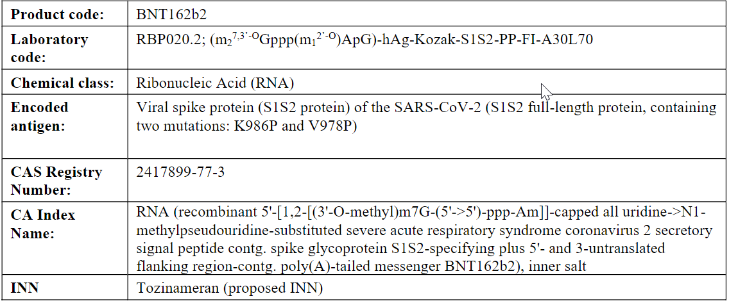

Structural formula (CTD section: S.1.2)
BNT162b2 drug substance is a single-stranded, 5'-capped mRNA that is translated into a protein (the encoded antigen). Figure S.1-1 illustrates the general structure of the antigen-encoding RNA, which is determined by the respective nucleotide sequence of the DNA used as template for invitro RNA transcription. In addition to the codon-optimized sequence encoding the antigen, the RNA contains common structural elements optimized for mediating high RNA stability and translational efficiency (5'-cap, 5'-UTR, 3'-UTR, poly(A)‐tail; see below). Furthermore, an intrinsic signal peptide (sec) is part of the open reading frame and is translated as an N-terminal peptide. The RNA does not contain any uridines; instead of uridine the modified N1-methylpseudouridine is used in RNA synthesis.
Figure S.1-1. General structure of the RNA
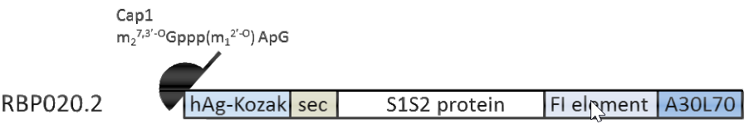
Schematic illustration of the general structure of the BNT162b2 drug substance with 5'-cap, 5'- and 3'-untranslated regions (hAg-Kozak and FI element, respectively), coding sequence with mutations and intrinsic signal peptide (sec) as well as poly(A)-tail (A30L70). Individual elements are not drawn to scale compared to their respective sequence lengths.

mRNA cap
A cap1 structure m27,3’-OGppp(m12’-O)ApG is utilized as specific capping structure at the 5′-end of the RNA drug substance (Figure S.1-2).

Figure S.1-2. 5’-cap analog (m27,3’-OGppp(m12’-O)ApG) for production of RNA containing a cap1 structure
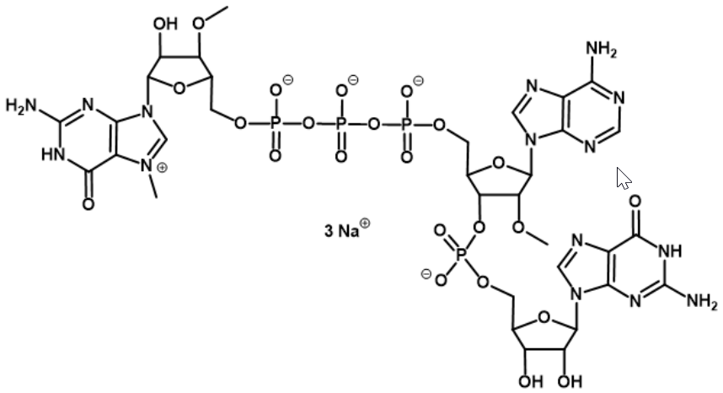
The cap1 structure (i.e., containing a 2’-O-methyl group on the penultimate nucleoside of the 5’-end of the RNA chain) is incorporated into the BNT162b2 drug substance by using a respective cap analog during in vitro transcription. For RNAs with modified uridine nucleotides, the cap1 structure is superior to other cap structures, since cap1 is not recognized by cellular factors such as IFIT1 and, thus, cap1-dependent translation is not inhibited by competition with eukaryotic translation initiation factor 4E. In the context of IFIT1 expression, mRNAs with a cap1 structure give higher protein expression.
Modified Uridine
The RNA does not contain any uridines; instead BNT162b2 drug substance is synthesized in the presence of N1-methylpseudouridine triphosphate (m1ΨTP) instead of uridine triphosphate (UTP).
RNA sequence
The general sequence elements of the BNT162b2 drug substance, as depicted in Figure S.1.2-1, are given below.
The vaccine is based on the spike glycoprotein (S) of the SARS-CoV-2 virus. The sequence was chosen based on the sequence for the “Severe acute respiratory syndrome coronavirus 2 isolate Wuhan-Hu-1”.
hAg-Kozak (nucleotides 2 to 54): 5'-UTR sequence of the human alpha-globin mRNA with an optimized ʻKozak sequenceʼ to increase translational efficiency.
Sec (nucleotides 55 to 102): Sec corresponds to the intrinsic S1S2 protein signal peptide (sec), which guides translocation of the nascent polypeptide chain into the endoplasmic reticulum.
S1S2 protein (nucleotides 103 to 3879): Codon-optimized sequence encoding the spike antigen of SARS-CoV-2. The S1S2 protein or spike glycoprotein is expressed on membranes. It facilitates recognition by the host cells as well as cellular uptake. The protein sequence contains two proline mutation (K986P and V987P), which ensures an antigenically optimal pre-fusion confirmation (P2 S).
FI element (nucleotides 3880 to 4174): The 3’-UTR is a combination of two sequence elements derived from the “amino terminal enhancer of split” (AES) mRNA (called F) and the mitochondrial encoded 12S ribosomal RNA (called I). These were identified by an ex vivo selection process for sequences that confer RNA stability and augment total protein expression.
A30L70 (nucleotides 4175 to 4284): A poly(A)-tail measuring 110 nucleotides in length, consisting of a stretch of 30 adenosine residues, followed by a 10 nucleotide linker sequence and another 70 adenosine residues designed to enhance RNA stability and translational efficiency in dendritic cells.

General properties (CTD section: S.1.3)
The general properties of BNT162b2 drug substance formulated at a target concentration of 2.25 mg/mL in DS formulation buffer (10 mM HEPES, 0.1 mM EDTA, pH 7.0) are summarized in Table S.1-2. The detailed descriptions of structural and functional studies conducted to characterize BNT162b2 are presented in Section 3.2.S.3.1 Elucidation of Structure and Other Characteristics.
Table S.1-2. BNT162b2 Drug Substance General Properties
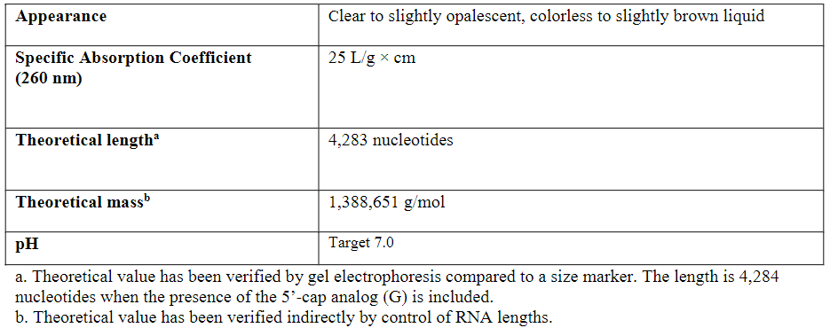

Assessor’s comments on S.1 General Information
Information concerning the nomenclature of the active substance has been provided as well as a graphic representation and a narrative description of the construct, where the therapeutic sequence and all included regulatory elements have been defined and the rationale for their inclusion has been described. The RNA nucleotide Sequence of the BNT162b2 drug substance is included. The information provided is considered in general adequate. However, the proposed mechanism of action should be addressed.
- The proposed mechanism of action should be presented in S.1 General Information.

  - Manufacture (CTD module 3.2.S.2)

Manufacturer(s) (CTD section: S.2.1)
The facilities involved in the manufacturing and release testing of the drug substance are listed in Table S.2.1-1 below.
Table S.2.1-1 Manufacturing and Release Testing Sites
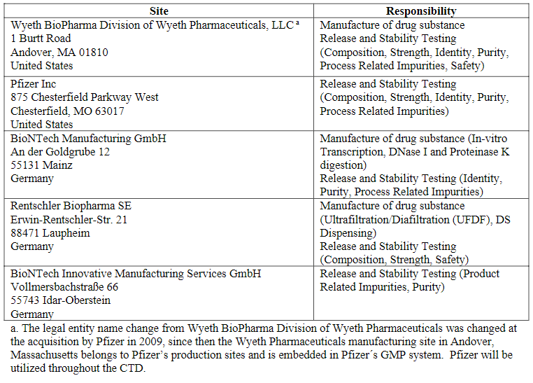

GMP
Assessment of the documentation of GMP compliance is within the remit of the European Medicines Agency (EMA).

Assessor’s comments on Manufacture (3.2.S.2.1):
The facilities involved in manufacturing and release testing of the BNT162b2 drug substance are listed and the corresponding responsibilities are sufficiently described. This is found acceptable.
GMP
The EMA Compliance and Inspection Service has reviewed the manufacturer information contained in the application form and available certificates from the EEA National Competent Authorities. EMA confirms that a GMP Distant Assessment (DA) of the US Andover and Chesterfield sites will be performed as soon as possible.
For sites located in the EU/EEA responsible for manufacture of biological active substances, the latest EU GMP certificate should be submitted.
- The Applicant should provide the latest GMPc for the following site: Rentschler Biopharma SE, Erwin-Rentschler-Strasse 21, 88471 Laupheim, Germany

Description of manufacturing process and process controls: Site Andover (CTD section: S.2.2)
This section includes the description of the manufacturing process for BNT162b2 drug substance. The RNA is first synthesized via an in vitro transcription (IVT)step followed by DNase I and proteinase K digestion steps, which aid in purification. The crude RNA is then purified through a 2-stage ultrafiltration/diafiltration (UFDF). Lastly, the RNA undergoes a final filtration before being dispensed and stored frozen.
A flow diagram for the drug substance process is shown in Figure S.2.2-1. For each process step, this flow diagram lists the process inputs (materials added) and the process controls (process parameters, material attributes, process performance attributes (PPA), in-process tests for control (IPT-C) and in-process tests for monitoring (IPT-M)).
All unit operations are performed at ambient temperature (15-25 °C), unless otherwise stated.
Figure S.2.2-1 Drug substance manufacturing process
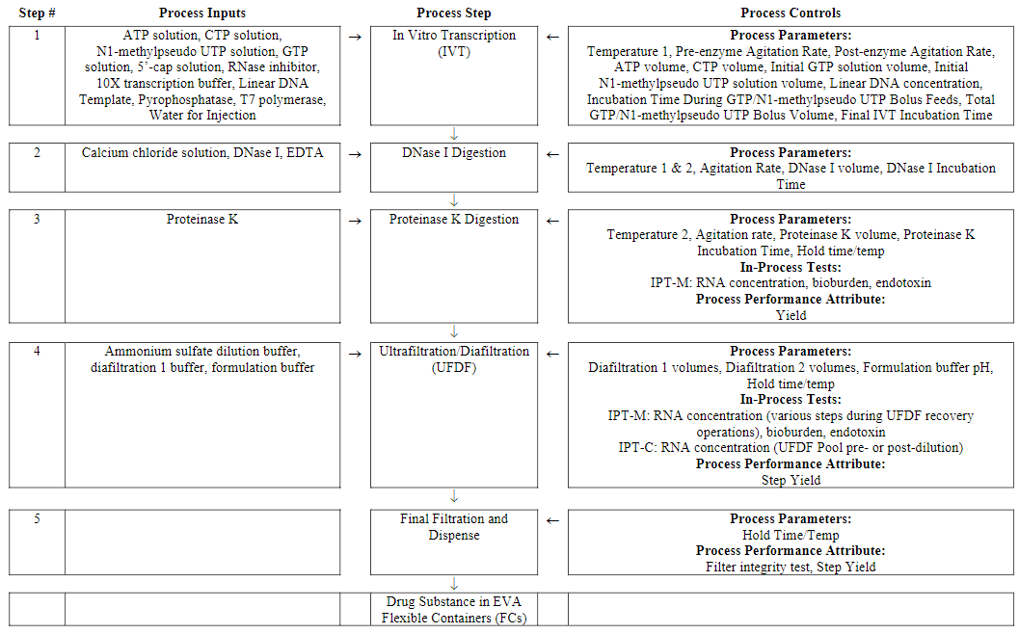
In Vitro Transcription (IVT)
The primary objective of the IVT step is to synthesize RNA for drug substance production.
To begin the IVT step, individual components are thawed and added to the reaction vessel, including ATP solution (100 mM adenosine 5’-triphosphate), CTP solution(100 mM cytidine 5’-triphosphate), N1-methylpseudo UTPsolution(100 mM N1-methylpseudouridine 5’-triphosphate), GTPsolution(100 mM guanosine 5’-triphosphate), 5’-cap solution(100 mM 5’-cap). RNase inhibitor, 10X transcription buffer(400 mM HEPES, 400 mM magnesium acetate, 100 mM DTT, 20 mM spermidine, pH 8.3) and the linear DNA template are also added to the reaction vessel with water for injection(WFI). During the reagent additions, pre-enzyme agitation and temperature control are initiated at target ranges. Finally, pyrophosphatase and T7 polymerase(T7 RNA polymerase) are added to the reaction vessel and agitation is increased to the post-enzyme agitation rate. The above volume additions total to the IVT starting target volume of 37.6 L. After these enzyme additions, the incubation time during GTP/N1-methylpseudo UTP bolus feeds begins.
During this incubation period, an equal mix of N1-methylpseudo UTP and GTP is delivered as 11 bolus feeds. After all the feeds are completed, a final IVT incubation time is initiated. Upon completion of the final IVT incubation time, the process immediately proceeds to the DNase I digestion operation.
The IVT step is controlled using the process parameters shown in Table S.2.2-1.
Table S.2.2-1 Vitro Transcription Process Parameters
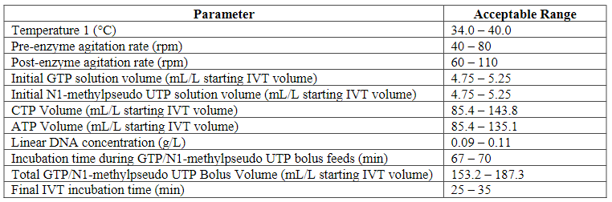
DNase I Digestion
The primary objective of the DNase I digestion step is to reduce the size of linear DNA template to enable subsequent removal across the ultrafiltration/diafiltration step.
A calcium chloride solution (50 mM calcium chloride) and a DNase I solution are added at the end of the final IVT incubation. Temperature (Temperature 1) and agitation rate are maintained during this step. Upon completion of the DNase I incubation time, EDTA (500 mM EDTA) is addedand the temperature setpoint is updated (Temperature 2). After the EDTA addition, the process proceeds with the proteinase K digestion.
The DNase I digestion step is controlled using the process parameters shown in Table S.2.2-2.
Table S.2.2-2 DNase I Digestion Process Parameters
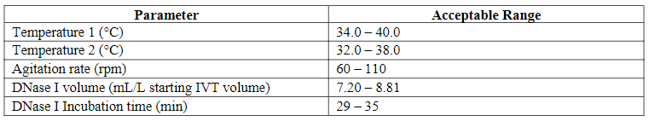
Proteinase K Digestion
The primary objective of the proteinase K digestion step is to reduce the size of proteins in the reaction mixture for subsequent removal across the ultrafiltration/diafiltration step.
Proteinase K solution is added to the reaction vessel and incubated for a predetermined amount of time. Temperature and agitation rate are maintained during this step. At the completion of proteinase K incubation time, the pool can be maintained at ambient temperature for less than 24 hours or held at 2 – 8 °C for up to 72 hours before moving to ultrafiltration/diafiltration.
The proteinase K digestion step is controlled using the process parameters shown in Table S.2.2-3.
Table S.2.2-3 Proteinase K Digestion Parameters
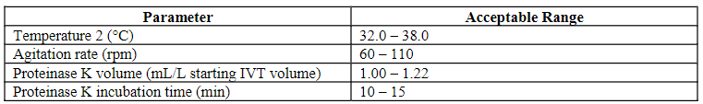
Ultrafiltration/Diafiltration (UF/DF)
The UFDF step removes small process-related impurities and also concentrates and buffer exchanges the RNA into the final DS formulation (10 mM HEPES, 0.1 mM EDTA, pH 7.0).
To prepare for the UFDF step, the sanitized UFDF membranes are equilibrated with diafiltration 1 buffer (200 mM ammonium sulfate, 10 mM HEPES, 0.1 mM EDTA, pH 7.0). The pH and conductivity of the equilibrated membranes are verified.
Prior to UFDF, the post-proteinase K pool is diluted 2-fold with an ammonium sulfate dilution buffer (400 mM ammonium sulfate, 10 mM HEPES, 0.1 mM EDTA, pH 7.0). The diluted proteinase K pool then undergoes a 2-stage diafiltration; first with a minimum of 5 diavolumes (DV) using diafiltration 1 buffer followed by a minimum of 10 diavolumes using formulation buffer (10 mM HEPES,0.1 mM EDTA, pH 7.0).
Based on the retentate RNA concentration determined after diafiltration2, the diafiltered retentate is then concentrated, if needed,and recovered through a 0.45/0.2μm dual-layer filter into a flexible container. The UFDF system is subsequently rinsed and added to the retentate pool through the same dual-layer filter. Formulation buffer may be added to target approximately 2.25 mg/mL. An in-process test for control (IPT-C), with established acceptance criteria, is then performed for RNAconcentration (as described in Section3.2.S.2.4 Manufacturing Process). The final pool is then filtered through a second 0.45/0.2μm dual-layer filter into a flexible container (UFDF pool).
After use, the UFDF membranes are cleaned with 0.5 N sodium hydroxide solution and stored in 0.1N sodium hydroxide solution.The UFDFpool can be maintained at ambient temperature for less than 24 hours or held at 2 – 8°C for up to 72 hours prior to start of the final filtration and drug substance dispense.
The UFDF is controlled using the following process parameters.
Table S.2.2-4 UFDF Process Parameters
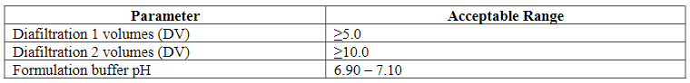
The following in-process tests for control (IPT-C) are conducted for the UFDF step.
Table S.2.2-5 In-Process Tests (Control) for UFDF
The UFDF membrane lifetime will be established through at-scale concurrent validation studies that are currently ongoing.
Final Filtration and Dispense
The UFDF pool undergoes a bulk final 0.45/0.2 μm filtration into a flexible container. Final drug substance release testing is performed at this stage. The drug substance (DS) is then dispensed into ethylene vinyl acetate (EVA) flexible containers (FC). The DS FCs can be held at 2 –8 °C for up to 72 hours prior to freezing.
Drug substance storage and transportation
The DS FCs are frozen and stored between -15 °C and -25 °. DS FCs shipments using an insulated shipper are qualified for a shipping time of up to 106 hours at temperatures ≤-15 °C as supported in Section 3.2.S.2.5.
Bulk Final Refiltration Procedure
In the event that the post-use integrity test on the final 0.45/0.2 μm filter fails, the bulk DS may be refiltered through an unused 0.45/0.2 μm filter. The Bulk Filtration and Dispense Refiltration step is performed in the same manner as the initial Final Filtration and Dispense step. The bulk DS is mixed and sampled for bioburden and endotoxin evaluation prior to being filtered through the new 0.45/0.2 μm filter. The newly used 0.45/0.2 μm filter is flushed with WFI and integrity tested. The results of a refiltration integrity test must pass or the batch is rejected.
Batch scale and definition [Andover]
Commercial scale drug substance batches are executed at a scale of 37.6 L starting volume for in vitro transcription (IVT). All material produced is purified by a single, two-stage ultrafiltration/diafiltration (UFDF) to produce drug substance.
The batch number system for drug substance consists of a material designation code followed by a unique number assigned by the material inventory system. Each drug substance batch is assigned one batch number for the entire process. Batches are released under their drug substance batch number.
Description of manufacturing process and process controls: Site BNT Mainz & Rentschler (CTD section: S.2.2)
Section not provided.

Assessor’s comments on Description of manufacturing process and process controls (3.2.S.2.2):
Information on the manufacturing process and process controls for the manufacturing site BNT Mainz & Rentschler is not yet provided. Therefore, the comments below are related only to the Andover site. It is expected that no significant differences between the two processes are envisaged. However, minor process adaption could be accepted provided that they will be appropriately validated.
Overall description of the manufacturing process steps
The manufacturing process of BNT162b2 drug substance involves five major steps. The RNA is first synthesized from linear DNA via an in vitro transcription (IVT) step. It should be observed that the linear DNA template is defined as a starting material, and therefore manufacturing of the template via plasmid DNA is described and assessed in section 3.2.S.2.3. The IVT step is followed by two enzymatic steps, i.e. the DNase I and proteinase K digestion steps, which aid in purification. The crude RNA is then purified through a two-stage ultrafiltration/diafiltration (UFDF) step. Lastly, the RNA undergoes a final filtration before being dispensed and stored frozen.
A flow diagram is provided, presenting the process inputs and the process controls for each step. The purpose of each step in the manufacturing process is sufficiently described. The process parameters and corresponding acceptance criteria are listed for each step. It is noted that not all process parameters are listed, but that the lists include all critical and several non-critical process parameters. Acceptance criteria and criticality of the process parameters are described and assessed in section 3.2.S.2.6. In general, it is agreed that the key process parameters are described in section 3.2.S.2.2. However, for the IVT step, the added volumes of the enzymes T7 polymerase and pyrophosphatase should be regarded as critical, unless justified (see section 3.2.S.2.6).
Hold times are provided for each step, while the validation of hold times is assessed in section 3.2.S.2.5.
The overall description of the manufacturing process is found acceptable. The Applicant explains that the UFDF membrane lifetime remain to be established and the concurrent validation plan is adequately described in S.2.5.
It should be noted that future changes to any of the process parameters listed in S.2.2, reagardless of the classification of CPP or non-CPP, should be applied for as variation applications.
Drug substance transportation
The drug substance is stored between -15 °C and -25 °. Transportation using an insulated shipper is qualified for a shipping time up to 106 hours at ≤-15 °C, as described in section 3.2.S.2.5.
Reprocessing
It is stated that if the post-use integrity test on the final 0.45/0.2 μm filter fails, refiltration is allowed. It is clearly defined that reprocessing at the final filtration step is only allowed once. This is found acceptable.
Batch scale and definition
It is explained that commercial scale drug substance batches are executed at a scale of 37.6 L starting volume for in vitro transcription (IVT). All material produced is purified by a single, two-stage ultrafiltration/diafiltration (UFDF) to produce drug substance. The batch numbering system is sufficiently described. Each batch is assigned one batch number for the entire process. This is found acceptable. However, in addition, information on the final DS volume should be provided.
- Information on the final batch volume should be provided. The Applicant should state either the total batch volume or the approximate number of DS containers generated from one batch. The dossier should be updated accordingly. (OC)

Control of materials (CTD section: S.2.3)
Data for this section is pending and will be updated once the data has been generated, analyzed, and verified.
Materials Used in Manufacture [Andover]
A list of the materials and solutions used in the manufacture of BNT162b2 drug substance is given in section 3.2.S.2.3 Control of Materials – Materials Used in Manufacture [Andover]. The site of manufacture has a vendor management program, including appropriate quality systems, to ensure control of raw materials used for GMP manufacturing. As a result, these materials are purchased from approved suppliers. The raw materials used in the drug substance manufacturing process are tested and released upon receipt in accordance with internal raw material specifications. Specifications for all non-compendial grade raw materials are described in Section 3.2.S.2.3.2. Purified water or water for injection (WFI) manufactured at the facility is used throughout the drug substance process and meets USP/Ph. Eur. Requirements.
Table S.2.3-1. Solutions and Buffers Used in the Manufacturing Processes
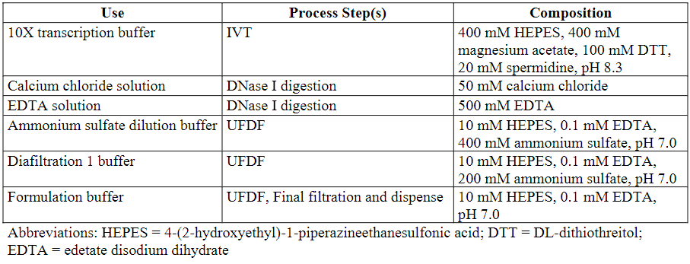
Table provides the list of raw materials used during the manufacturing processes. Raw materials as listed in the table below are used to prepare the listed solution/buffers.
Table S.2.3-2. Raw and Starting Materials Used in the Manufacturing Processes
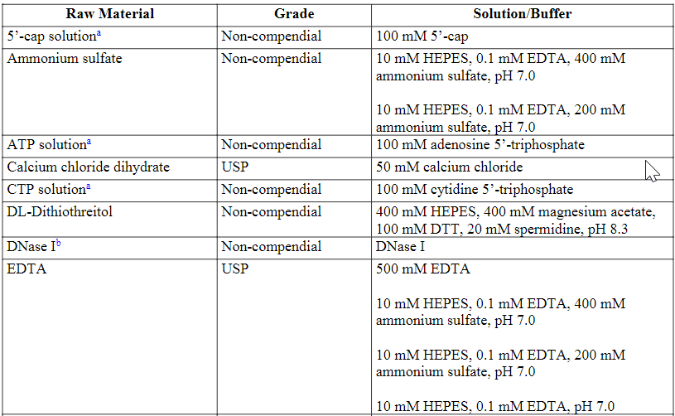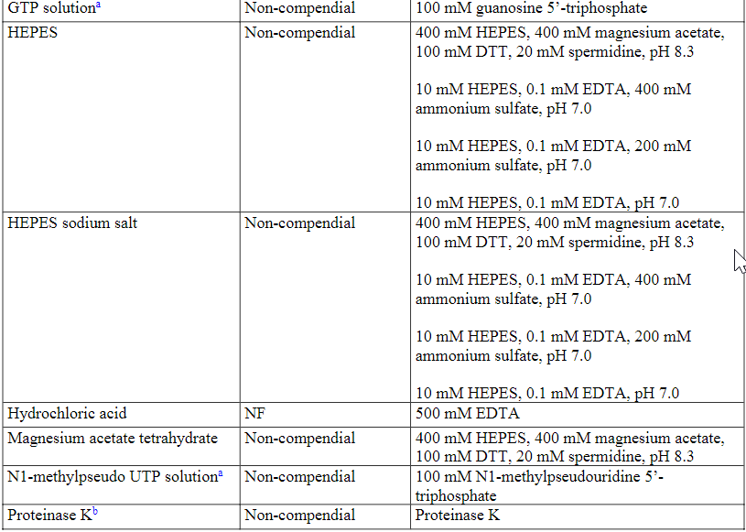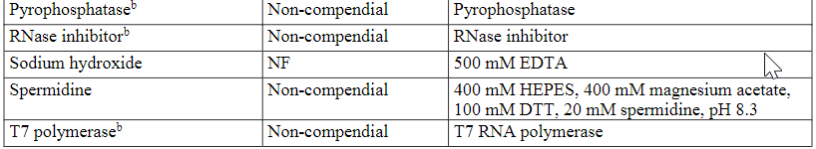
a. Starting material
b. 50% glycerol in buffer solution
Abbreviations: HEPES = 4-(2-hydroxyethyl)-1- piperazineethanesulfonic acid; DTT = DL-dithiothreitol; EDTA = edetate disodium dihydrateor ethylenediaminetetraacetic acid; NF = National Formulary; USP = United States Pharmacopeia
The current acceptance criteria for non-compendial starting materials and raw materialsused during IVT, DNase I digestion, proteinase K digestion, and UFDFprocesses are presented in Table S.2.3-3.
Table S.2.3-3. Acceptance Criteria for Non-Compendial Starting Materials and Raw Materials Used in Manufacturing
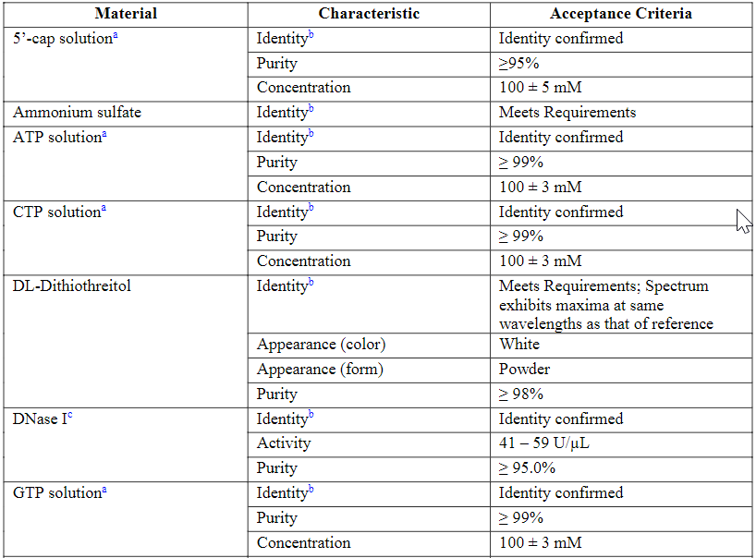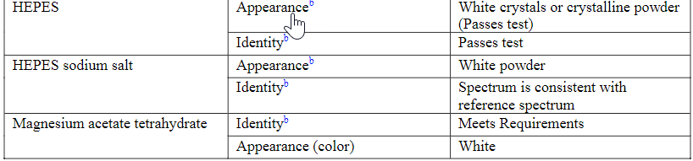
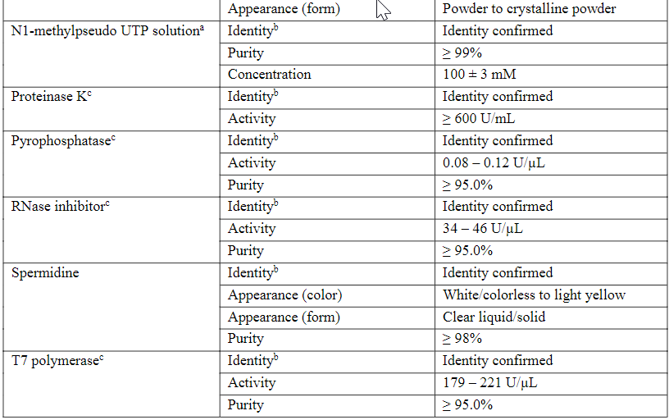
a. Starting material
b. Test is performed by or on behalf of the drug substance manufacturer to confirm vendor’s certificate of analysis
c.50% glycerol in buffer solution

Filter materials have been shown to be suitable for use in drug substance manufacturing.
Table S.2.3-4. Filter Materials Used in the Manufacture of Drug Substance
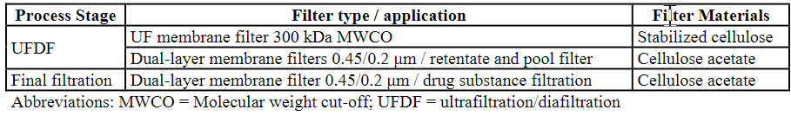

Control of Materials - Source, History and Generation of Plasmids
Plasmid Used for Production of the Linear DNA Template
Manufacture of the BNT162b2 drug substance is achieved using in vitro transcription that includes a linear DNA template as a starting material. The linear DNA template is produced via plasmid DNA from transformed DH10B Escherichia coli cells. The plasmid, pST4-1525, is a 7,824 base pair plasmid designed for the production of BNT162b2. In addition to the sequence coding for the transcribed regions, the plasmid DNA contains a promoter for the T7 RNA polymerase, the recognition sequence for the endonuclease used for linearization, the kanamycin resistance gene, and an origin of replication.
Figure S.2.3-1. pST4-1525 Plasmid Map
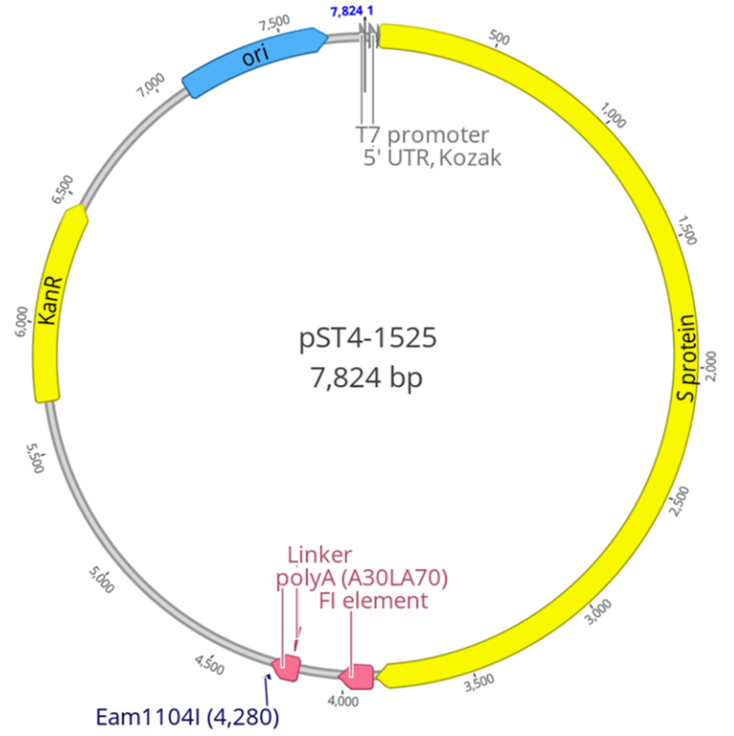

Table S.2.3-4. Functional Elements of pST4-1525
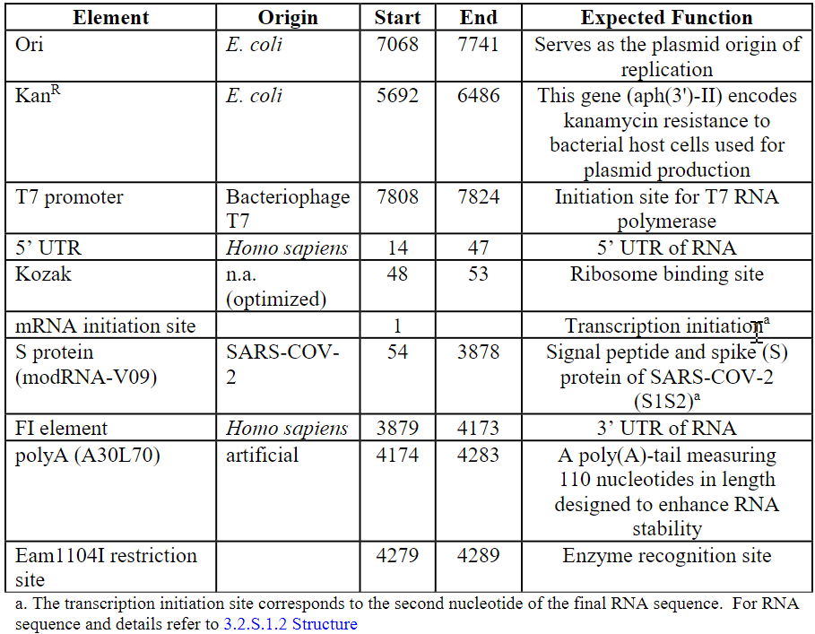
Plasmid Cell Bank and Linear DNA Template Manufacturer(s)
The cell bank manufacture and storage, starting material (linear DNA template) manufacture and associated testing are performed in the Pfizer facility at 875 Chesterfield Parkway West, Chesterfield MO 63017. The cell bank testing was performed at Charles River laboratory, Inc, 358 Technology Dr, Malvern, PA 19355.The cell bank sequence testing was performed at Genewiz, 115 Corporate Boulevard, South Plainfield, NJ 07080.
Plasmid Cell Banking System, Characterization and Testing
Plasmid cell banks have been prepared in accordance with ICH guideline: ICH Q5D Derivation and characterization of cell substrates used for production of biotechnological/biological products. Cell banking operations were performed in a controlled manufacturing area with appropriate precautions against adventitious contamination and cross-contamination from other cell lines.
All materials used in the establishment of the pST4-1525master cell bank (MCB) and working cell bank (WCB) are sourced and manufactured consistent with the current industry guidelines including those from the European Medicines Agency (EMA), the Therapeutic Goods Administration (TGA), and the World Health Organization (WHO) for minimizing the risk of transmitting transmissible spongiform encephalopathies (TSE), including bovine spongiform encephalopathies (BSE).
The LB broth used in the establishment of the pST4-1525MCB and WCB contains casein digest peptone derived from bovine milk.
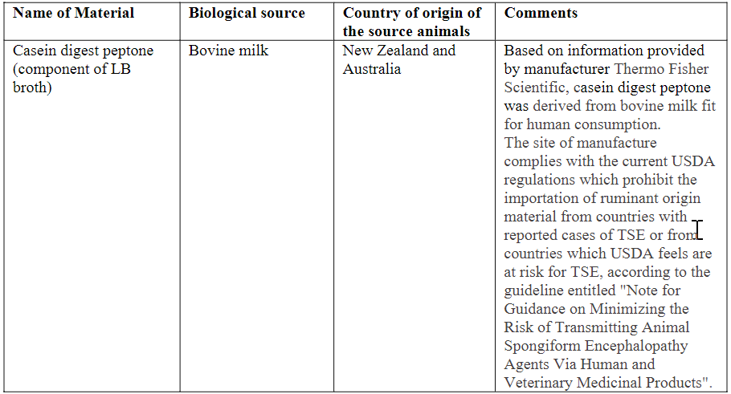
- Preparation of pST4-1525 Master Cell Bank
The plasmid pST4-1525 pre-Master Cell Bank (pre-MCB) was generated by transforming Escherichia coli DH10B competent cells with pST4-1525. A pure culture of transformed cells was produced by growth on selective medium. A single colony isolate was then grown in liquid culture and aliquots were taken and frozen to generate pre-MCB pST4-1525_preMCB_DH10B_20Apr2020.
Vials from pre-MCB pST4-1525_preMCB_DH10B_20Apr2020 were thawed to inoculate shake flasks containing LB Broth, additional yeast extract and kanamycin to a final concentration of 50 μg/mL. The flasks were placed in a shaker incubator (200 rpm) and incubated at 32 ± 2°C, for a maximum of 10 hours. The cultures were stopped once the optical density (OD) at 600 nm (OD600) reached a value of ≥ 2.0. Sterile glycerol was added to the cell culture to a final concentration of 20% (v/v). Aliquots of the formulated cell culture were dispensed into screw-cap cryovials, each containing approximately 1.5 mL of cell suspension. The vials were frozen using a controlled rate freezer and then transferred to storage in the vapor phase of liquid nitrogen freezers.
MCB DW8968 vials are stored at –125°C or colder. Storage is in the vapor phase of liquid nitrogen in validated freezers, with temperature and alarm monitoring. The freezers are in controlled access storage areas at multiple sites as a precaution against loss due to catastrophic events.
- Release testing of the Plasmid Master Cell Bank
Table S.2.3-5 Release testing of the Plasmid Master Cell Bank
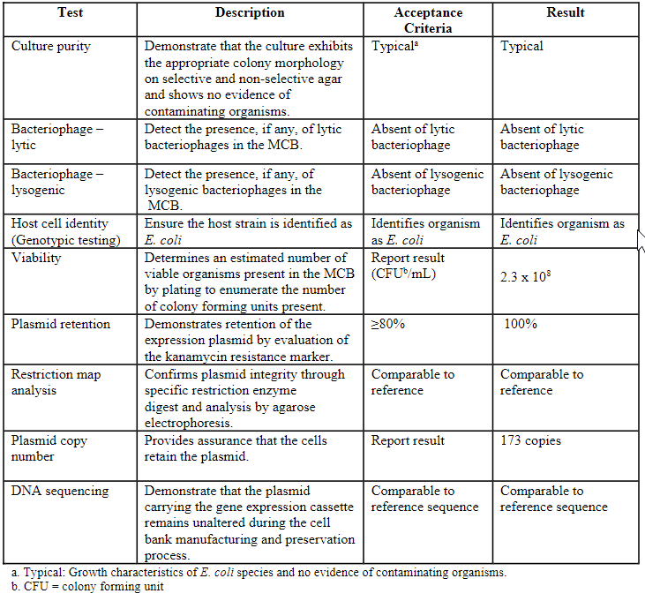
- Preparation of pST4-1525 Working Cell Bank
Vials of MCB DW8968 were thawed to inoculate shake flasks containing LB Broth, additional yeast extract and kanamycin to a final concentration of 50 μg/mL. The flasks were placed in a shaker incubator (200 rpm) and incubated at 32 ± 2°C, for a maximum of 10 hours. The cultures were stopped once the OD600 reached a value of ≥ 2.0. Sterile glycerol was added to the cell culture to a final concentration of 20% (v/v). Aliquots of the formulated cell culture were dispensed into screw-cap cryovials, each containing approximately 1.5 mL of cell suspension. The vials were frozen using a controlled rate freezer and then transferred to storage in the vapor phase of liquid nitrogen freezers.
WCB DW8970 vials are stored at –125°C or colder. Storage is in the vapor phase of liquid nitrogen in validated freezers, with temperature and alarm monitoring. The freezers are in controlled access storage areas at multiple sites as a precaution against loss due to catastrophic events.
- Release testing of the Plasmid Working Cell Bank
Culture purity and identity testing performed on the plasmid WCB DW8970 provide confirmation that the cell bank is free from microbial and bacteriophage contamination and is of an E. coli lineage. The studies were designed in accordance with ICH Q5D guidelines.
Table S.2.3-6 Release testing of the Plasmid Working Cell Bank
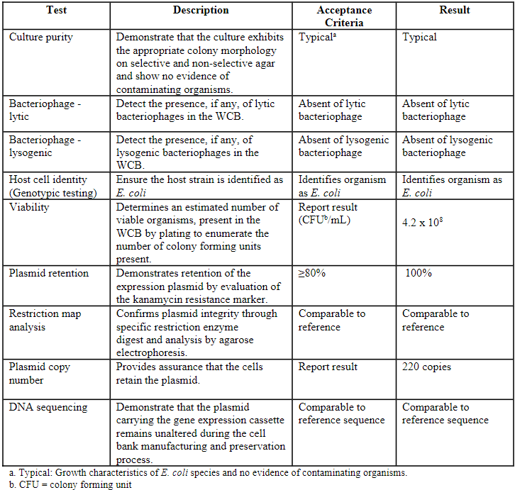
- Preparation, Qualification and Storage of Renewal Plasmid Working Cell Banks (WCBs)
Renewal plasmid working cell banks (WCBs) will be prepared by expanding cells thawed from the MCB DW8968. WCB manufacturing operations will be performed in a controlled manufacturing area with appropriate precautions against adventitious contamination and cross-contamination from other cell lines.
The process steps for WCB preparation are described below. All steps of the WCB preparation process are documented in a manufacturing batch record.

Table S.2.3-7. Process Steps for the Preparation of Renewal Plasmid WCBs
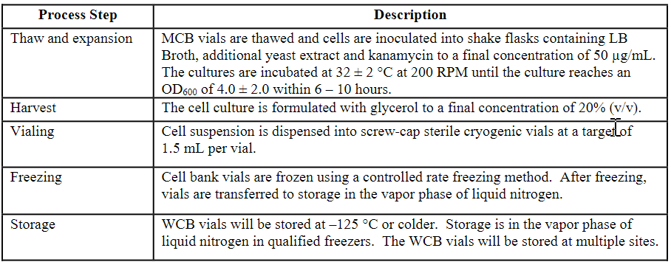
- Qualification of Renewal Working Cell Banks
Tests for identity, purity, and bacteriophage contamination will be performed to confirm the acceptability of renewal WCBs. In addition, future WCBs will be analyzed to demonstrate genotypic and plasmid integrity consistent with the MCB. The acceptance criteria for WCB qualification are summarized below.
Table S.2.3-8. Specification for Renewal Plasmid WCBs
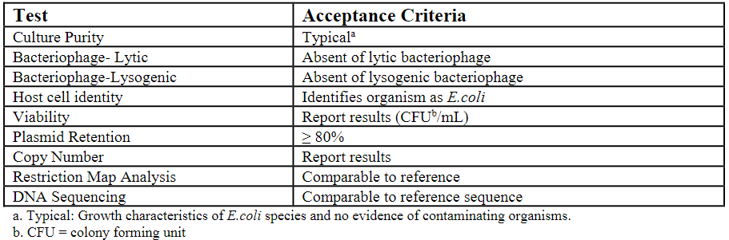

- Plasmid Cell Bank Stability Testing
The plasmid MCBs and WCBs are enrolled in a cell bank stability program consisting of viability and plasmid retention assays conducted at all stability time points. The stability testing timepoints occur at defined intervals beginning from the cell bank release date (time zero) and subsequently at 24 months, 48 months, 72 months, and then every five years until the cell bank is depleted or no longer used for manufacturing.

Linear DNA Template Manufacturing
Cells from the WCB are thawed and the culture is expanded in shake flasks, which are then used to inoculate the fermenter. The culture medium used for expansion and fermentation is a minimal salts/glucose medium that is free of animal-derived components.
Following fermentation, the cells are harvested and chemically lysed to recover the plasmid DNA. After this lysis step, the circular plasmid DNA is purified by ultrafiltration/diafiltration and chromatography.
Following purification, the circular plasmid DNA is incubated with a restriction enzyme, Eam1104I or equivalent, in order to linearize the plasmid followed by ultrafiltration/diafiltration. The linear DNA template is filtered and dispensed in a qualified biosafety cabinet in a qualified cleanroom in order to ensure the final linear DNA template is free of any adventitious agent.
The linear DNA template manufacturing process contains no components of animal origin.
The circular plasmid DNA and linear DNA template are tested to the specifications outlined in 3.2.S.2.3 Control of Materials – Materials Used in Manufacture [Andover] and the linear DNA template is used as a starting material in the drug substance manufacturing.

Linear DNA Template Specifications
The release specifications for the linear DNA template are given in Table S.2.3-9. The analytical control strategy includes sampling and testing of a selected number of attributes prior to linearization and the remainder of the attributes on the final linear DNA template.
Table S.2.3-9. Linear DNA Template Specifications
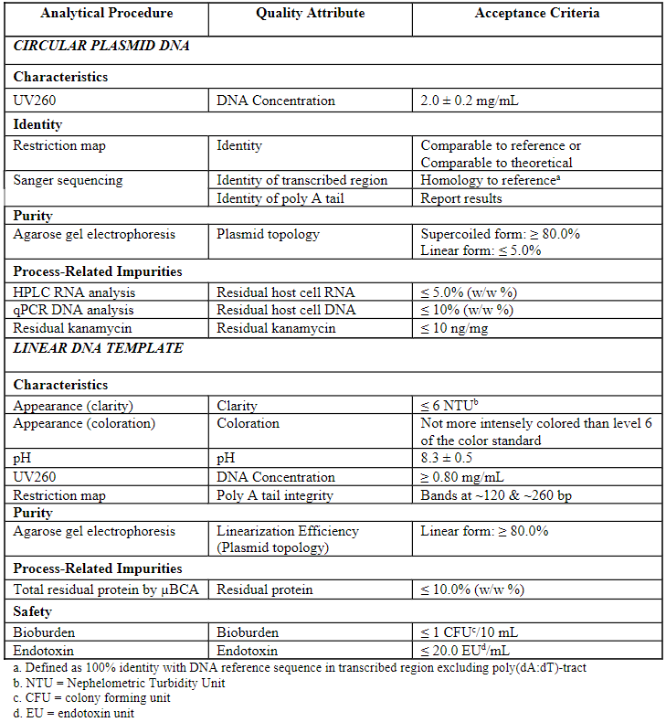
Linear DNA Template Batch Analysis
The batch analysis data for representative lots of the linear DNA template are given in Table S.2.3-10. At the time of manufacture of these batches, the commercial specifications had not yet been determined.
Table S.2.3-10. Linear DNA Template Batch Analysis for Representative Batches
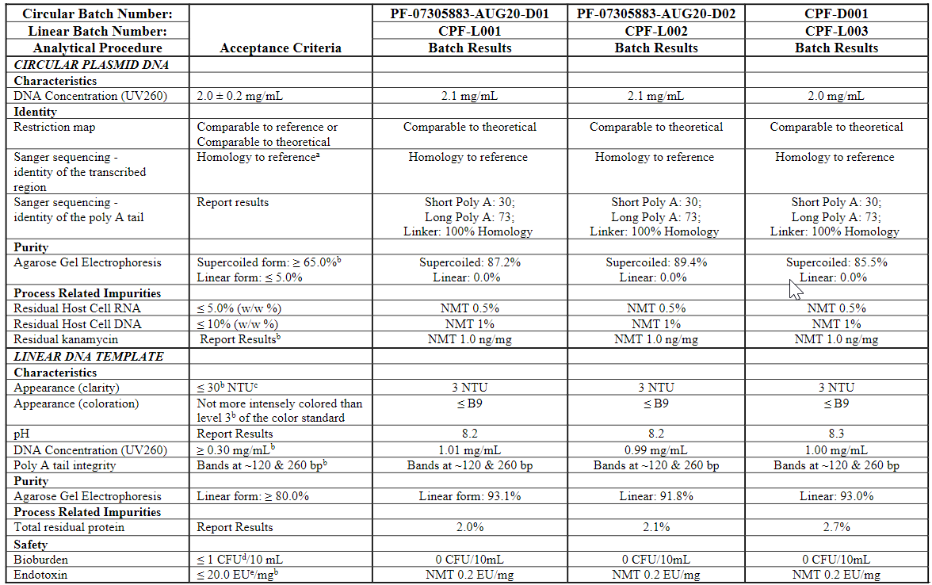
a.Defined as 100% identity with DNA reference sequence in transcribed region excluding poly(dA:dT)-tract
b.Denotes specification at time of release. Specification was subsequently updated as shown in Table 3.2.S.2.3-10.
c. NTU = Nephelometric Turbidity Unitd.
CFU = colony forming unit.
EU = endotoxin unit
Materials Used in Manufacture [BNT &Rentschler]
Section not provided.

Assessor’s comments on S.2.3 Control of materials:
An adequate overview of the raw materials and solutions used in the Drug Substance manufacturing process is provided. Limited acceptance criteria are included in a tabular format for all raw materials: Representative CoAs or specification should be included for the non-compendial materials (OC). In general, the submitted information seem to support an appropriate quality of raw materials, however, no information regarding microbiological control has been provided. Additionally, the risk of the presence of contaminating RNases should be addressed (OC). It is stated that identity testing for all raw and starting materials (but not for the linearized plasmid DNA) is performed by or on behalf of the drug substance manufacturer to confirm vendor’s certificate of analysis. This is endorsed. The applicant should consider additional in-house testing for the functional activity of starting and critical raw materials, such as enzymes used in the manufacturing process (OC).
A list of material of animal origin used in the Drug Substance manufacturing process is provided and include proteinase K, filter of various sizes, Flexible containers (Bag systems) used at various processing steps and to hold final drug substance, Clear C-flex tubing, various sizes, including manifold assemblies provided by vendors and Tubing assembly. Information regarding material composition is included but no CoAs are provided. Additional information on adventitious agents’ evaluation is provided and discussed in section 3.2.A.2.

Starting materials:
The listed starting materials include ATP solution, CTP solution, GTP solution, N1-methylpseudo UTP solution and 5’-cap solution and the linear DNA template. The approach is acceptable.

Linear DNA template
The linear DNA template is not part of the final product but defines the sequence of the mRNA product and therefore it is fundamental to ensure its adequate control. For example, changes to the manufacturing process for the linear DNA template (e.g. change to plasmid host cell) may result in a different impurity profile in the active substance. Therefore, the manufacturing process of this type of starting material should be appropriately described in the dossier in order to determine the adequacy of the controls for impurities in the drug substance and the purity/stability of the linear template DNA. Specific comments are given below.
BNT162b2 drug substance is manufactured by in vitro transcription using a linear DNA template, produced via plasmid DNA (pST4-1525) from transformed DH10B Escherichia coli cells. The functional elements of the pST4-1525 are sufficiently described in graphic and tabular formats and the sequence is included. Neither the source and generation of the pST4-1525 plasmid nor details on the specific E. Coli strain used are documented (OC).
The sites involved in manufacturing, testing and storage of the plasmids are listed.
The cell banks involved in the plasmid manufacturing process are described. MCB and WCB qualification tests are listed and include morphologic and genotypic identity, restriction map analysis and DNA sequencing, absence of contaminating bacteriophages, viability, plasmid retention and plasmid copy number. Relevant specifications are set and data from the current MCB and WCB are provided. Information is requested on the reference material used for restriction map analysis and DNA sequencing (OC). The plasmid MCBs and WCBs are enrolled in a cell bank stability program consisting of viability and plasmid retention assays conducted at all stability time points. The strategy is considered adequate.
pST4-1525 is manufactured by a fed-batch fermentation process initiated from the bacterial working cell bank (WCB). Following fermentation, the cells are harvested and chemically lysed to recover the plasmid DNA. After this lysis step, the circular plasmid DNA is purified by ultrafiltration/diafiltration and anion exchange chromatography. The circular plasmid DNA is filtered via 0.2 μm filtration and stored frozen at -60 to -90 °C; the hold time for this intermediate is not defined (OC). The filtrate is sampled for the circular plasmid DNA specifications. After thawing, the plasmid is linearized, concentrated, filtered and stored frozen at -15 to -25 °C. The filtrate is sampled for the linear DNA template specification. A list of the raw materials as well as the chromatography resins and filters used in the manufacture of the linear DNA template is provided. All materials used are animal origin free and sourced from approved suppliers. In general, the description of the manufacturing process of pST4-1525 is considered acceptable.
Specifications for the circular plasmid DNA as well as for the DNA linear template are provided. Process- and product-related impurities including host cell genomic DNA, RNA, proteins, endotoxins, bioburden and plasmid isoforms, for the plasmid DNA, are quantified routinely. The reference material for plasmid identity testing is not described (OC). Results from three different batches are provided for the circular and linearized plasmid and the proposed specification limits seem to be justified by the yet limited available data. No descriptions of the analytical methods used for the control of the linear DNA template nor evidence regarding their qualification/validation have been provided (OC). Considering the criticality of this starting material for the quality of the final product, this information should be provided. The Applicant is reminded that implementation of changes in the manufacture of the linear DNA template should be applied for in a variation application (OC).
As stated in the dossier, the linearized DNA template will be stored at -15 to -25 °C but no additional information nor data are provided to support stability (OC).
- Representative CoAs or full specifications should be provided for starting and non-compendial raw materials used in the manufacturing of BNT162b2 DS. It is expected that information regarding the microbiological control is included. Additionally, all raw materials should be demonstrated to be free from contaminating RNases, unless otherwise justified.
- Where relevant, the applicant should consider in house testing for the functional activity of starting and critical raw materials such as the enzymes used in the manufacturing process.
- Details on the E. Coli strain and the source and an overall description of generation (flow chart of the successive steps) of the plasmid used as template for the production of Drug Substance should be provided.
- Information should be provided regarding the reference material used in the restriction map analysis and DNA sequencing determination for MCB and WCB used for plasmid DNA template production.
- Appropriate descriptions of all analytical methods used in the release control of the linear DNA template as well as summaries of the results obtained in the method validation/qualification studies should be provided.
- The reference material for plasmid identity testing should be described.
- The stability of the linear DNA template and of the filtered circular plasmid DNA intermediate should be addressed. A shelf life for the linearized DNA template should be established and a stability protocol covering the proposed storage period should be included. Relevant available data should be provided to support this proposal.
- The Applicant should confirm that implementation of changes in the manufacture of the linear DNA template will be applied for in a variation application.

Control of critical steps and intermediates: Site Andover (CTD section: S.2.4)
Manufacturing process
This section provides a description of the controls of critical process steps employed during manufacture of BNT162b2 drug substance to ensure that product quality is maintained. Process parameters and tests that are used to control the process and drug substance quality are provided in this section.
Process parameters discussed in this section include all critical process parameters (CPPs). As described in Section 3.2.S.2.6 Process Development and Characterization, CPPs were conservatively defined after the Cause and Effect (C&E) risk assessment by evaluating the parameters which had a strong functional relationship to a quality attribute (high C&E scores). These relationships were supported by data available from the process characterization studies, established scientific rationale or platform knowledge. Due to rapid development of additional process knowledge, process parameters and ranges are expected to be updated in a subsequent submission to the MAA prior to its approval.
Table S.2.4-1 provides a list of in-process controls (critical process parameters and IPT-Cs) with their acceptable ranges/acceptance criteria for the drug substance manufacturing process.
Table S.2.4-1 Process Controls
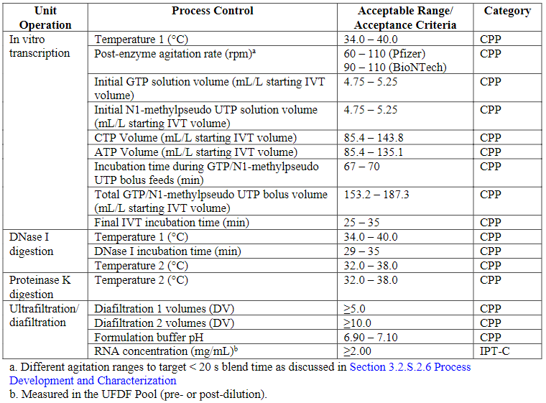
In-Process Test Methods [Andover] -In-Process Testing for Control (IPT-C)
Determination of RNA Concentration by Ultraviolet (UV) Spectroscopy
The UV spectroscopy method is used to quantitate the RNA concentration in the ultrafiltration/diafiltration (UFDF) pool (pre- or post-dilution) and is used to determine UFDF step yield. Details of the analytical procedure are described in Section 3.2.S.4.2. UV Spectroscopy. A summary of the method validation is detailed in Section 3.2.S.4.3 UV Spectroscopy.
In-Process Test Methods [Andover] -In-Process Testing for Monitoring (IPT-M)
Descriptions of the in-process test methods for monitoring are provided below. These IPT-Ms with established action limits are used to routinely monitor the manufacturing process and ensure that the process remains in a state of control.
Determination of RNA Concentration by Ultraviolet (UV) Spectroscopy
The UV spectroscopy method is used to quantitate the RNA concentration in the proteinase K pool sample to determine IVT yield and at various steps during the UFDF recovery operation. Details of the analytical procedure and the corresponding method validation are provided in Section 3.2.S.4.2 UV Spectroscopy and Section 3.2.S.4.3 UV Spectroscopy, respectively.
Bioburden
The bioburden procedure is performed to determine the microbial load of viable microorganisms in the proteinase K pool (post-hold), UFDF pool (post-hold), and the UFDF end of diafiltration 2 retenate (pre-recovery) samples. The analytical procedure is performed following the principles described in the local compendia, USP <61>, Ph. Eur. 2.6.12, and JP 4.05 using membrane filtration methodology.
Endotoxin
The purpose of bacterial endotoxin testing is to measure the level of bacterial endotoxins in the proteinase K pool (post-hold), UFDF pool (post-hold), and the UFDF end of diafiltration 2 retenate (pre-recovery) samples. The analytical kinetic turbidimetric limulus amebocyte lysate (LAL) procedure is performed following the principles described in the local compendia, USP <85>, Ph. Eur. 2.6.14, and JP 4.01.
Control of critical steps and intermediates: Site BNT Mainz & Rentschler (CTD section: S.2.2)
Section not provided.

Assessor’s comments on S.2.4 Control of critical steps and intermediates
This section provides a description of the controls of critical process steps employed during manufacture of BNT162b2 drug substance. Process parameters and tests that are used to control the process and drug substance quality are provided. Overall, the information provided in this section is found very brief. However, the criticality of the process parameters is assigned and assessed in section 3.2.S.2.6.
Furthermore, the Applicant claims that due to rapid development of additional process knowledge, process parameters and ranges are expected to be updated in a subsequent submission to the MAA prior to its approval. This is found acceptable, but the Applicant is reminded that all process parameters and ranges should be sufficiently validated. All changes in future submissions prior to MAA or CMA approval should be clearly stated.
The in-process test methods are defined either as in-process testing for control (IPT-C) or in-process testing for monitoring (IPT-M). The sole IPT-C is determination of RNA concentration in the ultrafiltration/diafiltration (UFDF) pool (pre- or post-dilution) by UV spectroscopy. This method is performed as described in section 3.2.S.4.2. Three IPT-Ms are listed; determination of RNA concentration in the proteinase K pool by UV Spectroscopy (same as above), bioburden and bacterial endotoxin testing. All three methods are applied to test the proteinase K pool (post-hold), the UFDF pool (post-hold), and the UFDF end of diafiltration 2 retenate (pre-recovery) samples. Bioburden and bacterial endotoxin testing are compendial methods.

Process validation and/or evaluation: Site Andover (CTD section: S.2.5)
Overview [Andover]
The validation of the drug substance manufacturing was conducted for independent, consecutive batches. The validation of the DS production process was designed to provide documented evidence that the manufacturing process, when operating within defined process controls, would consistently produce drug substance meeting pre-determined acceptance criteria and demonstrate expected, reproducible, and consistent process performance.
The PV acceptance criteria included all critical process parameters (CPPs) as determined in Section 3.2.S.2.6 Process Development and Characterization. The PV acceptance criteria also included evaluation of non-CPPs and outputs (e.g. step yield, in-process tests for control and monitoring) based on early process and parameter evaluations and experience from clinical development and engineering scale batches prior to process validation. All the acceptance criteria for the process parameters are captured as Normal Operating Ranges (NORs) unless stated.
The process performance assessments included as part of the validation of the drug substance production process are listed below.
Table S.2.5-1. Process Validation Batch Status and Lineage
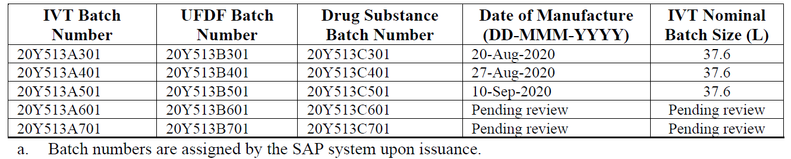
Validation of Removal of Impurities [Andover]
During process development and manufacture of the drug substance, the manufacturing process has successfully been shown to effectively and consistently deliver DS with acceptable levels of process and product related impurities and potential contaminants.
The panel of process and product related impurities and potential contaminants listed in 3.2.S.2.5 Process Validation and/or Evaluation - Removal of Impurities [Andover] will be further evaluated during process validation and was selected to demonstrate that the manufacturing process can consistently deliver drug substance with an acceptable level of impurities. These impurities will be controlled through drug substance release specifications and are discussed in detail in Section 3.2.S.3.2 Impurities.
Manufacturing Process [Andover]
Data for this section is pending and will be updated once the data has been generated, analyzed, and verified.
The purpose of this study was to demonstrate consistency of the in vitro transcription (IVT), DNase I digestion, proteinase K digestion, ultrafiltration diafiltration, final filtration and dispense unit operations for the drug substance manufacturing process for the first three process performance qualification (PPQ)/ process validation (PV) batches against the PPQ acceptance criteria.
The effective and consistent removal of process-derived impurities was demonstrated for the drug substance manufacturing process during process validation. These data are reported and discussed in Section 3.2.S.3.2 Impurities.
The drug substance validation batch release testing results are provided in Section 3.2.S.4.4 Batch Analysis. All results met the pre-determined acceptance criteria.
Performance of In Vitro Transcription, DNase I Digestion and Proteinase K Digestion
Consistency of the process was demonstrated by maintaining input parameters within the defined limits as specified by batch records and the protocol from the ongoing PPQ campaign. The number of batches for PPQ was increased during the campaign in order to evaluate further an increase in the range and target levels of nucleotides, ATP and CTP. Two additional PPQ batches were added to the campaign. The ATP and CTP volumes for all five PPQ batches were within the final validated range. Further details and justification based on characterization studies are discussed in 3.2.S.2.6 Process Development and Characterization.
Performance of Ultrafiltration Diafiltration (UFDF)
The purpose of this section is to summarize the data demonstrating consistency of the UFDF unit operation for the drug substance manufacturing process. The UFDF step reduces the amount of small product-related and process-related impurities and concentrates and buffer exchanges the RNA into the final drug substance matrix.
Consistency of the process was demonstrated by maintaining input parameters within defined limits as specified by batch records and the protocol from the ongoing PPQ campaign. Data are presented in the dossier.
Table S.2.5-2. UFDF Results
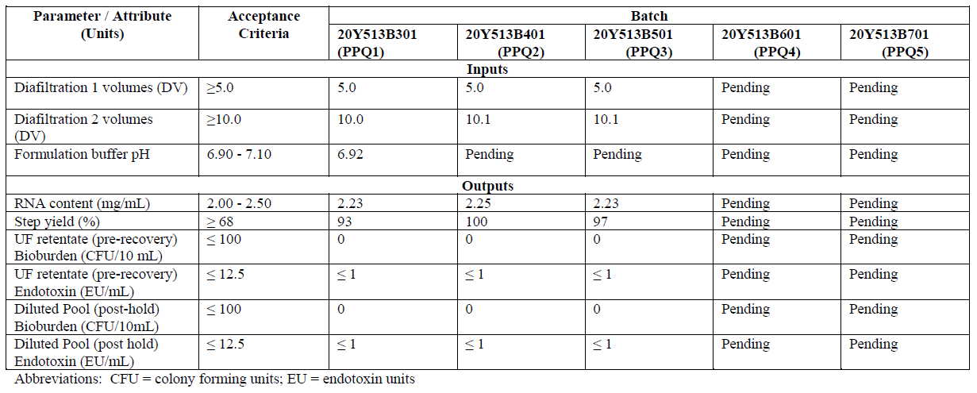
Final Filtration and Dispense
The purpose of this study was to demonstrate consistency of the final filtration unit operation prior to dispensing into flexible containers for the drug substance manufacturing process. The UFDF pool is filtered into a single flexible container following final filtration before dispensing directly into multiple flexible containers for storage to ensure dispense uniformity.
Effectiveness of final filtration unit operation was assessed by evaluating the final filter integrity. Sanitary control was also evaluated by performing bioburden and endotoxin testing. Consistency of the process was demonstrated by assessing the final filter integrity and step yield within limits as specified by batch records and the protocol from the ongoing PPQ campaign. Data are presented in the dossier.
Final Filtration Refiltration
A laboratory scale validation study was performed to demonstrate that a one-time refiltration of the drug substance through the final filtration step at the commercial scale has no adverse effects on the drug substance. The study was performed under protocol using laboratory scale filters with comparable volume-to-area ratios and porosity as used at the commercial scale of drug substance manufacturing process.
Samples from an initial bulk filtration pool at the commercial scale for one drug substance batch was taken for analysis. The initial bulk filtration sample was refiltered through an unused laboratory scale filter and sampled (refiltration 1). In order to evaluate worst case conditions, the refiltration step was repeated once more through a separate unused laboratory scale filter and sampled (refiltration 2).
Data from laboratory scale refiltration studies were collected. The results of this study are planned to demonstrate that the final filtration refiltration step has no adverse effects on the quality of the drug substance.
Hold Times
Routine manufacturing of DS does not require holding of in-process pools. However, to aid in manufacturing scheduling and flexibility, strategic holds (≥24 hours) of the in-process pools were validated for microbial control and product biochemical stability. Studies were executed under protocol to demonstrate both microbial control and biochemical stability of the RNA over a defined, extended, hold time (see separate heading below).
Deviations, Events, and Non-Conformances
Deviations encountered during the execution of the validation study will be investigated. Investigations will assess the potential impact on the validation studies and on the purified drug substance quality. Summary of the deviations will be presented in this section following the completion of the PPQ.

Validation of In-Process Test Methods [Andover]
Data for this section is pending and will be updated once the data has been generated, analyzed, and verified.
The Limulus Amebocyte Lysate (LAL) bacterial endotoxin analytical procedure, using the kinetic turbidimetric LAL method, was validated for the quantitative determination of the level of bacterial endotoxins in BNT162b2 in-process samples. The bacterial endotoxins analytical procedure was performed in alignment with the current United States Pharmacopeia (USP) Chapter <85>, Ph. Eur. 2.6.14, and JP 4.01.
The validation of the bioburden analytical procedure (performed following the principles described in USP <61>, Ph. Eur. 2.6.12, and JP 4.05) for BNT162b2 drug substance (DS) was performed based on guidance from USP <1227>. The method validation (challenge recovery test) challenges the test method to ensure that the test articles are non-inhibitory to the recovery of inoculated microorganisms.
Process Validation and/or Evaluation - Hold Times [Andover]
Data for this section is pending and will be updated once the data has been generated, analyzed, and verified.
Multiple hold time studies have been performed for the DS process to establish the maximum duration of holds for in-process pools. These studies were designed to demonstrate effective microbiological control of bioburden and endotoxin and product quality at both normal routine processing as well as at maximum allowable batch record limits.
In-process pool hold times are not required for routine processing, but strategic holds in the process ≥24 hours to aid in manufacturing scheduling were validated. Periods of less than 24 hours are considered active processing times and are not evaluated unless product is shown to be unstable.
Data presented in this section will demonstrate microbial hold data from media simulation studies using the containers at commercial scale and biochemical stability for in-process pools at small scale to support the validation of in-process holds. Biochemical stability for durations <24 hours during routine processing were also evaluated as part of the study and the conditions are summarized in Table 2.3.S.2.5-2.

Table S.2.5-3. Validated Maximum In-Process Hold Times
In-Process Pool | Hold Temperature (°C) | Container Type | Validated Hold Time (h)
Post proteinase K (ProK) pool | 2 – 8 | Polyethylene (PE) | ≤72
Ultrafiltration/diafiltration (UFDF) pool | 2 – 8 | Polyethylene (PE) | ≤72
Drug substance (before freezing) | 2 – 8 | Ethylvinylacetate (EVA) | ≤72
Post proteinase K (ProK) pool | 25 | Polyethylene (PE) | N/Aa
Ultrafiltration/diafiltration (UFDF) pool | 25 | Polyethylene (PE) | N/Aª
a. Routine processing times < 24 hours and are not required to be validated
maximum hold study at commercial scale for drug substance at 2 – 8 °C was executed to assess microbial control and biochemical stability of the product at the drug substance dispense step in the flexible container used for drug substance storage. Material from a commercial scale batch (batch 20Y513C201) was sampled for the study. The study met all acceptance criteria and supported a maximum hold time of ≤72 hours.
Table S.2.5-4. Cumulative or Maximum Hold at Commercial Scale Results
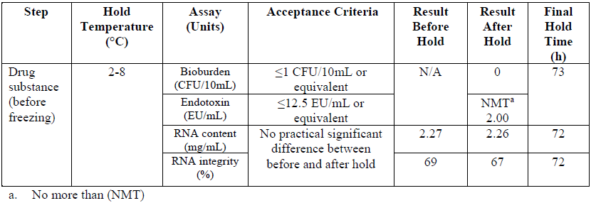

The media hold studies are intended to show microbial control at the commercial scale. Data from the surrogate media hold study in flexible containers for commercial scale at worst-case conditions is shown in Table 3.2.S.2.5-4. The surrogate media used was confirmed to promote microbial growth.
Table S.2.5-5. Microbial Control Study Results (Media Hold)
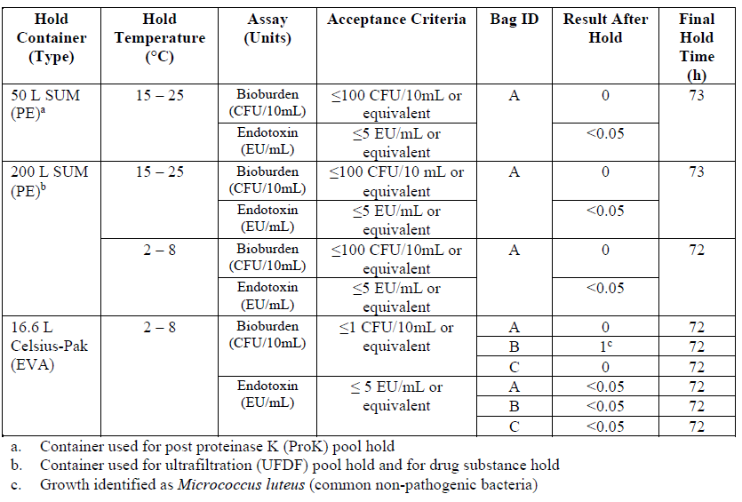
The small scale in-process hold studies are intended to support biochemical stability at commercial scale. Process aliquots from three commercial scale batches were held in appropriate containers to mimic the material of construction used at commercial scale. Fill volume ratios for the small-scale study were the lowest expected fill volumes at commercial scale or lower. Worst-case conditions for the process pools were selected for assessing biochemical stability.
Following each hold, aliquots of all pools were prepared and submitted for analysis to determine the potential impact of the hold time on RNA product quality. In addition to testing the in-process holds described in Table 3.2.S.2.5-1, worst-case hold times at 25°C for ≤36 hours were also evaluated as part of the study. Intermediate hold times were also included for sample analysis. At the 2 – 8 °C condition, hold times of 0, 24, 48 and 72 hours and for the hold temperature of 25 °C condition, hold times of 0, 12, 24 and 36 hours. Assays to detect possible degradation of the molecule were performed, including, RNA content and RNA integrity by capillary electrophoresis (CE). No practical significant difference between before and after hold was observed and the in-process pools demonstrated biochemical stability over the evaluated hold times.
The assays results are presented in the dossier.
Filter Qualification and Validation [Andover]
Data for this section is pending and will be updated once the data has been generated, analyzed, and verified.
Vendor information and recommendations were reviewed for all direct product contact filters used in the manufacture of drug substance. Filter operational performance was assessed against the vendor recommendations. The assessment is ongoing, and the filtration steps will be performed within specified parameter ranges with confirmation that the appropriate filters and filter sizes have been selected.
The filter membrane chosen for final filtration of drug substance solution is a 30” 0.45/ 0.2 μm cellulose acetate. Data from the filter validation studies will be provided when available.
Extractable testing will be performed on the final bioburden reduction filter using water as the extracting fluid. Based on the results of this testing, components of the filter capsule will be confirmed to be non-toxic as per USP <88> Biological Reactivity Tests for Class VI Plastics and USP<88> Safety Test.
Based on the extractables study results with water as the model solvent for worst case conditions, a leachable study will be performed with product under process specific conditions. The study is currently ongoing, and the results will be updated when available.
Final filtration validation conclusions are pending study completion.
Shipping Performance Qualification [Andover]
This section summarizes the data generated to support the successful qualification of the shipping process for transport of frozen drug substance in ethylvinylacetate (EVA) flexible containers (FCs) at a temperature of ≤ 15 °C during the air and ground shipments from the drug substance manufacturing site Pfizer, Andover, MA USA to the drug product manufacturing sites up to 106 hours. This leaflet covers multiple routes for the global supply chain.
The leaflet also covers the shipping qualification for the 8.3 L EVA FCs that may be used in the future after appropriate qualifications during at-scale batch operations.
Drug substance is manufactured at Pfizer, Andover and dispensed using the drug substance batch product concentration to a target fill of 34.8 g into 16.6 L EVA flexible containers (FCs). Depending on the batch product concentration, the minimum fill volume is 4.2 L and the maximum fill volume is 16.6 L. The FCs are frozen and stored at -20 ± 5 °C. The FCs are shipped from the Andover DS manufacturing site to the Kalamazoo and Puurs DP manufacturing sites. Temperature control of DS during shipment uses a qualified passive pallet shipper packed with dry ice and phase change material. The passive pallet shipper is qualified to maintain a temperature of ≤ -15 °C for a transit time of up to 106 hours. The expected transit time from the DS manufacturing site Pfizer, Andover to the DP manufacturing site in Kalamazoo is 24 hours and for the DP manufacturing site in Puurs is 96 hours.
The overall qualification strategy considered both thermal and mechanical aspects of shipping.
Table S.2.5-6. OQ Thermal Testing Results
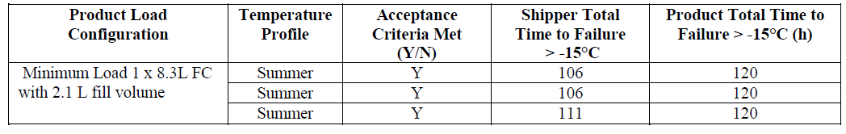
Table S.2.5-7. OQ Mechanical Testing Results
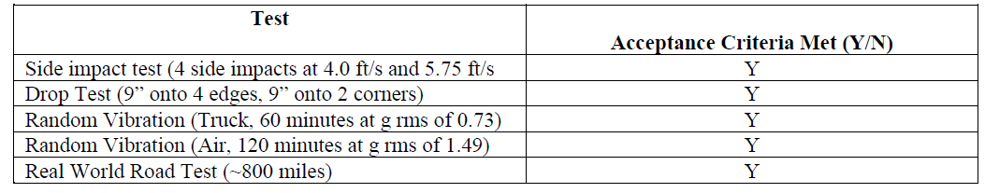
Table S.2.5-8. PQ Result Summary
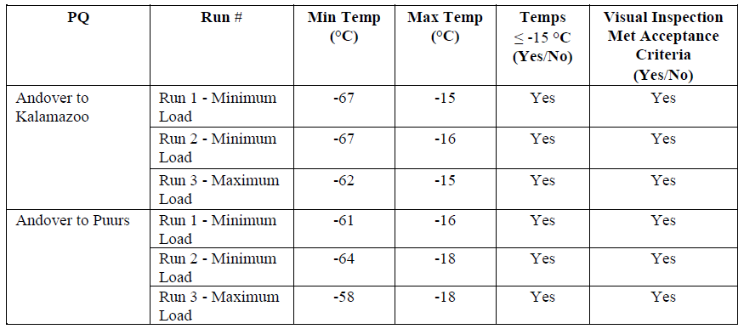

Additional Process Evaluation [Andover]
The maximum number of cycles that the UFDF membrane can be reused will be validated at commercial scale. Table 3.2.S.2.5-8 outlines the membrane performance tests for commercial scale membrane lifetime validation.
Table S.2.5-9. Performance Tests for Commercial Scale Membrane Lifetime Validation
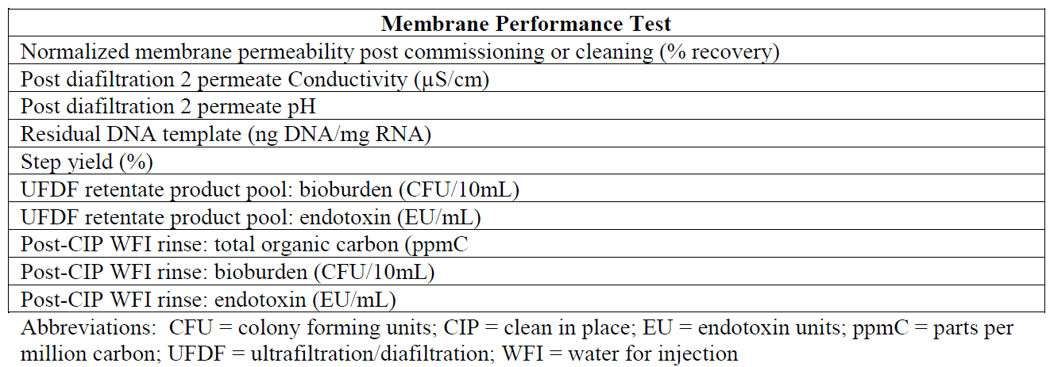
A process monitoring program that performs trending and analysis of release attributes and critical processing parameters will be implemented for ensuring the consistency of the manufacturing process. Under this program, risk assessments are performed, process data trends or shifts are evaluated when identified, and corrective actions implemented as appropriate. Any changes related to licensed process parameters will be assessed and subjected to required regulatory process.
Process validation and/or evaluation - Site BNT Mainz & Rentschler (CTD section: S.2.5)
Section not provided.

Assessor’s comments on S.2.5 Process validation and/or evaluation: (Site Andover):
For the process validation studies a total of five validation batches will be included, all these batches have been manufactured representing the commercial batch size of 37.6 L. The results from batches PPQ4 and PPQ5 are still pending.
- Several validation studies are still pending and will be updated once the data has been generated. Therefore, a time-plan for the submission of these additional process validation data should be provided before marketing authorization approval.
- Table 3.2.S.2.5-1 in section Process Validation and/or Evaluation - Overview (Andover) needs to be clarified and aligned with information presented in other parts of the dossier. In section 3.2.S.6 it is stated that the DS batches PPQ4 and 5 (20Y513B601 and 20Y513B701) were manufactured 17 Sep 2020 and 24 Sep 2020 respectively.
Hold times
It is stated that in-process pool hold times are not required for routine processing, but strategic holds in the process ≥24 hours to aid in manufacturing scheduling were validated. The small scale in-process hold studies are intended to support biochemical stability at commercial scale. The hold times for the Proteinase K pool, UFDF pool and DS before freezing as listed in S.2.2 are all acceptably validated for hold times ≤72 hours.
Filter Qualification and Validation
Pending
Shipping Performance Qualification
The shipping qualification strategy are described in detail and considered both thermal and mechanical aspects of shipping. The shipping procedures and configuration for transport of frozen DS to the DP manufacturing sites were validated to maintain product temperature in the acceptable range for durations up to 106 hours.
UFDF membrane lifetime
The strategy for UFDF membrane lifetime validation is to perform concurrent validation of the membranes at commercial scale. Parameters related to performance and cleaning of membranes will be evaluated as listed in Table S.2.5-9. This strategy is found appropriate since control of process parameters and IPC-tests are in place for every batch.

Manufacturing process development (CTD section: S.2.6)
A scientific and risk-based approach has been used to identify the vaccine critical quality attributes (CQAs) and develop DS and DP manufacturing processes that consistently deliver the desired quality.
This manufacturing process development section for drug substance is organized as follows:
- Quality Attributes
- Process Risk Assessment Strategy
- Process Development and Characterization
- Risk Assessment of Process Related Impurities
- Development History and Comparability
- Control Strategy
- Analytical Method Evolution

Quality Attributes (1)
Quality attributes (QAs) of the drug substance (DS) were identified and assessed for criticality and were initially identified based on their potential relationship to drug product (DP) quality. The process initially considered the quality target product profile (QTPP) of the vaccine DP and the potential impact of the attributes to safety and/or efficacy of the DP.
The following DS attributes (Table S.2.6-1) were identified a priori as a required aspect of the control strategy. This is based on known impact to efficacy and/or safety and compendial requirements or regulatory expectations. No criticality assessment was performed on these attributes due to the automatic inclusion into the control strategy.
Table S.2.6-1. Routine Controlled Drug Substance Attributes
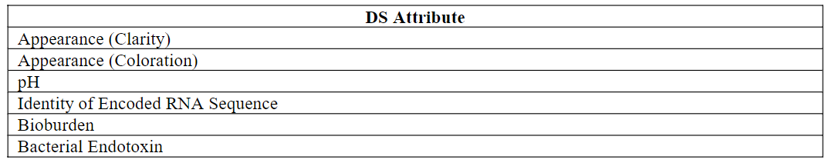
Table S.2.6-2 summarizes the DS attributes designated as QA or critical quality attribute (CQA) as well as the rationale for the criticality assignment. The DS attribute criticality assignment for the DS is primarily governed by the potential impact to safety and/or efficacy of the DP. In addition, process capability, robustness and process controls were taken into consideration for establishing the overall control strategy for DS, including release and stability testing, and other control strategy options such as in-process testing or validation strategies.
Table S.2.6-2. Drug Substance Attributes Criticality Designation and Rationale
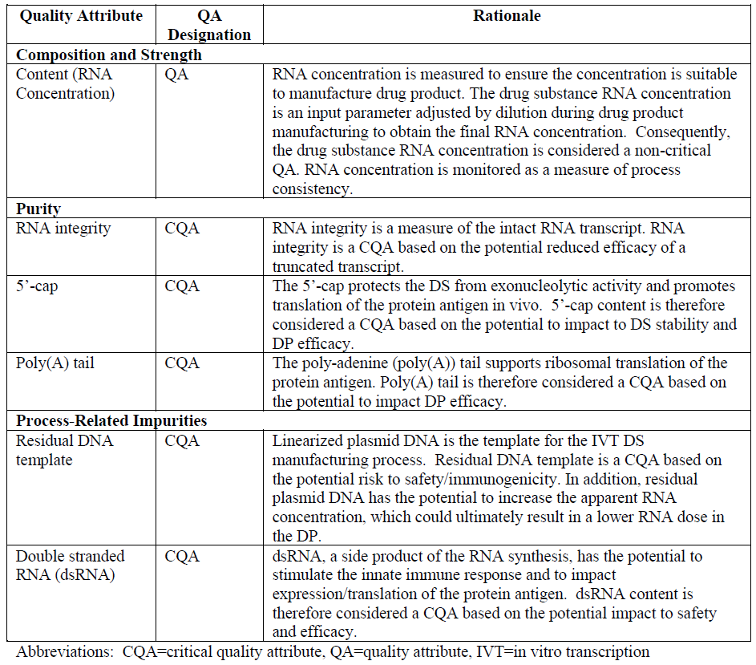
Process Risk Assessment Strategy (2)
A structured quality risk management program is utilized for all new products, which includes Cause and Effect Matrices (C&E) and Failure Modes and Effects Analysis (FMEA).
A C&E assessment is initially performed in order to prioritize higher risk process parameters for process characterization studies and other critical control strategies. The scoring for the initial C&E tables was performed based upon prior knowledge including process and platform understanding, manufacturing experience, and relevant public domain information.
Following an update to the C&E scores, FMEA tables are generated. The FMEA exercise ensures adequate attention is given to higher risk process parameters with respect to process control. The FMEA is used to evaluate independent process parameters for each step with respect to their level of control (occurrence and detection) and their potential to impact DS quality and yield (severity). Potential risk is quantitated via scoring for severity, occurrence and detection to give an overall risk priority number (RPN) as the output of the FMEA assessment. As part of the FMEA assessment, the higher risk process parameters are ranked in relation to RPN scoring and risk mitigation identified.
Process Development and Characterization (3)
Data for this section is pending and will be updated once the data has been generated, analyzed, and verified.
This section includes a discussion of the scale-down models as well as the approach, results and conclusions from the process characterization studies completed. This section also includes description of approaches taken to identify critical process parameters, as well as how the operating ranges have been defined in order to assure product quality.
For evaluated parameters, batch record NORs are implemented. These batch record ranges were implemented to ensure consistency of the manufacturing process. For a subset of evaluated parameters, PARs are designated where manufacturing data supports the range. This exercise leads to the designation of acceptable ranges for all process parameters. A subset of parameters and acceptable ranges discussed in this section are also tabulated in Section 3.2.S.2.2 Manufacturing Process and Section 3.2.S.2.4 Manufacturing Process.
Based on the initial risk assessment, critical process parameters (CPPs) were identified with ranges either based on the characterization data to date (PARs) or based on the NORs that were implemented for consistency of manufacture. As additional product and process knowledge is gained, this section may be updated with an updated list of CPPs and non-CPPs or with updated acceptable ranges.
Table S.2.6-3 Process Development and Characterization Strategy
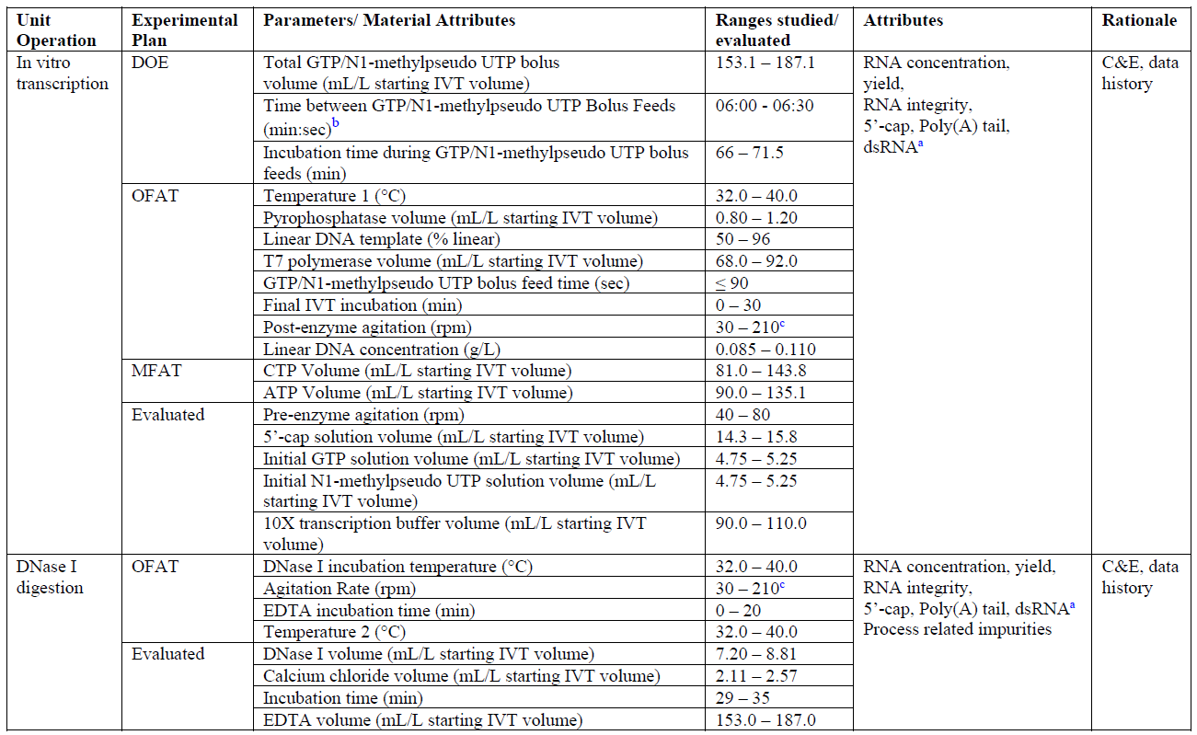
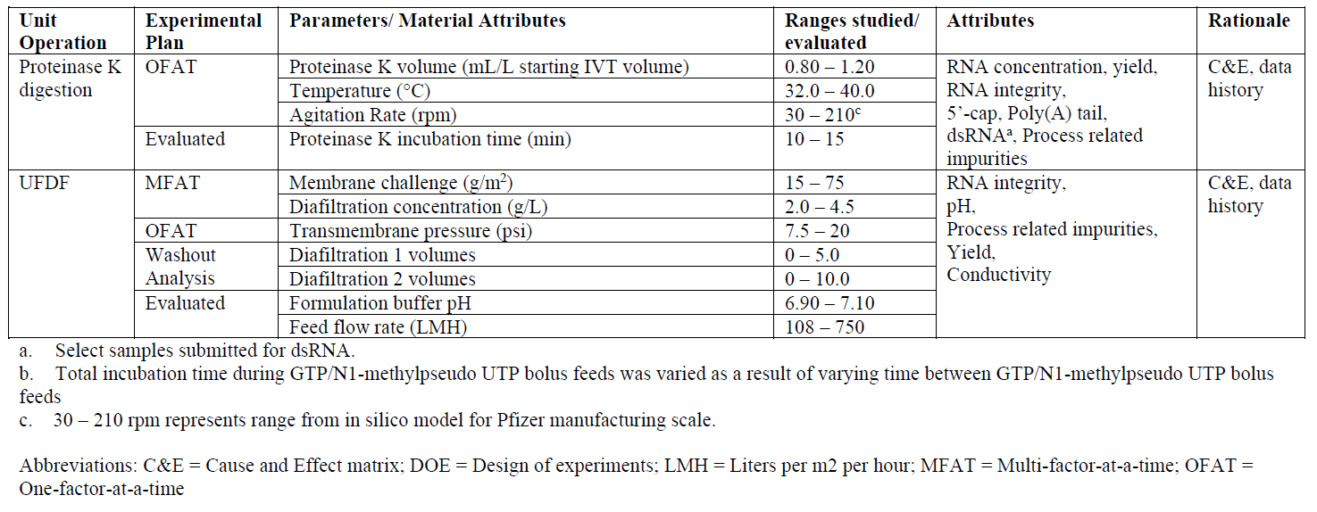
Overview
For process 2, strategic choices were made to improve the process. This is an enzymatic process that does not involve the complex intracellular reactions that occur within cells. Therefore, all material additions into the system and their concentrations are known and chosen based on platform experience from BioNTech’s other RNA programs.
BioNTech transferred process 2 to Pfizer at lab scale, and process scale-up activities were then performed in parallel by BioNTech and Pfizer. Both companies aligned on the small scale and scale-up manufacturing processes.
For the current process, linearized plasmid DNA template was chosen for scalability in order to feasibly supply the current vaccine needs. The GTP and N1-methylpseudo UTP starting concentrations are controlled at a low target and these solutions are delivered as bolus feeds. These ribonucleotides were chosen to be limiting reagents to aid in capping and to reduce potential dsRNA impurities. The 5’-cap is in stoichiometric excess to the GTP to enable the preferential incorporation of the 5’-cap as the first addition to the RNA transcript. Additionally, controlling the N1-methylpseudo UTP concentration in the reaction is proposed to reduce the dsRNA impurities.
T7 polymerase (T7 RNA polymerase) and pyrophosphatase are added last to start the reaction. The ribonucleotide building blocks are assembled by the T7 polymerase. T7 polymerase is magnesium dependent, but the magnesium can be chelated by pyrophosphate released by the addition of each ribonucleotide to the growing chain. Pyrophosphatase is used to maintain sufficient levels of free magnesium by breaking down the pyrophosphate into molecules that will no longer chelate the magnesium.
After the IVT operation, the DNase I and proteinase K digestion operations reduce the size of the linear DNA and enzyme impurities to enable removal by the UFDF operation. The DNase I digests the linear DNA template and requires both magnesium and calcium for activity, so calcium chloride is added as magnesium is already present. At the end of the incubation time, EDTA is added stoichiometrically to chelate the calcium and magnesium, halting enzymatic activity. The proteinase K then digests the proteins added to the reaction.
The UFDF removes small process-related impurities resulting from the IVT through proteinase K steps. This step also buffer exchanges the RNA into the DS formulation matrix.
Agitation rates
Table S.2.6-4. Blend Time as Related to Agitation Rates at Prescribed Scales
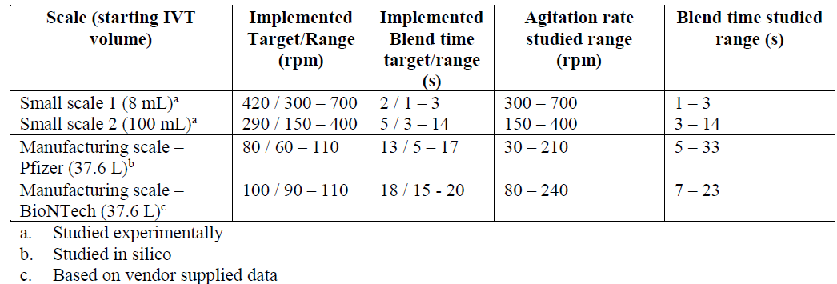
Although the small scale study assessing agitation rates did not show significant impact on performance or measured quality attributes, post-enzyme agitation rate was chosen as a CPP due to the high C&E score and the need for a well-controlled blend time during IVT reaction during bolus feeds. Results are pending for additional attributes. Conversely, the pre-enzyme agitation rate was chosen as non-CPP because time before enzyme addition is much longer than blend time.
For the DNase I digestion and proteinase K digestion steps, respectively, the agitation rates were identified as non-CPPs. This is due to the low C&E scores as the incubation time is much longer than the blend time.
IVT Development and Characterization
Based on the outcome of the C&E scoring, 10 process parameters were initially chosen to characterize impact on quality and process performance attributes. As shown in Table S.2.6-3, one DOE and several OFATs were utilized to study these IVT parameters. Addition volumes for 5’-cap and 10X transcription buffer, linear DNA concentration, and pre-enzyme agitation rate were evaluated as non-CPPs and the NORs were established to enable sufficient manufacturing control.
During the initial C&E scoring, addition volumes for ATP and CTP were identified as non-CPPs as both were supplied in theoretical excess. However, from the Pfizer GMP1 and GMP2 campaigns at manufacturing scale showed the potential for CTP to become limiting during the DS process. Although GMP1, GMP2, and PPQ1 batches in Pfizer met the DS release acceptance criteria, the CTP volume target was increased for the Pfizer PPQ2 batch to the maximum end of range (from 90.0 to 99.0 ml/L starting IVT volume) as a mitigation for CTP limitation during IVT.
In parallel, small scale studies were conducted to understand the impact of a wider range of CTP and ATP, since ATP was identified as the next potential limiting nucleotide. Results showed that increasing the volumes of both CTP and ATP not only mitigated these nucleotide limitations, as measured at the end of the proteinase K step, but also increased integrity and yield and decreased dsRNA. Therefore, ATP and CTP volumes were identified as CPPs prior to the Pfizer PPQ3 batch. As a result of the small scale studies, acceptable ranges for ATP and CTP volumes were widened at the higher end from 99.0 to 143.8 mL/L starting IVT volume for CTP and 99.0 to 135.1 mL/L starting IVT volume for ATP. The full acceptable range for both ATP and CTP are listed in Table S.2.6-3. The target volume was also increased from 90.0 to 107.9 mL/L starting IVT volume for ATP and 90.0 to 135.1 mL/L starting IVT volume for CTP. These changes were implemented for Pfizer PPQ3 batch onwards and for the BioNTech PPQ campaign. In summary, the lower end of the updated range remained the same while the updated target and upper end of range was increased based on the MFAT study for ATP and CTP addition volumes.
The GTP/N1-methylpseudo UTP bolus feed total volume and incubation time during bolus feeds were identified as CPPs due to the high C&E score. As a result, NORs were established in pending characterization data.
The final IVT incubation time was studied as an OFAT with a range of 0 – 30 minutes. The final IVT incubation time was identified as a CPP due to the high C&E score and the NOR is listed pending characterization data.
The incubation time during the bolus feeds is a CPP, so the time between each bolus feed is a non-CPP as it is well controlled with total incubation time and delivery of 11 feeds.
An OFAT approach was used to study temperature for IVT, DNase I digestion and proteinase K steps. The studied range of 32.0 – 40.0°C was held across all three steps. All temperatures have been identified as CPPs due to the high C&E score with potential to impact RNA integrity, Poly(A) tail, yield, and residual impurities. While results are pending, NORs were established.
Percent linearization of the DNA template is a material attribute of the starting material for the IVT step. It was studied through an OFAT approach across a wide range to understand impact on process performance and quality attributes. This material attribute is controlled as a release specification. Additionally, the linear DNA concentration in the IVT reaction was studied as an OFAT from 0.085 – 0.110 g/L. While results are pending, NOR was established.
Additional OFATs were performed to study pyrophosphatase and T7 polymerase volume additions. The pyrophosphatase volume was studied at 0.80 – 1.20 mL/L starting IVT volume and T7 polymerase volume was studied at 68.0 - 92.0 mL/L starting IVT volume. These parameters have been identified as non-CPPs as they are most likely to impact yield only and not quality attributes. As a result, NORs were established pending characterization data.
The initial GTP and N1-methylpseudo UTP volumes were determined to be CPPs due to the potential for GTP to impact 5’-cap levels and the N1-methylpseudo UTP to impact dsRNA. The range was evaluated and established as a NOR until further characterization work can establish a PAR.
Table S.2.6-5. In Vitro Transcription Acceptable Ranges
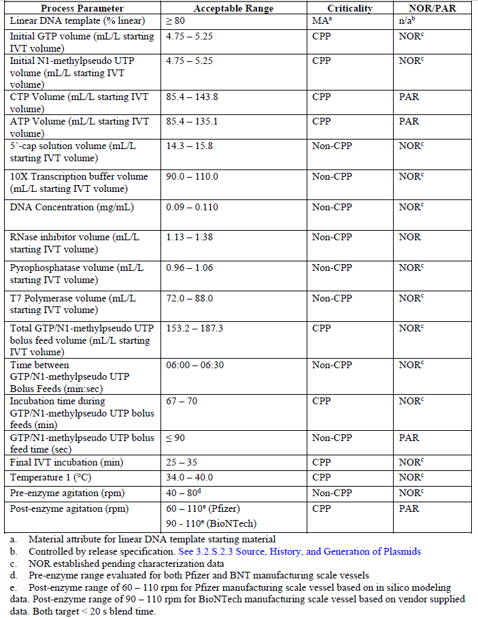
DNase I Digestion Development and Characterization
The DNase I incubation temperature has been identified as a CPP, due to the high C&E score. As a result, a NOR was established pending characterization data. The EDTA incubation temperature was also identified as a CPP, due to high C&E score. The NOR is evaluated based on BioNTech platform knowledge.
The incubation time during DNase I digestion was identified as a CPP due to potential impact on quality attributes. The process parameter was evaluated and a NOR was established around the target. EDTA incubation time was evaluated and the experience at small scale and commercial scale was assessed. Based on the combined experience at various scales, no impact to process performance or product quality was observed for the various EDTA incubation times, and therefore was designated a non-CPP.
The ranges around the targets for DNase I, calcium chloride, and EDTA volumes were evaluated and NORs were established.
Table S.2.6-6. DNase I Digestion Acceptable Ranges
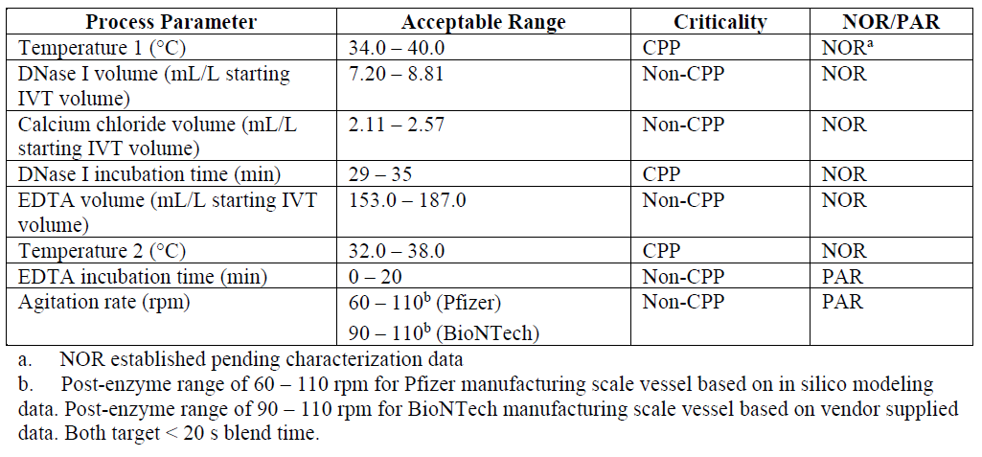
Proteinase K Digestion Development and Characterization
Based on the outcome of initial C&E scoring, two process parameters, temperature and proteinase K volume, were studied to characterize their impact on quality and process performance attributes. In addition to the quality attributes evaluated for the IVT step, the proteinase K parameters are also evaluated against process related impurities, specifically residual T7 polymerase and residual DNase I.
As previously stated, temperature was identified as a CPP for the IVT, DNase I digestion, and proteinase K digestion steps, and this operation range has been studied as an OFAT.
Proteinase K volume was studied as an OFAT at 0.80 – 1.20 mL/L starting IVT volume, but analytical results are pending, so the evaluated NOR of 1.00 – 1.22 mL/L starting IVT volume is listed.
The proteinase K incubation time is specific to the time after proteinase K is added to the reaction vessel and controlled at process temperature. Proteinase K incubation time was evaluated at 10-15 minutes based on BioNTech platform knowledge and was designated a non-CPP. The lower range is sufficient to reduce process-related impurities to acceptable levels and the additional time at process temperature will only aid in that activity.
Table S.2.6-7. Proteinase K Digestion Acceptable Ranges
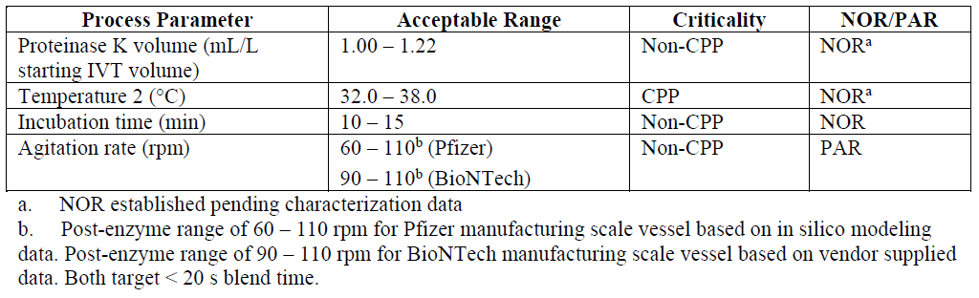
Ultrafiltration/Diafiltration (UFDF) Development and Characterization
Based on the outcome of initial C&E scoring and initial characterization studies, two process parameters (diafiltration 1 volumes and diafiltration 2 volumes) were studied to characterize their impact on quality and process performance attributes. Additionally, as a result of the yield increase due to the CTP and ATP expanded ranges, wider membrane challenge, diafiltration concentration ranges and feed pressure were also studied.
After a minimum of 5.0 DVs during diafiltration 1 and 10.0 DVs during diafiltration 2, a minimum of 2 log reduction of small molecule process related impurities (e.g. proteinase K, spermidine, and ammonium sulfate) was achieved. All results were within acceptable limits, thus supporting a PAR. These parameters were identified as CPPs due to their direct impact for removing small molecule process-related impurities.
MFAT studies were performed for membrane challenge and diafiltration concentration. From these studies the RNA integrity, yield, and process related impurities were within DS relevant process history. As a result, membrane challenge and diafiltration concentration were designated non-CPPs with PARs equivalent to the studied range.
The pH of the formulation buffer used during diafiltration 2 was evaluated at the NOR of 6.90 - 7.10. This parameter was identified as a CPP due to its direct impact on the DS pH.
OFAT studies are currently ongoing. Data for a UFDF performed at a transmembrane pressure (TMP) of 7.5 psi resulted in acceptable yields and DS results and comparable to Process 1 DS with respect to RNA integrity, pH and process-related impurities. The OFAT study is ongoing for TMP up to 20 psi to support an upper end NOR TMP of ~17.5 psi. This parameter is currently identified as a non-CPP based on current data supporting no impact to product quality.
Feed flow rate was evaluated from lab-scale and manufacturing scale batches. This parameter is dependent on the feed pressure (Andover) or delta pressure (Rentschler) and therefore not directly controlled. Feed flow is identified as non-CPPs with lab-scale and manufacturing scale data supporting PARs.
Table S.2.6-8. UFDF Acceptable Ranges
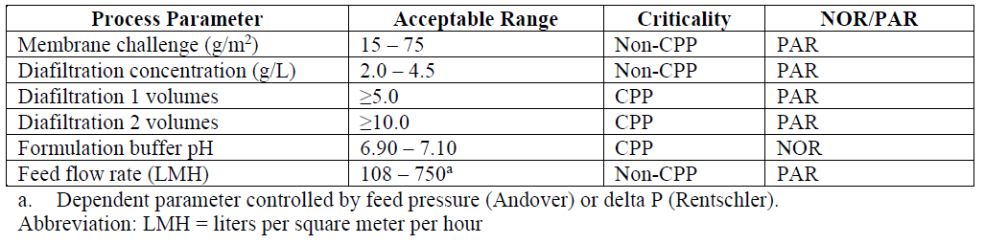
Drug Substance Formulation
The drug substance formulation is 2.25 mg/mL of RNA in 10 mM 4-(2-hydroxyethyl)-1-piperazine ethanesulfonic acid (HEPES), 0.10 mM ethylenediaminetetraacetic acid (edetate disodium dihydrate, EDTA) (NaOH, pH 7.0). HEPES buffer was selected based on prior knowledge. This buffer is a standard nonchelating buffer which is typically used in RNA formulations.
The buffer concentration and pH were chosen based on the theoretical assumptions (number of phosphate groups from the RNA). The formulation has EDTA which was included as it was known from the literature that it helps to stabilize RNA by chelating residual divalent cations that can catalyse nonspecific RNA hydrolysis. The concentration of EDTA was also defined on prior knowledge and what is typically used for RNA formulations.
Risk Assessment of Process Related Impurities (4)
Data for this section is pending and will be updated once the data has been generated, analyzed, and verified.
This includes a safety risk assessment for all the potential process related impurities included in the drug substance process relative to patient safety. These potential impurities include small molecules, enzymes and the NTP/Capping Structure and are listed in Table S.2.6.4-1. This section does not include plasmid related impurities or residual DNA template.
Table S.2.6.4-1. Additional Process Related Impurities
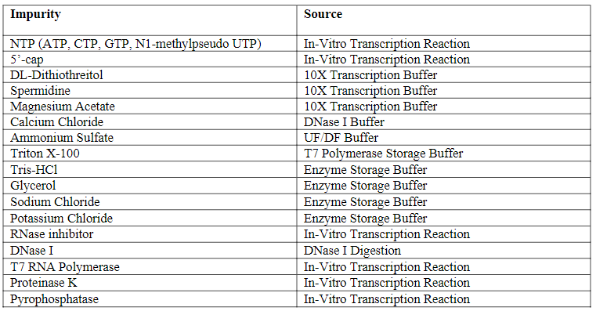
The goal of this safety risk assessment is to compare the theoretical worst-case concentration of impurities that could be introduced into the final drug product assuming no removal of the impurities throughout the process. The risk assessment informs the testing and control strategies warranted for each potential impurity. The safety concern risk assessment calculations throughout this section are based on the following assumptions:
• No impurity removal during downstream processing.
• Maximum single daily dose of 30 μg per 5.6 kg patient (Infant) using a 0.5 mg/mL drug product concentration, therefore μg/day is equivalent to μg/dose. Dosing regimen is two intramuscular injections 21 days apart.
The calculated worst-case values are then compared against pre-determined safety limits to evaluate potential risk to patient safety. If the worst-case values of an impurity do not pose a safety concern, no further monitoring of such an impurity is warranted.
If the worst-case level of an impurity exceeds the pre-determined safety limits, any available commercial scale data for the specific impurity will be provided in the relevant section and at a minimum will be monitored as part of process validation to demonstrate consistent removal to acceptable levels. For those impurities employing a safety concern threshold that warrant monitoring where levels in drug substance exceed the safety concern threshold then additional toxicology assessment will be performed. None of the impurities that warranted monitoring exceeded the safety concern threshold when measured in drug substance.
Tables S.2.6.4-2 to S.2.6-5 shows the calculated theoretical worst-case doses for the impurities. Table S.2.6.4-6 shows the experimental results for the impurities whose worst-case doses exceeded the safety concern threshold.
Table S.2.6.4-2. NTPs and 5’ Cap Safety Risk Assessment – Theoretical Worst-Case Dose (Assuming No Process Removal)
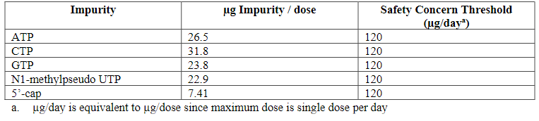
Table S.2.6.4-3. Small Molecule Safety Risk Assessment – Theoretical Worst-Case Dose (Assuming No Process Removal)
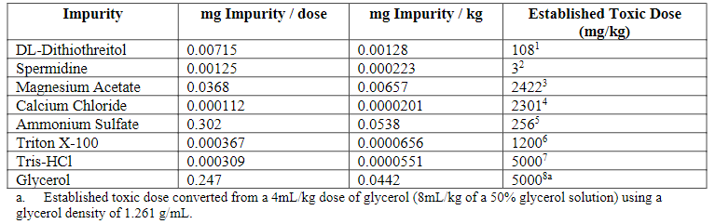
Table S.2.6.4-4. Small Molecule Safety Risk Assessment – Theoretical Worst-Case Dose (Assuming No Process Removal)
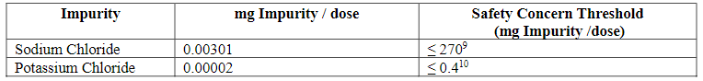
Table S.2.6.4-5. Enzyme Safety Risk Assessment – Theoretical Worst-Case Dose (Assuming No Process Removal)
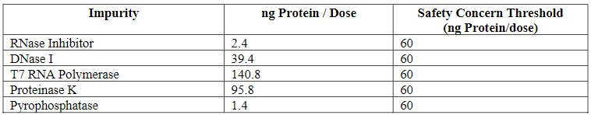
Table S.2.6.4-6. T7 RNA Polymerase and Proteinase K Results for Clinical, Initial Emergency Supply and Process Performance Qualification BNT162b2 DS Batches
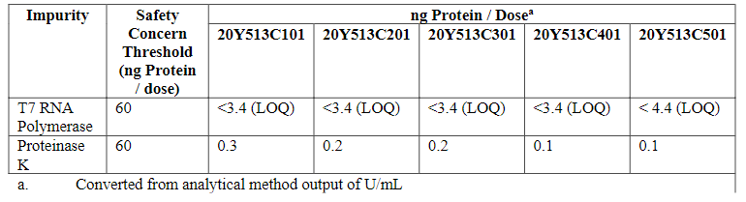
NTPs, 5’ cap, small molecule process related impurities, RNase inhibitor, DNase I and pyrophosphatase from the BNT162b2 drug substance manufacturing process have been shown through a safety-based risk assessment to be significantly below pre-determined limits with no removal and do not pose a safety risk to patients. Based on the safety-based risk assessment, these impurities are not required to be monitored during drug substance manufacturing
T7 RNA polymerase and proteinase K levels measured in small scale, commercial scale drug substance and process validation batches manufactured to date are below the safety concern threshold and therefore do not pose a safety concern.
Data will be provided for the impurities identified for monitoring as part of this safety assessment and will be updated for additional batches once testing is complete.
Development History and Comparability (5)
Data for this section is pending and will be updated once the data has been generated, analyzed, and verified.
This section includes the chronological history of the batches and major changes during the production campaigns. The batches are compared in the comparability assessment with focus on critical quality attributes as well as heightened product characterization. The results indicate that the changes resulted in comparable or improved product quality
A chronological summary for the drug substance batches manufactured by BioNTech and Pfizer sites are provided in Table S.2.6-9. These batches have been used throughout pre-clinical and clinical development. Both BNT162b1 and BNT162b2 are described in the table. Information from BNT162b1 is presented because the data provides additional platform knowledge. BNT162b1 is also a RNA construct but encodes for only the spike protein receptor binding domain instead of the full spike protein encoded by BN162b2.

Table S.2.6-9. Drug Substance Batches
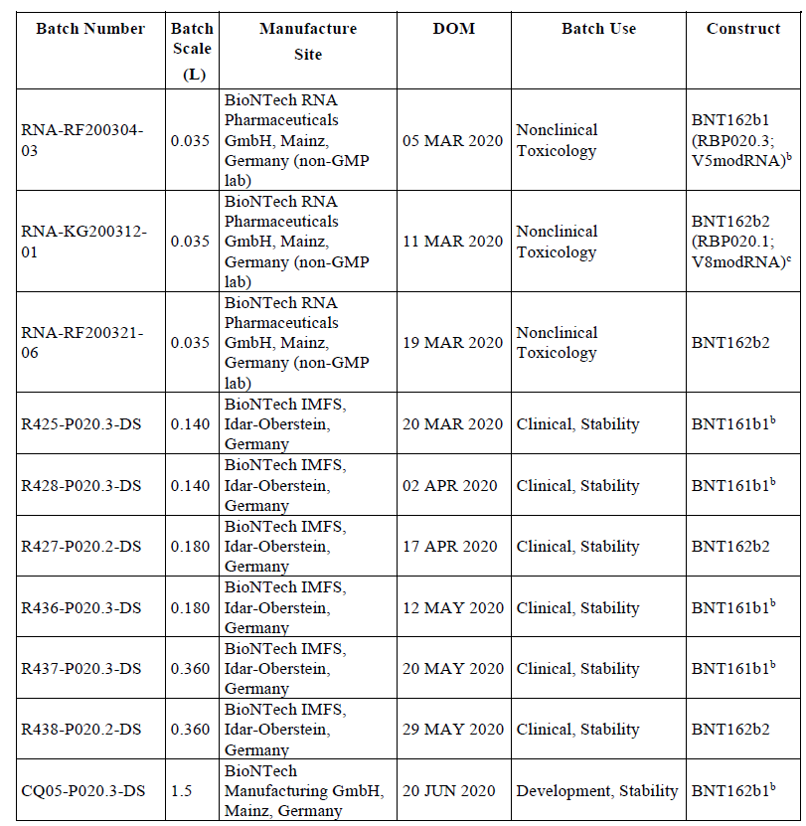
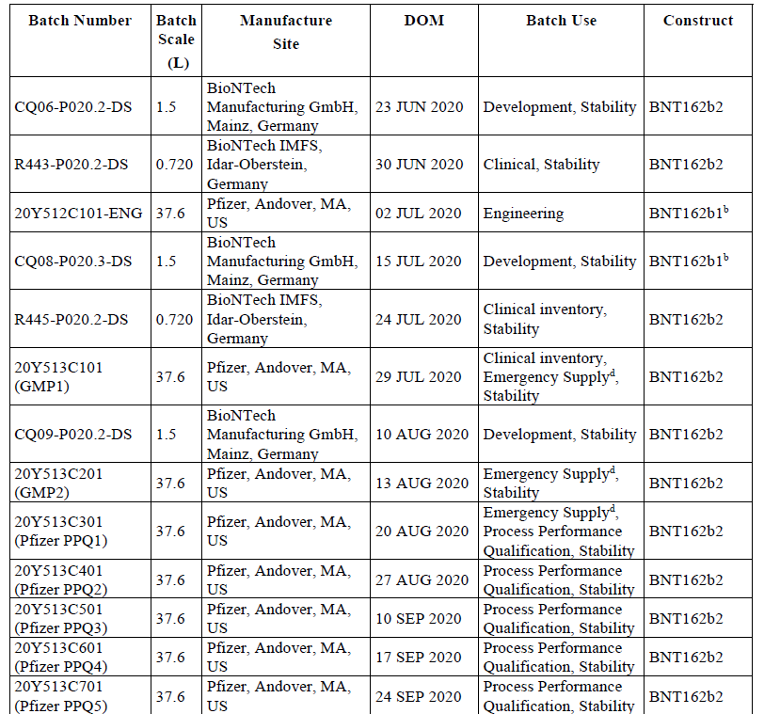
Abbreviations: IMFS = Innovative Manufacturing Services
a. In vitro transcription reaction starting volume
b. BNT162b1 is also a RNA construct but encodes for only the spike protein receptor binding domain instead
of the full spike protein encoded by BN162b2.
c. RBP020.1 and RBP020.2 code for the same antigen, but with variations in the used codons, thus, they differ
slightly in the nucleotide sequence. Codon optimization has been performed either via a BioNTech proprietary
algorithm (RBP020.1) or with a published algorithm (Raab et al. 2010; RBP020.2).
d. Emergency supply designation applies to U.S. market.
Abbreviations: DOM = date of manufacture

Table S.2.6-10 provides a high-level summary of the process changes from early development to commercial. Changes were implemented to improve the drug substance manufacturing robustness and scalability to develop a process for commercialization (via a medium scale production of 1.5L). Once the commercial process was developed, it was used to produce additional CTM for Phase 2/3 clinical trials and material for commercial supply as well as emergency supply at 37.6 L scale.
Table S.2.6-10. Process Comparison
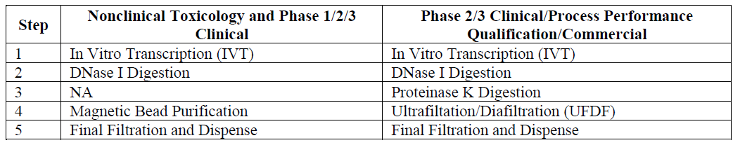
Table S.2.6-11 summarizes all the development changes from the toxicology material to process performance qualification (PPQ)/commercial batches.
Table.S.2.6-11. Overview of Process Development
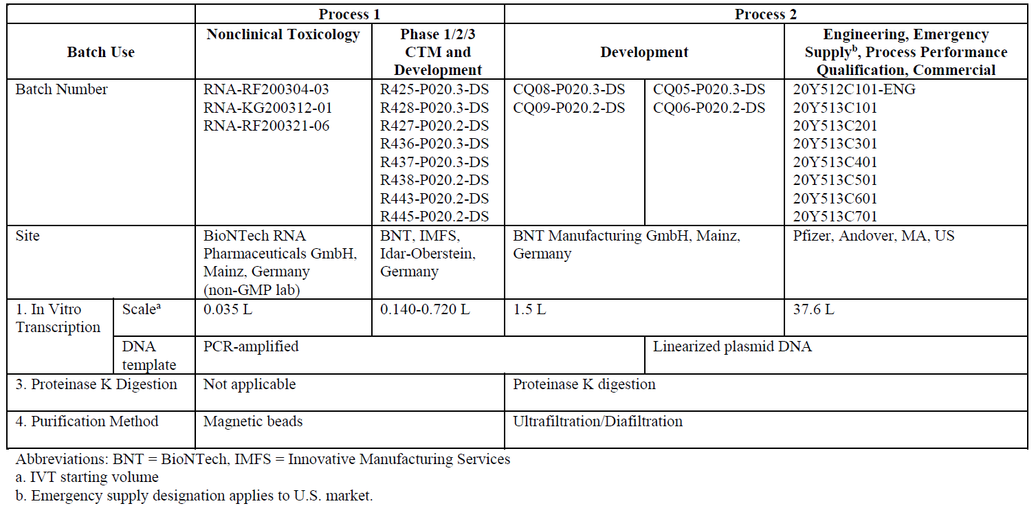
Process 1
As seen in Table S.2.6-11, two changes were made within Process 1 between nonclinical toxicology and Phase 1/2/3 process: the scale of the reaction and the site. The increase in scale was required to make sufficient material for clinical trials. The location changed from a non-GMP lab into GMP facilities. This process was based on BioNTech platform knowledge from other mRNA therapeutic programs.
Process 2
After the completion of the Phase 1 CTM production, an assessment was performed to determine the scalability, robustness, and productivity of the process. First, the scale increased from 0.720 L to 1.5 and 37.6 L by moving toward a scalable reactor configuration. The DNA template changed from a PCR template to linearized plasmid DNA in order to meet commercial demands. Additionally, the magnetic bead purification was replaced with proteinase K digestion and UFDF steps. The magnetic bead purification method was not scalable, but removed small molecule impurities (e.g. spermidine, DTT), residual DNA, and enzyme impurities (e.g. T7 polymerase, DNase I). A DNase I digestion step was already present in the process for reducing the size of the DNA to complement the UFDF. Additionally, the proteinase K digestion step was implemented to reduce the size of the enzyme impurities and the UFDF was implemented to remove the small molecule impurities, residual DNA, and the enzyme impurity fragments.

Comparability of Drug Substance Used to Manufacture Clinical and Emergency Supply Lots
The assessment of product quality comparability will take a stepwise approach. As a first step, analytical comparability of the BNT162b2 drug substance critical quality attributes was evaluated for Process 1 batches manufactured at BNT and Process 2 batches manufactured at Pfizer, Andover. Comparability before and after process changes is demonstrated through a comparison of the release test results for all available batches, as well as side-by-side testing and heightened characterization for three Process 1 DS batches and one Process 2 DS batch (Table S.2.6-12).
Table S.2.6-12. BNT162b2 Clinical and Emergency Supply Drug Substance Batches
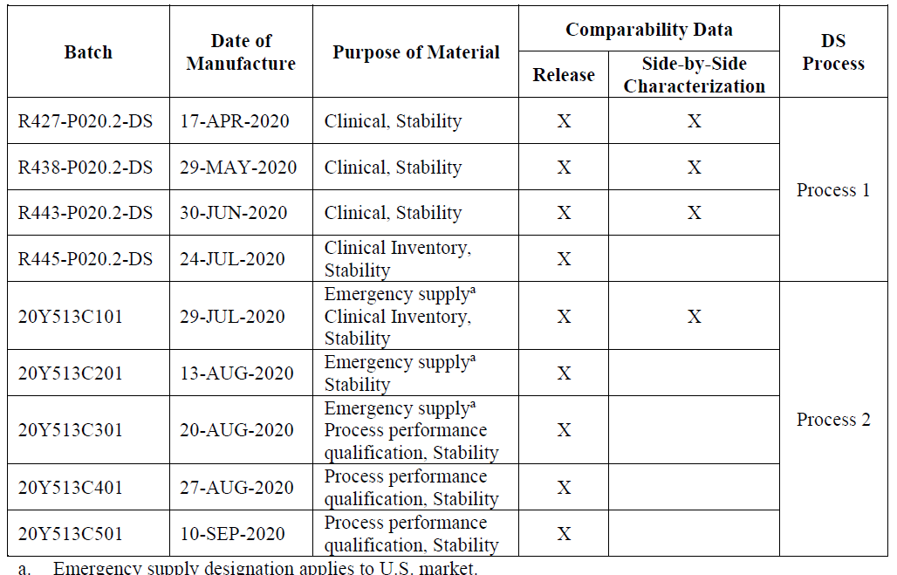
The comparability assessment evaluated a combination of release and heightened characterization testing. Additional heightened characterization using mass spectrometry and spectroscopic characterization methods was performed to compare DS primary and higher order structure elements.
Taken together, the results support the conclusion that the commercial scale Process 2 DS batch manufactured at Pfizer, Andover is comparable to Process 1 batches manufactured for clinical supply. Supportive profiles, data and detailed discussions of each comparative characterization analysis are provided in the dossier. The data demonstrate that all the DS batches are comparable and no site- or scale-specific trends were noted for any of the attributes tested.
Table S.2.6-13. BNT162b2 Drug Substance Release and Additional Testing Results
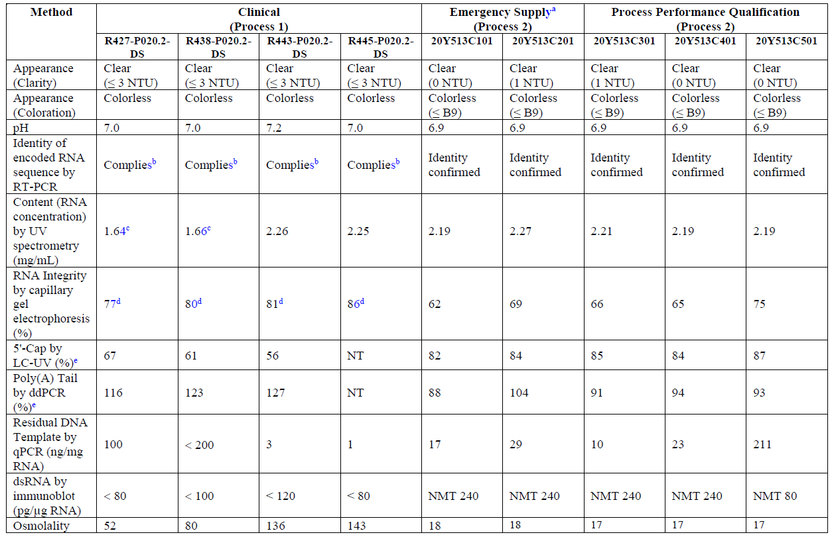
Table S.2.6-14. BNT162b2 Drug Substance Side-by-Side Comparability Testing Results
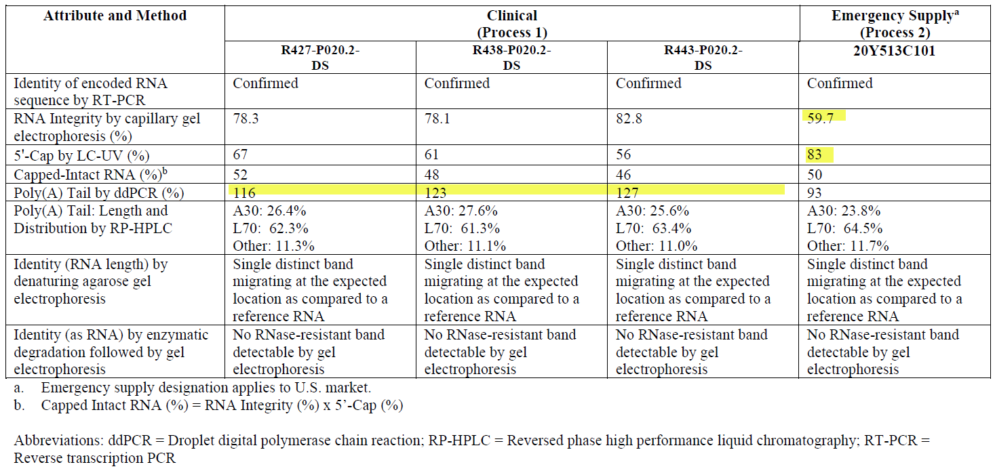
In addition to all release data meeting the acceptance criteria established at the time of release testing, side-by-side testing confirmed that Process 2 batch 20Y513C101 is comparable to the Process 1 batches. Differences observed in RNA concentration were expected and reflect changes in the concentration target and specification acceptance criterion. Differences in osmolality are consistent with downstream process changes, where the use of ethanol and NaCl in Process 1 resulted in higher osmolality as compared to Process 2. Process 1 and Process 2 DS batches show consistent removal of residual DNA template, dsRNA and other impurities. Residual DNA template in Process 1 batches was cleared to levels ≤ 200 ng/mg RNA and Process 2 batches have < 220 ng/mg RNA. Additionally, all clinical process 1 and process 2 batches were within specification acceptance criterion for dsRNA and comparably low (< 240 pg / mg RNA).
A small decrease in RNA integrity was observed for the Process 2 batches, and the variability of this attribute continues to be monitored. To further optimize process robustness, CTP volume and ATP volume process parameters were adjusted prior to the manufacture of batch 20Y513C501. Release testing revealed batch 20Y513C501 RNA integrity levels consistent with the Process 1 batches. Additionally, the relative abundance of 5’-capped RNA is slightly higher in the Process 2 batches. As the RNA integrity and 5’-cap attributes are critical to translation of the protein antigen in vivo, the proportion of capped-intact RNA is used to compare the Process 1 and Process 2 materials that were tested side-by-side. The range of Process 1 capped-intact RNA is 46 to 52% as compared to 50% for Process 2. The proportion of poly-adenylated RNA is > 90% for all Process 1 and Process 2 materials. Small differences in poly(A) content, including some values reported over 100%, are attributed to method variability, as it is not practically feasible to achieve greater than 100% poly-adenylated RNA content.

Additional Discussion on Side-by-Side and Heightened Characterization Comparability Testing Results: BNT162b2 Process 1 and Process 2 Drug Substance Batches
Additionally, a specifically selected series of state-of-the-art characterization analyses was performed to assess additional aspects and demonstrate comparability of the BNT162b2 DS structure. Side-by-side comparability studies were performed using mass spectrometry to characterize the 5'-cap, poly(A) tail, and oligonucleotide mapping. Circular dichroism was performed to characterize higher order structure.
Figure S.2.6-1. Identity by Agarose Gel Electrophoresis
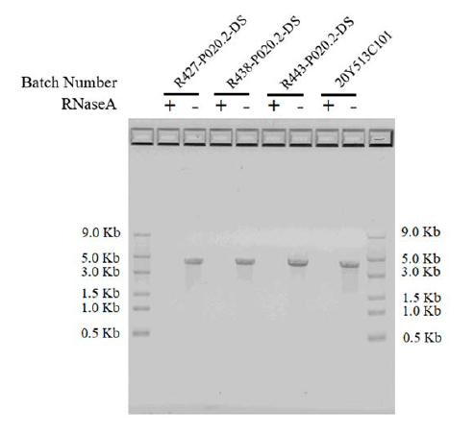
Figure S.2.6-2. BNT162b2 Poly(A) Tail Analyzed by RP-HPLC-UV
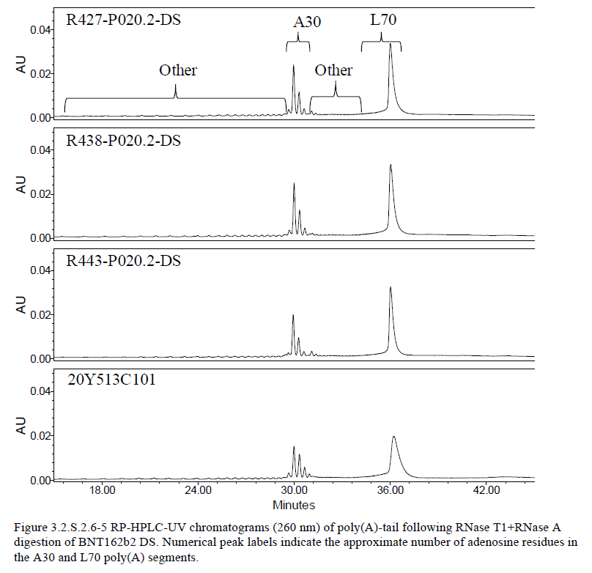
The characterization of the 5' end capped (5'-Cap) and un-capped species of BNT162b2 DS was accomplished by ion-pair reversed-phase high performance liquid chromatography- ultraviolet light detection at 260 nm and online electrospray ionization mass spectrometry (RP-HPLC/UV-ESI MS) or LC-UV/MS.
Cap Assay UV Chromatograms are shown in Figure S.2.6-Y. Characterization by LC- UV/MS confirms that the 5'-capped and uncapped structures are the same in both Process 1 and 2 with a redistribution toward higher 5'-capping levels in Process 2. It is anticipated that a higher 5'-Cap level may enable a more stable and efficacious BNT162b2 DS. Therefore, Process 1 and Process 2 DS batches are considered comparable with respect to 5’-Cap.
Figure S.2.6-3 5'-Cap Assay UV Chromatograms of BNT162b2 DS RNase Cleaved Fragments
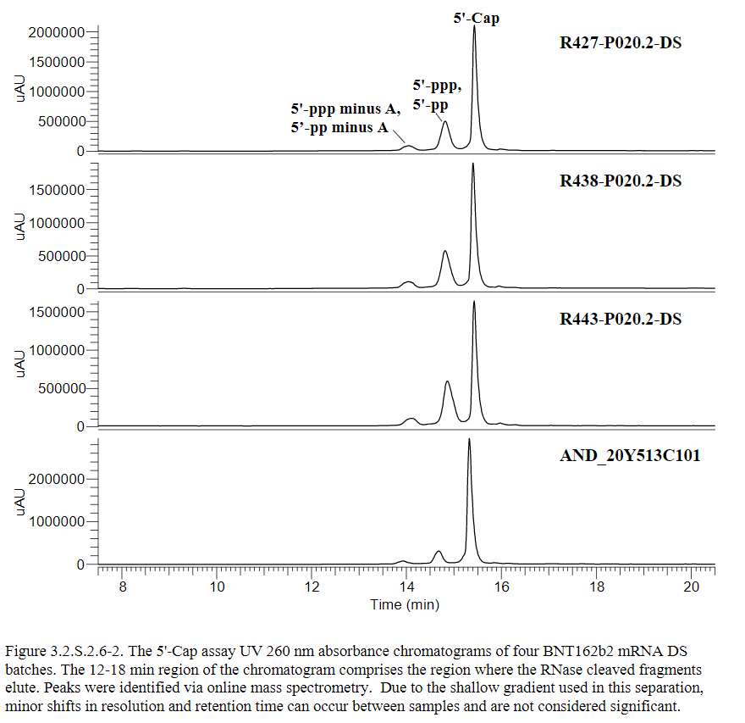
To facilitate in-depth characterization of the BNT162b2 poly(A) tail using state-of- the-art mass spectrometry techniques, drug substance samples were digested using only RNase T1. In contrast to the double digest method described in 3.2.S.2.6.4.2.3, the greater specificity of the singly- digested material, in combination with affinity purification enables improved mass spectrometric determination of the A30 and L70 distribution and sequence confirmation. Analysis of the 3ʹ polyadenosine tail (poly(A)-tail) of BNT162b2 DS was accomplished byion-pair reversed-phase high performance liquid chromatography with UV detection at 260 nm and on-line electrospray ionization mass spectrometry (RP- HPLC-UV/ESI MS or LC-UV/MS). The poly(A)-tail of BNT162b2 DS was cleaved by ribonuclease T1 (RNase T1) followed by isolation via oligo(dT)25 affinity purification. This characterization method monitors two poly(A)-tail segments: A30 andL70. Transcriptional slippage gives rise to a distribution of species with more or fewer adenosine nucleotides in each segment.
Both expected short (A30) and long (L70) segments of the poly(A) tail were observed in the RP-HPLC/UV chromatograms for all four DS batches at comparable relative abundances. Using LC-UV/MS, the most abundant A30 segment species for all batches was the 30-adenosine species, with a range from 28 – 34 adenosines observed in all batches. A minor redistribution in the relative abundance of these species was observed, with increased abundance for the longer adenosine forms in the Process 2 DS compared to the Process 1 DS. Unlike the poly(A) A30 segment, where the respective species are resolved both chromatographically and mass spectrometrically, the poly(A) L70 distribution is only resolved by MS.
By LC- UV/MS, the mass spectral distribution of poly(A) L70 segment species was narrower for the Process1 batches: R427-P020.2-DS, R438-P020.2-DS and R443-P020.2-DS, as compared to the Process 2 batch, 20Y513C101. This observation coincides with the narrower chromatographic elution profile of the L70 region for the Process 1batches and the slightly later elution position of the Process 2 batch. Additionally, the identification of predominant poly(A) L70 segment species differed between the two processes. For Process 1 R427-P020.2-DS, R438-P020.2-DS and R443-P020.2-DS batches, the 71A1C and 72A1C species formed the apex of the distribution. Here, the 71A and 72A represent the number of adenosine residues in the sequence and the 1C denotes the inclusion of one cytidine monophosphate.
Differences in the extent of cytidine monophosphate incorporation and transcriptional slippage remain under investigation. Taken together, the quantitative measurement of the poly(A) tail species by LC-UV and heightened characterization by LC- UV/MS demonstrate that both Process 1 and Process 2 derived DS batches contain predominantly 30 adenosine in the A30 species and at least 70 adenosine nucleotides in the L70 species, with observed distribution differences not expected to impact safety or efficacy.
Figure 2.6-4 Mass Spectra of L70 Poly(A) Segment
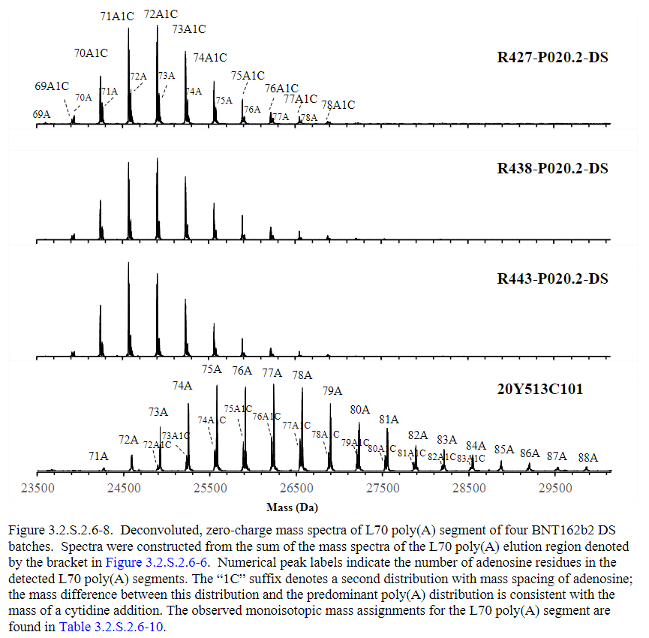
Comparative LC/MS/MS –Oligonucleotide Mapping of BNT162b2 Process 1 and Process 2 DS Batches
The primary sequence of BNT162b2 drug substance was analyzed by LC/MS/MS -oligonucleotide mapping. BNT162b2 DS batches were digested with RNAse T1, and the resulting enzymatic fragments were separated by ion-pair reversed-phase high performance liquid chromatography (IP-RP-HPLC) with UV detection at 260 nm. All major and minor peaks in the oligonucleotide map were identified by on-line electrospray ionization mass spectrometry with tandem mass spectrometry (MS/MS) by higher-collision dissociation.
Comparative Higher Order Structure Characterization of BNT162b2 DS Batches
Circular dichroism (CD) spectroscopy was used to assess the higher-order structure of BNT162b2 in solution for Process 1 and Process 2 DS batches. CD spectra were recorded in triplicate for each BNT162b2 DS batch, and all samples from all batches were analyzed side-by-side from a 1xPBS solution. The averaged CD spectra were overlaid for visual inspection, and for each DS batch, the CD spectra exhibit the same alternating peaks and troughs and match each other closely at all wavelengths from 200 nm to 330 nm.
The close match of all CD spectra in the superimposed views and respective similarity scores confirm that BNT162b2 Process 1 and Process 2 DS batches are comparable to each other with respect to higher order structure.
Expressed protein size by Western blot
The protein size after in-vitro expression of BNT162b2 drug substance was determined using Western blot. Expressed protein size was confirmed to be comparable for three Process 1 batches and the Process 2 batch. Figure 3.2.S.2.6-15 shows that the expressed protein size is consistent with the expected size of BNT162b2 drug substance and comparable across all tested batches. In addition, relative expression levels are comparable for all batches, as evidenced by comparable band intensity at each load level across all batches.
Figure S.2.6-5 BNT162b2 Expressed Protein Size by Western Blot
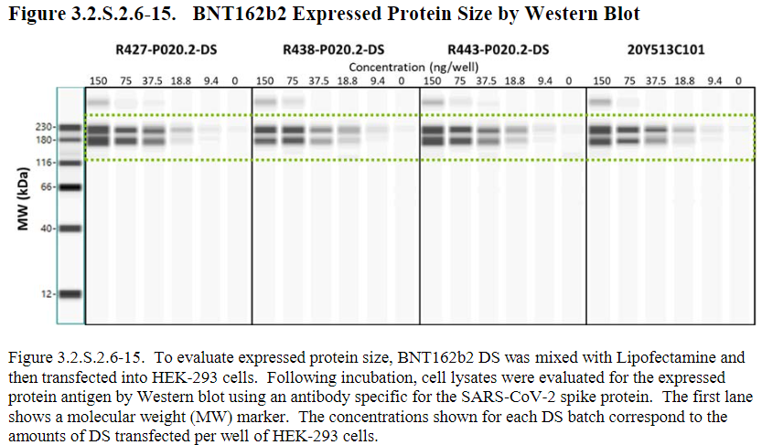
Control Strategy (6)
Data for this section is pending and will be updated once the data has been generated, analyzed, and verified.
This section includes the approach to developing the control strategy as well as the summary for the control strategy for all quality attributes controls implemented and section references to where the controls are described in greater detail.
A risk management tool was used to document, assess and refine the control strategy for the vaccine. By applying the tool, the elements of the control strategy were defined and systematically documented. The control strategy takes into account all in-process tests, quality attributes, and process performance attributes (PPAs). The strategy determines where in the process to introduce appropriate controls to consistently guarantee product quality. This allows one to readily identify what elements are being used for each of the quality attributes and PPAs. Finally, as modifications to the control strategy are proposed, the information within this tool will be updated to reflect those modifications as well as to assess whether the revisions effectively and efficiently mitigate residual risk.
The control strategy for the drug substance (DS) is linked to drug product (DP). Prior to finalization of the control strategy, both drug substance and drug product elements were considered in totality to assure final drug product quality is met throughout the shelf life.
In-process tests for control (IPT-C) are in-process tests used to control a quality attribute to be within a specified range to meet desired DS/DP quality. These in-process tests have associated acceptance criteria. In-process tests for monitoring (IPT-M) are in-process tests used to measure a quality attribute to either ensure that it is consistent with respect to previous process history or to enable forward processing. The monitoring tests may have action limits.
Similarly, process parameters are either monitored or controlled. When a process parameter control is specified, this indicates that the parameter and specified ranges are maintained within the specified acceptable ranges. When process parameter monitoring is specified, this indicates that it is for observation only.
Figure S.2.6-6. Elements of Control Identified for the Vaccine Control Strategy
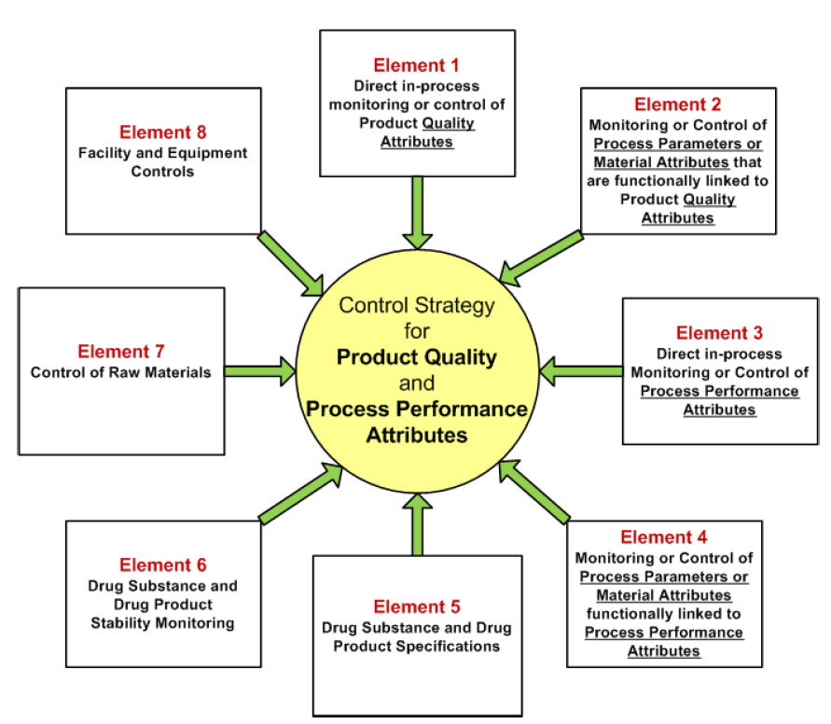
A visual summary of the outputs from this control strategy for all DS quality attributes is shown in Table 3.2.S.2.6-1. The criticality assignment of these quality attributes is described above under the heading Quality Attributes.
Both monitoring and control aspects of in-process tests (IPTs) and process parameters were noted in constructing each of the individual elements as necessary. Analytical procedures and control limits for IPT-Cs are described Section 3.2.S.2.4.
Table S.2.6-15. Summary of the Elements of Control for DS Quality Attributes
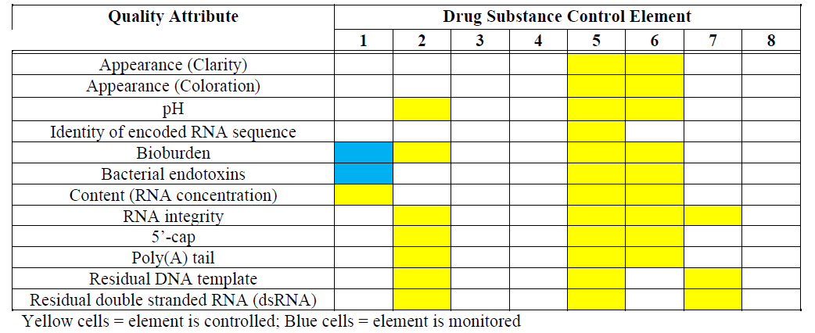

Analytical Method Evolution (7)
The analytical testing strategy applied to BNT162b2 drug substance has evolved throughout the development history. These changes to the analytical testing strategy are summarized in the below Table S.2.6-16.
Table S.2.6-16. Evolution of BNT162b2 Drug Substance Methods
Process |  | Clinical  (Process 1) | Emergency Supplyª  (Process 2) | Process Performance Qualification, Commercial Supply  (Process 2)
Quality Attribute | Analytical Procedure
Clarity | Appearance | R | R | R, S
Coloration | Appearance | R | R | R, S
pH | Potentiometry | R | R | R, S
Osmolality | Osmometry | R | Not required | Not required
RNA sequence | Sequencing of DNA starting material | R | Not required | Not required
Content  (RNA concentration) | UV Spectroscopy | R, S | R, S | R, S
Identity: RNA length | Agarose gel electrophoresis | R | Not required | Not required
Identity: as RNA |  | R | Not required | Not required
Identity of encoded RNA sequence | RT-PCR | Not required | R | R
RNA integrity | Capillary gel electrophoresis | R, S | R, S | R, S
5’-Cap | HPLC-UV | Not required | Not required | R, S
Poly(A) tail | ddPCR | Not required | Not required | R, S
Residual DNA template | qPCR | R | R | R
Residual double stranded RNA (dsRNA) | Immunoblot | R | R | R
Bacterial endotoxins | Endotoxin (LAL) | R | R | R, S
Bioburden | Bioburden | R | R | R, S
a. Emergency supply designation applies to U.S. market.
Abbreviations: R = Release; S = Stability; RT-PCR = reverse transcription polymerase chain reaction; ddPCR = droplet digital PCR; qPCR = quantitative PCR; dsRNA = double stranded RNA; LAL = Limulus amebocyte lysate

The agarose gel electrophoresis method has been replaced with the reverse transcription-polymerase chain reaction (RT-PCR) method to confirm the encoded RNA sequence, as described in Section 3.2.S.4.2 Analytical Procedures – RT-PCR. This method positively identifies the encoded RNA sequence as BNT162b2, and demonstrates identity as RNA, as only RNA can be reverse transcribed.
The capillary gel electrophoresis method for RNA integrity was modified with respect to data processing. During method development the software for data evaluation was changed, resulting in lower absolute integrity numbers, which is mainly caused by different baseline subtraction settings. Raw data for three BNT162b2 drug substance batches were reprocessed with updated data processing parameters. The original and updated values are presented in the dossier, alongside data generated during side-by side analytical comparability as detailed in 3.2.S.2.6 Developmental History and Comparability Assessment.
Table S.2.6-17. Capillary Gel Electrophoresis - Comparison of Processing Methods
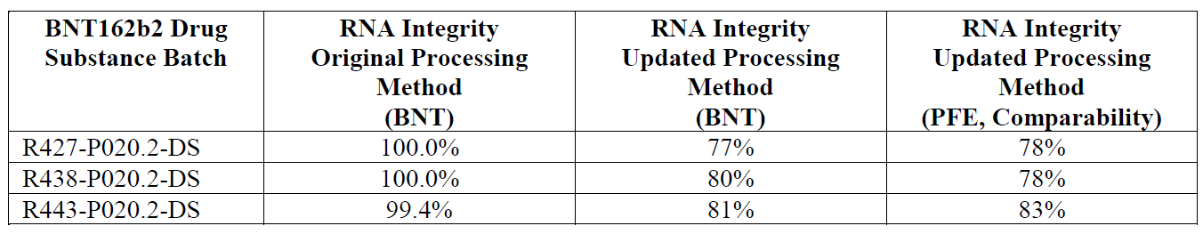

Assessor’s comments on S.2.6 Manufacturing process development:
Critical Quality Attributes (CQAs) (1)
A summary of the quality attributes with the rationale for the criticality assignment is provided. The rationale for classification into CQA or QA is presented for each attribute and appears reasonable. The identified CQAs are; RNA integrity, 5’-cap, Poly(A) tail, residual DNA template and double stranded RNA (dsRNA). To be noted, for poly(A) tails, both percentage of Poly(A) positive mRNA molecules as well as the length of the Poly(A) tails are considered CQAs. A related concern is raised in S.4.
Process Risk Assessment Strategy (2)
The general description of the Process Risk Assessment Strategy using Cause and Effect Matrices (C&E) and Failure Modes and Effects Analysis (FMEA) is found acceptable.
Process Development and Characterization (3)
Data for this section is pending.
Discussion of the scale-down models as well as the approach, results and conclusions from the process characterization studies are presented. The approaches taken to identify critical process parameters (CPPs) are also described and at large found acceptable. To be noted, the assessment is based on the currently submitted data and therefore the final evaluation of the control strategy cannot be made at this point. It should also be noted that future changes to any of the process parameters listed in S.2.2, reagardless of the classification of CPP or non-CPP, should be applied for as variation applications.
Initially, addition volumes for ATP and CTP were identified as non-CPPs as both were supplied in theoretical excess. Following the Pfizer GMP campaigns and additional smalls cale studies it was shown that these volumes could be limiting and the ranges were widened at the higher end. The approach to only change the higher end of the ranges is not understood. It is also noted that after the adjustment of these volumes the RNA integrity levels increased (see also discussion below in relation to the comparability study).
- It is noted that the ranges studied for addition volumes for CTP and ATP as stated in 3.2.S.2.6 are 81.0-143.8 and 90.0-135.1 mg/L respectively and that the acceptable ranges proposed are 85.4-143.8 and 85.4-135.1 mg/L. It seems as if the lower acceptable range of 85.4 mg/L proposed for ATP volume have not been studied, this needs to be clarified. In addition, it needs to be justified why the lower end of the ranges for both CTP and ATP volumes remained unchanged although the target ranges were increased (from 90 to135.1 and 107.9 mg/L respectively), to avoid that these nucleotides will be limiting in order to increase the percentage of the RNA integrity.
These ranges need to be further justified and clarified and the dossier updated accordingly.
In the In vitro transcription (IVT) step T7 RNA polymerase and pyrophosphatase are added to start the reaction. The ribonucleotide building blocks are assembled by the T7 polymerase. T7 polymerase is magnesium dependent, but the magnesium can be chelated by pyrophosphate released by the addition of each ribonucleotide to the growing chain. Pyrophosphatase is used to maintain sufficient levels of free magnesium by breaking down the pyrophosphate. It is claimed that the added volumes of these two enzymes have been identified as non-CPPs as they are most likely to impact yield only. This conclusion is not entirely agreed upon.
- The added volumes of the enzymes T7 polymerase and pyrophosphatase are considered important process parameters that should be classified as CPPs and as such included in the description of the manufacturing process in section 3.2.S.2.2 of the dossier. In addition, it needs to be clarified if the actual volumes loaded are calculated based on enzyme activity as stated in the certificates of the actual batch of the enzymes that are used. (See also question in section 3.2.S.2.3 above).
Risk Assessment of Process Related Impurities (4)
Data for this section is pending.
A safety risk assessment for potential process-related impurities included in the drug substance process relative to patient safety is provided in this section. The potential impurities include small molecules, enzymes and the NTP/Capping Structure. The sources of the impurities are sufficiently addressed.
The safety risk assessment strategy involves comparison of the theoretical worst-case concentration of impurities, assuming no removal, to calculated safety concern thresholds. If the worst-case level of an impurity exceeds the pre-determined safety limits, any available commercial scale data for the specific impurity will be provided in the relevant section and at a minimum will be monitored as part of process validation to demonstrate consistent removal to acceptable levels.
The worst-case levels of NTPs, 5’ cap, small molecule process related impurities, RNase inhibitor, DNase I and pyrophosphatase from the BNT162b2 drug substance manufacturing process were calculated to be significantly below the pre-determined safety limits. This is found acceptable. The T7 RNA polymerase and proteinase K levels were further investigated and it was demonstrated that the detected concentrations in the clinical, initial emergency supply and PPQ BNT162b2 DS batches were well below the safety concern threshold. The Applicant states that data will be provided for additional batches once testing is complete. This is found acceptable. However, the analytical assays used to determine the T7 RNA polymerase and proteinase K levels in the DS are not stated.
- The Applicant should provide data on the T7 RNA polymerase and proteinase K levels in additional commercial scale DS batches, once testing is complete. In addition, the Applicant should briefly describe the methods applied to determine the concentrations of these two enzymes in the BNT162b2 DS samples. The dossier should be updated accordingly.
Development history and Comparability (5)
Data for this section is pending.
Two DS processes have been used during the development history; Process 1 and 2. Details about process differences, justifications for making changes, and results from a comparability study is provided. The major changes between DS Process 1 and 2 are; increased process scale, DNA template changed from a PCR template to linearized plasmid DNA, magnetic bead purification replaced with proteinase K digestion and UFDF steps.
In the comparability study a decrease in RNA integrity was observed for the Process 2 batches compared to Process 1 batches (78.1-82.8% compared to 59.7%). After adjustment of process parameters for CTP and ATP volumes batch 20Y513C501 (PPQ3) was manufactured with RNA integrity level of 75%, more consistent with the Process 1 batches.
- The percentage for RNA integrity as presented in the side-by-side comparability testing in section 3.2.S.2.6 is different compared to the values reported in batch analysis in 3.2.S.4.4 (for example; batch 20Y513C101 (GMP1) 59.7% compared to 62%). A clarification is needed, and the dossier should be updated accordingly.
Regarding the 5’ cap end of the DS, LC- UV/MS characterisation confirmed that the 5'-capped and uncapped structures are the same in Process 1 and 2, but that there is a slight shift towards higher 5'-capping levels in Process 2. This is found acceptable.
Furthermore, the poly(A)tail of the 3’ end was characterised by LC-UV/MS. The expected short (A30) and long (L70) segments of the poly(A) tail were observed after RNase T1 cleavage. While the results for the A30 segment were demonstrated to be comparable between Process 1 and Process 2 batches, significant differences were identified for the L70 segment. As expected, poly(A) tail heterogeneity was observed both for Process 1 and Process 2 batches, due to transcriptional slippage. Longer poly(A) tails were observed for the Process 2 batch, while the most abundant L70 segments of the Process 1 batch were demonstrated to contain an additional cytidine residue. The Applicant claims that the differences in the extent of cytidine monophosphate incorporation and transcriptional slippage remain under investigation.
- Differences in the poly(A)tail pattern were observed when comparing the Process 1 and Process 2 DS batches. The differences in the extent of cytidine monophosphate incorporation and transcriptional slippage should be further investigated and the possible impact on efficacy and safety should be discussed. The only Process 2 DS included in the comparison was manufactured prior to the adjustment of CTP and ATP volumes. Results obtained on the PPQ batches manufactured after adjustment (PPQ 3, 4 and 5) should also be presented and discussed.
The overall primary sequence of BNT162b2 drug substance was demonstrated to be comparable by LC/MS/MS -oligonucleotide mapping. Circular dichroism (CD) spectroscopy was used to assess the higher-order structure of BNT162b2 in solution. Process 1 and Process 2 DS batches were demonstrated to be highly similar.
To demonstrate functionality, the protein size after in-vitro expression of BNT162b2 drug substance was determined using Western blot. The expressed protein sizes were demonstrated to be comparable between Process 1 and Process 2 batches. However, the method is only briefly described and the relevance of the results is therefore difficult to assess. Please refer to section 3.2.S.3 for further comments.
Control strategy (6)
Data for this section is pending.
A risk management tool was used to document, assess and refine the control strategy for the vaccine. By applying the tool, the elements of the control strategy were defined and systematically documented. An overview of the control strategy for all quality attributes is presented and seems acceptable. To be noted, the assessment is based on the currently submitted data and therefore the final evaluation of the control strategy cannot be made at this point.
Analytical Method Evolution (7)
The changes to the analytical testing strategy made during the development history is acceptably described.

  - Characterisation (CTD module 3.2.S.3)

Elucidation of structure and other characteristics (CTD section: S.3.1)
This section describes the structure and characteristics of BNT162b2 drug substance (DS) which have been assessed using the analytical approaches outlined in Table S.3.1-1. Analytical characterization was performed with BNT162b2 drug substance batch (20Y513C101).
Table S.3.1-1 Characterization Strategy for BNT162B2 Drug Substance
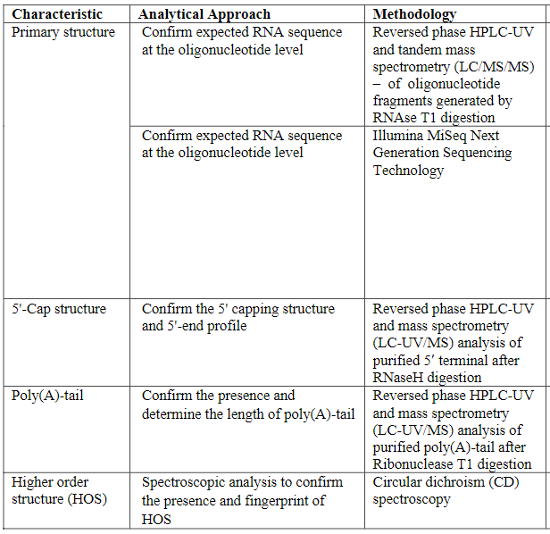
Oligonucleotide mapping
The primary sequence of BNT162b2 DS was analyzed by LC/MS/MS - oligonucleotide mapping. BNT162b2 DS was digested with RNAse T1, and the resulting enzymatic fragments were separated by ion-paired reversed-phase high performance liquid chromatography (IP-RP-HPLC) with UV detection at 260 nm. All major and minor peaks in the oligonucleotide map were identified by on-line electrospray ionization mass spectrometry with tandem mass spectrometry (MS/MS) by higher-collision dissociation (IP-RP-HPLC/ESI MS/MS or LC/MS/MS). The observed masses and MS/MS fragmentation patterns of oligonucleotides in each peak were consistent with the expected RNAse T1 fragments of BNT162b RNA. Given the possibility of sequence isomers after RNAse T1 digestion, the oligonucleotide map also was assigned via software using decoy sequences of BNT162b2 (randomized and reversed) in the presence of the BNT162b2 target sequence to confirm correct peak assignments. The vast majority of the oligonucleotide isomers were assigned to the target BNT162b2 RNA sequence rather than to any of the decoy RNA sequences, demonstrating the specificity of the method. The detected enzymatic fragments account for 90.5% of the overall BNT162b2 RNA sequence.
Sequencing of RNA
In order to further confirm sequence identity, RNA sequencing for BNT162b2 DS was performed using the Illumina MiSeq Next Generation Sequencing (NGS) technology. The RNA sequencing generated approximately 9.4 million reads, providing a minimum coverage depth of 100,000× at a given position within the coding region of the BNT162b2 transcript. These reads were mapped to the Eam1104I-linearized pST4-1525 reference plasmid and the sequence identity was confirmed. Taken together, the RNA sequencing results further demonstrate that the BNT162b2 transcript generated during the in vitro transcription (IVT) process bears the correct RNA sequence as predicted from the linear DNA template.
5'- Cap Characterization by LC-UV/MS
The characterization of the 5' end capped (5'-Cap) and un-capped species of BNT162b2DS was accomplished by ion-pair reversed-phase high performance liquid chromatography- ultraviolet light detection at 260 nm and online electrospray ionization mass spectrometry (RP-HPLC/UV-ESI MS) or LC-UV/MS.
Overall, characterization of BNT162b2 DS with the 5'-Cap method confirms that the predominant form of the 5' terminus contains the full-length 26 nucleotide RNase cleaved fragment with the 5'-Cap structure, accompanied by minor to trace levels of uncapped and truncated/extended species.
3ʹ Poly(A)-tail Characterization by LC-UV/MS
Analysis of the 3ʹ polyadenosine tail (poly(A)-tail) of BNT162b2 DS was accomplished by ion-pair reversed-phase high performance liquid chromatography with UV detection at 260 nm and on-line electrospray ionization mass spectrometry (RP-HPLC-UV/ESI MS or LC-UV/MS). The poly(A)-tail of BNT162b2 DS was cleaved off by ribonuclease T1 (RNase T1) followed by isolation via oligo(dT)25affinity purification.
The LC- UV/MS results demonstrate that BNT162b2 DS contains the expected poly(A)-tail A30 and L70 segments with the expected heterogeneity associated with transcriptional slippage.
Higher order structure
The higher order structure of BNT162b2 mRNA DS was characterized in solution using circular dichroism (CD) spectroscopy. A CD spectrum is a measure of differential absorption of the left- and the right-circularly polarized light by the test article, which arises due to structural asymmetry. The ordered structure of mRNA yields a CD spectrum that may contain positive and/or negative signals, while the absence of a CD signal generally indicates a lack of ordered structure.
The spectrum exhibits the typical profile of an RNA molecule with a strong negative band around 210 nm, less intense positive band at about 225 nm, very strong positive band between 260 and 280 nm and rather weak negative signal around 290 nm. The negative CD signal at 210 nm and strong positive rise below 200 nm are indicative of a right-handed RNA conformation. The negative and positive signals indicate that molecules of BNT162b2 mRNA DS are well folded.

Impurities (CTD section: S.3.2)
Data for this section is pending and will be updated once the data has been generated, analyzed, and verified.
This section summarizes the impurities that are controlled and monitored during the BNT162b2drug substance manufacturing process. Process validation data collected to date is provided for each impurity and will continue to be updated as testing for additional process validation batches is complete.
Process-Related Impurities
Process- related impurities are defined as impurities that originate from the manufacturing process and may be derived from reagents used in the in-vitro transcription and purification processes. The process related impurities discussed in this section include residual DNA template.
Residual DNA Template
Residual DNA template is a process-related impurity derived from the linearized DNA template added to the in-vitro transcription reaction. Residual DNA template is further controlled through routine testing using the analytical procedure described in 3.2.S.4.2 Quantitative Polymerase Chain Reaction(qPCR) and the BNT162b2 drug substance specification as described in 3.2.S.4.1 Specification. Results are shown in Table S.3.2-1 for process validation batches manufactured to date
Table S.3.2-1 Residual DNA Template Results for Clinical, Initial Emergency Supply and Process Performance Qualification COVID-19 Vaccine BNT162b2 Drug Substance Batches (Andover)
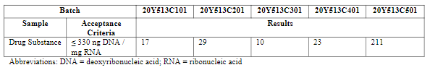
Additional Process Related Impurities
The additional process related impurities that were evaluated include nucleoside triphosphates (NTPs) and capping structure, small molecules, and enzymes. For further information about the evaluation of potential process-related impurities and result refer to Section 3.2.S.2.6 Risk Assessment of Potential Process Related Impurities.
Product-Related Impurities
The product related impurities discussed in this section include double stranded RNA.Safety assessment of double stranded RNA was performed as part of specification setting. Refer to 3.2.S.4.5 Justification of Specificationsfor informationpertaining tolevels of these impurities relative to patient safety.
Double Stranded RNA
Double stranded RNA is a product-related impurity derived from the in-vitro transcription reaction. Double stranded RNA is further controlled through routine testing using the analytical procedure described in 3.2.S.4.2 Immunoblot and the BNT162b2 drug substance specification as described in 3.2.S.4.1 Specification. Results are shown in Table S.3.2-2 for process validation batches manufactured to date.
Table S.3.2-2 Double Stranded RNA Results for Clinical, Initial Emergency Supply and Process Performance Qualification COVID-19 Vaccine BNT162b2 Drug Substance Batches (Andover)
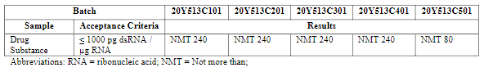
Potential Contaminants
Potential contaminants are defined as any adventitiously introduced materials (e.g., chemical,biochemical, or microbial species) not intended to be part of the manufacturing process of the drug substance or drug product (ICH Q6B).The potential contaminants that may be present in BNT162b2 drug substance are endotoxin and bioburden.During manufacture of the BNT162b2 drug substance, the manufacturing process has successfully been shown to effectively and consistently deliver drug substance with acceptable levels of the process and product related impurities and potential contaminants. Results are presented for bacterial endotoxin and bioburden in Tables S.3.2-3 and S.3.2-4, respectively.
Table S.3.2-3 Bacterial Endotoxin Results for Clinical, Initial Emergency Supply and Process Performance Qualification COVID-19 Vaccine BNT162b2 Drug Substance Batches (Andover)
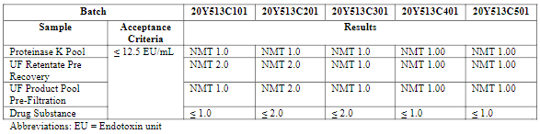
Table S.3.2-4 Bioburden Results for Clinical, Initial Emergency Supply and Process Performance Qualification COVID-19 Vaccine BNT162b2 Drug Substance Batches (Andover)
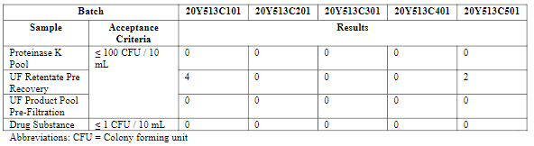

Assessor’s comments on S.3 Characterisation:
Elucidation of structure and other characteristics
Analytical characterization was performed on BNT162b2 drug substance batch 20Y513C101, which was manufactured by DS Process 2 at commercial scale. This is found acceptable.
The characterisation involves primary structure, 5’ cap structure, poly A tail and higher order structure. Overall, state-of-the-art methods was applied and the results confirmed the expected sequence and quality attributes. However, it is observed that no biological characterisation is presented and the mode of action is not described.
- In the Development History and Comparability section (3.2.S.2.6), the expressed protein size is evaluated by in vitro expression followed by Western blot. Results obtained by this method could be regarded as biological characterisation and should be included in section 3.2.S.3. The method needs further description and the results should be sufficiently characterized.
- A brief method description including conditions for protein expression, gel separation, and western blot assay should be provided.
- The expected protein size should be stated and supported by theoretical calculations.
- The identities of the two distinct bands should be explained. If possible, the identities of the bands should be confirmed and characterized by LC-MS/MS.
- The Applicant should provide data on protein expression in terms of percentage of successfully transduced HEK293 cells using the lipofectamine transfection system.
- Even though full biological characterisation is not possible to perform on DS, the strategy to determine potency and relevant functional assay(s) should be described in section 3.2.S.3. Results obtained on DP could be included, to demonstrated functionality.
Primary structure
Primary structure was confirmed by oligonucleotide mapping. The RNA sequence was digested by RNAse T1 and the oligonucleotide fragments were separated by reversed phase HPLC, followed by UV detection and MS/MS. Fragments corresponding to 90.5% of the overall BNT162b2 RNA sequence were detected.
As an orthogonal method, RNA sequencing using the Illumina MiSeq Next Generation Sequencing (NGS) technology was applied. The results confirm the RNA sequence.
5’ structure and poly A tail
The 5’-cap and 3’ poly A tail were confirmed by two separate LC-UV/MS-methods. Chromatograms are shown, accurate mass data for both the 5’-cap and 3’ poly A tail are presented, and all peaks are assigned. It was demonstrated that the predominant form of the 5’ terminus is the full-length nucleotide sequence with the 5’-Cap, but that there are also other minor species including phosphorylated, truncated and extended species. Analysis of the 3’ poly A-tail demonstrated that BNT162b2 DS contains the expected tail, but that there is some heterogeneity due to transcriptional slippage.
Higher order structure
The higher order structure of BNT162b2 mRNA DS was characterized in solution using circular dichroism (CD) spectroscopy. The obtained spectrum showed the typical profile of an RNA molecule, indicative of a well folded right-handed RNA conformation. This is found acceptable.
Impurities
The Applicant states that data for this section is pending and will be updated once the data has been generated, analyzed, and verified.
Process-related and product-related impurities as well as potential contaminants are described in this section. Five batches are evaluated for impurities, i.e. clinical, initial emergency supply and PPQ batches.
The sole product-related impurity addressed here is double-stranded RNA, derived from the in-vitro transription reaction. Results from the five DS batches demonstrate that the level of double stranded RNA is low, acceptable and consistent.
In addition to double stranded RNA, there are potentially more product-related impurities, for example truncated RNA, also referred to as fragmented species. When characterising the primary structure in section 3.2.S.3.1, no method determining intact RNA is included. Nevertheless, the DS specification includes a test for RNA integrity based on capillary gel electrophoresis. It is demonstrated that truncated RNA constitutes a significant proportion of the BNT162b2 DS. The truncated forms are not further characterised and the possible associated risks are not discussed.
- Truncated RNA species should be regarded as product-related impurities. Even though two methods, namely agarose gel electrophoresis and capillary gel electrophoresis, have been applied to determine RNA integrity of BNT162b2 DS, no characterisation data on truncated forms is presented. This is especially important considering that the current DS and DP acceptance criteria allows for up to 50% fragmented species. Therefore, the dossier should be updated with additional characterisation data on mRNA integrity. (MO)
- Results obtained on RNA integrity by capillary gel electrophoresis and agarose gels should be included in the characterisation section (3.2.S.3). The truncated forms should be sufficiently characterised, i.e. the identities should be described and it should be discussed if the fragmented species are expected to be similar between batches.
- The potential safety risks associated with truncated RNA isoforms should be thoroughly discussed with reference to the batches used, clinical experience and possibly literature data.
- Upon changing to Process 2, a decrease in RNA integrity was observed. As a concequence, the CTP and ATP volumes were adjusted to align better with RNA integrity results from Process 1. It should be clarified if the early Process 2 batches will be used in clinical trials or as commercial products. The potential risks of using these batches as compared to Process 1 batches should be sufficiently addressed.
Residual DNA template is a process-related impurity derived from the linearised DNA template added to the in-vitro transcription reaction. Residual DNA template is controlled by qPCR as defined in the DS specification, and the levels for all five batches are demonstrated to be well below the acceptance criteria. Additional process-related impurities, including nucleoside triphosphates (NTPs) and capping structure, small molecules, and enzymes, are evaluated and assessed in Section 3.2.S.2.6 Risk Assessment of Potential Process Related Impurities. Taking section 3.2.S.2.6 into account, the process-related impurities are sufficiently described. Some uncertainty remains regarding the approach to determine the levels of T7 RNA polymerase and proteinase K (see OC section 3.2.S.2.6).
The potential contaminants described in this section are endotoxin and bioburden. Acceptable results are shown for the Proteinase K pool, UF retentate pre recovery, UF-product pool and the drug substance.

  - Control of drug substance (CTD module 3.2.S.4)

Specification (CTD section: S.4.1)
Table S. 4-1. Specifications
Quality Attribute | Analytical Procedure | Acceptance Criteria
Composition and Strength
Clarity | Appearance (Clarity) ª | ≤ 6 NTU
Coloration | Appearance (Coloration) ª | Not more intensely coloured than level 7 of the brown (B) colour standard
pH | Potentiometry ª | 7.0 ± 0.5
Content (RNA Concentration) | UV Spectroscopy | 2.25 ± 0.25 mg/mL
Identity
Identity of Encoded RNA Sequence | RT-PCR^{b} | Identity confirmed
Purity
RNA Integrity | Capillary Gel Electrophoresis | ≥ 50% intact RNA
5’- Cap | RP-HPLC | ≥ 50%
Poly(A) Tail | ddPCR | ≥ 70%
Process Related Impurities
Residual DNA Template | qPCR^{b} | ≤ 330 ng DNA/mg RNA
Product Related Impurities
dsRNA | Immunoblot^{b} | ≤ 1000 pg dsRNA/µg RNA
Safety
Bacterial Endotoxin | Endotoxin (LAL) ª | ≤ 12.5 EU/mL
Bioburden | Bioburden ª | ≤ 1 CFU/ 10 mL
a. Compendial
b. Assay not performed on stability.
Abbreviations: NTU = Nephelometric Turbidity Units; B = brown; RT-PCR = reverse transcription polymerase chain reaction; ddPCR = droplet digital PCR; qPCR = quantitative PCR; dsRNA = double stranded RNA;
LAL = Limulus amebocyte lysate; EU = endotoxin unit; CFU = colony forming unit

Assessor’s comments on S.4.1 Specification:
The proposed specification for drug substance is found, in general, acceptable with respect to the analyses chosen for routine release testing. The CQAs RNA integrity, 5’-cap, Poly(A) tail, residual DNA template and double stranded RNA (dsRNA) are all included in the release specification. However, no method references are included, this needs to be updated.
Potency testing is not included in the control of DS but instead is performed at the level of DP release. Considering the nature of this product, the approach is endorsed.
The length of the poly(A) tails in BNT162b2 DS is important for RNA stability and translational efficiency and therefore should be included in DS release testing (OC).
- The proposed commercial drug substance specifications, the method descriptions and the method validation summaries should be updated to include in-house method identification numbers for the non-compendial methods. The information is required in order to provide a clear link between the specification and the descriptions and validations of analytical procedures used for routine testing. Furthermore, for the compendial methods references to relevant parts of the Ph Eur should be included. Section 3.2.S.4.1, 3.2.S.4.2 and 3.2.S.4.3 of the dossier should be updated accordingly. (OC)
- The length of the poly(A) tails in BNT162b2 DS is important for RNA stability and translational efficiency and therefore should be included in DS release testing.
The limits proposed for the different analyses are discussed below in Assessors comments to S.4.5 (“Justifications of specifications”).

Analytical procedure (CTD section: S.4.2)
All analytical methods used for testing of the drug substance are described in the dossier.
The following tests are performed in accordance with Ph Eur; clarity (Ph Eur 2.2.1), colour (Ph Eur 2.2.2), pH (Ph Eur 2.2.3), bacterial endotoxins (Ph Eur 2.6.14) and bioburden (Ph Eur 2.6.12).
Capillary gel electrophoresis (CGE)
The purpose of this analytical procedure is to determine the percent integrity of RNA in drug substance (DS) and drug product (DP).
This method uses capillary gel electrophoresis (CGE) to separate components based on the differential migration of RNA of different molecular weights in an applied electric field. In this procedure, the test sample (TS) is subjected to a denaturant containing formamide that unfolds the RNA and dissociates non-covalent complexes. When subjected to an electric field, the denatured RNA species migrate through the gel matrix, as a function of length and size, toward the anode. An intercalating dye binds to RNA and associated fragments during migration allowing for fluorescence detection. The intact RNA is separated from any fragmented species allowing for the quantitation of RNA integrity by determining the relative percent time corrected area for the intact (main) peak.
Figure S.4.2-1. Representative Electropherogram of BNT162b2 Drug Substance (Full View)
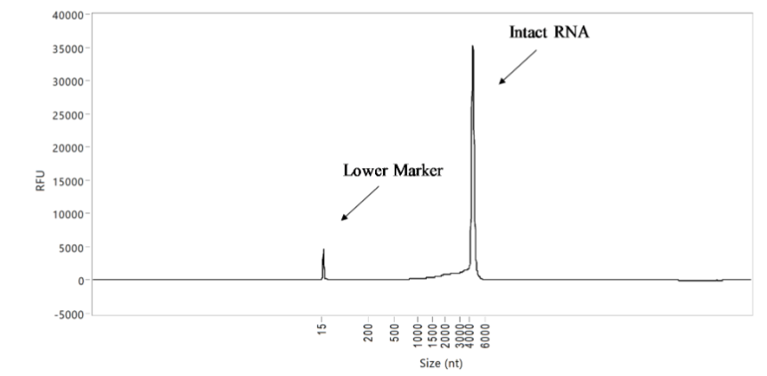
Figure S.4.2-2. Representative Electropherogram of BNT162b2 Drug Substance (Enhanced View)
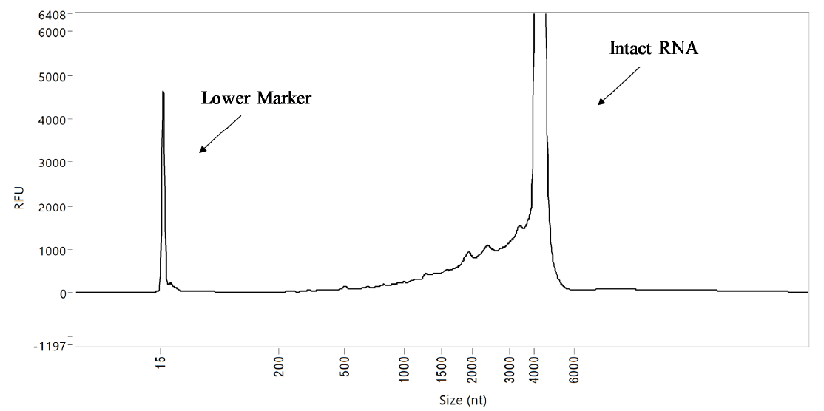
Reversed Phase-High Performance Liquid Chromatography (RP-HPLC)
The purpose of this analytical procedure is to measure the relative amount of 5’- capped RNA species in the drug substance. Test samples are digested using RNase H followed by affinity purification and reversed phase-high performance liquid chromatography (RP-HPLC) with UV detection.
After an annealing process to a biotinylated probe complementary to the last 26 bases of the 5’ end of the RNA, samples are digested with RNase H, followed by streptavidin-matrix based affinity purification of the resultant duplexes from the much larger mRNA remnants. The short oligonucleotide capped and uncapped species are eluted from the streptavidin-matrix, and relative quantification of the 5’-cap is accomplished by RP-HPLC analysis of the ensemble of RNA capped and un-capped molecules. The relative amount of capped species is determined by dividing the capped species signal by the total species signal.
Figure S.4.2-3. Representative Chromatograms of Assay Control
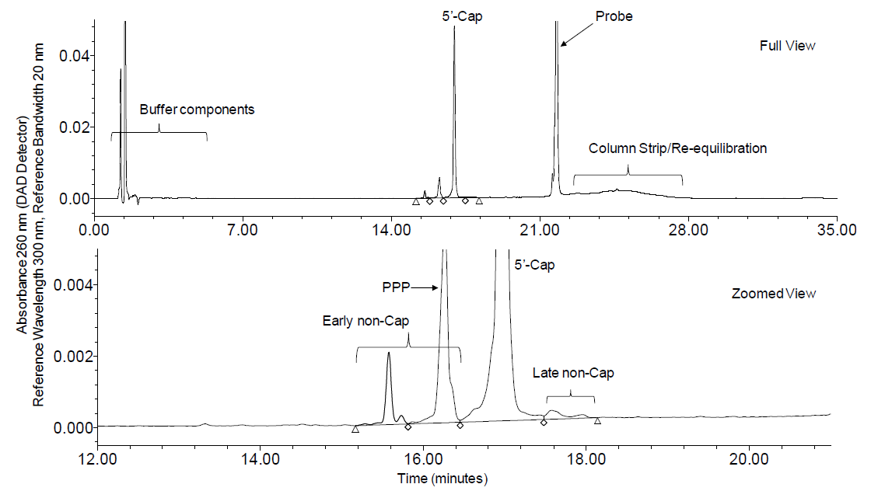

Reverse Transcription-Polymerase Chain Reaction (RT-PCR)
The purpose of this analytical procedure is to confirm the identity of the encoded RNA sequence derived from the BNT162b2 (pST4-1525) products. This procedure uses primers and a probe specific for the pST4-1525 sequence to perform a single step real-time RT-PCR assay intended for the detection of nucleic acid from RNA in both drug substance (DS) and formulated RNA lipid nanoparticle drug product (DP). Identification of the RNA is reported as presence or absence of the target RNA.
A single step RT-PCR assay is performed to detect nucleic acid from the RNA in DS and formulated DP. This assay is designed to detect a target of 63 bp amplicon in a gene that encodes for S protein in the BNT162b2. The amplicons are detected using a real-time PCR system that measures the fluorescence signal generated during amplification in real-time.
Sample Preparation
Extraction of RNA from the DP can be performed prior to analysis using a magnetic bead-based extraction. Lysis buffer is included as a negative extraction control (NEC) to ensure no cross contamination during the RNA extraction process.
Sample Dilution: An example sample preparation scheme is outlined below. Test samples (TS) are serially diluted (1:100, 1:10,000, and 1:100,000) in nuclease-free water.
Standard and Control Solution Preparation: Example control solution preparations are outlined below.
- Positive PCR Control: Assay control, at 50 pg/μL, is used as the positive PCR control.
- Negative PCR Control: Nuclease-free water is used as the negative PCR control.
- Negative Extraction Control (NEC): The NEC (lysis buffer), included in the extraction process, is required if DP TS extraction is performed.
Procedure: An example procedure is outlined: An aliquot of TS (1:100,000 dilution), PCR control, negative PCR control, and NEC (if applicable) are added to the appropriate wells of a PCR plate in triplicates each. RT-PCR reaction mix containing RT-qPCR master mix, 900 nM forward primer(5’-ACCGAGAAGTCCAACATCATCA-3'), 900 nM reverse primer(5'-CTGGGTCTTGCTGTCCAGTGT-3'), 250 nM probe(5’-6FAMGGCTGGATCTTCGGC-MGBNFQ-3’) and nuclease-free water is prepared and an aliquot is added to each well. The plate is sealed, centrifuged, and analyzed in the PCR system with the typical parameters listed in Table S.4.2-1.
Table S.4.2-1. Typical PCR System Operating Parameters
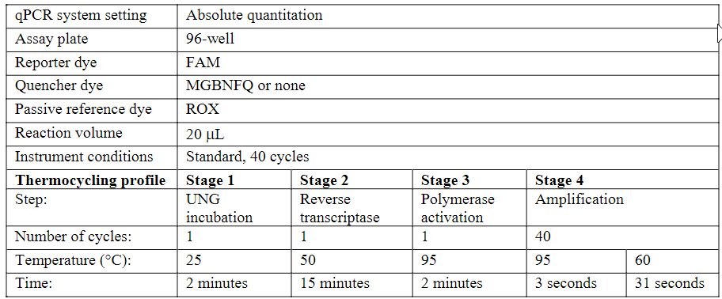
Abbreviations: FAM = 6-C arboxyfluorescein, MGBNFQ = minor groove binding non-fluorescent quencher,ROX = carboxy-X-rhodamine

Table S.4.2-2. Assay and Sample Acceptance
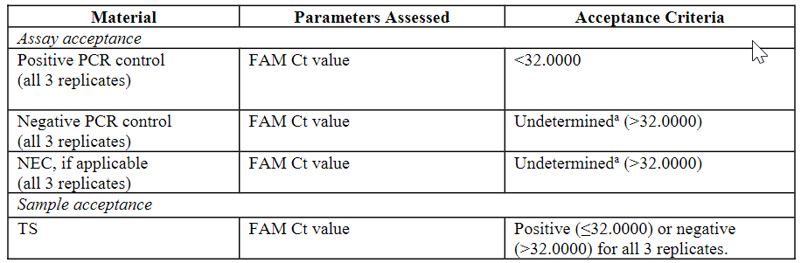
Abbreviations: FAM = 6-Carboxyfluorescein, Ct = threshold cycle
a. On occasion, a FAM signal may be detected in the negative control wells; the ROX passive reference dye may become quenched because the dye aggregates in the well. Quenching of the ROX signal, will cause an artificial increase because the final FAM Ct signal is a ratio of FAM to ROX signal. Check the component plot to make sure there is no amplification in the negative controls. In the presence of any amplification in the negative controls, the assay is invalid. If FAM Ct signal >32.0000 is detected in the negative control along with no amplification in the component plot, the negative control results are reported as valid.

Droplet Digital Polymerase Chain Reaction (ddPCR)
The purpose of this analytical procedure is to quantitate the poly(A) tail in the messenger ribonucleic acid (mRNA) in BNT162b2 drug substance (DS) using droplet digital polymerase chain reaction (ddPCR) technology.
The assessment of BNT162b2 drug substance for presence of the RNA poly(A)tail as determined by droplet digital PCR (ddPCR) is performed at release and on stability.
The ddPCR technology is a digital form of polymerase chain reaction (PCR) that uses a water-in-oil emulsion system to quantify target nucleic acids. Thousands of nanoliter sized droplets are formed from each sample, and PCR amplification is then performed on each droplet. Post amplification, fluorescence is measured in order to detect the number of positive and negative droplets.
This procedure describes a two-step reverse transcription ddPCR assay for the quantitation of mRNA poly(A) tail. For the first step, a primer specific for the poly(A) tail of the mRNA is used to generate complementary deoxyribonucleic acid (cDNA) by reverse transcription (RT).
For the second step, cDNA is diluted to a final target concentration of 1000 copy/μL (theoretical total input). Primers and a fluorescent probe specific for the 3’ end of the mRNA sequence are used for droplet digital polymerase chain amplification. Fluorescence of the droplets is measured at the end of amplification. The poly(A) tail is quantified as a percent of the copy number that have 3’ end in the total number of mRNA copies
Sample preparation: An example sample preparation scheme is outlined. DS test samples (TS) are diluted to a target concentration of 0.5 ng/μL in nuclease-free water.
mRNA Internal Control (IC) Preparation: IC is prepared in the same manner as TS.
Procedure: An example procedure scheme is outlined.
- mRNA Primer Annealing: A working solution of anchored oligo-dT primer (TTT TTT TTT TTT TTT TTT TTT TVN) is prepared in nuclease-free water. The mRNA primer annealing solution is prepared and is dispensed in a PCR plate or strip, where aliquots of IC and TS are added according to the assay layout. The mRNA primer annealing reaction thermal cycling is performed as shown in Table S.4.2-3.
Table S.4.2-3. Typical mRNA Primer Annealing Reaction Thermal Cycling Conditions
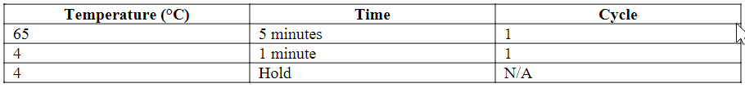
- mRNA cDNA Synthesis: The cDNA synthesis master mix (Table S.4.2-4) is prepared just prior to use.
Table S.4.2-4. Typical cDNA Synthesis Master Mix
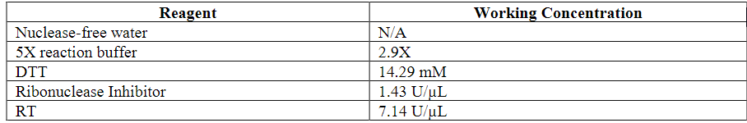
Abbreviations: RT = Reverse Transcriptase; DTT = Dithiothreitol
The cDNA synthesis reaction thermal cycling is performed as shown in Table S.4.2-5.
Table S.4.2-5. Typical cDNA Synthesis Reaction Thermal Cycling Conditions
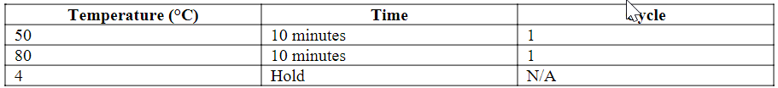
- mRNA RNase H Reaction
Table S.4.2-6. Typical RNase H Master mix
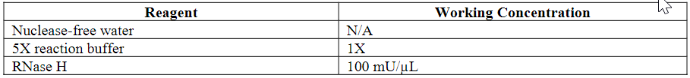
The RNase H reaction thermal cycling is performed as shown in Table S.4.2-7.
Table S.4.2-7. Typical RNase H Reaction Thermal Cycling Conditions
- ddPCR Reaction and Analysis
The ddPCR primer and probe working solution in nuclease-free water is prepared as shown in Table S.4.2-8.
Table S.4.2-8. Typical ddPCR Primer and Probe Working Solution
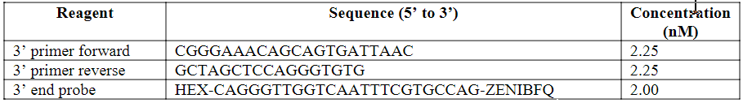
Abbreviations: HEX =hexachloro-fluorescein; ZENIBFQ = ZEN–Iowa Black fluorescence quencher
The ddPCR master mix is dispensed in all wells of the ddPCR reaction plate, according to the plate layout design for plating IC, all TS, non-template controls (NTC), and blanks (if needed), each in triplicate wells. Blank wells are created to complete partially filled plate columns to ensure proper droplet generation. IC and each TS are then added to appropriate wells, and water is added to all NTC and blank wells.
The ddPCR reaction thermal cycling is performed as shown in Table S.4.2-9.
Table S.4.2-9. Typical ddPCR Reaction Thermal Cycling Conditions
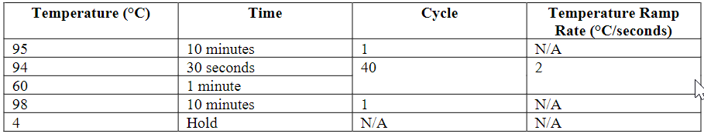
The plate is analyzed using the system software, with typical instrument setup parameters listed in Table S.4.2-10.
Table S.4.2-10. Typical Droplet Reader Settings
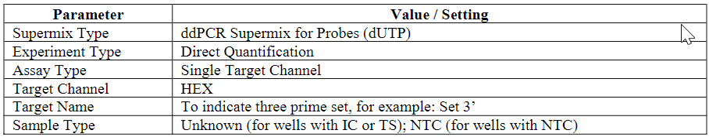
Abbreviations: HEX = hexachloro-fluorescein
The settings apply to all wells containing IC, TS or NTC. Blank wells are not included in the droplet reader plate layout.
- Assay and Sample Acceptance Criteria
Assay acceptance criteria are assessed by analysis of NTC and IC results. Sample acceptance criteria are assessed by analysis of TS results. The criteria listed in Table S.4.2-11 must be met to demonstrate assay and sample acceptance.
Table S.4.2-11. Assay and Sample Acceptance
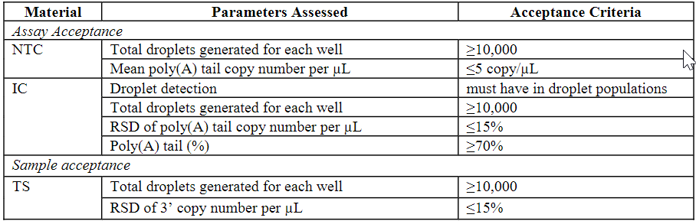
Abbreviations: RSD = relative standard deviation

- Calculations and Data reporting
The copy number per μL values for the positive and negative droplet populations are reported by the instrument software program for each well.
The mean, standard deviation and RSD (%) are calculated for each sample from 3’ copy number per μL values for triplicate wells.
Percent poly(A) tail is calculated for each sample as percent mean 3’ copy number per μL relative to the input (e.g. input = 1000 copy/μL)
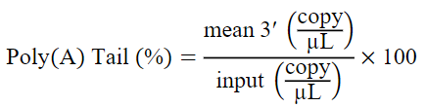
Provided the assay and sample acceptance criteria are met,the percent poly(A)tail of the TS is reported.

Quantitative Polymerase Chain Reaction (qPCR)
The purpose of this analytical procedureis to quantify the residual DNA template in BNT162b2 drug substance (DS) samples.
The level of residual DNA template in test samples is determined by quantitative polymerase chain reaction (qPCR) using fluorescence technology. A qPCR master mix containing target specific primers and fluorescent qPCR quantitation reagent is added to all the sample wells. Samples are prepared in a series of dilutions and are analyzed by qPCR. During extension, primers anneal and PCR product is generated. When polymerization is complete, the fluorescent dye binds to the double-stranded product, resulting in an increase in fluorescence.The fluorescence signal is proportional to the amount of PCR product. The quantitation of DNA is performed during the exponential phase of the reaction at a cycle threshold (Ct) where amplification of a target sequence is first detected above the established signal threshold. This Ct point is dependent on the amount of DNA originally present in the sample. The concentration of DNA in the test sample is interpolated from the linear regression of the standard curve, taking into account the dilution factor.
Sample Preparation: An example sample preparation scheme is outlined.
For each test sample (TS), dilutions are prepared by diluting DS in the appropriate diluent, typically at 1:1,000 and 1:10,000.
Standard and Control Preparation: An example standard and control preparation scheme is outlined.
- Blank and No-Template Control (NTC): If blank is included in the assay, the sample diluentis used as blank. Water (RNase/DNase free) is used as the No-Template Control (NTC) for the PCR plate.
- Standard Curve Preparation: An intermediate dilution of a qualified lot of linearized plasmid standard is prepared at a concentration of approximately 2.50×10⁵pg/mL. From this intermediate dilution, a standard curve is prepared by serial dilution: e.g. six standards with DNA concentrations over the range of 0.1 – 10,000 pg/mL.
Procedure:
- Preparing the PCR Plate: An example assay plate preparation scheme is outlined below. The qPCR master mix is prepared containing fluorescent qPCR quantitation reagent, T7 UP forward primer (5'-CCT GAT TCT GTG GAT AAC CGT ATT ACC GCC A-3', 0.30 μM), and Kozak reverse primer (5'-CTC TCT GAG TCT GTG GGG ACC AGA AGA ATA C-3’, 0.30 μM) in nuclease-free water. Master mix is dispensed into each well to be analyzed, and aliquots of blank, NTC, STD dilutions, and TS dilutions are then added to appropriate wells.
- PCR Analysis: Typical instrument operating parameters are shown in Table S.4.2-12
Table S.4.2-12. Typical Instrument Operating Parameters
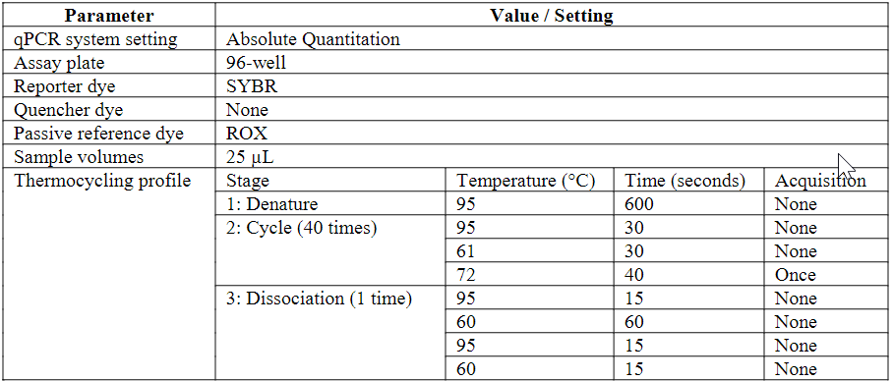
Abbreviations:SYBR = SYBR Green I;ROX = carboxy-X-rhodamine
- System Suitability, Assay, and Sample Acceptance: System suitability is assessed by analysis of the standards. Assay acceptance is assessed by analysis of the standard curve, NTC and blank (if applicable). Sample acceptance is assessed by analysis of TS replicates.The criteria listed in Table S.4.2-13 must be met to demonstrate system suitability, assay and sample acceptance
Table S.4.2-13. System Suitability, Assay, and Sample Acceptance
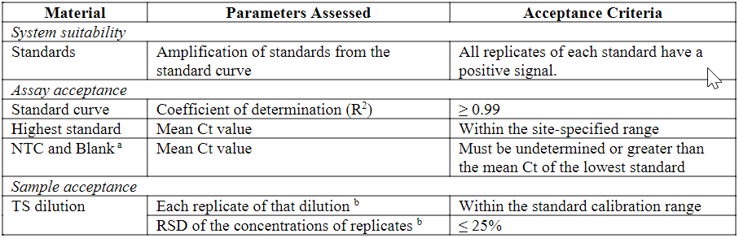

Immunoblot
The purpose of the immunoblot analytical procedure is to detect double stranded RNA (dsRNA) in BNT162b2 drug substance (DS). Samples are spotted onto a membrane and exposed to an anti-dsRNA antibody. A secondary antibody with a chemiluminescent readout is used to detect the primary antibody. The amount of chemiluminescence provides semi-quantitation of the amount of dsRNA when compared to limit standards.
Sample Preparation: DS test samples (TS) are prepared at the target concentration innuclease-free water.
Standard and Control Solution Preparation:
- dsRNA Standards: An example dsRNA standard preparation is outlined. A series of 7 dsRNA standards are prepared by serial dilution from a dsRNA stock solutionwith 200 ng/μL Poly (A)-RNA solution.
- Poly (A)-RNA Negative Control: The poly (A)-RNA negative control is prepared at the target concentrationin nuclease-free water
Procedure: An example procedure scheme is outlined including dot blot assembly, sample loading, membrane blocking, primary antibody incubation, secondary antibody incubation and development with substrate and dot blot image acquisition.
Assay acceptance is assessed by analysis of the dsRNA standards, negative control and TS. The criteria listed in Table S.4.2-14 must be met to demonstrate assay acceptance.
Table S.4.2-14. Assay Acceptance
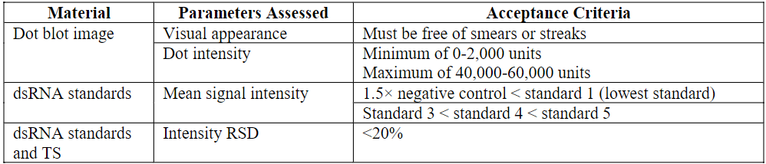
The mean adjusted intensity value for each standard level and TS is calculated. The limit level below which each TS falls is determined by comparing the mean adjusted intensity of the TS to the mean adjusted intensity of each standard level.
Provided the assay acceptance criteria are met, the residual dsRNA content of the TS is reported as < the determined limit level.

Validation of analytical procedure (CTD section: S.4.3)
Capillary gel electrophoresis (CGE)
The capillary gel electrophoresis analytical procedure is validated as a quantitative procedure for the determination of percent integrity of RNA in BNT162b2 drug substance (DS) and drug product (DP) and includes assessments of precision (repeatability and intermediate precision), accuracy, specificity, linearity, detection limit, quantitation limit, range and robustness. The validation results from Pfizer (DS and DP) and BioNTech (DS only) are provided in separate summary tables.
Reversed Phase-High Performance Liquid Chromatography (RP-HPLC)
The RP-HPLC analytical procedure is validated as a quantitative procedure for the determination of the 5’-cap content in BNT162b2 drug substance (DS) and includes assessments of precision (repeatability and intermediate precision), accuracy, specificity, linearity, quantitation limit, range and robustness. The validation results are provided in a summary table.
Reverse Transcription-Polymerase Chain Reaction (RT-PCR)
The RT-PCR analytical procedure is validated as an identification assay to confirm the identity of the encoded RNA sequence in BNT162b2 drug substance (DS) and drug product (DP) and includes assessments of specificity and robustness. The validation results from Pfizer (DS and DP) and BioNTech (DS only) are provided in Table S.4.3-1 and Table S.4.3-2, respectively.
Table S.4.3-1. Validation Summary for the RT-PCR Analytical Procedure for Drug Substance and Drug Product (Pfizer)
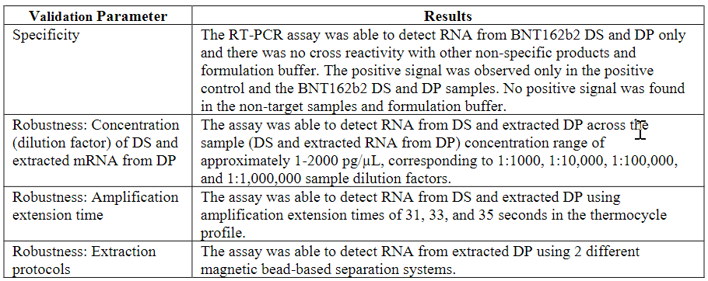
Table S.4.3-2. Validation Summary for the RT-PCR Analytical Procedure for Drug Substance (BioNTech)
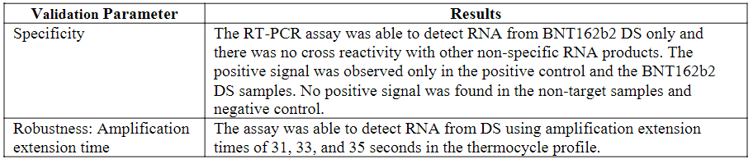

Droplet Digital Polymerase Chain Reaction (ddPCR)
The ddPCR analytical procedure is validated as a quantitative procedure for the quantitation of mRNA poly(A) tail in BNT162b2 drug substance (DS). This validation includes assessments of precision (repeatability and intermediate precision), accuracy, specificity, linearity, range and robustness. The validation results are provided in Table S.4.3-3.
Table S.4.3-3. Validation Summary for the ddPCR Analytical Procedure
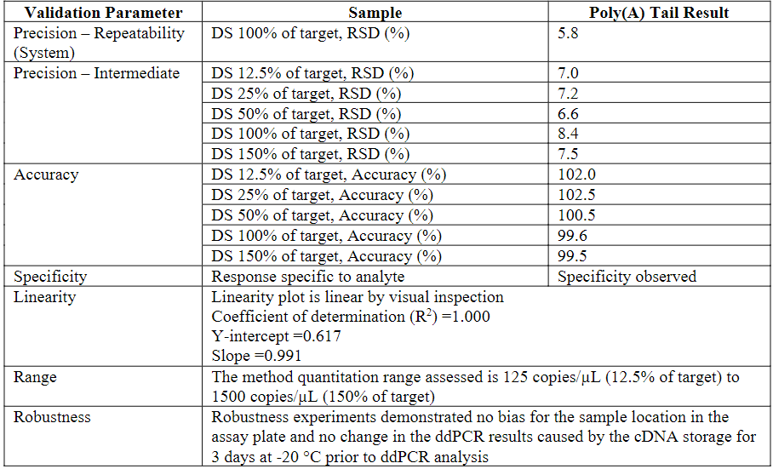

Quantitative Polymerase Chain Reaction (qPCR)
The qPCR analytical procedure is validated as a quantitative procedure for determining residual DNA template content in BNT162b2 drug substance (DS) and includes assessments of precision (repeatability and intermediate precision), accuracy, specificity, linearity, quantitation limit, range and robustness (different plasmid standard constructs). The validation results from Pfizer and BioNTech are provided in Table S.4.3-4 and Table S.4.3-5.
Table S.4.3-4. Validation Summary for the qPCR Analytical Procedure (Pfizer)
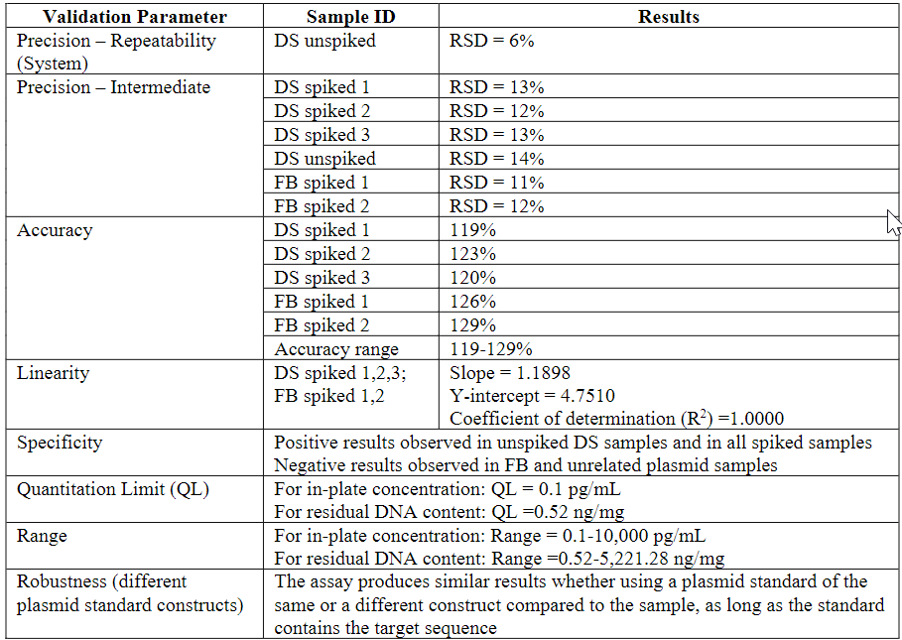
Abbreviations: FB = formulation buffer

Table S.4.3-5. Validation Summary for the qPCR Analytical Procedure (BioNTech)
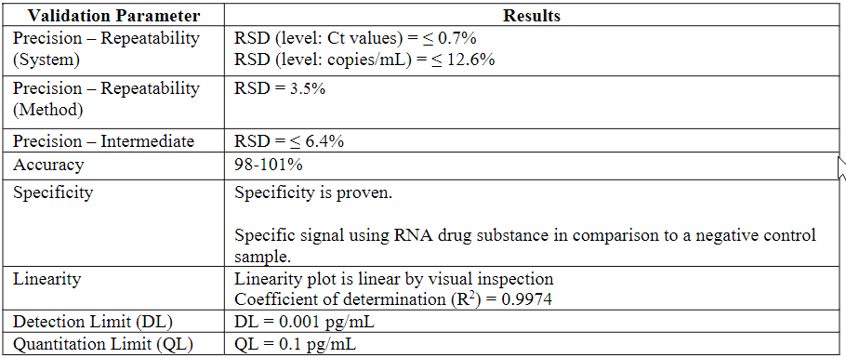

Immunoblot
The immunoblot analytical procedure is validated as a limit test for determining the double stranded RNA (dsRNA) content in BNT162b2 drug substance (DS) and includes assessments of specificity and detection limit. The validation results are provided in Table S.4.3-6.
Table S.4.3-6. Validation Summary for the Immunoblot Analytical Procedure
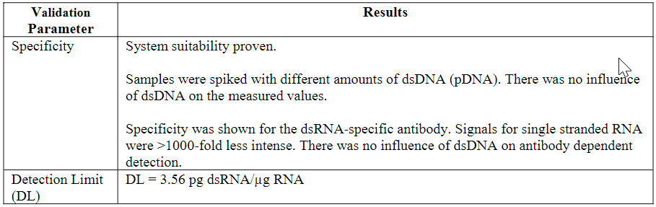

Assessor’s comments on S.4.2 and S.4.3 Analytical procedures:
S.4.2:
A general comment which applies to several/all the analytical method descriptions in this section is that rather brief details are given. Some of the assays are not presented in sufficient detail and often method descriptions are based on “examples” of procedures, controls and standards as well as on “typical” system operating parameters (OC). This hampers a full understanding the operation or, sometimes, the scientific basis of the assay. Furthermore, since several of these assays are none standard and complex, this interferes with assessment of suitability. The lack of sufficient information on critical reagents, standards or equipment hinders regulatory control of critical aspects of the assays. Several concerns are raised for specific assays requesting that critical procedures, reagents, standards and equipment are highlighted (see below).
- For all in-house analytical procedures used in the release of DS, method descriptions are based on “examples” of procedures, controls and standards as well as on “typical” system operating parameters. These terms raise uncertainties regarding the developmental stage, and the control of critical steps of these assays. The analytical methods used in the control of DS are expected to be finalized. The applicant is requested to confirm this and to update the relevant parts of the dossier with unequivocal method descriptions and additional details, if needed. The applicant should also confirm that any significant changes in analytical procedures will be applied for in a variation procedure. The dossier should be updated accordingly.
S.4.3:
It is claimed that the analytical methods were validated against the parameters presented in ICH Q2(R1). However, the validation summaries presented are far too brief to be able to conclude on suitability of the in-house analytical methods. The quality of BNT162b cannot be properly assessed, if the reliability of the analytical methods cannot be guaranteed.
- The information in the dossier does not support that any of the in-house analytical procedures applied for drug substance has been properly validated in line with ICH Q2. The validation summaries provided are far too brief and important details are missing. The Applicant should submit more comprehensive validation summaries of all non-compendial methods, for example in the form of short validation reports. The validation summaries should include all relevant calculations, acceptance criteria, description of and results obtained for individual samples. Chromatograms and dose response curves should be included, where applicable.
Module 3.2.S.4.3 of the dossier should be updated accordingly.
CGE and RP-HPLC
The in-house analytical methods for CGE and RP-HPLC are at large well described and includes details on typical test conditions, operating parameters, representative electropherograms and chromatograms as well as information on system suitability testing. However, as further detailed in the general question above use of wording “an example sample preparation” and “typical operating parameters” is not found appropriate”.
Reverse Transcription-Polymerase Chain Reaction (RT-PCR)
The RT-PCR method is used to determine the presence of the encoded RNA sequence derived from the pST4-1525 and, in general, is deemed suitable to estimate identity of BNT162b2 products. Three replicates per sample are used and positive and negative (nuclease-free water and lysis buffer included in the extraction process for DP control) controls are included. The method description, however, does not include information on the nature of the positive control. Furthermore, the method description is based on “examples” of control solution preparations and method procedure as well as on “typical” system operating parameters. A clear and unequivocal description of the method should be provided. Furthermore, a description of the mRNA extraction step needed for determination of the identity of BNT162b2 DP should be included and this step should be appropriately addressed in the method validation procedures (OC).
The proposed assay acceptance criteria for the qualitative RT-PCR-based assay used for determination of DS identity requires a Ct value for the positive PCR control of NMT than 32 simultaneous with a Ct value for the negative controls of NLT 32. The applicant is requested to further justify the suitability of this method in relation to these acceptance criteria, especially in the absence of validation data (OC).
The mRNA extraction step needed for determination of the identity of BNT162b2 DP should be included in the description of the RT-PCR-based assay and this step should be appropriately addressed in the method validation procedure (OC).
The RT-PCR method has been validated with respect to specificity and robustness (dilution of DS and mRNA extracted from DP, amplification extension time and extraction protocols) but only short summary in tabular format has been provided, which is not considered sufficient for a proper evaluation (OC).
- Regarding the RT-PCR method for determination of DS and DP identity:
- Information regarding the positive control used in the should be provided.
- The proposed assay acceptance criteria for the qualitative RT-PCR-based assay used for determination of DS identity requires a Ct value for the positive PCR control of NMT than 32 simultaneous with a Ct value for the negative controls of NLT 32. These criteria are not considered relevant to support method suitability. More stringent acceptance criteria should be established and supported by relevant data.
- The mRNA extraction step needed for determination of the identity of BNT162b2 DP should be included in the description of the RT-PCR-based assay and this step should be appropriately described and addressed in the method validation procedure. This question relates to the DP part of the dossier.
Droplet Digital Polymerase Chain Reaction (ddPCR)
The ddPCR technology is a digital form of polymerase chain reaction (PCR) that uses a water-in-oil emulsion system to quantify target nucleic acids. Thousands of nanoliter sized droplets are formed from each sample, and PCR amplification is then performed on each droplet. Post amplification, fluorescence is measured in order to detect the number of positive and negative droplets.
In the control of BNT162b2 Drug Substance, this method is proposed for the quantification of the poly(A) tail in the messenger ribonucleic acid (mRNA). It is acknowledged that ddPCR technology permits a superior quantification of low expressing/abundant targets and is less sensitive to low amounts of impurities possibly present in the reaction solution. The technical procedure is considered sufficiently described but the suitability for this method for the intended purpose needs additional clarifications. The rationale by which the method determines the percent poly(A) relative to the input (which is not clearly described) should be further addressed. Additionally, as for the qPCR-based method, it is unclear whether the method procedures presented in the dossier are locked or just examples or typical parameters are given (OC)
Only a short summary in tabular format has been provided for the validation of this method. This is considered too limited to allow for a proper evaluation. More details should be provided (OC). With respect to the storage conditions of the cDNA prior ddPCR, storage at room temperature, with no hold time established, is mentioned in the method description but a storage time of 3 days at –20°C is examined in the validation studies with respect to method robustness. These discrepancies should be clarified (OC).
- Regarding the ddPCR-based method for determination of poly(A) tails in the mRNA DS:
- Information regarding the internal control used in the should be provided.
- From the limited description of the ddPCR-based assay for quantification of poly(A) tails it seems that the cDNA generated using a poly(T) primer is used both as a template for further amplification of the (poly(A) positive mRNA)-derived cDNA and also as the theoretical input based on which the final calculation of the Poly(A) tails is made. This strategy is not understood. The suitability of this approach and the rationale by which the method is able to determine the percent poly(A) tails in the mRNA DS relative to the input (which should be clearly defined) needs to be better described.
- With respect to the storage conditions of the cDNA prior ddPCR, storage at room temperature, however with no hold time defined, is mentioned in the method description, but a storage time of 3 days at –20°C is examined in the validation studies with respect to method robustness. These discrepancies should be clarified
Quantitative Polymerase Chain Reaction (qPCR)
The purpose of the quantitative polymerase chain reaction (qPCR) analytical procedure is to quantify the residual DNA template in BNT162b2 drug substance (DS) samples. The assay is deemed suitable for its purpose and, in general, the description provided is considered adequate. Additional information should be included regarding the qualified lot of linearized plasmid standard. Furthermore, as for the RT-PCR -based method and ddPCR-based method, it is unclear whether the method procedures presented in the dossier are locked or just examples or typical parameters are given(OC).
Only short summaries of the validation exercises performed for the qPCR method at Pfizer and BioNTech have been provided, in tabular format. This is considered too limited to allow for a proper evaluation. More details should be provided (OC).
- Information on the qualified lot of linearized plasmid standard used in the qPCR-based method to quantify the residual DNA template in BNT162 b2 DS should be provided.
Immunoblot
An immunoblot analytical procedure is used to detect double stranded RNA (dsRNA) in BNT162b2 drug substance (DS). Samples are spotted onto a membrane and exposed to an anti-dsRNA antibody. A secondary antibody with a chemiluminescent readout is used to detect the primary antibody. The amount of chemiluminescence provides semi-quantitation of the amount of dsRNA when compared to standards. Additional information regarding the critical reagents standards and equipment used should be highlighted in the dossier (OC). In the description of the method varying incubation times or incubation times with only lower limits are given. These cannot be accepted in the absence of a validation exercise demonstrating the robustness of the method (OC). Furthermore, the validation summary provided in tabular format is considered to limited to allow for an appropriate evaluation (OC).
- With respect to the immunoblot analytical method used for deterination of dsDNA in BNT162b2 DS:
- additional information regading the critical reagents (such as antibodies), standards and equipment used as well as repesentative dot blots and standard curves should be highlighted in the dossier. The robustness of the method should be appropriately demonstrated in the validation exercise, if different reagents, e.g. different clones or different vendors for the antibodies, are envisaged.
- An incubation time of >16h is defined for the primary antibody incubation step. An upper limit shuld be defined as well. Unless otherwise justified, all variable incubation times described in the method should be considered in the validation exercise, in order to demonstrate the robustness of the assay.

Batch analyses (CTD section: S.4.4)
BNT162b2 drug substance batches used for nonclinical toxicology, clinical trials, process performance qualification (PPQ), emergency supply, and stability are summarized in this section.
A full drug substance genealogy can be found in Section 3.2.S.2.6 Developmental History and Comparability. The analytical testing strategy applied to BNT162b2 drug substance has evolved throughout the development history. Information on the drug substance method evolution/testing strategy is provided in Section 3.2.S.2.6 Analytical Method Evolution.

Table 3.2.S.4.4-1. Batch Analyses for Clinical, Emergency Supply and Process Performance Qualification COVID-19 Vaccine BNT162b2 Drug Substance Batches
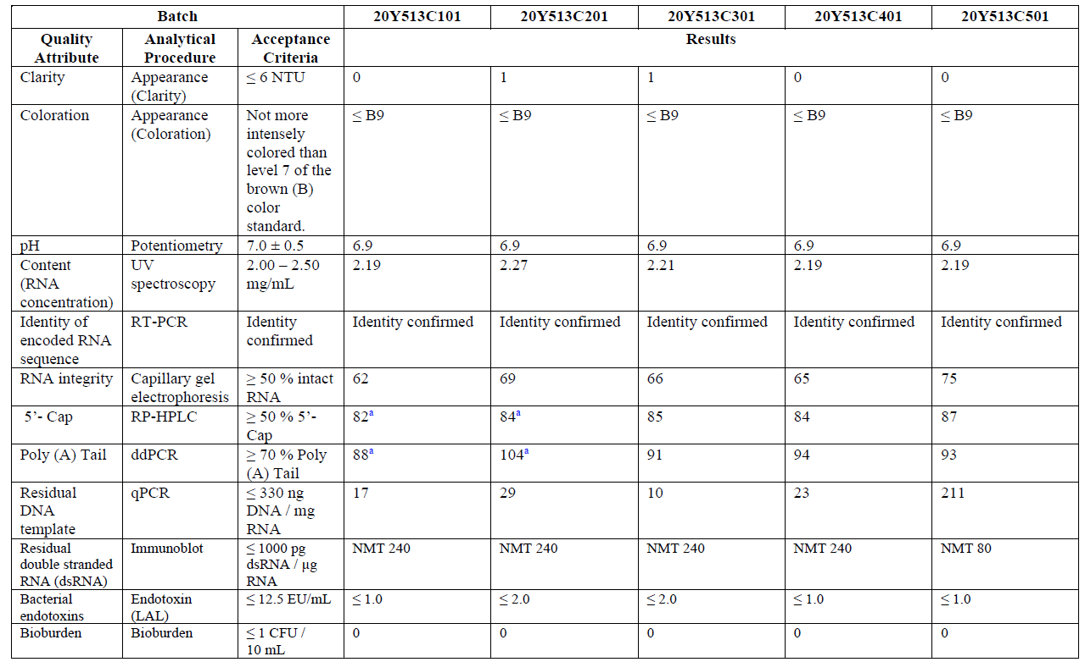

Assessor’s comments on S.4.4 Batch analysis:
Batch results are presented for DS batches used for nonclinical toxicology, clinical trials, process performance qualification (PPQ), emergency supply, and stability.
- Batch results should be presented for the two newly manufactured batches PPQ4 and PPQ5. This is considered important to verify that the volume adjustments made for ATP and CTP volumes before manufacturing of PPQ3 (20Y513C501) consistently results in RNA integrity levels similar to levels achieved in process 1 batches.

Justification of specification (CTD section: S.4.5)
The specification for BNT162b2 drug substance is based on an understanding of the control strategy and CQAs for the drug substance. The attributes tested and associated acceptance criteria ensure the consistency of drug substance and linkage to clinical experience. This preliminary specification was established to ensure the quality, purity, potency/biological activity and safety of the commercial drug substance at release and during storage. The specification was informed by:
- Development experience (manufacture and analytical) with BNT162b2 drug substance;
- Total BNT162b2 manufacturing experience, including drug substance batches used to manufacture drug product lots used in nonclinical and clinical studies;
- The ongoing release and stability data for drug substance.
Currently, process performance qualification and associated characterization are ongoing and based on their outcome, the specification will be reassessed.
Because no appreciable stability data are yet available for representative BNT162b2 drug substance at the recommended storage condition of -20 ° ± 5 °C, the acceptance criteria used for stability over shelf life will be the same as the acceptance criteria used for batch release. Finally, the Sponsor also acknowledges that only a limited data set representing drug substance manufactured at the commercial scale and process is available at this time to inform the determination of acceptance criteria. When an adequate number of batches have been manufactured, the specification and all associated acceptance criteria will be reassessed.
Comparability between process 1 and process 2 batches has been demonstrated as shown in Section 3.2.S.2. Development History and Comparability Assessment, and therefore it is appropriate to include process 1 data in the specification evaluation.
Table S.4.5-1. BNT162b2 Drug Substance Batch Summary for Evaluation of Specifications
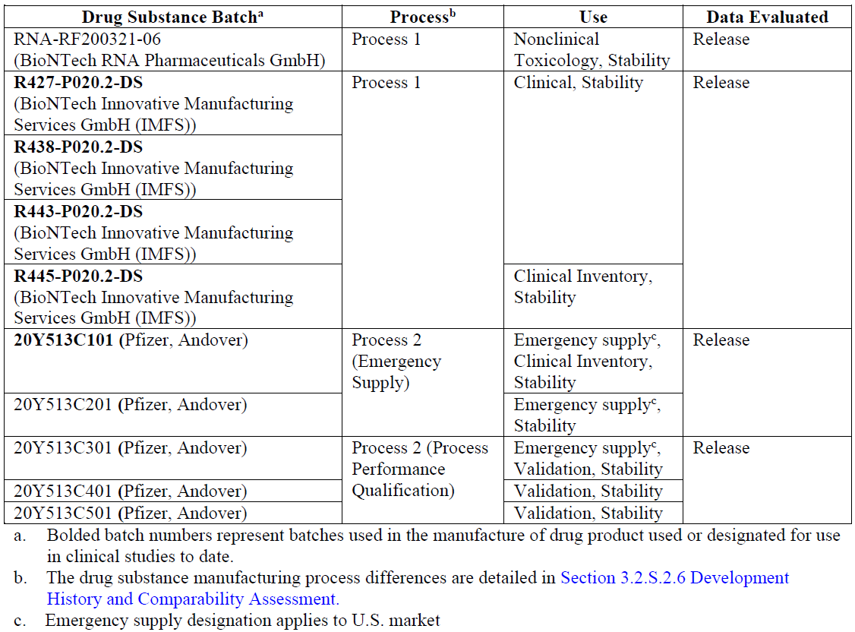
Appearance
Clarity
For each DS batch, release results were reported based on either a visual assessment (nonclinical and process 1 drug substance batches), or a Ph. Eur. 2.2.1 compliant instrumental assessment (process 2 drug substance batches). The release test results were all reported (Section 3.2.S.4.4 Batch Analyses) as either clear, or ≤3 nephelometric turbidity units (NTU), which is considered the typical appearance of nucleic acid solutions.
The commercial Release and Stability Acceptance Criteria for Clarity is ≤ 6 NTU.
Coloration
The coloration of DS is routinely monitored at release and on stability. The analytical procedure is based on compendial requirements. For each DS batch, the results for coloration were reported using either a visual assessment in the absence of reference solution comparisons (nonclinical toxicology and process 1 clinical/clinical inventory batches) or by the Ph. Eur. 2.2.2 method (process 2 drug substance batches). The range in coloration results for DS batches at release throughout development is summarized as either colourless or B9 (the lowest intensity brown colour standard).
The commercial acceptance criterion for appearance (coloration) at release and during stability studies is “Not more intensely coloured than level 7 of the B (brown) colour standard”.
pH
The pH of the DS is determined for every batch at release and during stability studies as a measure of general product quality. This assessment is performed in accordance with Ph. Eur.2.2.3 and USP<791>. The DS is a buffered aqueous solution specifically developed with a target pH range of 6.5 to 7.5 to ensure RNA stability.
The commercial acceptance criterion for pH at release and during stability studies is 7.0 ± 0.5.
Content (RNA Concentration)
The content (RNA concentration) of DS is determined by the measurement of the absorbance of the solution at 260 nm by UV spectroscopy. The test results are reported in units of mg/mL. Content is measured for every batch of DS for release as well as for those batches on stability. The correct RNA concentration within the target ±11% ensures the appropriate RNA concentration input for DP processing. For the nonclinical batch and much of process 1 manufacture, the acceptance criterion for content was targeted for 1.70 mg/mL. All data for release met this criterion.
Prior to and in preparation for implementation of process 2 manufacture, the content acceptance criterion was increased to 2.25 ± 0.25 mg/mL to facilitate DP processing. The lower limit for content of 2.00 mg/mL ensures that DS meets the minimum required RNA concentration for further processing. All batches manufactured after this change met the updated criteria.
Table S.4.5-2. BNT162b2 Drug Substance Release Data for Content
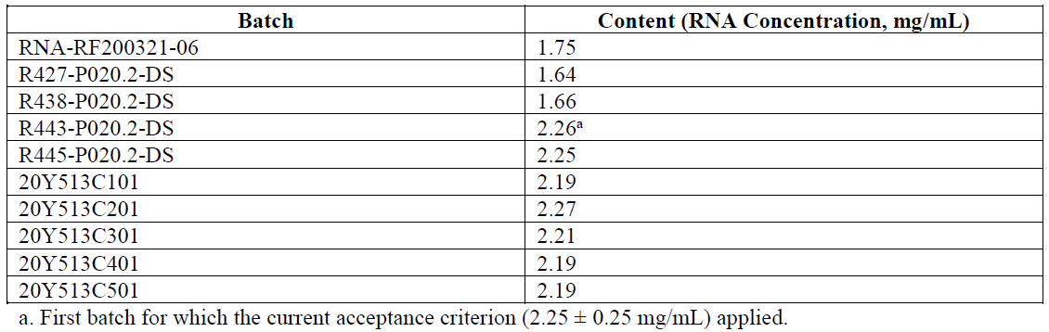
Table S.4.5-3. Commercial Release and Stability Acceptance Criterion for Content (RNA Concentration)

Identity of Encoded RNA Sequence
The identity of the DS encoded RNA sequence is assessed by reverse transcription PCR (RT-PCR). This attribute is monitored for every batch at release. This method was introduced for process 2 DS and is not performed on stability. The commercial acceptance criterion for identity of the encoded RNA sequence at release is “Identity confirmed”.
RNA Integrity
Capillary gel electrophoresis is routinely used to evaluate the RNA integrity of the DS at release and during stability. The method can detect potential degradation products based on their respective migration times and data are reported as relative peak area. Changes were made in the method related to data processing in preparation for process 2 manufacture. Bridging studies demonstrated that data processed by the updated processing method resulted in apparently lower % intact RNA results, with a systematic offset of as much as 23%. See Table S.4.5-4 for comparative results pre- and post-reprocessing for nonclinical and process 1 DS batches. (Note that the certificate of analysis results for nonclinical and process 1 drug substance batches correspond to results obtained prior to reprocessing). The release test results for RNA integrity for DS batches (one nonclinical toxicology batch, four process 1 clinical/clinical inventory batches and five process 2 batches), using the updated data processing procedure, correspond to a range of 62% to 86% RNA integrity.
Table S.4.5-4. BNT162b2 Drug Substance Release Data for RNA Integrity
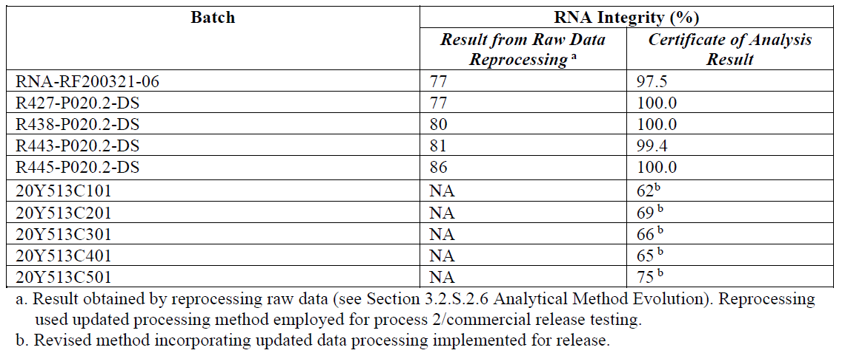
To establish the acceptance criterion lower limit for % intact RNA, data from all batches manufactured by process 1 and process 2 as shown in Table S.4.5-4 have been considered. The comparability of these DS materials has been evaluated and process 1 and 2 DS batches were demonstrated to be comparable based on this assessment. Drug product (lot EE8493) manufactured from the 20Y513C101 DS has also been designated as clinical material and emergency supply.
The acceptance criterion lower limit for % intact RNA has therefore been adjusted in conjunction with the output from the updated data processing and in light of the established comparability of process 1 and process 2 materials. Recent DS manufacturing characterization studies suggest that by increasing the concentration of specific nucleotide triphosphates somewhat higher production yields and potentially higher % integrity may be achieved, as suggested by the 20Y513C501 integrity results. As additional supply nodes are introduced and manufacturing experience is gained, acceptance criteria will be evaluated and revised, as appropriate. Based on this understanding, the acceptance criterion for commercial release and stability for RNA integrity is shown in Table S.4.5-5.
Table S.4.5-5. Commercial Release and Stability Acceptance Criterion for RNA Integrity
5’-Cap
Reverse phase HPLC with UV detection is used to evaluate the relative amount of 5’-capped RNA species in the DS. Following an annealing process to a biotinylated probe, the RNA is digested and affinity purified. The resultant capped and uncapped species of RNA (intact and fragments) are quantified by RP-HPLC. The presence of the appropriate 5’-cap protects the RNA thereby helping to ensure mRNA translation. This assay is performed at release and during stability studies. Preliminary data obtained using a development method for process 1 batches (R427-P020.2-DS through R445-P020.2-DS) and the release data for process 2 batches (20Y513C101 through 20Y513C501) are shown in Table S.4.5-6. These data for 5’-cap range from 57% to 87%.
Table S.4.5-6. BNT162b2 Development, Comparability and Release Data for 5'-Cap (%)
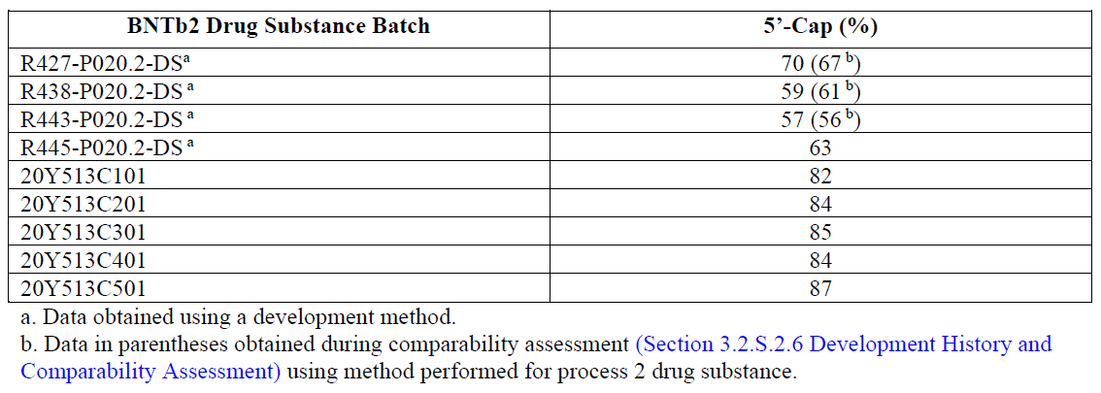
To establish the acceptance criterion lower limit for 5’-cap, data from all batches manufactured by process 1 and process 2 have been considered. The comparability of these DS materials has been evaluated, and process 1 and 2 batches were demonstrated to be comparable. DP lots manufactured from the process 1 DS batches have been assessed clinically, and a DP lot (EE8493) manufactured from the 20Y513C101 process 2 DS has also been designated for use as clinical material.
As additional supply nodes are introduced and manufacturing experience is gained, including learnings from process performance qualification and the associated characterization, acceptance criteria will be evaluated and revised, as appropriate. Based on this understanding, the preliminary acceptance criterion for commercial release and stability for 5’-cap is presented in Table S.4.5-7.
Table S.4.5-7. Commercial Release and Stability Acceptance Criterion for 5’-Cap

Poly(A)Tail (ddPCR)
Data obtained during development are shown in Table S.4.5-8.
Table S.4.5-8. Development, Comparability and Release Data for Poly(A) Tail (%)
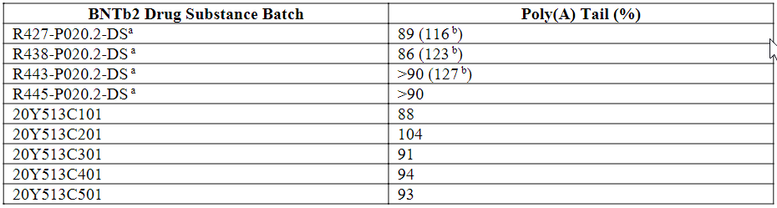
a. Data obtained using a development method
b. Data in parentheses obtained during comparability assessment (Section 3.2.S.2.6 Development History and Comparability Assessment) using method performed for process 2 drug substance.
To establish the acceptance criterion lower limit for poly(A) tail, data from all batches manufactured by process 1 and process 2 have been considered. Drug product lots manufactured from the process 1 drug substance batches have been assessed clinically, and drug product manufactured from the 20Y513C101 process 2 drug substance has also been designated as clinical material.
Based on this understanding, the proposed preliminary acceptance criterion for commercial release and stability for poly(A) tail is ≥70%.
Residual DNA Template
Residual DNA template is a process-related impurity in BNT162b2 drug substance that is tested for at time of BNT162b2 drug substance release. Residual DNA is measured using a quantitative PCR (qPCR) test. Release test results for BNT162b2 drug substance, 1 nonclinical toxicology batch, 4 process 1 clinical/clinical inventory batches and 5 process 2 batches, are shown in Table S.4.5-9.
Table S.4.5-9. BNT162b2 Drug Substance Release Data for Residual DNA Template
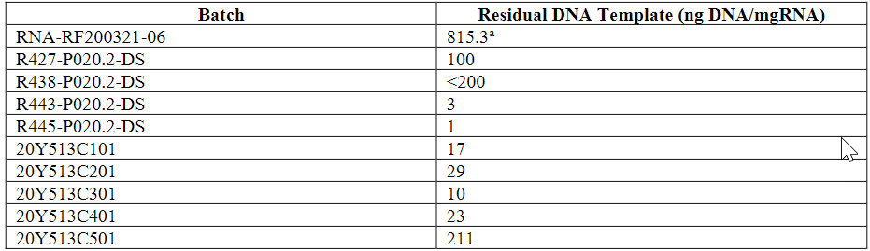
a. Incorrect DNase I stock solution used, leading to higher values of residual DNA template
The specification for residual DNA template was based on the WHO recommendation of not more than 10 ng DNA/dose. Based on these considerations, and assuming a maximum dose of 30μg, the commercial acceptance criterion at release is ≤330 ng DNA/mg RNA.
Bioburden
The DS is routinely monitored for bioburden to ensure product safety and to demonstrate the consistency of the manufacturing process. Bioburden is measured in accordance with Ph. Eur. 2.6.12, USP<61> and JP 4.05. Through preclinical development, the bioburden acceptance criterion was <1 CFU/mL. For process 1 and 2 clinical manufacture, the acceptance criterion was tightened to
≤1 CFU/10 mL. Prior to process 2 manufacture and enrolment in the stability program, no stability evaluation for bioburden was performed. All DS batches tested to date have met their respective acceptance criteria. The results generated throughout clinical development demonstrate the consistent and effective process capability to minimize the introduction of bioburden into the DS.
The commercial acceptance criterion for bioburden at release and during stability is ≤1 CFU/10 mL.
Bacterial Endotoxins
The endotoxin test results for the DS batches at release demonstrate the capability of the manufacturing process to consistently and effectively minimize the introduction of bacterial endotoxins. Bacterial endotoxins is measured in accordance with Ph. Eur. 2.6.14, USP<85> and JP 4.01. The commercial acceptance criterion has been set to ensure that the DP does not exceed the compendial limit of 5 EU/kg-hr with a target DP concentration of 0.50 mg/mL RNA concentration. Assuming a 30μg RNA dose and the 12.5 EU/mL proposed DS limit, the amount of bacterial endotoxin calculated associated with the dose is (0.030mg RNA / 2.25 mg/mL) * 12.5 EU/mL or 0.17 EU, regardless of the patient weight. This value is substantially below the 5 EU/kg-hr limit, providing a substantial safety margin for contributions from DP manufacturing.
The proposed commercial release and stability acceptance criterion is ≤ 12.5 EU/mL.

Assessor’s comments on S.4.5 Justification of specification:
It is noted that the applicant states that the proposed specification is considered as a preliminary. The specification is based on experience from development, manufacturing and ongoing release and stability data for the drug substance (one nonclinical toxicology batch, four process 1 clinical/clinical inventory batches and five process 2 batches). In addition, it is stated that based on the outcome of the ongoing process performance qualification and associated characterization studies the specification will be reassessed. Since the currently available stability data is very limited it is found reasonable that the acceptance criteria proposed for end of shelf life are the same as the acceptance criteria for batch release.
RNA integrity
The DS release results for RNA integrity, is in the range 62% to 86% and the proposed acceptance criteria is ≥50% intact RNA. However, there is no information in relation to the level of RNA integrity that can be considered clinically qualified.
5’- Cap
The DS release results for the relative amount of 5’-capped RNA, is in the range 57% to 87% and the proposed acceptance criteria is ≥50%. However, there is no information in relation to the relative amount of 5’-capped RNA, that can be considered clinically qualified.
The following comments should be taken into account when the acceptance criteria in the specification is reassessed in connection with the planned CMA application.
- The proposed acceptance criteria for the percentage of 5’- Cap (≥50%) is not considered justified and should be tightened to better reflect the data presented for the DS material used in the manufacturing of the clinical, emergency supply and PPQ batches. In addition, batch release results from two newly manufactured batches PPQ4 and PPQ5 should be included in the reassessment of the acceptance criteria.

Droplet Digital Polymerase Chain Reaction (ddPCR)
Batch data are provided only for the Emergency Supply and Process Performance Qualification COVID-19 Vaccine BNT162b2 Drug Substance Batches (Process 2). In the justification for the poly(A) method, additional data from DS batches used in the manufacturing of clinical material are provided. These results are obtained using a development method, ion-pair reversed-phase high performance liquid chromatography with UV detection at 260 nm and on-line electrospray ionization mass spectrometry (RP-HPLC-UV/ESI MS or LC-UV/MS). When further analysed for comparability purposes using the commercial method, significantly higher values for poly(A) are obtained. The proposed specification limit (≥70%) is not considered justified and should be tightened to mirror the data presented for the DS material used in the manufacturing of the clinical, emergency supply and PPQ batches (OC).
- The proposed specification limit (≥70%) for the percentage poly(A) attribute is not considered justified and should be tightened to better reflect the data presented for the DS material used in the manufacturing of the clinical, emergency supply and PPQ batches.
Quantitative Polymerase Chain Reaction (qPCR)
Batch analysis have been provided for material used in the manufacturing of clinical, emergency supply and PPQ material.
The specification for residual DNA template was based on the WHO recommendation of not more than 10 ng DNA/dose. Based on these considerations, and assuming a maximum dose of 30μg, the commercial acceptance criterion at release is ≤330 ng DNA/mg RNA. The approach is endorsed.

  - Reference standards of materials (CTD module 3.2.S.5)
Drug substance reference material is being prepared for use as a reference material and/or assay control for the release and stability testing of drug substance and drug product clinical and process validation materials, as well as initial commercial supply. A summary of the drug substance reference material is presented in Table S.5-1.
A two-tiered system for in-house reference material will be implemented in the future to support the commercial product. After implementation, the primary reference material (PRM) will be intended to last throughout the commercial product lifetime and will be used for qualification of future working reference materials (WRM). PRM is not intended to be used in routine testing. An initial WRM will also be made and implemented in the future to support routine testing of commercial drug substance and drug product until it is consumed and replaced.
Table S. 5-1 Summary of Reference Materials
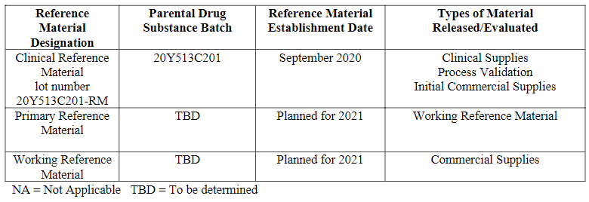
Clinical Reference Material
The initial Clinical Reference Material (CRM) was prepared from a suitable GMP drug substance, batch 20Y513C201, that is representative of commercial materials. The CRM was aliquoted into polypropylene cryovials and stored frozen at -20°C ± 5 °C.
Release testing was performed on parent batch 20Y513C201 and results are detailed in Table S. 5-2.
Table S. 5-2 Release Test Results of Clinical Reference Material
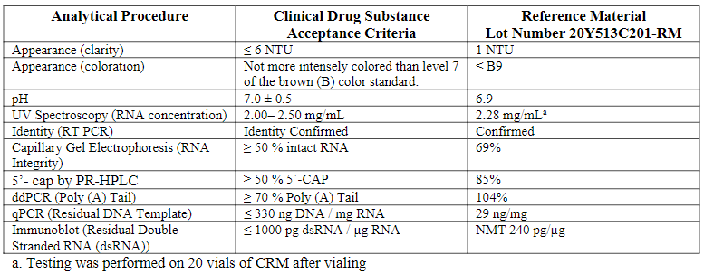
The CRM has been placed on formal stability at both the intended storage of -20 ±5 °C and the alternate intended storage of-60 to -90 °C. The initial period of use for the CRM is 6 months. The CRM will be monitored over time according to the protocol described in Table S.5-3.
Table S. 5-3 Formal Stability Protocol for Clinical Reference Material, Stored frozen at both the -20 ± °C and -60 to -90 °C Condition
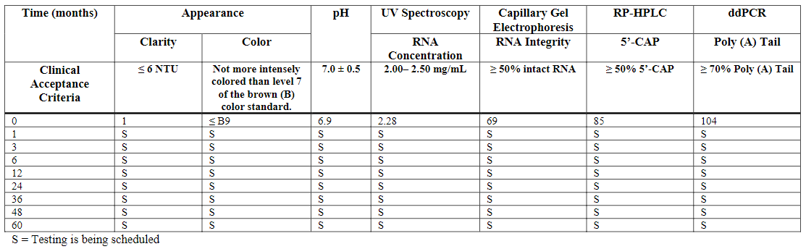
The initial CRM, stored frozen at both -20 ± 5 °C and at -60 to -90 °C, will be evaluated at 1 month, 3 months, 6 months, 12 months and then annually, at a minimum, while in use. The stability data may be used to extend the period of use of the CRM provided that acceptable product quality and stability are demonstrated.
Strategy for Commercial Reference Material
A two-tiered system for future commercial reference material will be implemented as recommended in ICH Q6B: Specifications: Test Procedures and Acceptance Criteria for Biotechnological/Biological Products. A PRM and an initial WRM will established in 2021 for the drug substance reference material. The PRM will be the standard against which WRMs are qualified and the PRM will be intended to last the lifetime of the commercial product. The initial WRM, being implemented in the future, will be used to support routine release and stability testing, and is intended to be consumed and replaced. This two-tiered system will ensure consistent commercial drug substance and commercial drug product quality throughout the product lifecycle.
Further information on the selection, preparation, qualification and stability of the PRM and WRMs will be provided in the future.

Assessor’s comments on S.5 Reference Standards or Materials:
This section describes the current reference standard and the future strategy for implementation of reference standards. It is stated that the standard will be used as a reference material and/or assay control for the release and stability testing of both DS and DP. However, the actual methods where the reference standard is and will be applied are not stated.
- It should be clarified for what release and stability testing methods the reference standard is used and will be used in future. The function of the reference standard should be briefly stated for each assay, i.e. result evaluation/normalisation, sample compliance, assay control etc. The information could be provided preferentially in a tabulated form.
The current standard is referred to as the Clinical Reference Material (CRM). It is stated that the CRM will be used for clinical supplies, process validation and initial commercial supplies. The CRM is prepared from the GMP BNT162b2 DS batch 20Y513C201. Release data is presented in the dossier. The intended storage condition is -20 ±5 °C, but an alternative storage condition of -60 to -90 °C is also evaluated. A stability protocol is provided.
- It is noted that the CRM is derived from a Process 2 DS batch that was established in September 2020. It should be explained if another reference standard was used to perform release tests on Process 1 DS batches. All initial reference materials should be listed.
- The CRM is derived from an early Process 2 batch which has a slightly lower RNA integrity than the clinical batches and possibly also to future batches, due to target value optimisation. The Applicant should comment on the suitability and potential risks of using this material as a reference standard.
- Neither the storage condition, nor the shelf-life is established for the CRM. The Applicant should explain if the reference standard is used in any of the methods included in the formal stability protocol. If this is the case, the Applicant should explain how compliance with the acceptance criteria can be guaranteed.
In future, two-tiered system for future commercial reference material will be implemented as recommended in ICH Q6B: Specifications: Test Procedures and Acceptance Criteria for Biotechnological/Biological Products. A PRM and an initial WRM will be established in 2021 for the drug substance reference material. The PRM will be the standard against which WRMs are qualified and the PRM will be intended to last the lifetime of the commercial product. The Applicant claims that further information on the selection, preparation, qualification and stability of the PRM and WRM will be provided in the future.
The use of a two-tiered system is encouraged. It is understood that the PRM and WRM is not yet established. The Applicant is reminded that the implementation of the two-tiered system should be applied for in a Type II variation application.
  - Container closure system (CTD module 3.2.S.6)
Data for this section is pending and will be updated once the data has been generated, analyzed, and verified.
EVA Containers
The drug substance is filled in ethylene vinyl acetate (EVA) containers (nominal size 12 L at Rentschler or 16.6 L at Andover) through an appropriately sized 0.2 µm filter. After filling, the inlet tubing is sealed prior to freezing and storage. The terms “flexible container” (FC) or “bag” are also interchangeably used to describe the EVA containers.
EVA containers are available in two models: controlled freeze thaw (CFT) and flexible freeze thaw (FFT). The primary part of the EVA container in contact with the drug substance is the same EVA multiple layer film used for both models. The differences in the models are in external, non-product contact structural elements only (FFT has a “bag in shell” feature).
EVA was chosen as the material of construction because it is suitable for freezing and storage of the DS. EVA containers have acceptable physical properties and thermal resistance over a wide temperature range. EVA containers also have an acceptable chemical resistance and provide a suitable contact surface for long-term storage of the DS in the frozen form. The containers are designed and qualified to appropriately protect the drug substance from the environment throughout storage.
The EVA container film contains multiple layers of different materials to provide a barrier structure: ethylene vinyl acetate copolymer acting as the external layer for handling, ethyl vinyl alcohol (EVOH) acting as the main gas barrier minimizing transmission of gases such as oxygen and carbon dioxide across the film, and ethylene vinyl acetate copolymer monomaterial (EVAM) which acts as the fluid contact layer. The mechanical properties of the EVA container film have been validated and are suitable for long term storage of drug substance at the target storage conditions.
The physicochemical properties of the EVAM contact layer have been tested in compliance with the recommendation of Ph. Eur. 3.1.7 Ethylene-Vinyl Acetate Copolymer for Containers and Tubing for Parenteral Nutrition Preparations and USP <661> Containers, Physicochemical Tests-Plastics. Biocompatibility tests have been performed by the vendor to demonstrate that all components used for manufacture are biocompatible and meet or exceed the current USP <87>, USP <88> and ISO 10993 requirements on “Biological Evaluation of Medical Devices”.
The EVA containers are for single use only and are supplied pre-sterilized and ready to use. The EVA containers are accepted on the basis of the supplier’s Certificate of Analysis (COA) or Certificate of Conformance (COC). Container integrity is confirmed visually at the point of use.
The compatibility of the DS with the containers has been evaluated through studies of DS stability in EVA containers. It is claimed that stability studies demonstrate that the DS is compatible with the container closure and remains in conformance to specifications over the proposed shelf life and storage conditions.
Extractables and Leachables
Extractables
A controlled extraction study performed on the EVA container film was used to establish a qualitative and quantitative extractable profile. The study was performed using model solvents that varied in pH and solvent strength.
Table 3.2.S.6-1. EVA Film Extraction Study Results and Calculated TDI
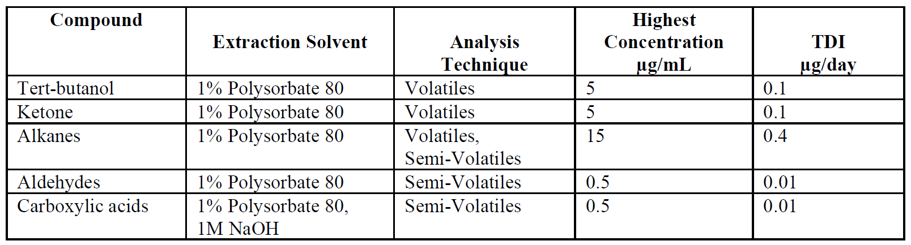
A Safety Concern Threshold (SCT) was initially defined as 1.5 µg/day Total Daily Intake (TDI) for each compound, a level at which any unidentified or identified leachable compound presents negligible safety concern to patients. Since all of the compounds were observed below the SCT of 1.5 µg/day TDI and the labeled storage for BNT162b2 is -20 °C, a temperature which has a lower risk of leachables, no potential leachable compounds have been selected to be validated into the leachable study methods.
Leachables
A leachable study is being initiated for the EVA container closure system using PPQ DS Batch 20Y513C301 out to 24 months. The leachable study will test samples at the initial time point, 6 months, 12 months, 18 months, and 24 months. Containers stored at -20 °C will be tested with screening methods for volatile compounds.
Although no leachable compounds are expected to be observed for DS stored in the EVA container closure stored at 20 °C, the methods were developed to semi-quantitate unexpected leachable compounds equal to or greater than 1.5 µg/day TDI. Any unexpected leachable compound reproducibly observed above 1.5 µg/day TDI will be confirmed and will undergo a compound-specific toxicological assessment.

Assessor’s comments on S.6 Container Closure System:
Data for this section is pending.
The drug substance is stored in 12 L or 16.6 L single-use, flexible, disposable bags of ethylene vinyl acetate (EVA). Compliance with Ph. Eur. 3.1.7 Ethylene-Vinyl Acetate Copolymer for Containers and Tubing for Parenteral Nutrition Preparations is claimed. Schematic drawings of the bags are provided in the dossier but no specification or certificate of analysis for the container or the EVAM contact layer are included.
The following additional information should be included in Module 3.2.S-6 of the dossier. (OC)
- A certificate of analysis of one representative batch of the EVAM contact layer demonstrating compliance with Ph. Eur. 3.1.7.
- A specification for the container closure system including dimensions (currently only schematic drawings are included).
The compatibility of the container for storage of drug substance is evaluated in the stability section.
A controlled extraction study has been performed on the EVA container film; all the compounds were observed below the Safety Concern Threshold of 1.5 µg/day TDI. Considering that the intended storage of the DS is -20 °C, a temperature which has a lower risk of leachables, it is reasonable that no specific leachable compounds have been selected for further studies. Nevertheless, a leachable study will be initiated to detect semi-quantitate unexpected leachable compounds equal to or greater than 1.5 µg/day TDI. This approach can be accepted.

  - Stability (CTD module 3.2.S.7)

Stability summary and conclusion (CTD section: S.7.1)
Table S. 7-1. Summary of On-going Stability Studies
Batch Number | Date of Manufacture | Batch Use | Study Type | Storage Condition | Available Data | Study Status
Process 2 bathes
20Y513C501  PPQ3  (Pfizer, Andover) | September 2020 | PPQ, Stability | Long Term | -20 ± 5 °C | Release in progress | On-going
 |  |  | Accelerated | 5 ± 3 °C | Release in progress | On-going
 |  |  | Thermal Stress | 25 ± 2 °C/ 60 ± 5% RH | Release in progress | On-going
 |  |  | Low Temperature | -90 to -60 °C | Release in progress | On-going
20Y513C401  PPQ2  (Pfizer, Andover) | August 2020 | PPQ, Stability | Long Term | -20 ± 5 °C | Release in progress | On-going
 |  |  | Accelerated | 5 ± 3 °C | Release in progress | On-going
20Y513C301  PPQ1  (Pfizer, Andover) | August 2020 | Emergency supplyª, PPQ, Stability | Long Term | -20 ± 5 °C | T=0 (Release) | On-going
 |  |  | Accelerated | 5 ± 3 °C | T=0 (Release) | On-going
20Y513C201  GMP2  (Pfizer, Andover) | August 2020 | Emergency supplyª, Stability | Long Term | -20 ± 5 °C | 2 weeks | On-going
 |  |  | Accelerated | 5 ± 3 °C | 2 weeks | On-going
 |  |  | Thermal Stress | 25 ± 2 °C/ 60 ± 5% RH | 2 weeks | On-going
 |  |  | Low Temperature | -90 to -60 °C | Release (T=0) | On-going
20Y513C101  GMP1  (Pfizer, Andover) | July 2020 | Emergency supplyª, Clinical inventory, Stability | Long Term | -20 ± 5 °C | 1 week | On-going
 |  |  | Accelerated | 5 ± 3 °C | 1 month | On-going
 |  |  | Thermal Stress | 25 ± 2 °C/ 60 ± 5% RH | 1 month | Complete
 |  |  | Low Temperature | -90 to -60 °C | 1 month | Complete
Process 1 bathes, supportive
R443-P020.2-DS  (BNT) | June 2020 | Stability, Clinical | Long Term | -20 ± 5 °C | Release (T=0) | On-going
 |  |  | Accelerated | 5 ± 3 °C | Release (T=0) | On-going
 |  |  | Thermal Stress | 25 ± 2 °C | 1 month | On-going
R438-P020.2-DS (BNT) | May 2020 | Stability, Clinical | Long Term | -20 ± 5 °C | Release (T=0) | On-going
 |  |  | Accelerated | 5 ± 3 °C | Release (T=0) | On-going
 |  |  | Thermal Stress | 25 ± 2 °C | 1 month | On-going
R427-P020.2-DS (BNT) | April 2020 | Stability, Clinical | Long Term | -20 ± 5 °C | 3 months | On-going
 |  |  | Accelerated | 5 ± 3 °C | 3 months | On-going
 |  |  | Thermal Stress | 25 ± 2 °C | 3 months | On-going
a. Emergency supply designation applies to U.S. market

The stability program is designed to follow ICH guidelines for stability of drug substance (ICH Guidelines Q1A and Q5C). To date, three drug substance batches, 20Y513C301, 20Y513C401 and 20Y513C501, manufactured using the commercial process (Process 2) have been placed on stability and stored under long term, accelerated, and thermal stress conditions. These batches have been aliquoted into small volume containers, which are representative of the commercial EVA (ethylene vinyl acetate) bags and stored under ICH conditions. The small volume containers represent a worse case with significantly higher surface area per unit solution volume compared to the large-scale commercial containers. Therefore, based on the use of the same product-contact materials of constructions (EVA) and a worse case dimensional ratio, the small volume containers are an appropriate scaled-down container closure system for use in the drug substance stability studies.
Two batches of clinical DS batches, 20Y513C101 and 20Y513C201, manufactured using the commercial process (Process 2) have been placed on stability and stored under long term, accelerated, and thermal stress conditions in small volume EVA bags. All eight drug substance batches currently on stability are considered to be predictive of the stability of the commercial materials based on comprehensive comparability assessments performed during development.
Additionally, three clinical batches of DS have been manufactured using Process 1 and placed on stability and stored under long term, accelerated, and thermal stress conditions. These supportive stability batches of DS have been stored in polypropylene tubes which are commonly used for storing aliquots of aqueous solutions as they are inert plastics and were acceptable containers for early phase, supportive stability studies.
A summary of all DS batches on stability studies and current available stability data are shown in Table S.7.1 above. These stability studies are currently on-going and data from these studies will be provided in the future and will be used to confirm the initial shelf life of the DS.
The shelf life will be extended beyond the 6 months initial shelf life using real time stability data on a minimum of 3 batches of commercially representative material. The sponsor will extend the assigned shelf life without notification providing the real time stability data at the intended storage condition is acceptable and within commercial specifications.
Additional drug substance batches representative of the commercial process may be placed on stability in the future. Protocols and data will be submitted in the future and used as additional support of the drug substance shelf life.
Long Term Storage Condition
Stability data from the batches stored at the long-term condition of -20 ± 5 °C are presented.
Up to 3 months of data are currently available at this condition for batches manufactured by BioNTech and up to 1 months of data are currently available for batches manufactured by Pfizer. All data remained within the clinical acceptance criteria in place at the time of testing and the proposed commercial acceptance criteria, where applicable.
Accelerated Condition
Stability data from the batches stored at the accelerated condition of 5 ± 3 °C are presented.
Up to 3 months of data are currently available at this condition for batches manufactured by BioNTech and up to 1 months of data are currently available for batches manufactured by Pfizer. All data remained within the clinical acceptance criteria in place at the time of testing and the proposed commercial acceptance criteria, where applicable.
Stressed Conditions
Stability data from the batches stored at the thermal stress condition of 25 ± 2 °C are presented.
Up to 1 month of data are available for one batch manufactured by Pfizer (study has completed) and up to 2 weeks of data are currently available for a second batch manufactured by Pfizer. Release testing is on-going for additional batches manufactured by Pfizer. Additionally, there is up to 3 months of data available for the three batches manufactured by BioNTech. Out of specification RNA Integrity results were generated at the 1 month timepoint for Pfizer batch 20Y513C101 and the 3 month time point for BioNTech batch R427-P020.2-DS when stored at the thermal stress condition of 25 ± 2 °C. All other data generated to date remained within the clinical acceptance criteria and the proposed commercial acceptance criteria, where applicable. It is not unexpected to generate out of specification results for stressed stability conditions and this demonstrates the stability indicating properties of the analytical methods, therefore the out of specification results do not impact the overall stability study.
A minimum of one process validation drug substance batch will be subjected to thermal cycling studies at a future date. These studies have not yet been initiated.
A minimum of one process validation drug substance batch will be subjected to the ICH photostability condition (option 2) at a future date. This study has not yet been initiated.

Post-approval stability protocol and stability commitments (CTD section: S.7.2)

Stability data (CTD section: S.7.3)
The stability data on which the summary and conclusion in S.7.1 is based, is included in the dossier.

Assessor’s comments on S.7 Stability:
The initial proposed commercial shelf life of the drug substance is 6 months when stored at the intended storage condition of -20 ± 5°C. The initial shelf life is based on the currently available data from stability studies utilizing material from three clinical DS batches manufactured using Process 1 and two clinical DS batches (up to 3 months data presented) and three process validation batches manufactured by Process 2 (up to 1 month data presented).
It is claimed that the results of the comparability studies support that stability data generated using drug substance manufactured using Process 1 can be considered predictive of the drug substance manufactured by Process 2. This conclusion is not fully agreed with as detailed above in section S.2.6.
Based on the currently very limited stability data presented for process 2 batches (only 1-month data available for one batch) no conclusion can be drawn in relation to the proposed shelf life for the DS.
In order to support the suggested shelf life for drug substance the following needs to be addressed:
- Updated reports from the ongoing stability data on the primary batches (including data from the ongoing process validation batches) should be provided.
It is stated that sponsor will extend the assigned shelf life without notification providing the real time stability data at the intended storage condition is acceptable and within commercial specifications. This kind of extensions can be accepted for clinical trials but not after marketing authorization approval.
- It should be confirmed that future extensions of the the assigned DS shelf life will be applied for in formal variation applications. The following statement should be removed for Module 3.2.7.1 of the dossier; “The sponsor will extend the assigned shelf life without notification providing the real time stability data at the intended storage condition is acceptable and within commercial specifications.”

- Drug product (CTD module 3.2.P)
  - Description and composition of the drug product (CTD module 3.2.P.1)
The BNT162b2 drug product is supplied as a preservative-free, multi-dose concentrate to be diluted for intramuscular injection, intended for 5 doses. The drug product is a sterile dispersion of RNA-containing lipid nanoparticles (LNPs) in aqueous cryoprotectant buffer.
Each vial, containing 0.45 mL of the drug product at pH 7.4 is designed to deliver a total of 5 doses after dilution by addition of 1.8 mL of sterile 0.9% sodium chloride solution, with each dose containing 30 µg of RNA in 0.3 mL. There is no manufacturing overage.
The drug product is supplied in a 2 mL glass vial sealed with a bromobutyl rubber stopper and an aluminum seal with flip-off plastic cap.
The composition of the drug product, including amounts per vial and function and quality standard applicable to each component, are given in Table P.1-1.
Table P.1-1. Composition of BNT162b2 drug product, multi-dose vial (225 µg/vial).
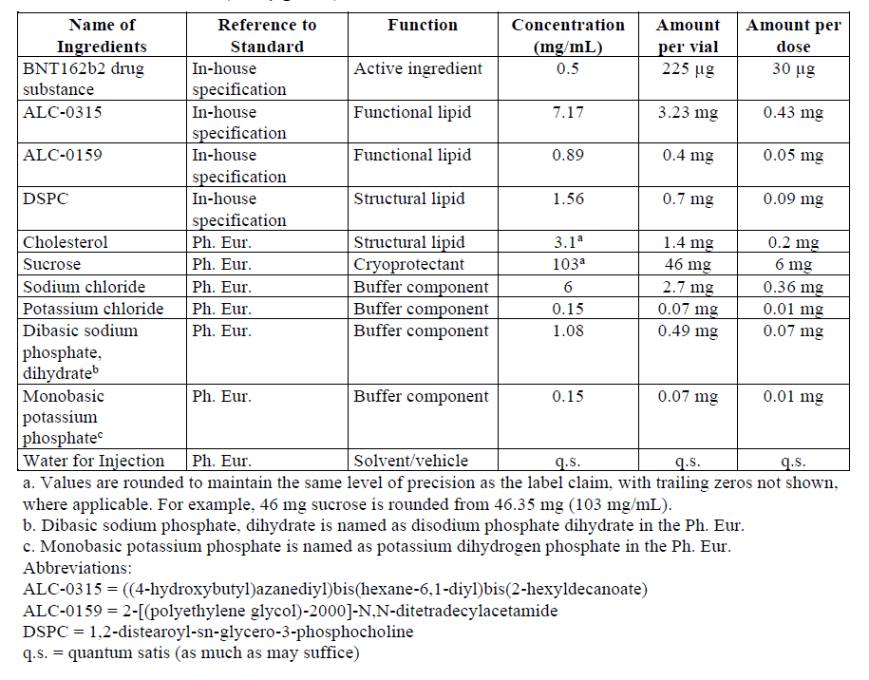

Assessor’s comments on P.1 Description and Composition of the Drug Product:
The drug product is a preservative-free, multi-dose concentrate to be diluted for intramuscular injection, intended for 5 doses. The drug product is a sterile dispersion of RNA-containing lipid nanoparticles (LNPs) in aqueous cryoprotectant buffer. No overages are applied to the formulation of the DP.
All excipients except the functional lipids ALC-0315 and ALC-0159 and the structural lipid DSPC comply to Ph. Eur. grade. The functional lipid excipients ALC-0315 and ALC-0159 are classified as novel excipients. Both structural lipids DSPC and cholesterol are used in several already approved drug products. See further comments in section P.4 Control of excipients and A.3 Novel excipients.
The vial, stopper and seal components are compliant with the appropriate Ph. Eur. monographs for primary containers and closures and are further addressed in section P.7.
All ingredients, including process aids used in the manufacture, should be specified in the composition together with a footnote that they are processing aid removed during manufacturing. Therefore, ethanol and citrate buffer should be added to the composition. Section P.1 should be updated accordingly. (OC)

  - Pharmaceutical development (CTD module 3.2.P.2)
The formulation and process development and holistic control strategy for BNT162b2 drug product are described herein. The pharmaceutical development of BNT162b2 utilizes principles described in the ICH Q8 Pharmaceutical Development and was based on sound scientific knowledge and prior experience with similar RNA-lipid nanoparticle vaccines, as well as risk assessments and development studies.
A QTPP was established to form the basis for development of BNT162b2. The development of the QTPP considered information from multiple inputs, including the World Health Organization’s Target Product Profiles for COVID-19 Vaccines. The QTPP describes the drug product in terms of quality characteristics, listing the intended product quality and performance characteristics to be achieved at the end of the drug substance and drug product manufacturing processes and linking these characteristics to the relevant CQAs. The QTPP for BNT162b2 with associated CQAs (both drug substance and drug product related) is provided in Table P.2-1. Quality attributes with associated criticality assessment are discussed in Section 3.2.P.2.3.
Table P.2-1. BNT162b2 drug product Quality Target Product Profile and Quality Attributes.
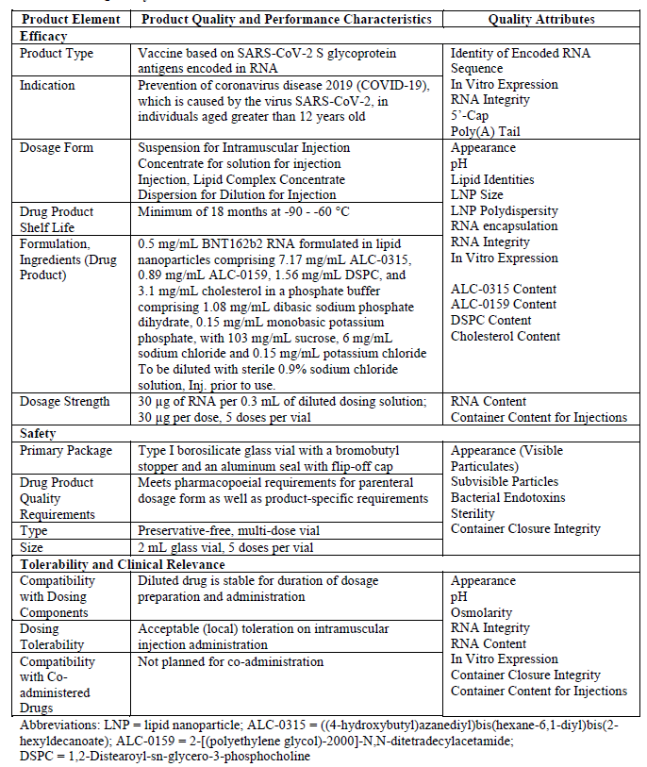
This section describes how the BNT162b2 drug product formulation, presentation, and manufacturing process were developed to ensure the drug product meets the requirements of the QTPP. CQAs are linked to the product attributes of the QTPP, bridging the QTPP to the control strategy. Because the drug substance is the source of the active component of the drug product, some of the QAs of the drug product are delivered in the drug substance process. The drug product control strategy, presented in Section 3.2.P.2.3 Control Strategy, is built on the assessment of CQAs for drug substance and drug product and considers how they are controlled in both the drug substance and drug product processes.

Components of the drug product (CTD section: P.2.1)

Drug substance (CTD section: P.2.1.1)
The RNA component of the drug substance is the only active ingredient in the BNT162b2 drug product. The drug substance is a single-stranded, 5’-capped mRNA produced by in vitro transcription and provided for drug product manufacture as a frozen (-20±5°C) aqueous solution (2.25±0.25 mg/mL) in 10 mM 4-(2-hydroxyethyl)-1-piperazineethanesulfonic acid (HEPES), 0.1 mM edetate disodium dihydrate (EDTA) at pH 7.0.

Excipients (CTD section: P.2.1.2)
The BNT162b2 drug product contains RNA LNPs formulated in phosphate-buffered saline and 300 mM (103 mg/mL) sucrose at target pH 7.4. The buffer components, concentration and rationale for use are presented in Table P.2-2.
Table P.2-2. Buffer components of BNT162b2 drug product.
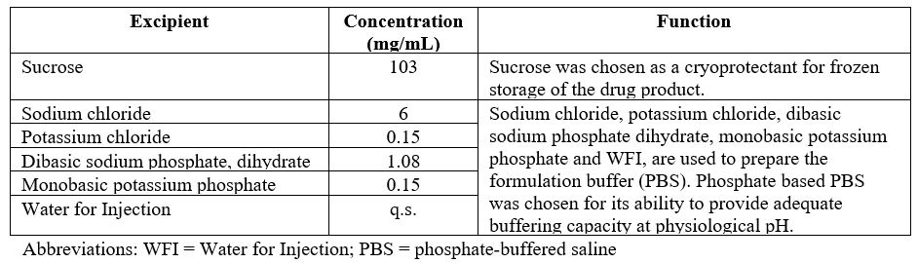
In addition, the BNT162b2 drug product contains four lipid excipients. Each has a functional or structural purpose in the assembly and/or enables stabilization of the LNP component of the drug product. The molecular weight and formula, as well as structure, physical state and storage condition, are shown in section 3.2.P.4 for each of the lipids, followed by a description of the function of each lipid in the assembly and/or stabilization of the RNA LNP.
Cationic lipid (ALC-0315)
The ionizable cationic lipid is the most important LNP component for providing successful delivery of RNA. Its properties are critical to the self-assembly process of the particle itself, the ability of the LNP to be taken up into cells, and the escape of the RNA from the endosome.
PEGylated lipid (ALC-0159)
The polyethylene glycol (PEG) lipid conjugate (PEGylated lipid) inserts itself in the outer lipid bilayer of the LNP. The PEG domain provides a steric barrier to interactions with surfaces or other LNP that may otherwise result in particle fusion during storage.
Phospholipid (DSPC)
The phospholipid component balances the non-bilayer propensity of the cationic lipid. The combination of the structural lipid DSPC and cholesterol is established for LNP as a platform and is also used in Onpattro®, a marketed product.
Sterol lipid (Cholesterol)
Cholesterol supports bilayer structures in the LNP by acting as a stabilizing intermediary in the interactions between the conventional phospholipid and the structurally novel cationic lipid and provides mobility of the lipid components within the LNP structure. Cholesterol is selected over other sterol lipids because it is considered safe as it is naturally occurring and ubiquitous.

Assessor’s comments on P.2.1 Components of the Drug Product:
The section on P.2.1 Components of the drug product is sufficiently described.

Drug product (CTD section: P.2.2)

Formulation development (CTD section: P.2.2.1)
The BNT162b2 drug product is manufactured as a preservative-free, sterile, multi-dose concentrate of RNA-containing lipid nanoparticles (LNPs) formulated in phosphate-buffered saline and 300 mM sucrose at pH 7.4 to be diluted for intramuscular (IM) administration. The drug product is filled at 0.45 mL/vial (0.5 mg/mL RNA) into 2 mL glass vials which are stoppered and capped. The vaccine drug product is diluted with 1.8 mL of sterile 0.9% sodium chloride solution to supply 5 doses per vial at 30 μg RNA/dose.
Development of a robust LNP formulation platform, that was ultimately applied to BNT162b2 drug product, was established based on formulation development studies specific to SARS-CoV-2 spike protein-encoded RNA constructs performed at Acuitas Therapeutics, along with the company’s historical knowledge of LNP formulation and process development. Studies are described and were performed with available drug substance and drug product material representing the modRNA platform and included both BNT162b1 and BNT162b2.
Table P.2-3 contains a list of the formulation development studies that were conducted during BNT162b2.
Table P.2-3. BNT162b2 formulation development studies.
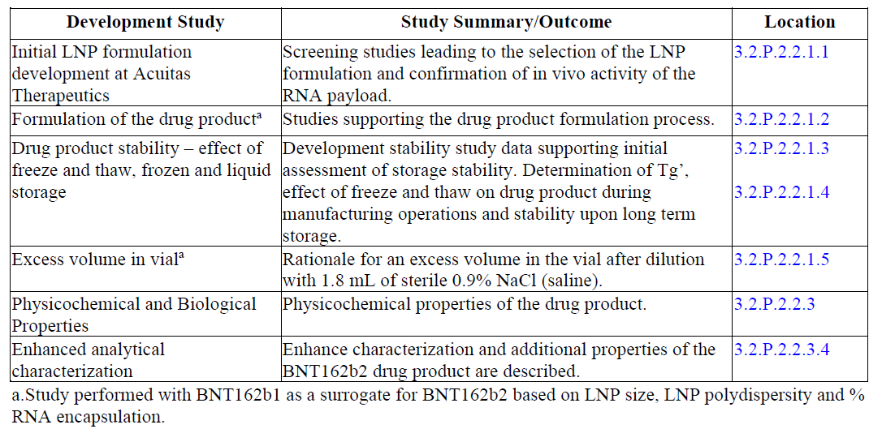
During the initial formulation development process, BNT162b2 was evaluated using assays that addressed the critical attributes required for determination of safety and potency of the drug product. The critical attributes related to LNP formation and payload delivery are primarily nanoparticle size, encapsulation efficiency, and an in vivo study to demonstrate potency of the nanoparticles, using a luciferase-encoded RNA as a surrogate. For manufacturing support, drug product was evaluated primarily for size, polydispersity, and the extent of RNA exposure (% encapsulation) of the LNPs to determine colloidal stability, a s well as RNA integrity (by capillary gel electrophoresis) and lipids content to determine the chemical stability of the components.
Lipid nanoparticle screening process
Formulation development began with screening of lipid nanoparticles. During pilot formulation, candidate cationic lipids were formulated with RNA encoding for luciferase and other component lipids in a standardized composition which comprised the cationic lipid (ALC-0315, ALC-0218, etc.), a PEGylated lipid (ALC-0159), DSPC and cholesterol. The use of RNA coding for luciferase allowed for visual assessment of expression and translation in model systems. Results of these studies led to the selection of ALC-0315.
The criteria to determine suitability for in vivo screening were the minimum encapsulation of RNA, the apparent pKa as well as LNP size and LNP polydispersity.
RNA molecules that are not fully encapsulated and protected by the LNP are considered inactive, as they are exposed to nucleases and further degradation after administration. RNA must be sufficiently intact to be successfully translated to the target protein, hence a minimum level of encapsulation efficiency needs to be achieved for a candidate RNA-LNP system. This minimum threshold is approximately 70% based on Acuitas Therapeutics general experience.
The hypothesized mechanism of delivery for RNA/LNPs involves binding of endogenous proteins to the LNP surface, which then act as ligands to facilitate receptor mediated endocytosis, followed by interaction with the interior of the endosome to trigger release of the RNA to the cytoplasm. ApoE has been identified as co-factor for LNP uptake.
Low surface charge in the blood compartment is considered critical to avoid nonspecific binding to and eventual aggregation with serum components or cellular surfaces which relates to toxicity. Conversely, a high cationic surface charge is required for the interaction with the endosomal membrane and eventual fusion and endosome escape. This dual nature of the LNP is achieved through ionizable cationic lipids, and successful compounds generally possess an apparent pKa (i.e., pKa as measured when part of an LNP as opposed to free in solution) within a target range of 5-7, preferably between 6 and 6.54. Therefore, novel cationic lipids are formulated as LNP and the apparent pKa is determined as an important selection criterion.
Historical experience with similar systems has indicated that well formed LNP are generally homogeneous with relatively narrow size distribution and a mean size that is within a preferred range, generally below 200 nm. The size range is thought to relate to the mode of action that involves the clathrin pathway.
Selection of ALC-0315 Formulation
Among the screened cationic lipids, ALC-0315 exhibited suitable physical characteristics regarding particle size, homogeneity, and RNA encapsulation efficiency. Based on this, the ALC-0315/ALC-0159/DSPC/cholesterol prototype was submitted for in vivo screening. The results demonstrate improved potency of the ALC-0315 prototype as compared to an internal benchmark (ALC-0218). ALC-0315 was identified as a highly potent cationic lipid and brought forward for further product development.
In vivo experiments after IM administration of the final ALC-0315/ALC-0159/DSPC/cholesterol LNP at molar ratio 47.5/10/40.7/1.8, confirmed expression of mRNA for this route of administration.
Formulation of the drug product
Parameters such as the buffer strength, N/P ratio (the molar ratio of the amine in the cationic lipid (N) to the phosphate in anionic phosphodiester backbone of RNA (P)) and mixing rate of organic and aqueous components have been optimized in order to enable efficient RNA encapsulation.
The ratio of cationic lipid to RNA for the ALC-0315 formulation is based on historical experience with similar lipids and nucleic acids and is specified in terms of an N/P ratio where N represents the molar ratio of the ionizable amine in ALC-0315 and P represents the phosphate in the anionic phosphodiester backbone of RNA. Efficient encapsulation requires that there is sufficient cationic lipid to interact with the entire phosphodiester backbone. Furthermore, there must also be sufficient free cationic lipid to effect endosomal release once administered which requires a molar excess of cationic lipid relative to the nucleotides. The target N/P ratio has not changed throughout development of the upscale process. A reasonable balance was found at an N/P ratio of 6.3, where neither LNP polydispersity and RNA encapsulation nor the LNP size is significantly affected.
Homogenous lipid nanoparticle formation with appropriately small sizes requires fast and efficient mixing of the aqueous and organic components. The flow rates of the organic and aqueous components are controlled independently by two separate pumps. Mixing apparatus dimensions have changed for scaleup to the commercial process (termed “Upscale” process) which necessitates a change in the target for flow rate.
Stability of the drug product
Data indicate that BNT162b2 drug product stored frozen at -70±10°C, -40±5°C and -20±5°C remained stable. At 2-8°C BNT162b2 drug product is stable for up to 6 weeks. When BNT162b2 drug product was stored at 25±2°C there was a decrease in in vitro expression and the results indicate that the drug product is stable for up to 10 days.
Frozen stability of the drug product
Differential scanning calorimetry was performed on the BNT162b2 frozen drug product, which exhibits two glass transition events characteristics of saccharide-containing formulations with onset temperatures at -51.8°C ±0.8°C and -38.8°C ± 0.1°C. The higher temperature event, Tg’, is identified as the glass transition of the maximally freeze-concentrated solution. Molecular mobility decreases below the glass transition which prevents instability over time. Based on an understanding of the glassy state dynamics and available stability data for the BNT162b1 and the BNT162b2 drug product instability at temperatures below -60°C is not expected.
Excess volume in vial
The target fill volume for 225 μg/vial is 0.45 mL. Since the drug product is intended for multiple doses, the vial contents are diluted with 1.8 mL sterile 0.9% sodium chloride for injection (normal saline) for a total dosing solution volume of 2.25 mL. In addition to the volume necessary to supply 5 doses (0.3 mL each for a total of 1.5 mL) here is an excess volume of 0.75 mL ensuring that five doses can be removed from the vial and delivered.

Overages (CTD section: P.2.2.2)
No overage has been added to BNT162b2 drug product.

Physicochemical and biological properties (CTD section: P.2.2.3)
In alignment with ICH Q8, the physicochemical and biological properties of BNT162b2 drug product relevant to the safety, performance and manufacturability of the drug product have been identified and appropriately characterized or controlled.
Density
The density of the BNT162b2 drug product has been measured as 1.04 g/mL at 20°C.
Viscosity
The viscosity of the drug product is 1.42 cP measured at 20°C, 0.5 mg/mL.
Thermal transitions
Differential scanning calorimetry was performed on the BNT162b2 frozen drug product, which exhibits two glass transition events characteristics of saccharide-containing formulations with onset temperatures at -51.8°C ± 0.8°C and -38.8 °C ± 0.1°C. The higher temperature event, Tg’, is identified as the glass transition of the maximally freeze-concentrated solution.
Enhanced analytical characterisation
Size distribution and particle shape
BNT162b2 drug product samples were analysed by AF4-MALS-QELS (Asymmetric Flow Field-Flow Fractionation (AF4) Multi-Angle Static and Quasi-Elastic Light Scattering) to characterize both particle size distribution and shape. BNT162b2 drug product LNP exhibits a narrow hydrodynamic radius (Rh) distribution predominantly between 30 and 41 nm. The overall ratio between root mean square radius and hydrodynamic radius (Rz/Rh) describes the shape of the particle. For BNT162b2, the average Rz/Rh ratio is 0.71, which is very close to the value of 0.77 for a solid spherical particle. The distribution of Rz/Rh ratio across the main peak also suggests that LNP with different sizes are still in similar spherical shape. The AF4-MALS-QELS results indicate that BNT162b2 drug product has a relatively homogeneous size distribution and is largely spherical.
Surface charge
BNT162b2 drug product was subjected to electrophoretic light scattering analysis to determine the zeta potential, which is defined as the electrostatic potential between the particle surface and the bulk solvent. The zeta potential distribution for BNT162b drug product is narrow and monomodal. The average apparent zeta potential is around -3.13 mV, indicating the surface of the LNP is slightly negatively charged. The nearly neutral LNP surface supports the mechanism that BNT162b2 drug product avoids non-specific binding events in the blood compartment.
Surface PEG
An ultra-high field (800 MHz) NMR spectrometer was used to characterize the surface characteristics of the LNP. NMR readily detected the protons associated with the PEG moiety of ALC-0159 at the surface of LNP due to the flexibility of PEG chains. The NMR peak assignments and intensity data confirms that PEG moiety from the functional ALC- 0159 lipid is present at LNP surface in the BNT162b2 drug product samples.

Assessor’s comments on P.2.2 Drug Product:
The section on formulation development describes and justifies the chosen formulation and is sufficiently comprehensive.
The DP is a preservative-free, sterile, multi-dose concentrate of mRNA-containing lipid nanoparticles (LNP) formulated in phosphate-buffered saline and 300 mM sucrose at pH 7.4 to be diluted for intramuscular administration.
The formulation development studies of the RNA containing lipid nanoparticles have been thoroughly described. The development of a robust LNP formulation platform was performed at Acuitas Therapeutics. Studies are comprehensively described and were performed with available drug substance, representative of the mRNA platform and included in the drug product.
The LNPs consists of four lipids, each has a functional or structural purpose. The ionizable cationic lipid ALC-0315 interact electrostatically with negatively charged nucleic acids and encapsulate the mRNA. The PEGylated lipid ALC-0159 is preferably inserted at the LNP surface as a steric barrier to interactions with surfaces or other LNPs to avoid aggregation during storage. The phospholipid DSPC and cholesterol are structural lipids providing a stable bilayer and enabling mobility of the lipid components in the LNP structure.
The formed RNA-containing LNPs are solid particles relatively homogeneous in size, largely spherical in shape and has a nearly neutral surface. Furthermore, the accumulated batch-data to date show a consistent manufacturing of lipid nanoparticles both with respect to size and polydispersity.
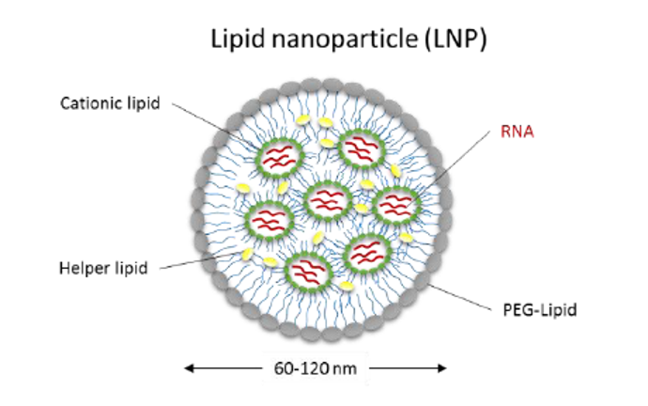
Critical quality attributes related to LNP formation and payload delivery are primarily LNP size, encapsulation efficiency, and in vivo potency (RNA integrity). Additionally, surface area is considered critical to avoid aggregation both during storage and with serum components in vivo. The ratio cationic lipid to RNA (N/P) is also critical for formation of LNP. An access of cationic lipid is required and a ratio of about 6 is found reasonable.
The DP is stored frozen at the recommended storage temperature of -90 to -60°C. Stability studies are ongoing for the determination of DP shelf-life, see section P.8.
The same DP formulation composition has been used throughout the nonclinical and clinical studies and will also be used for the manufacturing of the pending full scale commercial PPQ-batches.
There are no formula overages in the drug product, only an overfill which has been acceptably justified ensuring that five doses can be removed from the multi-dose vial and delivered.
The information given on physicochemical and biological properties is sufficient.
The section on P.2.2 Drug product is found acceptable.

Manufacturing process development (CTD section: P.2.3)

Development history (CTD section: P.2.3.1)
Data for this section is pending and will be updated once the data has been generated, analysed, and verified.
The BNT162b2 drug product is a preservative-free, sterile, multi-dose concentrate of RNA-containing lipid nanoparticles (LNPs) formulated in phosphate-buffered saline (PBS) and 300 mM sucrose at pH 7.4 to be diluted for intramuscular administration. The drug product has been developed to meet the quality target product profile as described in Section 3.2.P.2 Introduction. The LNP and drug product formulations and processes have remained the same throughout development, except for necessary changes to the scale as development has progressed from initial clinical supplies to commercial manufacture. Based on evaluation of the results of initial clinical trials, which included multiple RNA constructs, the RNA BNT162b2 construct has been chosen for commercial supply. Development history for the RNA drug substance is discussed in Section 3.2.S.2.6 Development History and Comparability Assessment.
The initial LNP and drug product formulation processes were developed at Acuitas Therapeutics, and scale-up and manufacture were performed at Polymun Scientific for clinical trial material and emergency supply (emergency use in the United States). The process has been transferred to Pfizer commercial facilities in Kalamazoo, MI, USA, and Puurs, Belgium, for manufacture of later clinical materials (Puurs), emergency supply and commercial supply. Commercial supply production facilities may vary on a market-by-market basis (see Section 3.2.P.3.1 Manufacturer(s) for registered facilities applicable to this dossier), however the processes are highly aligned and therefore a global view is presented within the development sections of the registration dossier. Changes to accommodate scale-up and facility fitting have been made; for example, the aqueous and organic phase concentrations and flow rates for LNP fabrication were changed from a “classical” process to an “upscale” process to enable higher process throughput, combined with “scale out” flexibility of parallel processing using multiple T-mixers. The scale of the tangential flow filtration (TFF) equipment was similarly adapted for larger batch volumes and higher process throughput. For manufacture of clinical and emergency supply, RNA drug substance was subjected to freeze in ethylene vinyl acetate (EVA) bags in temperature-controlled freezers for storage at -20°C at BioNTech IMFS with subsequent thaw at controlled room temperature at Polymun. For additional emergency supply and commercial manufacture, the freezing process to -20°C for drug substance in EVA bags may utilize programmed controlled freeze equipment or temperature-controlled freezers at the commercial drug substance manufacturing site, followed by thaw using programmed controlled thaw equipment or controlled room temperature thaw at drug product manufacturing sites. The development of the BNT162b2 LNP and drug product manufacturing process heavily leveraged prior knowledge from the RNA-delivery platform development at Acuitas Therapeutics and fill/finish of other sterile (aseptically manufactured) and biologic drug products at Pfizer.
The changes to the manufacturing process have been driven by operational efficiency, and, during facility transfer, driven by fit-to-facility equipment, leading to the proposed commercial process. An overall summary of major process changes made for the LNP fabrication and formulation and filling processes during development is provided in Table P.2-4. The indicated process changes are not expected to impact the overall product quality of the resulting drug product lots.
Table P.2-4. BNT162b2 drug product development history.
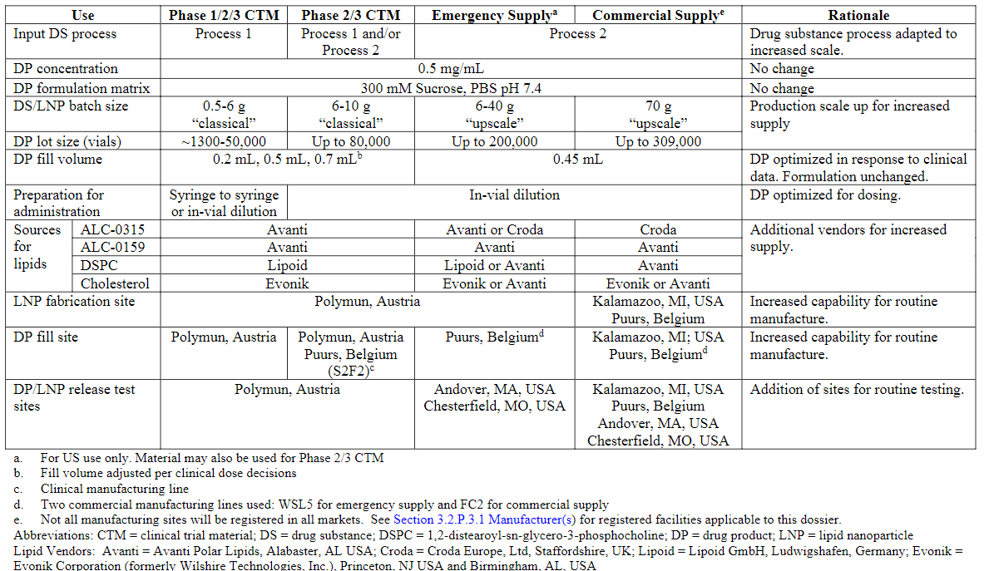
Demonstration of comparability
A comprehensive plan for demonstration of comparability among clinical supplies and commercial product including an assessment of the process designs and comprehensive characterization of the resulting product quality is planned.
Data for this section is pending and will be updated once the data has been generated, analysed, and verified.
For routine global commercial supply production, the LNP fabrication process has been fully transferred to multiple commercial production facilities, including both Pfizer, Kalamazoo, MI (USA) and Pfizer, Puurs, Belgium with fill/finish at the same sites. As a global view, two lines are being validated at Kalamazoo (Line 8 and Line 18) and one line is currently being validated at Puurs (FC2), though additional lines are planned for future validation and may be registered in the future in some markets.
An assessment of minor process adjustments made for fit-to-facility and equipment is summarized in Table P.2-5.
Table P.2-5. Comparison of drug product manufacturing processes (multiple markets).
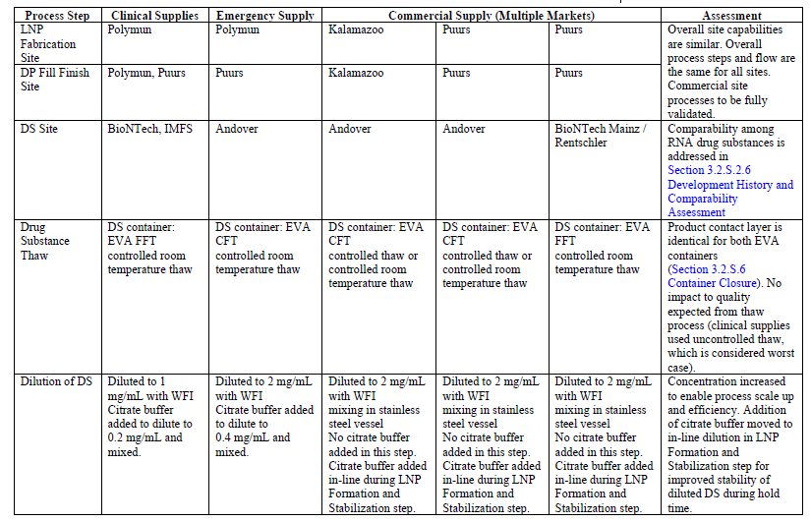
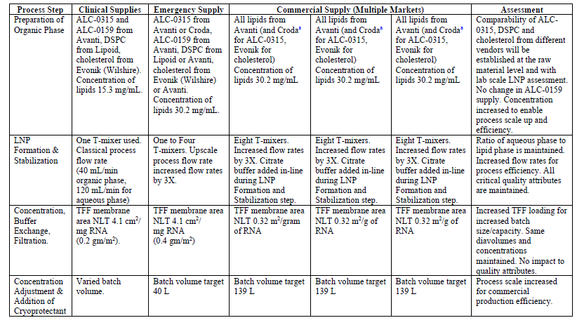
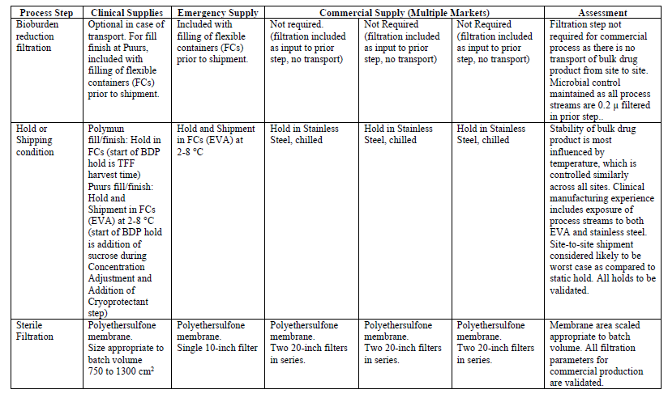
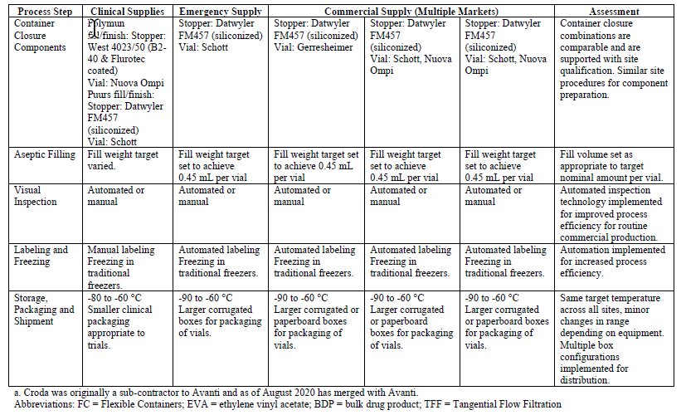
The assessment of product quality comparability will take a step-wise approach. As a first step, comparability is demonstrated between clinical and emergency supply drug product lots through a combination of release and heightened characterization testing. Subsequently, comparability will be established among representative lots of commercial drug product produced from each of the commercial manufacturing sites through completion of PPQ and a continued process verification program.
The drug product comparability assessment includes drug product lots used in Phase 1, Phase 2, and Phase 3 clinical studies, as well as a drug product lot manufactured for emergency supply in the US market (Table P.2-6). The panel of tests, both release and heightened characterization, are shown in Table P.2-7.
Table P.2-6. BNT162b2 clinical and emergency supply drug product lots.
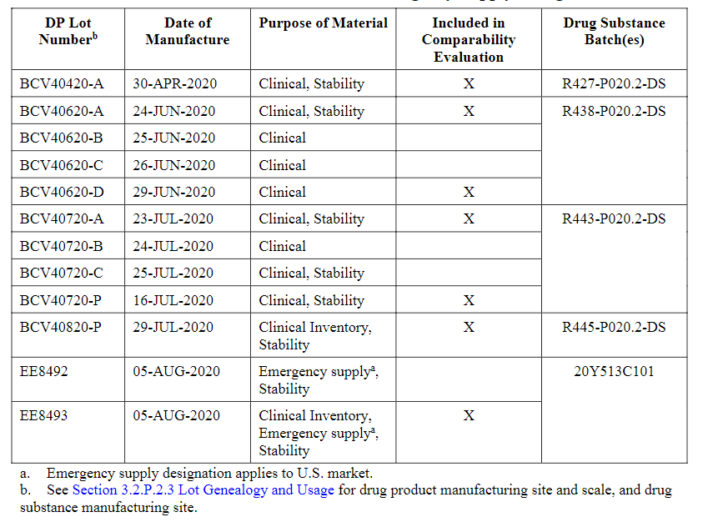
Table P.2-7. BNT162b2 drug product comparability testing panel.
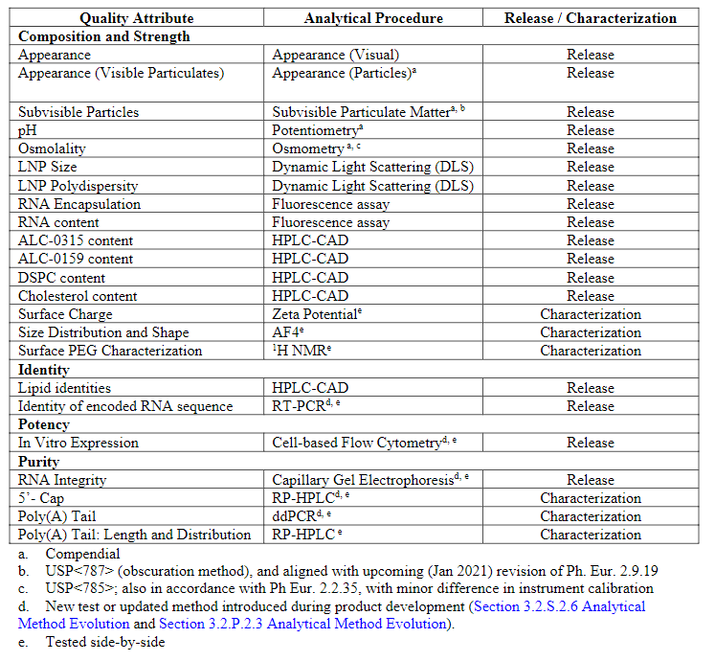
Comparability results are tabulated in Table P.2-8.
Table P.2-8. Comparability data for BNT162b2 drug product.
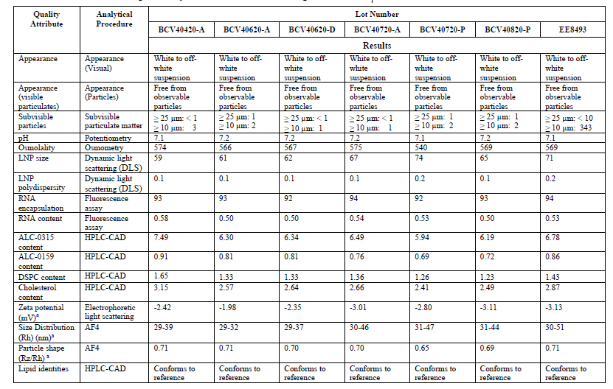
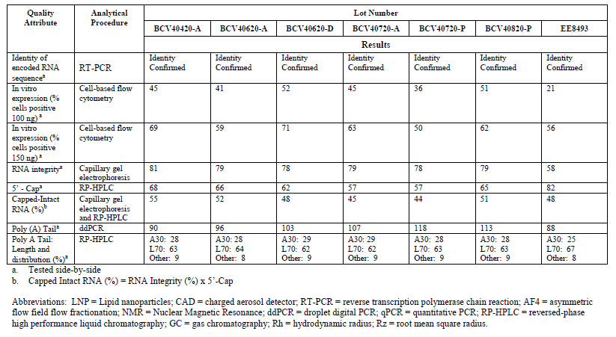
All quality attributes met the specification acceptance criteria at the time of testing and are consistent across clinical and emergency supply lots. Subvisible particles ≥ 10 µm were higher in lot EE8493 but remain well below compendial limits. In vitro expression from 100 ng drug product load was slightly decreased in drug product lot EE8493; however, when 150 ng drug product load was assessed, the in vitro expression was within the range observed in clinical lots (50-71%). Slightly lower RNA integrity was observed in lot EE8493; however, the side-by-side testing result for this lot is consistent with the RNA integrity of the starting DS batch 20Y513C101. A slightly higher relative abundance of 5’-capped RNA in lot EE8493 (82%) was revealed; again, consistent with the starting DS batch level, as measured in the side-by-side DS comparability assessment.
These small differences the clinical and emergency supply lots are not expected to impact efficacy.
All drug product lots demonstrated comparable surface charge with nearly neutral zeta potential. Size distribution by AF4 provides direct measurement of polydispersity, and all lots showed a similar hydrodynamic radius range. AF4 also provides shape information, and the Rz/Rh ratio is consistent for all tested drug product lots. ¹H-NMR of drug product LNP provides information on surface PEG, and the spectra are comparable for all batches.
A comprehensive demonstration of comparability among clinical supplies and commercial product including an assessment of the starting drug substance batches, raw materials (e.g. ALC-0315, DSPC and cholesterol) from different vendors, process designs, and comprehensive characterization of the resulting product quality is planned.

Assessor’s comments on P.2.3.1 Development History:
The development history of the drug product is sufficiently described.
The DP analytical comparability evaluation employed release testing and extended characterization methods. It is agreed that comparability has been reasonable demonstrated between the clinical supply lots manufactured with the “classical” LNP process and the representative emergency supply lot manufactured with the “upscale” LNP process with only small differences noted. However, it should be noted that no comparisons were made in the DP comparability evaluation with respect to IPC´s and accelerated/stressed stability testing.
It is stated in the dossier that the applicant has a plan for a comprehensive demonstration of comparability among clinical supplies and the commercial product including an assessment of the starting drug substance batches, raw materials (e.g. ALC-0315, DSPC and cholesterol) from different vendors, process designs and comprehensive characterization of the resulting product quality. Data for this section is pending and will be updated once the data has been generated, analysed, and verified. Four commercial PPQ-batches will be manufactured in November and December 2020. The results for the comparability of the commercial PPQ-batches versus the clinical supply batches of DP is pending and will be provided for assessment during the procedure.
In summary, no final conclusion on comparability can be drawn until all comparability data among clinical supplies and the commercial product (PPQ-batches) will be provided for assessment.

Quality attributes (CTD section: P.2.3.2)
Quality attributes (QAs) of the BNT162b2 drug product were identified and assessed for criticality.
Critical quality attributes (CQAs) were identified by means of a quality risk and criticality assessment, along with experimentation that determined the extent to which variation in the CQAs had an impact on the quality of the vaccine. Table P.2-9 summarizes the attributes designated as CQAs as well as the rationale for the criticality assignment.
Table P.2-9. Critical quality attributes (CQAs) and rationale for BNT162b2 drug product.
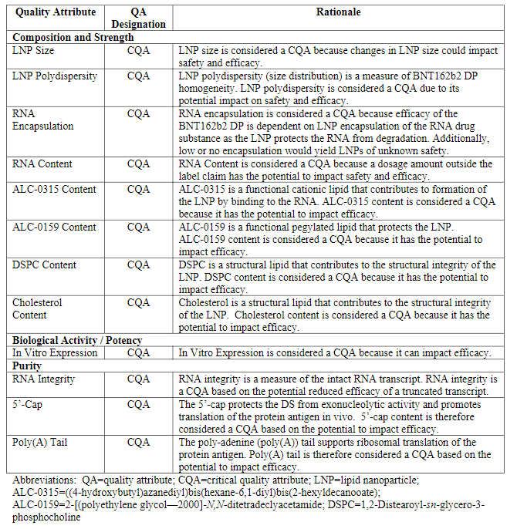

Process risk assessment strategy (CTD section: P.2.3.3)
Consistent with the expectations for drug development and in alignment with ICH Q8 and ICH Q9 a variety of risk assessment tools have been utilized in an iterative process to direct process development and characterization.
The initial risk assessment was performed based upon prior knowledge including process and platform understanding, manufacturing experience, and relevant public domain information. Characterization studies were identified for process parameters with high cause and effects (C&E) scores. For remaining low scoring C&E parameters, normal operating ranges (NORs) were established without formal studies based on evaluation of relevant process history and/or equipment capability to ensure consistency in manufacture. Among the parameters with high C&E scores, critical process parameters (CPPs) for the process were conservatively defined based on process characterization work to date, scientific rationale and current process understanding. For the PPQ (process validation) campaigns, all CPPs will be included to confirm consistent process performance.
Following the completion of characterization studies and PPQ, parameter criticality and associated range and settings will be reassessed.
The next phase of risk assessment includes use of a failure modes and effects analysis (FMEA) as an iterative risk assessment tool for the evaluation of process parameters. FMEA tables will be generated for all parameters. The FMEA exercise ensures adequate attention will be given to high risk process parameters with respect to process control. The FMEA will be used to evaluate independent process parameters for each step with respect to their level of control (occurrence and detection) and their potential to impact drug product quality and yield (severity). Potential risk will be quantitated via scoring for severity, occurrence and detection to give an overall risk priority number (RPN) as the output of the FMEA assessment. As part of the FMEA assessment, the high-risk process parameters will be ranked in relation to RPN scoring and risk mitigation identified. Where operational or procedural controls are deemed insufficient or further process understanding required, further characterization studies will be performed as needed.
The control strategy for BNT162b2 drug product consists of multiple elements including input material controls, in-process testing, procedural controls in batch records, release testing and process monitoring etc. A multi-level control strategy ensures consistent manufacture of acceptable product.

Process development and characterization (CTD section: P.2.3.4)
Data for this section is pending and will be updated once the data has been generated, analysed, and verified.
The initial process including LNP fabrication and drug product formulation, designated as the Research process, was developed at Acuitas Therapeutics, Vancouver, BC, Canada. A stage-appropriate scaled process was then developed in two phases at Acuitas Therapeutics, based on the same mixing apparatus configuration and using the same principles as the Research scale process. During the first phase of the scale up process development (referred to as the Classical process), the changes involved introduction of pumps more suitable to higher flow rates and the implementation of conventional tangential flow filtration for the buffer exchange in order to manage the larger intermediate volumes at larger scales. The second phase of the scale up process (referred to as the Upscale process) focused on increasing the mass throughput of the RNA and lipids though the mixing device, in order to increase the batch size by six-fold in comparison to the Classical process. Suitability of the scaled manufacturing process was demonstrated with representative formulations in other programs. Transfer of the scaled manufacturing process for RNA/LNPs with the ALC-0315 formulation has been performed for manufacturing of animal and clinical trial material (using the Classical process) and emergency supply of the vaccine (using the Upscale process) at Polymun Scientific Immunbiologische Forschung GmbH. The commercial supply of the vaccine is achieved through a scale out approach in manufacturing of the LNPs. Scale out process is defined as the use of more than one T-mixer for LNP formation (i.e. 2-8 T-mixers) depending on the batch size, which was implemented at Polymun and at Pfizer Puurs and Kalamazoo.
The ongoing process development and characterization studies represent a combined experience derived both from laboratory scale studies using scale-down models and scaled-up manufacturing experience. A global approach to development is being undertaken across multiple manufacturing facilities in order to maximize vaccine production and availability with a highly aligned drug product manufacturing process.
Hold times
The range for some hold times during commercial manufacture will be limited by available media fill simulated process validation (see Section 3.2.P.3.5) a holistic approach was taken to establish ranges for hold times based on the physicochemical stability of BNT162b2 and important process materials, e.g. lipids during the LNP fabrication process. Hold times are confirmed during PPQ manufacturing.
Stability of lipids solubilized in ethanol
A study was performed to evaluate the stability of lipids ALC-0135, ALC-0159, DSPC and cholesterol in absolute ethanol during solubilization at 35°C and to support a process hold time at ambient temperature. Data indicates essentially no degradation of the lipids under these conditions. The lipids are stable when dissolved in 100% ethanol and stored at 25°C for up to 4 days.
Lipid nanoparticle in-process holds
A development study was performed to determine appropriate LNP hold times at room temperature or 2-8°C for the commercial manufacturing process. The LNP downstream process steps were interrupted by hold times. The control was the same LNPs processed without the hold times.
Samples were analysed for size and polydispersity by dynamic light scattering, RNA content and encapsulation efficiency by fluorescence assay, RNA integrity by capillary gel electrophoresis (CGE) and in-vitro expression (IVE) by flow cytometry. Results of suggests no difference between the control and final hold time study samples.
Acceptable hold times for LNPs during the manufacturing process are shown in Table P.2-10.
Table P.2-10. Acceptable hold times during LNP manufacture.
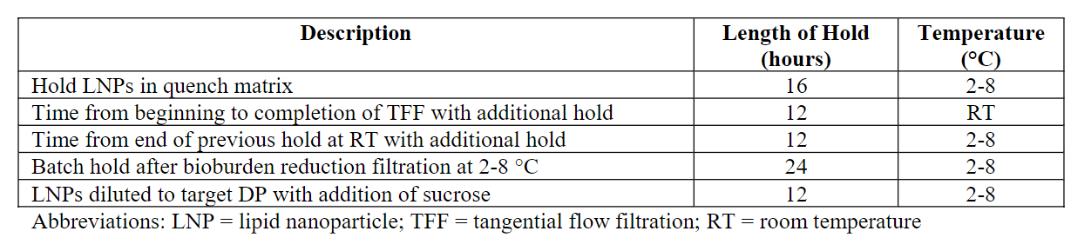
Laboratory scale product contact materials compatibility and light exposure studies
Product contact materials studies are not planned in the development laboratory as contact materials for commercial manufacture (filtration membranes/housings/tubing/tanks) are comparable to those used for clinical manufacture and have therefore been demonstrated to be appropriate through manufacturing experience.
A light exposure study was performed. The study included process steps from receipt of drug substance through final freeze of the drug product vials. The results demonstrate that the maximum manufacturing times in ambient light determined for the Kalamazoo and Puurs commercial sites are acceptable with respect to UV and visible light exposure as there was no effect on the drug substance and the drug product quality attributes attributable to light exposure under the conditions tested.
Drug product hold times for packing, shipping and point of use
The purpose of this hold time study was to evaluate the impact of cumulative temperature cycling based on potential time out of condition covering manufacturing, transportation and period of use requirements. The results indicated no change to the critical quality attributes of the drug product and therefore support the conditions outside of long-term storage (-90 to -60°C) for 14 days at 2-8°C, 3 days at 25°C and up to 4 freeze/thaw cycles.
Formal stability studies
While development studies only consider physicochemical quality attributes, the formal stability studies are designed to follow ICH guidelines.
Drug substance thaw
The frozen drug substance provided in EVA bags is thawed at 25°C or controlled room temperature. Most manufacture of clinical supplies utilized a freezer for freezing and controlled room temperature for thawing of drug substance. The controlled freeze/thaw equipment enables better heat transfer enabling faster rates and improved efficiency. For drug substance produced in Pfizer Andover, a controlled freeze process is used. Pfizer Puurs and Pfizer Kalamazoo both have extensive experience using controlled thaw equipment to thaw drug substances for other products.
Data derived demonstrate that BNT162b1 drug substance is robust to a wide range of freezing and thawing process conditions.
Manufacturing experience for clinical supply to date has included freezing of drug substance in a freezer and thawing in a controlled temperature room (controlled room temperature thaw). For process efficiency, controlled freeze and thaw equipment is introduced for commercial manufacturing. Multiple cycles of freeze and thaw are supported. Thawing parameters are not critical, and controlled thaw and controlled room temperature thaw can be used interchangeably as equipment permits.
Dilution and mixing of drug substance
Mixing was not identified as high risk during the process risk assessment and, during process validation manufacturing, mixing speed will be evaluated from a homogeneity and product quality perspective.
The data obtained during process qualification and process performance qualification are expected to confirm that the mixing parameters used in the manufacturing process are appropriate to achieve homogeneity and that BNT162b2 is robust to the mixing shear stress experienced during the manufacturing process.
Preparation of the organic phase
The weights of the lipids and the ethanol for dissolution vary depending on batch size. In addition to the weight of each component, each of which is considered critical for consistent formation of the lipid nanoparticles, proper mixing of the organic phase at target 30-35°C is important based on clinical manufacturing experience and will be monitored during process qualification and validation.
Lipid nanoparticle formation and stabilization
The general process is based on rapid mixing of the aqueous nucleic acid solution and the organic lipid solution in such a way that a sudden change in the solubility of the lipid components is triggered. This abrupt change drives the lipids towards self-assembly in the form of LNPs. The properties of the cationic lipid were chosen such that nascent formation of particles occurs by association with the oppositely charged backbone of the nucleic acid. In this way, the particles are formed around the nucleic acid, which results in much higher encapsulation efficiency than is achieved in the absence of interactions between nucleic acids and at least one of the lipid components.
The lipid concentration is controlled in terms of the mole ratio of cationic lipid (N) to RNA nucleotide groups (P) in the RNA. The ratio of cationic lipid to RNA for the ALC-0315 formulation is based on experience with similar lipids and is characterized by an N/P ratio. Efficient encapsulation requires that there is sufficient cationic lipid to interact with the entire phosphodiester RNA backbone. In addition, there must be sufficient free cationic lipid to effect endosomal release upon administration. While a molar excess of cationic lipid is required, it must be balanced with the potential for toxicity of a given dose of mRNA. An N/P ratio of 6.3 has been found to be a reasonable balance. The other lipid components are calculated according to the target molar lipid proportions relative to the cationic lipid.
The rapid mixing is achieved by pumping the two solutions independently at flow rates that mirror the 3:1 volume ratio through a simple mixing assembly. Post mixing the suspension is diluted in-line in a ratio of 2:1 LNP suspension to citrate buffer (pH 4.0) for stabilization and collected for further processing.
Development of LNP manufacturing “Classical process” and “Upscale process” has been performed to receive higher flow rates and increase the mass throughput. Equipment and materials have been scaled up appropriately at the manufacturing sites to meet the projected batch sizes.
Data shows that the physicochemical properties and the N/P ratios of the LNPs produced in the Upscale process are comparable to those from the Classical process and clinical trial materials.
Evaluation of quality attributes of the drug product, including biological activity, indicated that there was no difference in drug product produced from the Classical process and the Upscale process.
Buffer exchange and concentration
The upscale process was developed to enable larger scale manufacturing for emergency supply and commercial supply. Equipment and materials have been scaled up appropriately at the manufacturing sites to meet the projected batch sizes.
Based on lab scale studies and clinical manufacturing studies performed through Classical process development and Upscale process development, the parameters for the commercial process were determined.
Concentration adjustment and addition of cryoprotectant
The weights of the sucrose and the PBS are considered critical at this early stage of development though mixing parameters at this stage of the process are not considered critical. Based on evaluation of available information and experience the process parameter are determined.
Comparison between clinical trial material (CTM) and emergency/commercial manufacturing process
The comparison between the CTM and emergency/commercial processes are shown in Table P.2-11.
Table P.2-11. Comparison between the process for CTM and emergency/commercial supply.
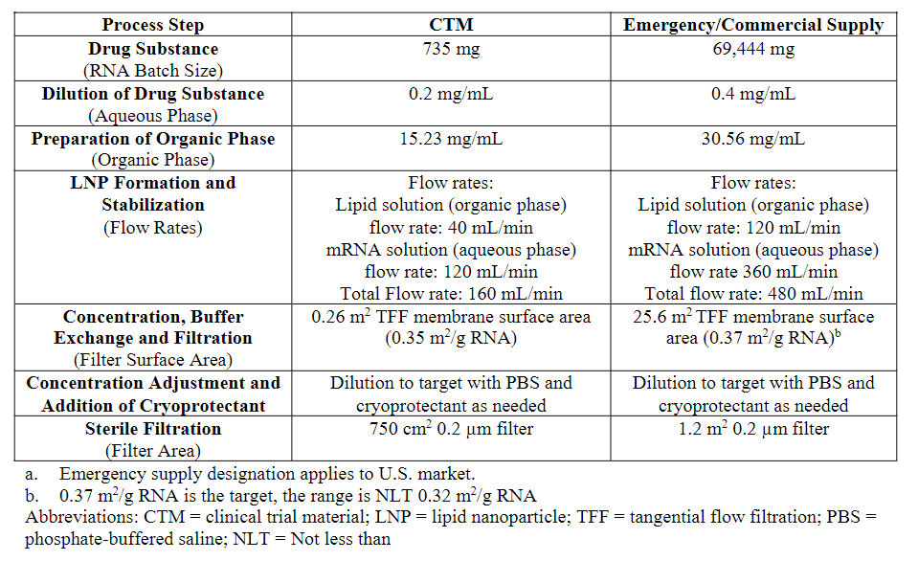
Sterile filtration
PES filter membrane (0.2 μm) is a commonly used sterilizing grade filter for sterile drug product manufacture in the pharmaceutical and biotechnology industry. No significant adsorption of LNPs is expected based on manufacturing experience during clinical development.
Filter sizing
A laboratory scale study was conducted to determine filter capacity. PES filters for the redundant sterile filtration proposed for commercial manufacturing are appropriately sized based on flow rate and filter capacity, as both filters have a larger surface area than the minimum predicted by the lab-scale study.
Filtration shear stress
The shear rate experienced by BNT162b2 bulk drug product inside filter membrane pores was evaluated. Under actual manufacturing conditions the target filtration pressure is 15 psi. These results show that BNT162b2 bulk drug product is not sensitive to filtration shear stress under targeted manufacturing process conditions.
Filter adsorption
BNT162b2 drug product was adsorbed to the filter material for the first 4 fractions and then recovered to starting concentration. For a 139 L batch size, the loss is projected to be 0.6%. This is not considered a significant loss.
Filter flush for leachables removal
A dynamic filter flush study was performed by Pall Corporation to determine the amount of water needed to flush the PES filter to reduce total organic carbon (TOC) levels. Flush volumes for the filter have been set based on this study.
Re-filtration process
Re-filtration of bulk drug product may be necessary for reasons including, but not limited to, issues related to filter integrity and the integrity of the holding vessel post-sterile filtration. Results indicate that quality of the drug product is not adversely affected by 5 filtrations.
Filter validation
Sterile filtration membrane validation studies were executed by Pall and are detailed in Section 3.2.P.3.5.

Aseptic filling
Vials are filled to the target fill weight using piston pumps or rotary piston pumps, and a fill weight check is performed at defined time intervals.
Stoppering, sealing and capping vials
An initial study was performed to determine the correlation of the residual seal force (RSF) and container closure integrity (CCI) at -80°C as a function of a vial-stopper combination and stopper compression.
Visual inspection
100% visual inspection is performed for commercial drug product manufacture. Commercial sites will use automated visual inspection with the ability for manual inspection if needed.
Freezing of drug product
Freezing rates and hold temperatures affect the structural characteristics of the frozen matrix.
Based on an understanding of the glassy state dynamics and available stability data instability at temperatures below -60°C is not expected.
A systematic study explored the impact of a range of cooling/freezing rates on the quality of BNT162b2 drug product including a very slow programmed rate of 0.02°C/min and a very fast uncontrolled rate from -5°C to -60°C with immersion in liquid nitrogen (37.26°C/min). No significant impact or any distinct trends were observed over the broad range of cooling rates that the product could potentially experience during commercial manufacturing. From these data, a cooling rate of 0.02 to 37.26°C/min is acceptable provided the cooling rate is achievable by the equipment.
This demonstrates that the freezing rate is a non-critical parameter. Commercial freezing equipment is incapable of achieving rates faster than 7°C/min. To ensure thermal homogeneity during freezing, cooling rates ≤ 5°C/min are recommended.
Drug product robustness to freezing and warming during storage
During the freezing and frozen storage operations the drug product will likely be exposed to room temperature several times. A study was performed using freezing and warming cycling to determine the effect of potential temperature excursions on the stability of the drug product.
There was no effect on the size and polydispersity of the LNPs, the encapsulation efficiency (%) and the total mRNA content of the drug product after thermal cycling using any of the three test processes which indicates that even under the worst-case conditions tested the drug product stability was maintained.

Assessor’s comments on P.2.3.4 Process Development and Characterization:
The development of the manufacturing process is extensively described, and critical process parameters are defined.
The lipid nanoparticle (LNP) formation is one critical manufacturing step. The process development is described and physicochemical properties (e.g. LNP size, polydispersity, RNA encapsulation, lipid to RNA ratio (N/P) as well as LNP topology by X-ray scattering) has been evaluated during upscale. The provided results are comparable. The tested parameters are considered relevant, covering the critical attributes size, shape, encapsulation and lipid to RNA molar ration.
The product is sterile filtrated and aseptic processed. According to “Guideline on the sterilisation of the medicinal product, active substance, excipient and primary container” terminal sterilisation should be used whenever possible since it provides the highest assurance of sterility. However, due to the nature of this drug product, terminal sterilisation is most likely not applicable, and the selected sterilisation method is considered acceptable without any further justification from the applicant.

Lot genealogy and usage (CTD section: P.2.3.5)
Data for this section will be updated once additional data has been generated, analysed, and verified.
The BNT162b2 and BNT162b1 drug product lots manufactured for nonclinical studies, clinical studies, stability, and development/demonstration purposes are listed in Table P.2-12.
Table P.2-12. Drug product lot genealogy and usage.
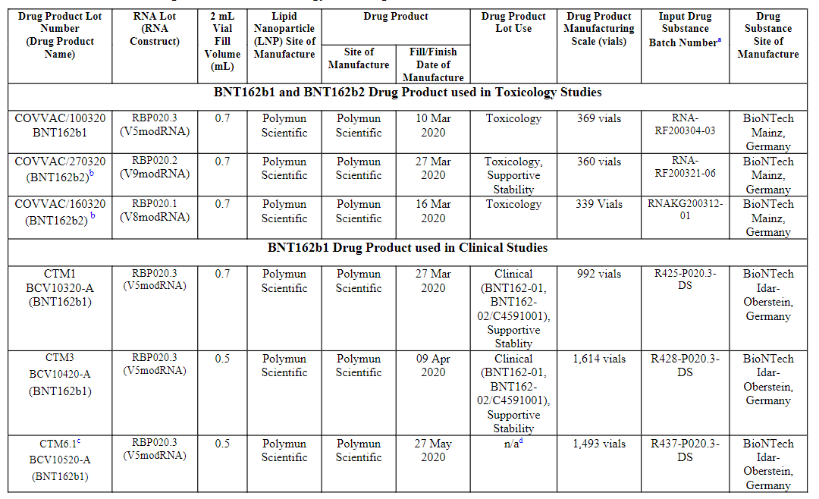
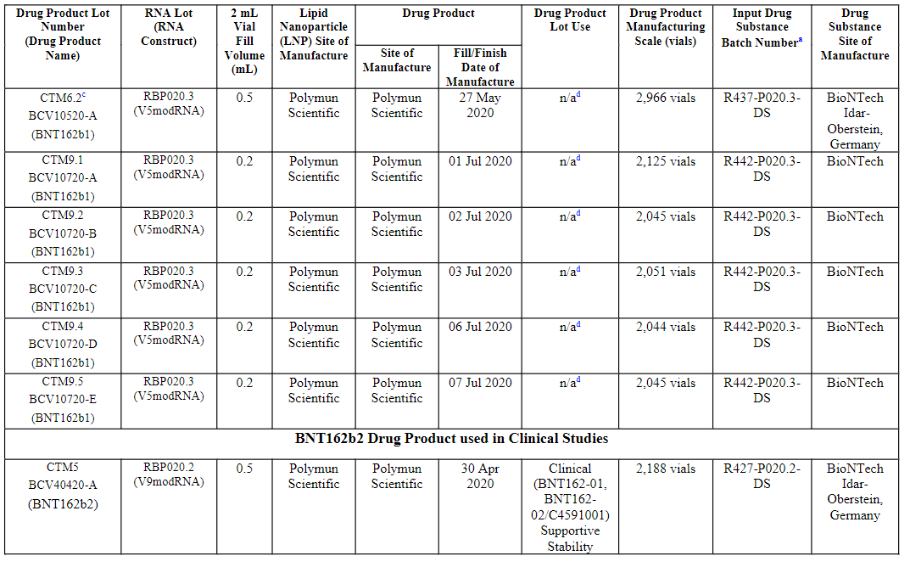
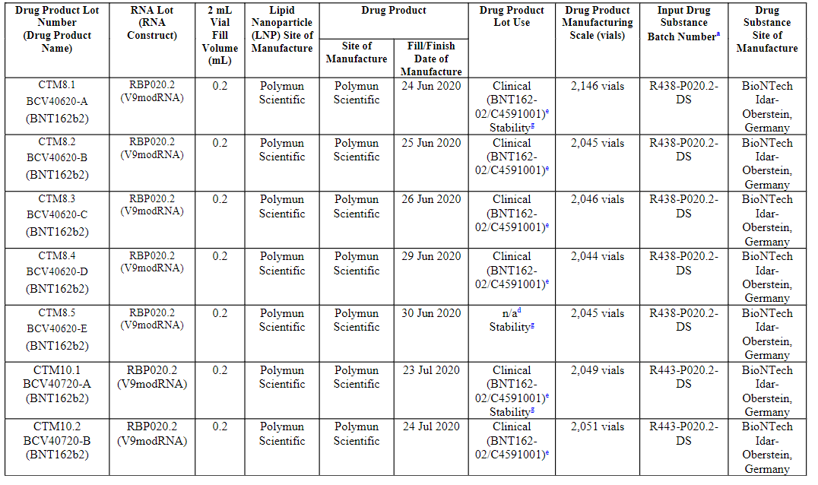
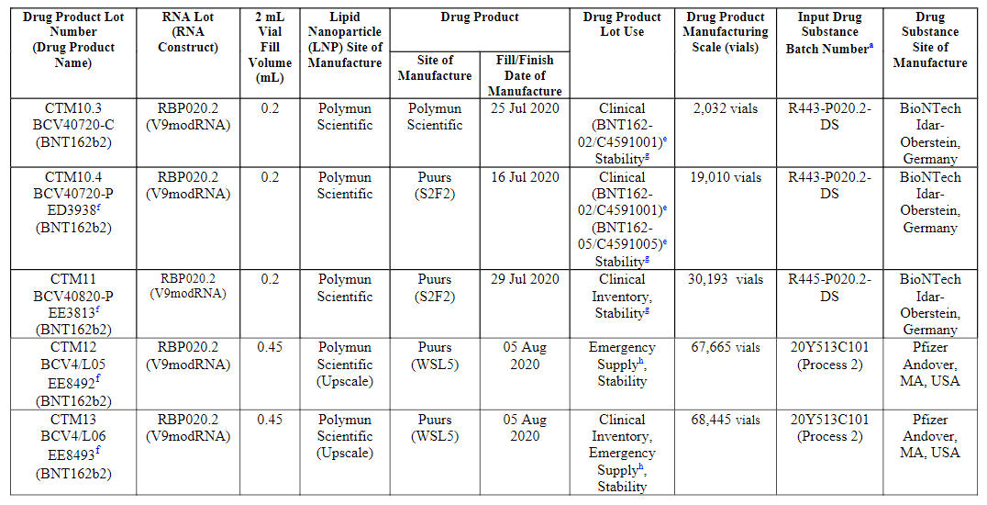
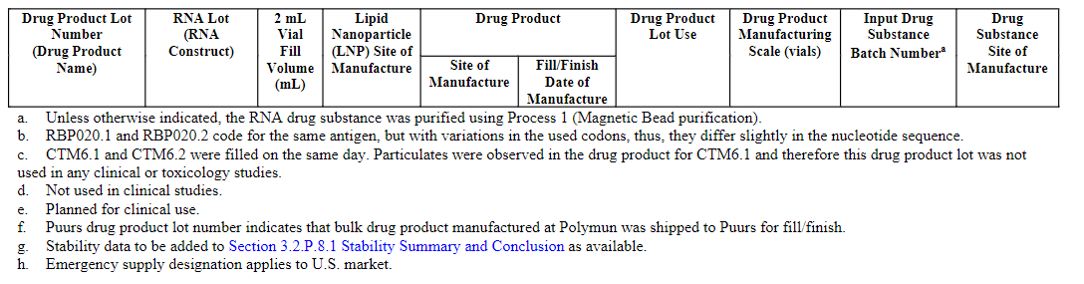

Assessor’s comments on P.2.3.5 Lot Genealogy and Usage:
A batch history and usage for DP has been provided from early nonclinical studies to clinical studies and stability testing. In addition, information regarding the RNA construct and DS batch number is included. It should be noted that the same DP formulation composition has been used throughout the nonclinical and clinical studies and will also be used for the manufacturing of the pending PPQ-batches.

Control strategy (CTD section: P.2.3.6)
Data for this section is pending and will be updated once the data has been generated, analysed, and verified.
Capturing the elements of control, application of the risk assessment and refinement of the control strategy are iterative processes. The control strategy for the BNT162b2 drug product was developed using a holistic approach considering and assessing several elements of control. The control strategy for the drug product is linked to drug substance. Prior to finalization of the control strategy, both drug substance and drug product elements were considered in totality to assure final drug product quality through shelf-life is met.
Element 1 – Direct in-process monitoring or control of product Quality Attributes
In the first defined element of control, direct in-process monitoring and/or control that is applied throughout the drug product was identified. This monitoring and control relate to the attributes that are specifically tested in the course of processing. This element of control is described by the in-process testing applied in the process.
Element 2 – Monitoring or control of process parameters or material attributes functionally linked to product Quality Attributes
In the second defined element of control, monitoring and/or control of process parameters functionally linked to quality attributes are identified. Sources of information to populate this element include BNT162b2 process characterization studies and related risk assessments. Monitoring and controls of process parameters and material attributes in each unit operation are identified, and functional relationships between those process parameters or material attributes and corresponding quality attributes are documented. Process parameters discussed in this element include all critical process parameters (CPP) identified to date. Upon the completion of the characterization studies, this section will be updated with not only the updated list of CPPs, but also relevant non-CPPs that also have an impact of quality attributes.
Element 3 – Direct in-process monitoring or control of process performance attributes
The third defined element of control is similar to the first defined element; however, in this instance direct monitoring and control of process performance attributes (e.g. yield) are documented. While this element is not explicitly discussed herein as the discussion is focused upon quality attributes, this element is documented to assure appropriate monitoring and controls are in place to assure consistency of process performance.
Element 4 – Monitoring or control of process parameters or material attributes functionally linked to process performance attributes
The fourth defined element of control is similar to the second defined element. However, in this instance, monitoring or control of process parameters and material attributes that are functionally linked to process performance attributes are documented. While this element is not explicitly discussed herein as the discussion is focused upon quality attributes, this element is documented and updated to assure that any modifications in the control strategy do not have a deleterious impact on process performance.
Element 5 – Drug product testing specifications
The fifth defined element of control encompasses the drug product release testing and specifications.

Element 6 – Drug product stability monitoring
The sixth defined element of control encompasses the attributes selected to be monitored on stability and the associated acceptance criteria. Stability monitoring will continue to be managed in line with the stability protocols as part of the stability commitment.
Element 7 – Control of raw materials
The seventh defined element of control encompasses control of raw materials linked to quality attributes and/or process performance attributes. In addition, any raw material controls that are linked to process performance and/or product quality attributes are documented.
Element 8 – Facility and equipment control (cGMP and procedural)
cGMPs mitigate some of the specific risks associated with the manufacture and delivery of particular attributes associated with the BNT162b2vaccine. Development of any product-specific control strategy is predicated on the existence of prerequisite programs, including cGMPs and pharmaceutical quality systems for the manufacturing facilities.
Microbiological quality throughout the manufacturing process is maintained through a combination of cGMP controls including facility and environmental, equipment, personnel, policy and procedure controls. These controls are not specific to the BNT162b2 vaccine process and therefore are not further elaborated in the control strategy. Routine in-process testing for bioburden and endotoxin confirm the effectiveness of these general cGMP controls in maintaining microbiological quality.

Assessor’s comments on P.2.3.6 Control Strategy:
The control strategy is in general considered sufficiently described. Data for this section is pending and will be updated once it is generated, analysed, and verified.

Analytical method evolution (CTD section: P.2.3.7)
The analytical testing strategy applied to BNT162b2 drug product has evolved throughout the development history as drug product testing sites have changed.
Bridging experiments from supportive studies, were conducted for the analytical methods that were changed or replaced.
Subvisible particles were initially tested using Ph. Eur. 2.9.19 microscopic method. Pfizer testing will be performed using the USP <787> light obscuration method. The light obscuration method is higher throughput, which is desirable due to the number of batches to be tested. The USP<787> light obscuration method was assessed by Pfizer using a representative drug product sample. Due to the product being a lipid nanoparticle and the turbidity observed in the drug product, running the sample undiluted with light obscuration would saturate the detector. Therefore, there was a need to use a dilution paired with light obscuration for measuring subvisible particles. The light obscuration method under USP<787>, using an appropriate dilution, was found to be suitable.
Capillary gel electrophoresis (CGE) and RT-PCR have been evaluated as identity tests for BNT162b2 drug product. The CGE method compares the migration time of the RNA to the migration time of a reference RNA. In the RT-PCR method the primers and probes are highly specific for the intended BNT162b2 RNA sequence. The generated amplification in the RT-PCR method is specific to BNT162b2 RNA and therefore a better measure of BNT162b2 identity.
Capillary gel electrophoresis technology was used throughout the lifecycle of BNT162b2 drug product for RNA integrity. Initially a different instrument was used. A bridging study was carried out showing comparable data.

Assessor’s comments on P.2.3.7 Analytical Method Evolution:
The analytical testing strategy of drug product has changed throughout the development and these changes have been described. Bridging studies have been performed for analytical tests that have been changed or replaced (subvisible particles, identity of encoded RNA sequence and RNA integrity). This is found acceptable.

Container closure system (CTD section: P.2.4)
Data for this section is pending and will be updated once the data has been generated, analysed, and verified.
The container closure systems for the commercial BNT162b2 drug product are described in Section 3.2.P.7 Container Closure System.
The selection of the primary packaging materials for use with BNT162b2 drug product was made based on results of various physicochemical, biological and functional tests of the primary packaging components, as well as the targeted delivery volumes, available components currently qualified for use on the filling line at the manufacturing site for commercial production, sufficient supply capabilities at the component manufacturers and a history of acceptable component performance for parenteral applications. The data provided demonstrate the suitability of the primary packaging components.
The glass vial meets USP <660>, Ph. Eur. 3.2.1, and JP 7.01 compendial requirements for chemical testing for Type I glass containers. The elastomeric stoppers meet USP <381>, Ph. Eur. 3.2.9 and JP 7.03 compendial chemical testing requirements for elastomeric closures. Stopper testing has been performed and results demonstrating compliance is shown in 3.2.P.2.4 Container Closure System.
Controlled extraction studies were performed on the product contact bromobutyl rubber stopper material to establish a comprehensive qualitative and quantitative extractable profile. The studies were performed using model solvents that varied in pH and solvent strength.
Leachable studies are being set up to support the labeled shelf-life of the BNT162b2 drug product in its commercial container closure system out to 24 months.

Assessor’s comments on P.2.4 Container Closure System:
The development of the container closure system is sufficiently presented. The primary packaging is composed of glass vial and rubber stopper and are compliant with the compendial requirements of Ph. Eur. and are further addressed in section P.7.
Controlled extraction studies have been performed on the bromobutyl rubber stopper. Leachables studies are planned to be set up to support the proposed DP shelf-life of 24 months, the T0 will be provided later on during the procedure. The applicant should commit to provide the updated results from the leachables study for assessment. (OC)
As noted in Table P.2-5, the stopper has changed from the clinical supply “classical process” with flurotec coating to silicone coated stoppers for the “upscale process”, i.e. for the emergency supply and commercial supply. A justification should provided to bridge these two stoppers that there are no difference in the physicochemical and biological properties of the DP due to the difference in type of rubber stoppers used. (OC)

Microbiological attributes (CTD section: P.2.5)
The BNT162b2 drug product is supplied as a preservative-free, multi-dose concentrate to be diluted for intramuscular injection. The process of manufacturing encompasses the microbial reduction in the process flows by using pre-sterilized raw materials and supplies, HEPA-filtered, classified production areas, and personnel gowning controls. During manufacturing, the formulated bulk is 0.2 µm sterile filtered prior to being aseptically filled into vials. The sterilizing filter is tested for integrity as part of the manufacturing process.
The storage conditions of the final product do not support microbial growth, as the products are stored frozen at -90°C to -60°C. The container closure system and its components were selected based on their ability to protect the quality of the product over its shelf life and have been qualified for use.
The BNT162b2 drug product sterility testing is performed in accordance with USP <71>, Ph. Eur. 2.6.1 and JP 4.06. Alternatively, a rapid sterility test may be utilized. BNT162b2 drug product is tested for bacterial endotoxins during release according to USP <85>, Ph. Eur. 2.6.14 and JP 4.01; refer to Section 3.2.P.5.2 Endotoxin.
The BNT162b2 container closure system has been evaluated by both a dye ingress and headspace analysis testing method. These studies have produced acceptable data and verified that the stopper/vial/cap combination maintains integrity when capped with low, high and nominal capper settings. Results shown in section 3.2.P.2.5 Microbiological Attributes [Puurs] provide evidence of container closure integrity for the BNT162b2 drug product container closure system.

Assessor’s comments on P.2.5 Microbiological Attributes:
The information provided on microbiological attributes is found sufficient.

Compatibility (CTD section: P.2.6)
BNT162b2 is supplied as a frozen, sterile, preservative-free multi-dose concentrate for intramuscular injection, and after thawing is a white to off-white suspension free from observable particles which must be diluted prior to administration. The suspension is filled as 0.45 mL per vial containing 0.5 mg/mL BNT162b2. After dilution by the addition of 1.8 mL of sterile 0.9% sodium chloride solution (normal saline) into the drug product vial, the liquid suspension is opalescent, white to off-white and free from observable particles. After dilution, the vial contains 2.25 mL of dosing solution containing 0.1 mg/mL BNT162b2. At least five 0.3 mL doses each containing 30 µg of RNA are withdrawable from the prepared vial.
The studies described in this section have been performed to assess physicochemical stability of the drug product after dilution with saline using common preparation components, as well as to assess for growth potential of microorganisms.
Thawed hold time studies are ongoing as part of the formal stability program to demonstrate that thawed suspensions (undiluted) of BNT162b2 are physicochemically stable at the point of use.
Studies were performed to evaluate the physicochemical stability and compatibility of BNT162b2 diluted with normal saline in the original glass drug product vial and with commercially available administration components that are commonly used during preparation and storage of the dosing solution and/or during injection. The components evaluated were manufactured with different materials of construction provided by different vendors. The conditions evaluated (i.e., hold time, temperature, ambient light exposure) represent typical and/or worst-case conditions during dosage and administration anticipated in the clinical setting.

Assessor’s comments on P.2.6 Compatibility:
The drug product is a frozen, preservative-free, multi-dose concentrate to be diluted for intramuscular injection, intended for 5 doses. After thawing, the solution/suspension must be diluted with sterile 0.9% sodium chloride solution. The studies described have been performed to assess physicochemical stability of the DP after dilution with 0.9% sodium chloride solution in the original glass vial as well with commonly used commercially available administration components and using worst-case conditions for dosage and administration in the clinical setting. The thawed hold time (in-use period) of undiluted DP are ongoing as part of the stability program in section P.8.
Results presented support physicochemical stability of DP diluted in 0.9% sodium chloride solution for up to 24 hours at ambient or refrigerated temperatures and compatibility with dosing components (syringes and needles) for up to 6 hours. Furthermore, a microbiological in-use hold time study was performed by a challenge test including five compendial micro-organisms. No significant growth (>0.5log10 from the start-point) was observed for any of the microorganisms within 12 hours of inoculation with storage at 20-25°C of diluted DP in 0.9% sodium chloride solution. Therefore, based on the results from the microbiological in-use hold time study, it is agreed to the proposed in-use period for up to 6 hours at ambient temperatures. Furthermore, it is also stated by the applicant that the in-use period is in alignment with the WHO policy on the use of opened multi-dose vaccine vials (WHO Policy Statement: Multi-dose vial policy (MDVP) – handling of multi-dose vaccine vials after opening, rev 2014). This is acknowledged.
Compatibility of drug product is acceptably demonstrated by the dilution and administration simulation studies performed.

  - Manufacture (CTD module 3.2.P.3)

Manufacturer(s) (CTD section: P.3.1)
Table P.3-1 lists the sites that have responsibilities in the production of BNT162b2 drug product and their specified functions.
Table P.3-1. Sites and responsibilities for BNT162b2 drug product manufacture.
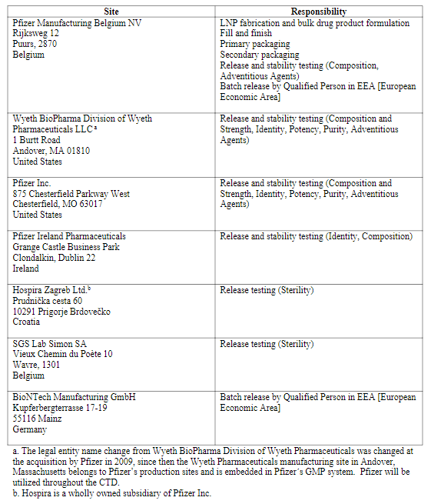

Batch formula (CTD section: P.3.2)
The target drug product batch size is 139 L (approximately 309 000 vials).

Description of manufacturing process and process controls (CTD section: P.3.3)
An overview of the manufacturing process is presented in Figure P.3-2. The manufacturing process includes lipid nanoparticle (LNP) fabrication and bulk drug product formulation (steps 1-6) followed by fill and finish (steps 7-11).
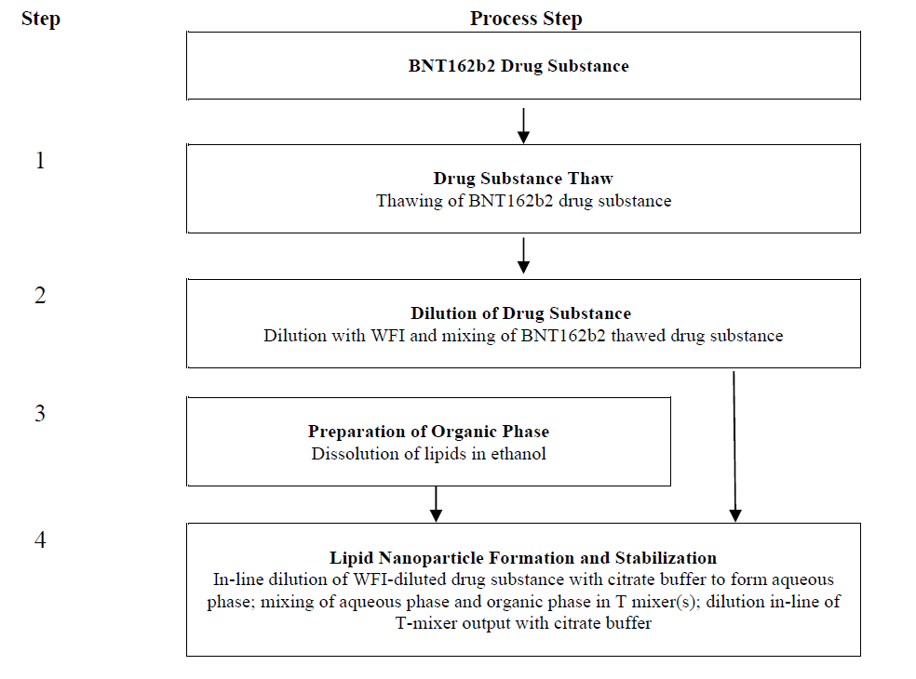
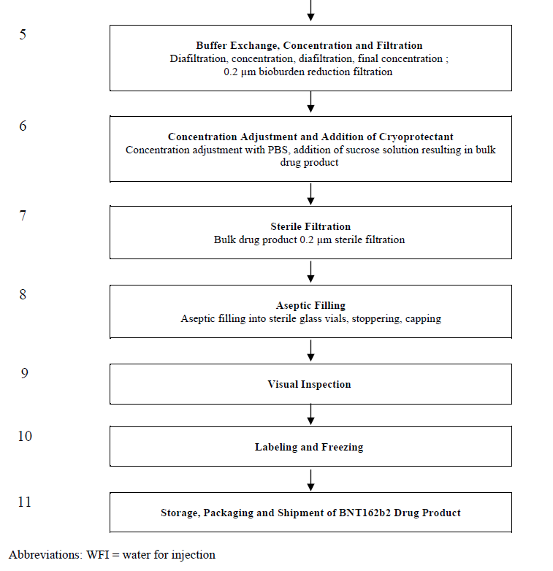
Figure P.3-2. Overview flow diagram of the BNT162b2 drug product manufacturing process.
LNP fabrication and bulk drug product formulation process description
The process flow diagram for the BNT162b2 LNP fabrication and bulk drug product formulation manufacturing process is presented in Figure P.3-3.
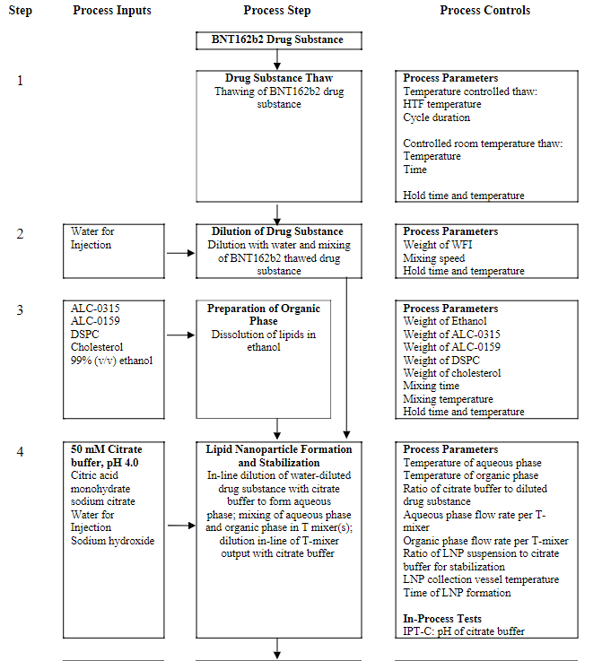
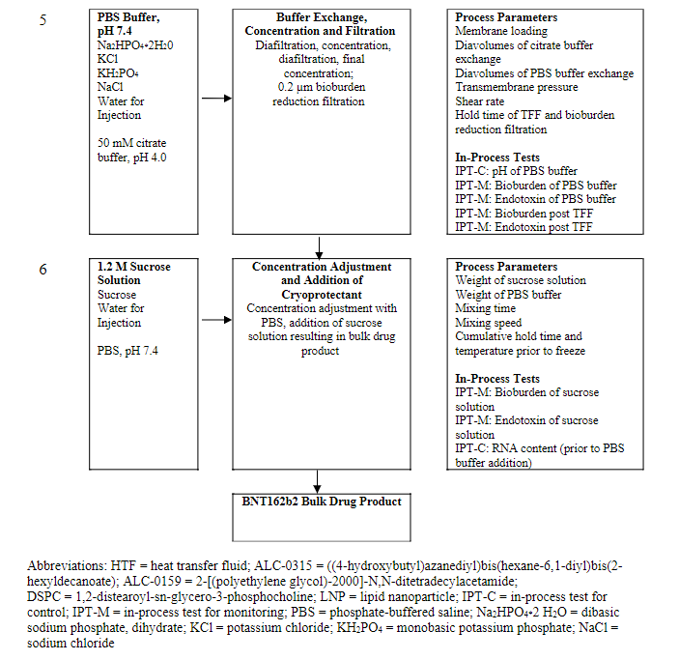
Figure P.3-3. Flow diagram of LNP fabrication and bulk drug product formulation manufacturing process and process controls.
Drug substance thaw (step 1)
Frozen drug substance in EVA bags may be thawed using controlled thaw equipment which consists of an automated freeze/thaw unit, agitation platform, and a validated thaw recipe. The EVA bags are placed between heat-transfer plates of the freeze/thaw unit. Once thawing is complete, the program ramps the heat transfer fluid (HTF) supply temperature down to a setpoint of 5°C, at which time the thawed drug substance hold time begins. The controlled thaw equipment remains at a 5°C setpoint until the EVA bags are removed.
Frozen drug substance EVA bags may also be thawed at controlled room temperature between 15-25°C. The bags are placed in a controlled temperature room and allowed to thaw with periodic monitoring.
The process parameters for drug substance thaw are summarized in Table P.3-4.
Table P.3-4. Process parameters for drug substance thaw.
Process parameter | Acceptable range
Heat transfer fluid (HTF) temperatureª | 25° (target set-point)
Cycle durationª | 4-6 hours
Temperature^{b} | 20±5 °C
Time^{b} | Maximum 48 hours^{c}
ªFor controlled drug substance thaw.
^{b}For controlled room temperature drug substance thaw.
^{c}Thaw duration will be confirmed based on the results of process qualification studies.
Dilution of drug substance (step 2)
Thawed drug substance is transferred from EVA bags to a manufacturing vessel. One or more drug substance containers and from one or more drug substance batches may be pooled to achieve the target drug product batch size.
Based on RNA content and weight of drug substance added to the vessel, the water for injection amount required for dilution to a target concentration of 2.0 mg/mL is calculated. The drug substance is diluted and then mixed until homogenous.
The process parameters for dilution of drug substance are summarized in Table P.3-5.
Table P.3-5. Process parameters for dilution of drug substance.
Process parameter | Controlled set-point
Weight of water for injection (WFI) | Calculated to achieve RNA content of 2.0±0.2 mg/mL
Mixing speed | 10-400 rpm
ªMixing speed is based on qualification range of equipment and process target will be confirmed based on the results of process qualification studies.
Preparation of buffers, organic phase and sucrose solution (step 3, 4, 5, 6)
Preparation of 50 mM citrate buffer. The pH of the buffer is measured and adjusted to pH 4.0 with sodium hydroxide, as necessary. Citrate buffer may be prepared as two separate buffers with one for use in the LNP formation step and the second for use in the buffer exchange and concentration steps. The citrate buffer is mixed until homogeneous and measured for pH and filtered with a 0.2 μm filter prior to use.
Preparation of phosphate-buffered saline (PBS) buffer, pH 7.4 used for the buffer exchange and concentration step, to flush filters, and for concentration adjustment of the bulk drug product. The PBS buffer is mixed until homogeneous and measured for pH. The PBS is filtered with a 0.2 μm filter prior to use.
The organic phase is prepared by first thawing the lipids from -20°C to 20±5°C. Ethanol is added to the organic phase vessel and heated to improve dissolution of the lipids. The lipids are added to the organic phase vessel while mixing followed by a final q.s. with ethanol. The solution is mixed until lipids are fully dissolved at 30-35°C and then cooled to 20±5°C for storage until use. An excess solution is prepared. The organic phase is filtered through a 0.2 μm filter in-line during transfer to the T-mixer during LNP formation.
Preparation of 1.2 M sucrose solution. The solution is mixed until homogeneous and is filtered with a 0.2 μm filter prior to use.
The in-process test for control (IPT-C) for preparation of citrate buffer and PBS buffer and process parameters for the organic phase are summarized in Table P.3-6.
Table P.3-6. In-process test for control (IPT-C) / process parameters for buffers, organic phase and sucrose solution.
In-process test / Process parameter | Acceptance criteria / Acceptable range
pH (citrate buffer) | 4.0±0.1
pH (PBS buffer) | 7.4±0.1
Weight of ALC-0315 | 21.0 g per 1 kg (unit formula)
Weight of ALC-0159 | 2.60 g per 1 kg (unit formula)
Weight of DSPC | 4.56 g per 1 kg (unit formula)
Weight of cholesterol | 9.08 g per 1 kg (unit formula)
Weight of ethanol | 962.8 g per 1 kg (unit formula)
Mixing time | Minimum of 30 minª
Mixing temperature | 30-35°Cª
ªMixing time and temperature will be confirmed based on the results of process qualification studies.

Lipid nanoparticle formation and stabilization (step 4)
To form the LNPs, the citrate buffer is combined in-line with the diluted drug substance in a 4:1 flow rate ratio to create the aqueous phase. The organic and aqueous phases are fed into a one or more parallel T-mixer(s) to form the LNPs. Post formation of the LNP suspension, the LNPs streams rejoin into a manifold to create one flow path and are stabilized via in-line dilution with citrate buffer in a 2:1 ratio of LNP suspension to citrate buffer and then collected in a vessel which is maintained at 2-25°C. The process parameters for formation and stabilization of lipid nanoparticles is summarized in Table P.3-7.
Table P.3-7. Process parameters for formation and stabilization of LNPs.
Process parameter | Acceptable range
Temperature of aqueous phase | 15-25°C
Temperature of organic phase | 15-25°C
Flow-rate ratio of citrate buffer to diluted drug substance for preparation of aqueous phase | 4:1 (target set-point)
Aqueous phase flow rate per T-mixer | 360 mL/min (target set-point)
Organic phase flow rate per T-mixer | 120 mL/min (target set-point)
Flow-rate ratio of LNP suspension to citrate buffer for stabilization | 2:1 (target set-point)
LNP collection vessel temperature | 2-25°C (target set-point)
ªMixing time and temperature will be confirmed based on the results of process qualification studies.
Buffer exchange, concentration and filtration (step 5)
The LNPs are processed through a tangential flow filtration (TFF) unit operation where they are first buffer exchanged with a minimum of 2 diavolumes of citrate buffer to remove ethanol from the suspension. The LNPs are then concentrated and buffer exchanged with PBS buffer, pH 7.4 for a minimum of 8 diavolumes. The LNPs go through a final concentration step.
Samples are taken for bioburden in-process testing prior to bioburden reduction filtration. The process parameters for tangential flow filtration are summarized in Table P.3-8.
Table P.3-8. Process parameters for buffer exchange and concentration.
Process parameter | Acceptable range
Diavolumes of citrate buffer | ≥ 2x
Diavolumes of PBS buffer | ≥ 8x
Transmembrane pressure | ≤ 500 mbar (7.3 psig)
Membrane loading | ≥ 0.32 m²/gram
Shear rate | ≤ 6000/s
The PBS-formulated suspension is filtered through a bioburden reduction filter into a holding vessel at 2-8°C and the filter then rinsed with PBS buffer for product recovery. A particulate removal filter may be used in series with the bioburden reduction filter.
Concentration adjustment and addition of cryoprotectant (step 6)
Samples are taken for RNA content prior to formulation of the bulk drug product. This in-process measurement of RNA content is used to calculate the final batch weight and thereby the amount of 1.2 M sucrose solution and PBS buffer required to achieve the target drug product RNA content of 0.5 mg/mL and 300 mM sucrose. The final volume of PBS buffer and 1.2 M sucrose solution is added, and the solution is mixed until homogenous at 2-8°C.
The process parameters IPT-C for concentration adjustment and addition of cryoprotectant are summarized in Table P.3-9.
Table P.3-9. In-process test for control (IPT-C) / process parameters for concentration adjustment and addition of cryoprotectant.
Process parameter / in-process test | Acceptable range / Acceptance criteria
Weight of sucrose solution (1.2 M) | Weight to achieve target sucrose concentration of 300 mM in bulk drug product
Weight of PBS buffer, pH 7.4 | Weight to achieve target RNS concentration of 0.5 mg/mL
Mixing time | Minimum of 10 minutesª
Mixing speed | 10-400 rpmª
RNA content (post bioburden reduction filtration prior to PBS addition) | ≥ 0.70 mg/mL
ªMixing time and mixing speed will be confirmed based on the results of process qualification studies.
Hold times
The hold times of the drug product in-process materials during LNP formation and bulk drug product formulation are provided in Table P.3-10.
Table P.3-10. LNP fabrication and bulk drug product formulation process hold times.
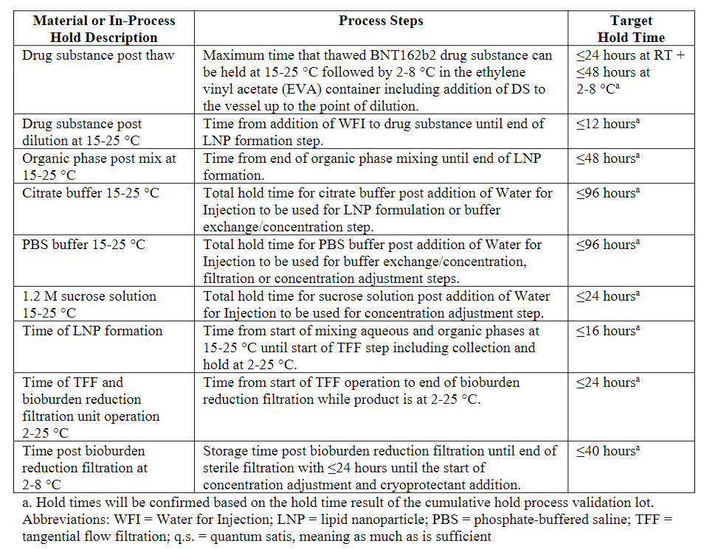
Fill and finish
The process flow diagram for the BNT162b2 fill and finish process is presented in Figure P.3-11.
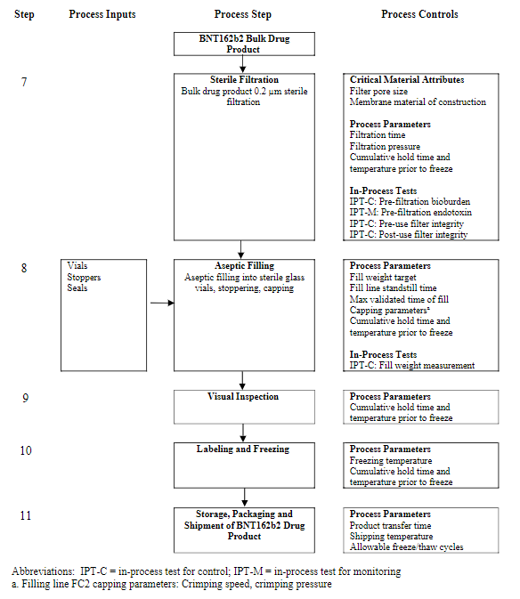
Figure P.3-11. Flow diagram of the BNT162b2 fill and finish manufacturing process and process controls.
Sterile filtration (step 7)
The bulk drug product is sterile filtered into a holding vessel maintained at 2-8°C. The bulk drug product suspension is filtered using two sequential redundant sterilizing grade filters. The filters are flushed prior to use with PBS buffer. Integrity of these filters are controlled by pre- and post-use integrity testing. The wetting agents available for pre and post use integrity testing are PBS buffer, water for injection or a mix of 60% isopropyl alcohol / 40% water (v/v). As this sterile filtration step includes a redundant filter, only one of the filters is required to pass both pre- and post-use filter integrity tests. The sterile filtration time cannot exceed the maximum time as determined by the bacterial retention filter validation discussed in Section 3.2.P.3.5. A sample is taken for bioburden prior to filtration. The process parameters and in-process test for control for sterile filtration are summarized in Table P.3-12.
Table P.3-12. Process parameters / in-process test for control (IPT-C) for sterile filtration.
Process parameter / in-process test | Acceptable range / Acceptance criteria
Pore size and material of construction | 0.2 µm hydrophilic PES
Effective surface area per filter | 1.2 m²
Filtration time | ≤ 4 hours
Filtration pressure | ≤ 20 psig
Pre-use filter integrityª | Pass
Post-use filter integrityª | Pass
Bioburden (pre-sterile filter) | ≤ 10 CFU/100 mL
ªAs this is a redundant filtration step, only one of the two filters is required to pass both pre- and post-filter integrity tests.
Preparation of vials and stoppers (step 8)
The vials are processed through the vial washer, where they are rinsed with water for injection (WFI). After washing, the vials are depyrogenated by means of dry-heat application. The sterilization/depyrogenation cycle complies to the acceptable conditions of Ph. Eur. 5.1.1 (287°C for at least 29.16 minutes to reach a sterility assurance level of 10⁻⁶). The cycle has been validated using a combination of temperature mapping and biological indicators as specified in Ph. Eur. 5.1.2.
Bulk stoppers are washed and depyrogenated with WFI, steam sterilized and dried. The stopper processor’s sterilization cycle complies with the reference condition (≥ 121°C, F0 ≥ 15 min to achieve a sterility assurance level of 10⁻⁶) of the Ph. Eur. 5.1.1. The cycle’s biological effectiveness is validated by exposure of biological indicators as specified in Ph. Eur. 5.1.2.
Aseptic filling (step 8)
The holding vessel is aseptically connected to the filling line and then sterile filtered bulk drug product is aseptically filled into vials. Prior to filling, the filling machine is set up to achieve the target fill weight and initial fill weight checks are performed. During filling, an in-process fill weight test is performed at routine intervals for each filling pump. This periodic check is performed for each filling pump to detect systematic errors related to fill weights. If the control limit is exceeded, the filling operation is interrupted and a fill weight assessment of vials filled between the last successful in-process fill weight check and the out-of-limit result is performed and documented. All non-conforming vials are rejected. The process parameters and in-process control tests for aseptic filling are summarized in Table P.3-13.
Table P.3-13. Process parameters / in-process test for control (IPT-C) for aseptic filling.
Process parameter / in-process test | Acceptable range / Acceptance criteria
Fill weight target | 0.422 to 0.516 gª
Fill line standstill timeª | Maximum of 8 hoursª
Max time of fill | 112 hours^{b}
Fill weight measurements | 0.422 to 0.516 g^{a,b}
ªFill weight target and fill line standstill time will be further confirmed based on the results of process qualification studies.
^{b}Based on aseptic media fill qualification studies.
Stoppering (step 8)
At the end of aseptic filling, a stopper is fully seated onto each filled vial. Vials are subsequently transferred to the capping station.
Capping (step 8)
The stoppered vials are transferred to the capper. A 100% check on the presence and position of the stopper is performed. The capper automatically rejects vials unless the stopper is fully seated. The stoppered vials are capped with aluminium overseals under laminar airflow and crimped onto each vial. Crimping speed is set during equipment setup prior to operations, while crimping pressure is set during routine maintenance. The physical equipment settings (crimping rail position and equipment height) are also set during equipment setup, as a function of the vial format. These combined settings are verified during equipment setup prior to operations, which includes a visual inspection of crimping quality and a manual verification of cap tightness. During routine operations, the settings remain unchanged throughout the capping process of each drug product lot. Settings may be adjusted if deemed necessary, and under such circumstances, settings are re-verified by a visual inspection of crimping quality, and a manual verification of cap tightness. Only the crimping speed may be lowered during the capping process of each batch without re-verification. The process parameters for capping are summarized in Table P.3-14.
Table P.3-14. Process parameters for capping.
Process parameter | Acceptable range
Crimping speed | Maximum 500 units/min
Crimping pressure | > 250 Nª
ªCrimping pressure range to be confirmed during process qualification studies.
Visual inspection (step 9)
Vials are 100% inspected for defects either through automated visual inspection or manual visual inspection.
During the 100% automated inspection process the vials are fed to the inspection machine. The vials undergo a check for product identity/safety, container integrity, product purity and cosmetic defects. The rejected vials are segregated in prelabeled reject trays. The acceptable vials are transferred to trays.
For automated inspection, prior to each batch, a challenge set of vials is run through the machine to confirm that the detection systems are reliably detecting defective vials and that the reject mechanisms are functioning properly.
If required, vials may undergo 100% manual visual inspection. Vials are manually inspected for product identity/safety, container integrity, product purity and cosmetic defect. The stoppers and caps are inspected for presence, proper position, seal imperfection, and stopper and crimp defects. All rejected vials are segregated into prelabeled reject trays. The remaining acceptable vials are placed into trays.
Samples that are required for release testing are removed after inspection.
Vials passing automated or manual inspection are statistically sampled for meeting acceptable quality limits. Throughout the inspection process, samples are taken for Acceptance Quality Limit (AQL) testing. Defects are classified as critical, major or minor and addressed according to site procedures. If the AQL for a critical defect category is exceeded, the product will be 100% inspected (manually or automated) for that defect category.
Labelling, packaging and freezing (step 10)
The labelling and packaging of the BNT162b2 vaccine vials for commercial distribution is performed on a fully automated or semi-automated packaging line.
Inspected vials are individually labelled with a vial label. Printers on the vial labeller are used to print batch-specific information on the vial labels. The line has integrated electronic verification systems, which electronically verify printed variable data and performs checks for label presence.
After labelling, the vials are counted and collected in tray boxes, using a semi-automated trayer or a manual traying process. After filling of the boxes, an insert is added and the boxes are manually closed and labelled. Packaged BNT162b2 vials are frozen and stored in a freezer at -90°C to -60°C pending shipment for commercial distribution.
Process parameters for freezing are summarized in Table P.3-15.
Table P.3-15. Process parameters for freezing.
Process parameter | Acceptable range
Freezing temperature | -90°C to -60°C
Storage, packaging and shipment (step 11)
Drug product vials are stored according to conditions supported by Section 3.2.P.8.1.
Prior to shipment, the traybox(es) containing the vials are moved from the freezer and placed into validated shippers that use dry ice for temperature-control. Temperature monitoring devices are inserted and activated for all shipping containers. The packaged vials are shipped under qualified conditions.
The final packaged products are transported by established transportation routes to point of use. Temperatures during shipment are verified to ensure that the product maintains-90 to -60°C. The point of use can maintain the product temperature in the shipper by adding additional dry ice. Alternative qualified insulated thermal conveyances may be used following appropriate qualification. Process parameters for storage and shipping are summarized in Table P.3-16.
Table P.3-16. Process parameters for storage and shipping.
Process parameter | Acceptable range
Transfer of drug product in secondary containers to freezers or shipping containers | ≤ 15 minutesª
Allowable freeze/thaw cycles post freezing at the site of manufacturing | ≤ 1 cycle^{b}
Shipping temperature | -90 to -60°C
Allowable freeze/thaw cycles post freezing step during transportation to point of use | ≤ 1 cycle^{b}
ªMaximum of 4 transfers allowed with product not to exceed -10°C and vials must be refrozen to -90 to -60°C between transfers.
^{b}Covers thaw at temperatures up to 25°C, not exceeding one hour at up to 25°C product temperature prior to start of re-freeze using a freezer with temperature set at -90 to -60°C.
Hold times
The hold times of the drug product in-process materials during sterile filtration, fill, and finish are provided in Table P.3-17. All hold times following sterile filtration will be within the validated media fill times, ensuring acceptable microbial control during the drug product manufacturing process. The sterile filtration processing steps will be within the maximum times determined by the bacterial retention filter validation.
Table P.3-17. Fill and finish process hold times.
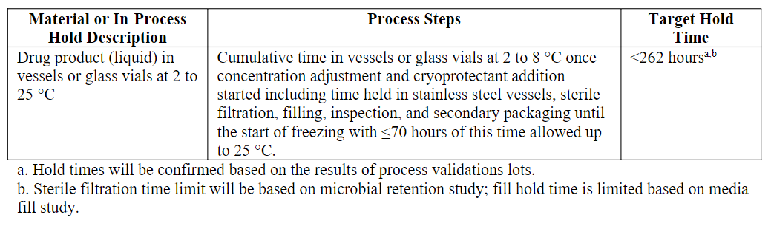

Assessor’s comments on P.3.3 Description of Manufacturing Process and Process Controls:
The manufacturing process consists of LNP fabrication, bulk drug product formulation, sterile filtration and aseptic filling. Critical manufacturing steps are discussed and relevant in-process controls are applied. Hold times are defined for both the LNP formation process and the fill and finish process.
Residual ethanol is not controlled in-process or in the final drug product specification. Data provided in Section P.5.5 demonstrates that ethanol is sufficiently removed in the final drug product (4.5-5.1 ppm in two emergency batches). Absence of test is therefore considered acceptable.
The lipid nanoparticle (LNP) formation is one critical manufacturing step and some additional information is requested regarding this step:
- According to pharmaceutical development (Section P.2.3.4) 2-8 parallel T-mixer may be used depending on the batch size and manufacturers equipment. In the description of manufacturing process (Section P.3.3) it is stated that “one or more” T-mixer(s) are used. The number of T-mixers should be defined in Section P.3.3 and the dossier should be updated accordingly. (OC)
- A drawing of the T-mixer including further details should be provided, e.g. geometry and dimensions. (OC)

Controls of critical steps and intermediates (CTD section: P.3.4)
Data for this section is pending and will be updated once the data has been generated, analysed, and verified.
In-process tests for control (IPT-Cs) and in-process tests for monitoring (IPT-Ms) are used throughout the process to ensure consistent manufacturing. IPT-Cs are in-process tests used to control a quality attribute/critical quality attribute within a specified range so that it meets the desired drug product quality. IPT-Ms have been implemented throughout the process to ensure consistency of the manufacturing process. IPT-Ms are used to monitor a quality attribute to either ensure it is consistent with previous process history or to enable forward processing.
In-process monitoring, control and hold times – LNP fabrication and bulk drug product formulation
The in-process controls (relevant process parameters and IPT-Cs) with their acceptable ranges/acceptance criteria for the LNP fabrication and bulk product formulation manufacturing operations is presented in the tables below.
Table P.3-18. Process controls for dilution of drug substance.
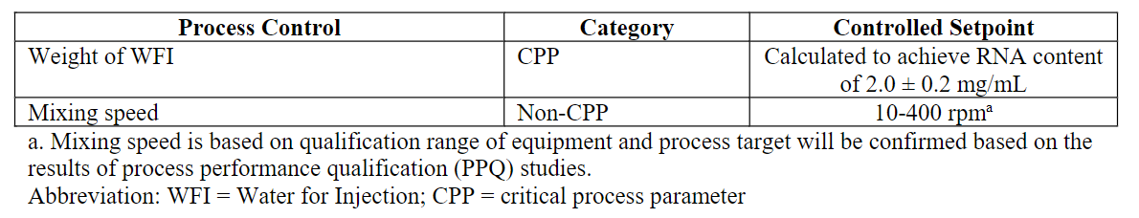
Table P.3-19. Process controls for buffer formulation.
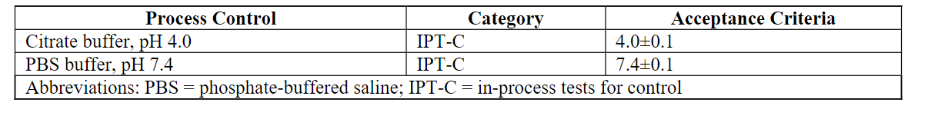
Table P.3-20. Process controls for preparation of organic phase.
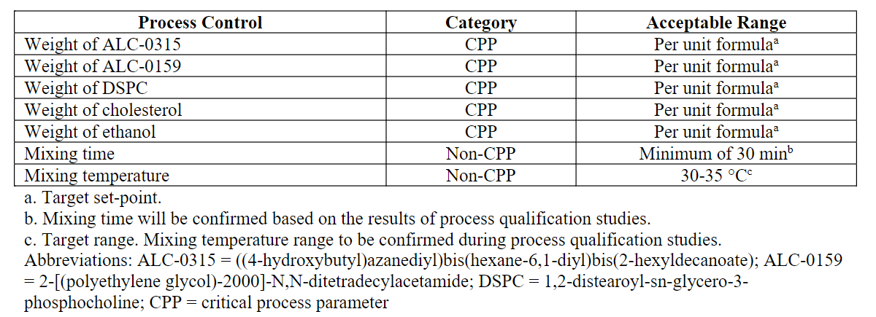
Table P.3-21. Process controls for formation and stabilization of LNPs.
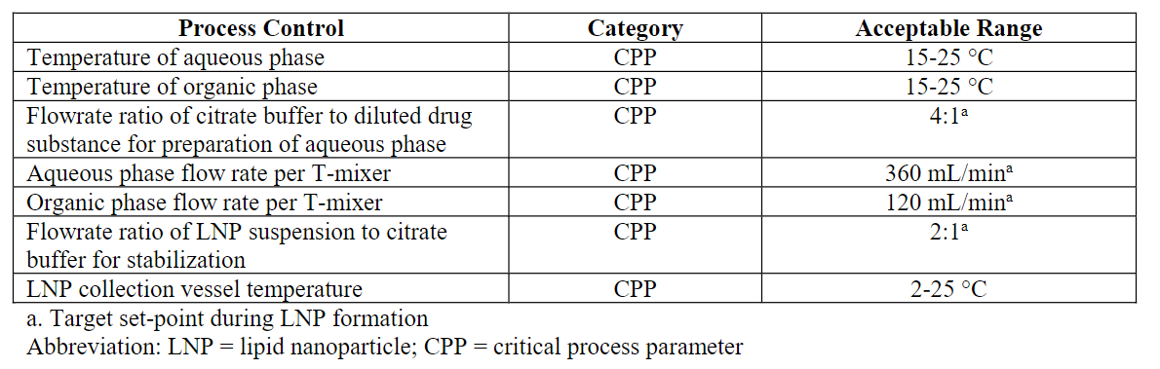
Table P.3-22. Process controls for concentration and buffer exchange.
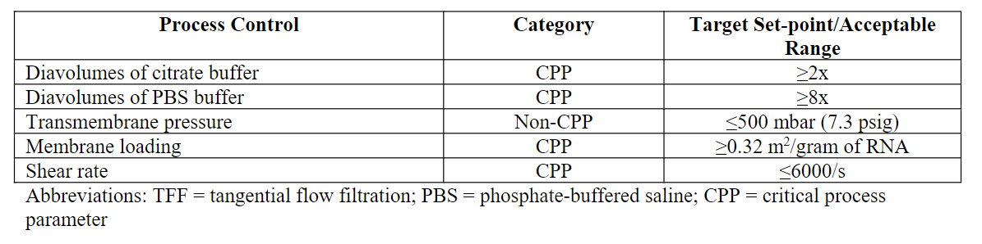
Table P.3-23. Process controls for concentration adjustment and addition of cryoprotectant.
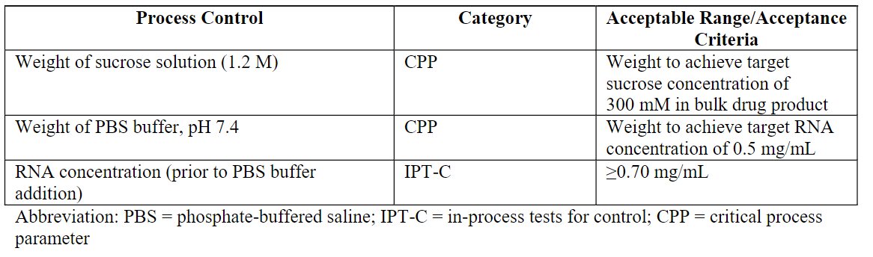
During process development, studies were performed to determine acceptable hold times for drug substance and bulk drug product during the drug product manufacturing process. The hold times will be confirmed during process validation studies. Table P.3-24 lists the hold times of the drug product in-process materials during LNP formation and bulk drug product formulation.
Table P.3-24. LNP fabrication and bulk drug product formulation process hold times.
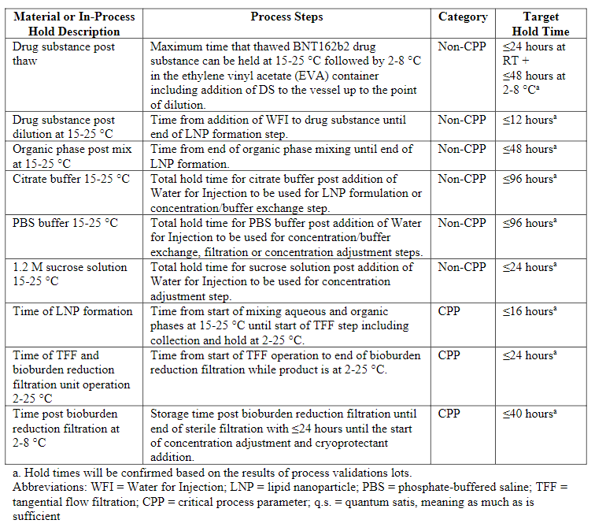
In-process monitoring, control and hold times – fill and finish
In-process controls (relevant process parameters and IPT-Cs) with their acceptable ranges/acceptance criteria for the fill and finish manufacturing operations are presented in the tables below.
Table P.3-25. Process controls for sterile filtration.
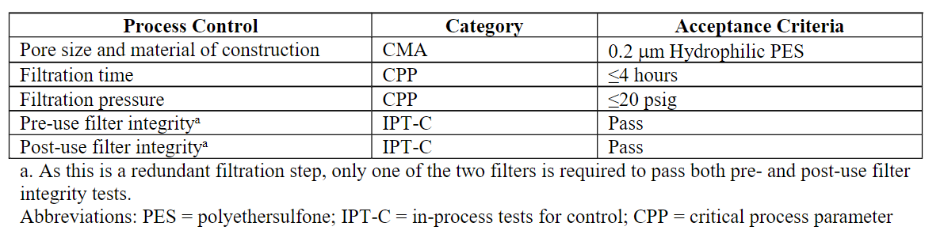
Table P.3-26. Microbial process controls for sterile filtration.
The filter integrity testing is performed by means of a forward flow integrity test or bubble point test. Different control limits can be applied for both pre-use and post-use filter integrity testing, depending on the wetting agent and temperature (Table P.3-27). A successful filter integrity test meeting any one of these control limits will be considered a successful filter integrity test.
Table P.3-27. Control limits for filter integrity testing.
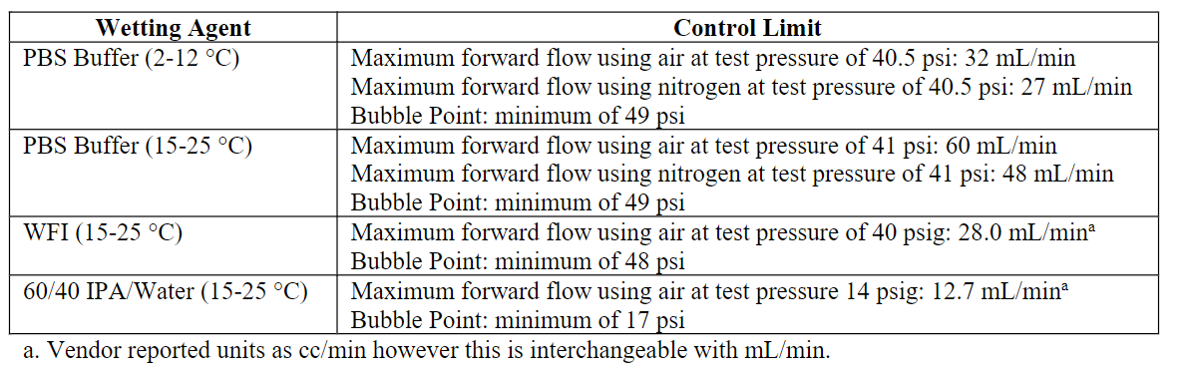
Filling process controls are provided in Table P.3-28. During production, an in-process fill weight test is performed at routine intervals for each filling pump. For the fill weight check, vials are weighed pre-fill (empty vial) and post-fill prior to stopper placement to determine the net weight of the filled product. This periodic check is performed for each filling pump on a set frequency to detect systematic errors related to fill weights. If the control limit is exceeded, the filling operation is interrupted. A fill weight assessment of vials filled between the last successful in-process fill weight test and the out-of-limit result is performed. During the fill weight check, vials measured as outside the acceptance criteria are rejected.
Table P.3-28. Process controls for aseptic filling.
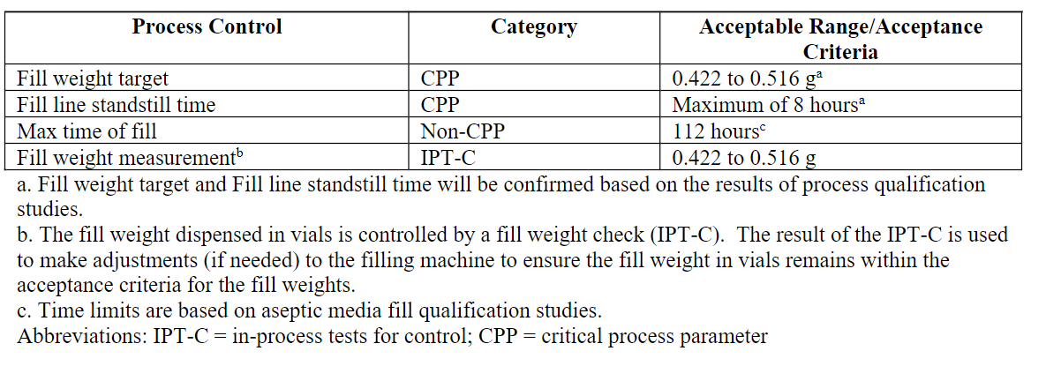
Table P.3-29. Process controls for capping.
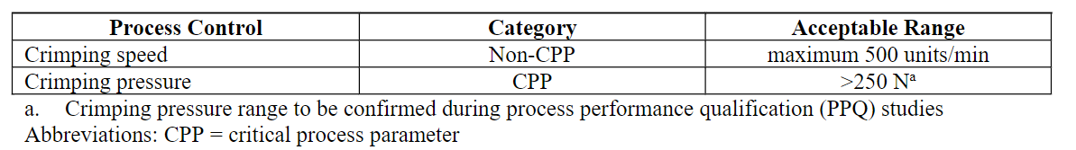
Table P.3-30. Process controls for freezing.
During process development, studies were performed to determine acceptable hold times for drug substance and bulk drug product during the drug product manufacturing process. Hold times will be confirmed during process validation studies. Table P.3-31 shows the hold times of the drug product in-process materials during sterile filtration, fill, and finish. All hold times following sterile filtration will be verified and consistent with the validated media fill times, ensuring acceptable microbial control during the drug product manufacturing process. The sterile filtration processing steps are within the maximum times determined by the bacterial retention filter validation.
Table P.3-31. Fill and finish process hold times.
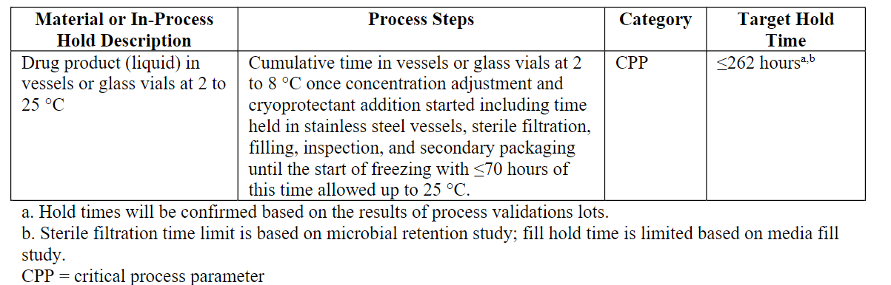
BNT162b2 drug product has an allowable time out of freezing during movement from freezers to packaging and into shippers of 15 minutes each for up to 4 transfers. Precooled movers or insulation is used to ensure the product temperature in the secondary packaging material does not exceed -10°C. BNT162b2 drug product has allowable out of condition post freezing at -90 to -60°C during manufacture, packaging and transport of up to 2 freeze/thaw cycles up to 25°C is supported by stability data for drug product. Table P.3-32 shows the time allowed out of freezing.
Table P.3-32. Time out of freezing for BNT162b2 drug product.
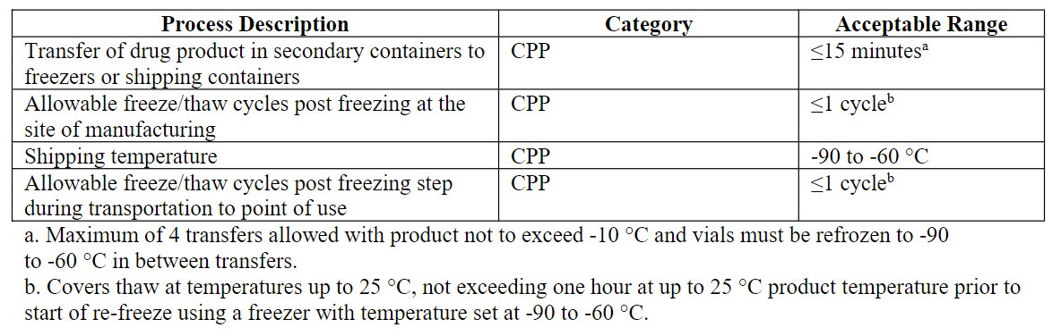

Process validation and/or evaluation (CTD section: P.3.5)
Data for this section is pending and will be updated once the data has been generated, analysed, and verified.
The objective of the process validation program will be to demonstrate that the BNT162b2 drug product manufacturing process consistently produces drug product lots of acceptable quality. The validation will include an appropriate number of consecutive process performance qualification (PPQ) lots (also called process validation (PV) lots), to be manufactured at commercial scale to validate the drug substance (DS) thaw (ethylene vinyl acetate [EVA] bags), transfer and dilution of DS, preparation of organic phase (lipids), lipid nanoparticle (LNP) formation and stabilization, buffer exchange and concentration, filtration, concentration adjustment and addition of cryoprotectant, sterile filtration, aseptic filling, stoppering and capping, visual inspection, labeling, freezing, secondary packaging, and shipping of the drug product vials.
Hold times [Puurs]
Data for this section is pending and will be updated once the data has been generated, analysed, and verified.
Maximum process hold times will be justified through developmental activities and additional qualification studies incorporated into the process validation runs. The routine in-process hold times for the BNT162b2 drug product manufacturing process will be confirmed during process validation lots.
All buffers and solutions held ≥24 hours will have microbial testing performed during all drug product process validation lots.
All in-process testing for the hold challenge batches will be required to meet the pre-determined acceptance criteria with results consistent across process validation batches as well as with commercial drug product acceptance criteria.
Validation of aseptic filling procedure by media fills [Puurs]
Aseptic simulations (media fills) have been performed to demonstrate that the aseptic manufacturing steps of the BNT162b2 drug product process at Puurs, Belgium, on the Focus Cell 2 (FC2) filling line will be performed aseptically.
Media fills are performed in accordance with aseptic processing guidelines and are periodically required as part of routine requalification of the facility. Media fills are performed after implementation of any significant facility, equipment, process or personnel flow changes in the aseptic fill area or upon introduction of new container closure systems that vary significantly from existing, qualified processes.
Shipping validation
Data for this section is pending and will be updated once the data has been generated, analysed, and verified.
This section summarizes the qualification of the shipping process for transport of BNT162b2 drug product by passive thermal shipping containers for air and road shipments in commercial images maintaining temperature conditions of -90 to -60°C from the drug product manufacturing and packaging site in Puurs, Belgium, to dosing sites in EU.
The overall qualification strategy considered both thermal and mechanical aspects of shipping in passive thermal shippers, supported by operational qualification (OQ) and performance qualification (PQ) testing.
Results of thermal qualification and mechanical performance studies have met specified acceptance criteria and support shipments of BNT162b2 drug product by dry-ice based thermal shipping containers when shipped from Puurs, Belgium, to dosing facilities in the EU either directly or via qualified distribution centers.
In addition to the thermal qualification activities for the passive thermal shippers, a simulated distribution study is being conducted to assess drug product and package integrity impact of concurrently applied transport hazards. This study will simulate exposure to worst-case concurrently applied transport hazards with durations replicating a global commercial shipping route that exceeds the anticipated real time shipping requirements.
Verification of in-process test methods
Data for this section is pending and will be updated once the data has been generated, analysed, and verified.

Assessor’s comments on P.3.5 Process Validation and/or Evaluation:
No full commercial scale batches are included in section 3.2.P.3.5 and the applicant states that “Data for this section is pending and will be updated once the data has been generated, analysed, and verified.”
However, it is stated in the dossier that four commercial PPQ-batches will be manufactured in November and December 2020. These batches will be executed according to defined protocols and evaluated with predetermined acceptance criteria. Furthermore, these batches will be used both to demonstrate the comparability of the commercial PPQ-batches versus the clinical supply batches as well as for process validation of the manufacturing process of the drug product. In addition, validation data on process hold-times, shipping validation and verification of in-process test methods are incomplete. Since all these validation data are pending, no final conclusion on process validation in section 3.2.P.3.5 can be drawn until these data are provided for assessment.
Media fills have been performed to validate the aseptic filling process and were run in accordance to guidelines. Results have been provided from three consecutive simulation studies and gave satisfactory results without any contaminated units. Results for the media fill cover the maximum process time for the manufacturing of drug product (maximum filling time is 112 hours) and simulate worst-case manufacturing conditions. The media fill validation demonstrated that aseptic conditions are maintained during the filling process.
Filter validation: Acceptable information has been provided on the 0.2 µm-filters used for sterile filtration, describing the material, pore size and surface area. All study results met the predetermined acceptance criteria and the studies for microbial retention, membrane compatibility, extractable substances and integrity test determination have shown that the 0.2 µm-filters are appropriate for sterile filtration of the drug product. However, the applicant should clarify if the 0.2 µm-filter used for bioburden reduction is identical with the 0.2 µm-filters used for sterile filtration. (OC)

  - Control of excipients (CTD module 3.2.P.4)

Specifications (CTD section: P.4.1)
The following compendial excipients are controlled according to respective Ph. Eur. monograph – cholesterol, sucrose, sodium chloride, potassium chloride, dibasic sodium phosphate dihydrate, monobasic potassium phosphate and water for injection.
Cholesterol – compendial excipient
The cholesterol selected for use is a plant-derived semi-synthetic substance rather than animal-derived. The compendial testing is performed per the Ph. Eur. monograph. In addition, residual solvents are tested by the cholesterol manufacturer due to the usage of these solvents in the manufacturing process and microbial testing is performed per Ph. Eur 2.6.12. The specification is provided in Table P.4-1. The quality attributes tested by or on behalf of the drug product manufacturer prior to their use in the manufacture of the lipid nanoparticle (LNP) drug product are indicated. The remaining tests are listed on the vendor’s Certificate of Analysis (CoA) and are required by the drug product manufacturer in order to release the material for use in the manufacture of the LNP drug product.
Table P.4-1. Specification for cholesterol.
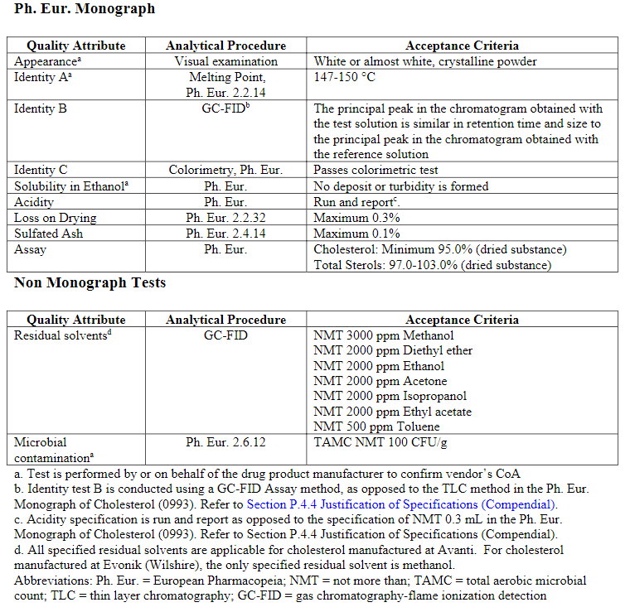
DSPC (1,2-distearoyl-sn-glycero-3-phosphocholine) – non-compendial excipient
DSPC is a non-compendial, non-novel excipient. The specification for DSPC is provided in Table P.4-2. The acceptance criteria for the tests that are performed by or on behalf of the drug product manufacturer for DSPC, prior to their use in the manufacture of the LNP drug product, are indicated with footnotes. The remaining tests are accepted based on the vendor’s CoA by the drug product manufacturer in order to release the material for use in the manufacture of the drug product.
Table P.4-2. Specification for DSPC.
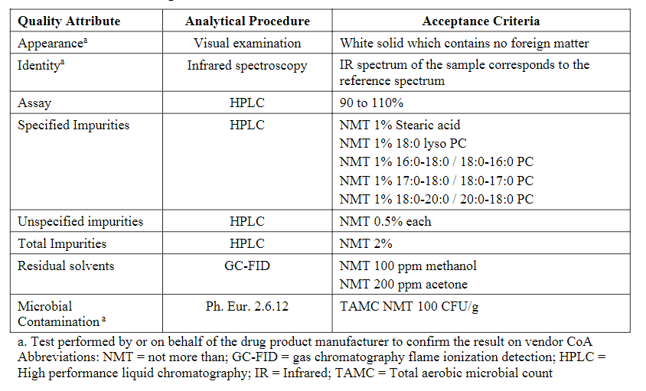
ALC-0315 ((4-hydroxybutyl)azanediyl)bis(hexane-6,1-diyl)bis(2-hexyldecanoate) – non-compendial, novel excipient
The acceptance criteria for the tests that are performed by or on behalf of the drug product manufacturer for ALC-0315, prior to their use in the manufacture of the lipid nanoparticle (LNP) drug product, are provided in Table P.4-3. Other tests are accepted based on the vendor’s Certificate of Analysis (CoA) by the drug product manufacturer in order to release the material for use in the manufacture of the LNP drug product. Details regarding the specification and methods performed at the supplier are provided in Section 3.2.A.3.4.
Table P.4-3. Specification for ALC-0315ª.
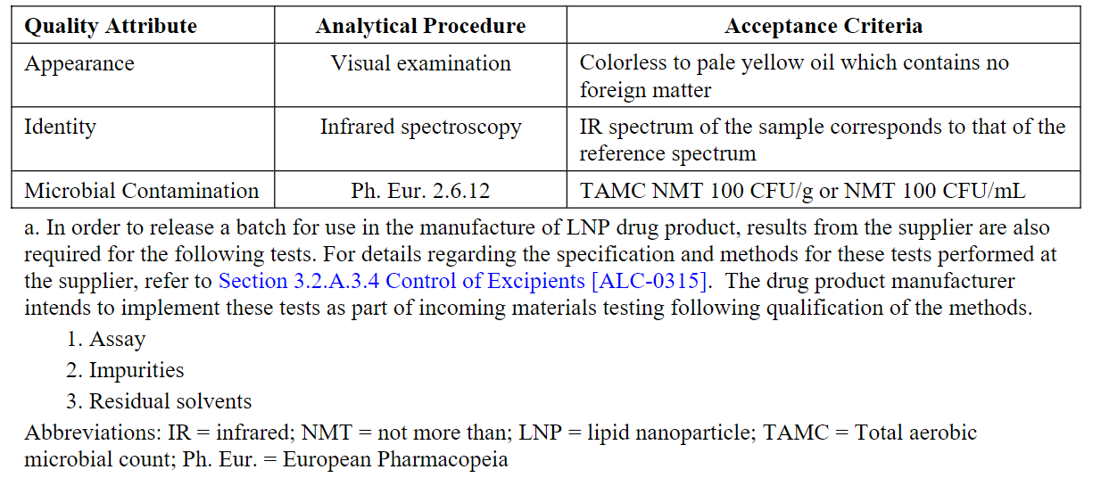
ALC-0159 (2-[(polyethylene glycol)-2000]-N,N-ditetradecylacetamide) – non-compendial, novel excipient
The acceptance criteria for the tests that are performed by or on behalf of the drug product manufacturer for ALC-0159, prior to their use in the manufacture of the lipid nanoparticle (LNP) drug product, are provided in Table P.4-4. Other tests are accepted based on the vendor’s Certificate of Analysis (CoA) by the drug product manufacturer in order to release the material for use in the manufacture of the LNP drug product. Details regarding the specification and methods performed at the supplier are provided in Section 3.2.A.3.4.
Table P.4-4. Specification for ALC-0159ª.
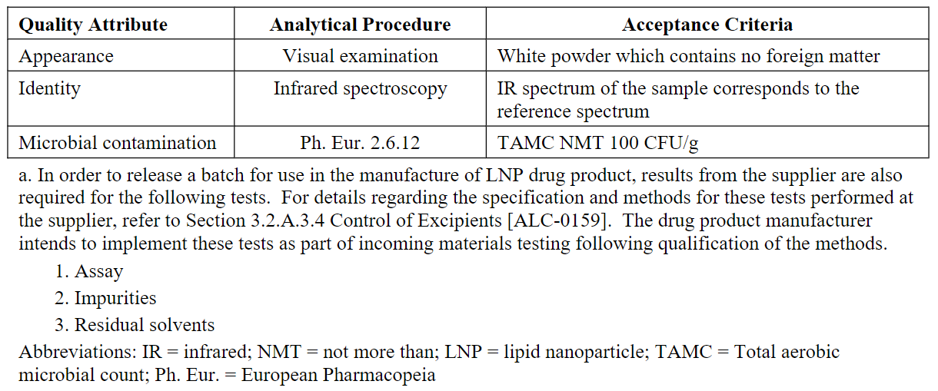

Analytical procedures (CTD section: P.4.2)
Cholesterol – compendial excipient
Identity and residual solvents are determined by GC-FID. Microbial testing is performed according to Ph. Eur. 2.6.12.
DSPC (1,2-distearoyl-sn-glycero-3-phosphocholine) – non-compendial excipient
Appearance is inspected by visual examination. Identity is determined by infrared spectroscopy (IR). Assay and impurities are determined by a gradient high performance liquid chromatography (HPLC) system with evaporative light scattering detection (ELSD). Residual solvents are determined by a gas chromatograph (GC) with flame ionization detector (FID). Microbial testing is performed according to Ph. Eur. 2.6.12.
ALC-0315 ((4-hydroxybutyl)azanediyl)bis(hexane-6,1-diyl)bis(2-hexyldecanoate) – non-compendial, novel excipient
Appearance is inspected by visual examination. Identity is determined by infrared spectroscopy (IR). Microbial testing is performed according to Ph. Eur. 2.6.12.
ALC-0159 (2-[(polyethylene glycol)-2000]-N,N-ditetradecylacetamide) – non-compendial, novel excipient
Appearance is inspected by visual examination. Identity is determined by infrared spectroscopy (IR). Microbial testing is performed according to Ph. Eur. 2.6.12.

Validation of analytical procedures (CTD section: P.4.3)
Cholesterol – compendial excipient
The GC-FID method is validated with respect to specificity, linearity, range, limit of detection, limit of quantitation and accuracy.
Verification of the microbial analytical procedure was performed.
DSPC (1,2-distearoyl-sn-glycero-3-phosphocholine) – non-compendial excipient
The HPLC method for assay and impurities is validated with respect to specificity, precision, accuracy, limit of quantitation, linearity and robustness. The GC method for residual solvents is validated with respect to specificity, precision, accuracy, linearity, range, limit of quantitation and robustness.
ALC-0315 ((4-hydroxybutyl)azanediyl)bis(hexane-6,1-diyl)bis(2-hexyldecanoate) – non-compendial, novel excipient
Non-compendial analytical procedures are verified by specificity.
ALC-0159 (2-[(polyethylene glycol)-2000]-N,N-ditetradecylacetamide) – non-compendial, novel excipient
Non-compendial analytical procedures are verified by specificity.

Justifications of specifications (CTD section: P.4.4)
Cholesterol – compendial excipient
The compendial excipient cholesterol meet the requirements of the current compendia.
Identity test B is conducted by gas chromatography (GC) instead of thin layer chromatography (TLC). GC is a superior method to TLC, and the method ensures that the identity is confirmed.
Acidity specification is “Run and Report” as opposed to Ph. Eur. monograph specification of not more than (NMT) 0.3 mL. A report only specification is appropriate because the acidity test is not relevant for synthetic cholesterol. All batches to date have met the limit of NMT 0.3 mL.
Residual solvents are tested as an additional test. Methanol and toluene are class 2 solvents and diethyl ether, acetone, ethanol, ethyl acetate and isopropanol are class 3 solvents. The specification limits comply with Q3C Option 1.
Microbiological contamination is an additional test. The limit is based on the general limits defined in Ph. Eur. 5.1.4 for non-sterile substances for pharmaceutical use.
Cholesterol for commercial drug product will be manufactured by Avanti and Evonik (Wilshire). Batch analysis results for one batch manufactured by Avanti and two batches from Evonik are provided.
DSPC (1,2-distearoyl-sn-glycero-3-phosphocholine) – non-compendial excipient
Assay value within the limits of 90 to 110% is acceptable for an excipient. The limits will be reassessed when data for more batches are available.
An acceptance criterion for NMT 1% for each specified impurity equates to a maximum of 1 microgram of an individual impurity in a single dose of the vaccine. This level poses minimal risk from a safety perspective as it is well below the qualification threshold of 1.0 mg in ICH Q3A and well below the M7 limit for an individual mutagenic impurity of 120 micrograms per day based on a less than lifetime exposure of ≤ 1 month treatment duration.
An acceptance criterion for NMT 0.5% for an individual unspecified impurity equates to a maximum of 0.5 micrograms of an individual impurity in a single dose of the vaccine. This level poses minimal risk from a safety perspective as it is well below the identification threshold of 1.0 mg in ICH Q3A and well below the M7 limit for an individual mutagenic impurity of 120 micrograms per day based on a less than lifetime exposure of ≤ 1 month treatment duration. Furthermore, the unprecedented speed of development for drug product in the context of a global pandemic led to limited manufacturing experience for DSPC. In this context, setting specifications based on batch data is not appropriate and could lead to supply issues. The proposed limit guarantees the safety of the patient whilst also ensuring that supplies are available to meet the challenging global demand for this product.
An acceptance criterion of NMT 2% equates to a maximum of 2 micrograms total impurities in a single dose of the vaccine. The total impurities limit is appropriate based on the limit for individual specified and unspecified impurities.
Methanol is a class 2 solvent and acetone a class 3 solvent. The specification limits comply with ICH Q3C Option 1.
The limit for microbiological contamination is based on the general limits in Ph. Eur. 5.1.4 for non-sterile substances for pharmaceutical use.
DSPC for commercial drug product will be manufactured by Avanti. Batch analysis results for two batch manufactured by Avanti and two batches from Lipoid that were used in manufacturing clinical drug product batches are provided.
ALC-0315 ((4-hydroxybutyl)azanediyl)bis(hexane-6,1-diyl)bis(2-hexyldecanoate) – non-compendial, novel excipient
Appearance, identity and microbial contamination is performed by or on behalf of the drug product manufacturer for the non-compendial excipient ALC-0315 prior to its use in the manufacture of the lipid nanoparticle (LNP) drug product. Details regarding the justification of specifications for the additional tests performed at the supplier are provided in Section 3.2.A.3.4.
ALC-0159 (2-[(polyethylene glycol)-2000]-N,N-ditetradecylacetamide) – non-compendial, novel excipient
Appearance, identity and microbial contamination is performed by or on behalf of the drug product manufacturer for the non-compendial excipient ALC-0315 prior to its use in the manufacture of the lipid nanoparticle (LNP) drug product. Details regarding the justification of specifications for the additional tests performed at the supplier are provided in Section 3.2.A.3.4.

Excipients of human and animal origin (CTD section: P.4.5)
There are no excipients of human or animal origin.

Novel excipients (CTD section: P.4.6)
The two novel lipid excipients used in the BNT162b2 drug product manufacturing – ALC-0159 (2-[(polyethyleneglycol)-2000]-N,N-ditetradecylacetamide) and ALC-0315 ((4-hydroxybutyl)azanediyl)bis(hexane-6,1-diyl)bis(2-hexyldecanoate)). Information is provided in Section 3.2.A.3. Supportive nonclinical and clinical safety data are provided in Section 2.4.4 and 2.5.5. All excipients are manufactured under GMP conditions.

Assessor’s comments on P.4 Control of Excipients:
The lipid nanoparticle (LNP) consists of two functional lipids (ALC-0315, ((4-hydroxybutyl)azanediyl)bis(hexane-6,1-diyl)bis(2-hexyldecanoate), a cationic lipid and ALC-0159, 2-[(polyethylene glycol)-2000]-N,N-ditetradecylacetamide) and two structural lipids (DSPC, 1,2-distearoyl-sn-glycero-3-phosphocholine and cholesterol).
ALC-0315 and ALC-0159 are novel excipients, not previously used in an approved drug product within EU. Additional information is provided separately in Section A.3.
DSPC is a non-compendial excipient sufficiently controlled by an in-house specification.
Cholesterol is sufficiently controlled according to the Ph. Eur. monograph with additional tests for residual solvents and microbial contamination.
The other excipients (sucrose, sodium chloride, potassium chloride, disodium phosphate dihydrate, potassium dihydrogen phosphate and water for injection) are controlled according to respective Ph. Eur. monograph. Since the manufacturing process consists of sterile filtration and aseptic filling, microbiological quality of the excipients is a critical parameter. Additional test for microbial contamination should be added for all compendial excipients, except for water for injection, where relevant or otherwise justified. (OC)
Quality controls for the processing aid excipients ethanol and citrate buffer is missing and should be provided. (OC)

  - Control of drug product (CTD module 3.2.P.5)

Specification(s) (CTD section: P.5.1)
The release and stability testing specifications for BNT162b2 drug product are provided in Table P.5-1.
Table P.5-1. BNT162b2 drug product specifications.
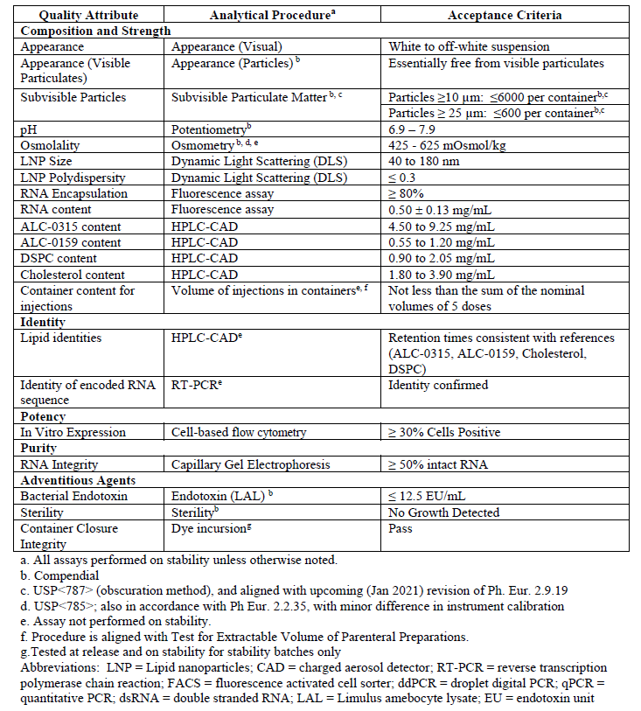

Analytical procedures (CTD section: P.5.2)
Analytical procedures that are common to BNT162b2 drug substance and BNT162b2 drug product are presented in Table P.5-2, and the corresponding methods are detailed in Section 3.2.S.4.2 Analytical Procedures. The analytical procedures that are specific to BNT162b2 drug product are listed in Table P.5-3 and are detailed in this section.
Table P.5-2. Analytical procedures common to BNT162b2 drug substance and drug product.
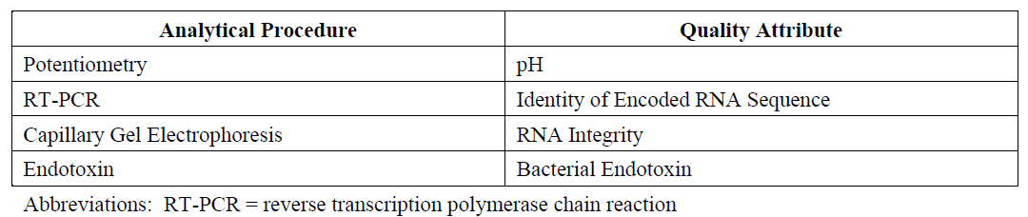
Table P.5-3. Analytical procedures for BNT162b2 drug product only.
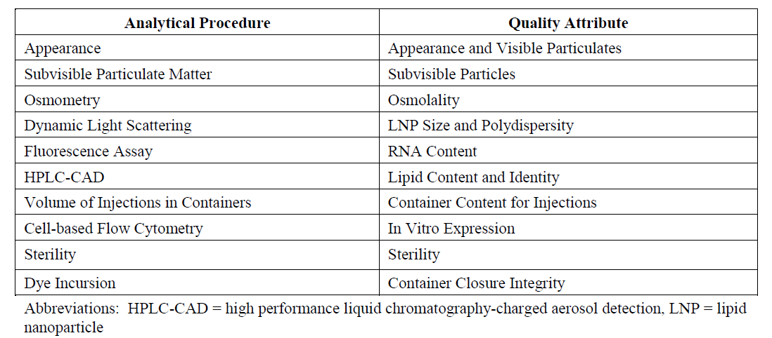
Cell-Based Flow Cytometry (Potency)
The purpose of this analytical procedure is to confirm the in vitro expression of SARS-CoV-2 spike protein encoded by the RNA in BNT162b2 drug product (DP).
Human embryonic kidney (HEK293T) cells are transfected with BNT162b2 DP. After incubation, the cells are harvested and transferred to assay plates. Transfected cells are stained, fixed, and permeabilized. Fixative is washed from the cells and a SARS-CoV-2 spike S1 primary antibody is added, which binds to any surface-expressed and intracellular SARS-CoV-2 S1 antigen. SARS-CoV-2 antigen is detected by addition of a phycoerythrin (PE)-conjugated secondary antibody. Cells are analysed by flow cytometry where the in vitro expression of the SARS-CoV-2 spike is determined as the percent positive cells (S1+) from the viable, single cell population.
Sample Preparation: An example sample preparation scheme is outlined. DP test samples (TS) are diluted to a target concentration of 1.5 μg/mL.
Standard and Control Solution Preparation: Example control solution preparations are outlined.
- Drug Product Control (DPC): The DPC is diluted with DPBS in the same manner as the TS.
- Negative Control (NC): DPBS is used as the NC.
Procedure: Example procedures for seeding HEK293Tcells, cell transfection, and in vitro expression are outlined including seeding of cells, cell transfection, cell harvest, live/dead stain, cell fixation and permeabilization, staining protocol, and flow cytometric acquisition. Representative cell population gates are provided in Figure P.5-4.
Figure P.5-4. Representative Cell Population Gates.
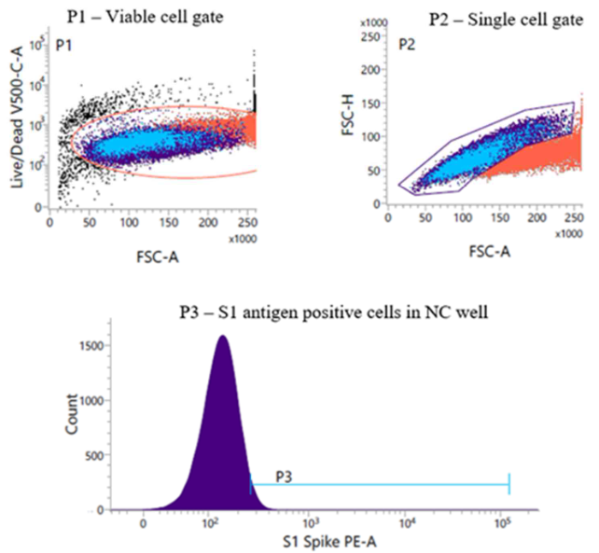
Figure P.5-5. Representative Flow Cytometry Plots.
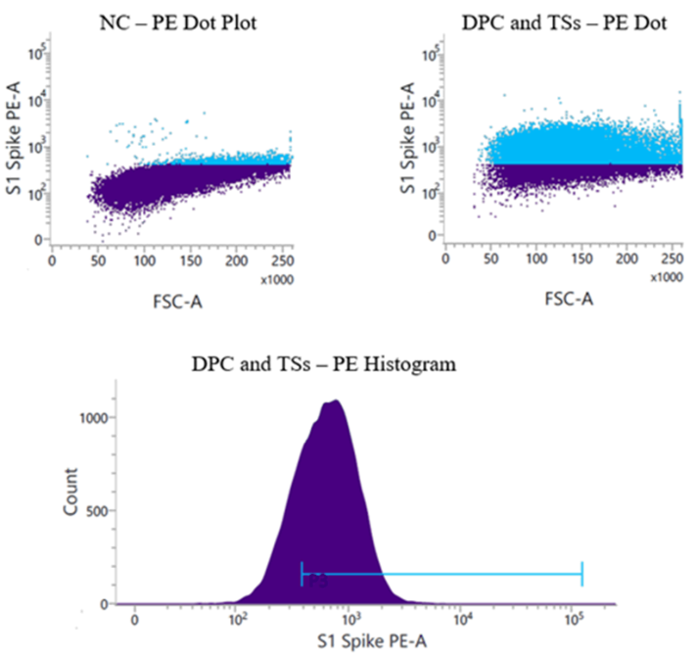
Assay and Sample Acceptance Criteria: Assay and sample acceptance criteria are assessed by analysis of the NC, DPC, and TS. The criteria listed in Table P.5-6 must be met to demonstrate assay and sample acceptance.
Table P.5-6. Assay and sample acceptance.
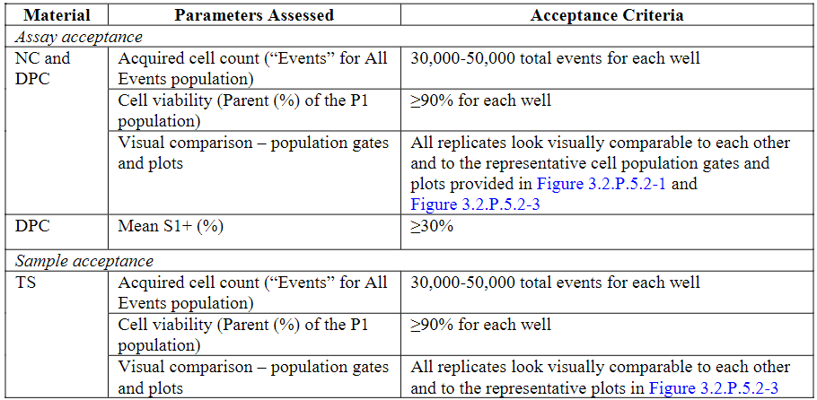
The mean S1+ cells (using “% Parent” of P3) of the replicates for each TS and each control are calculated. Provided the assay and sample acceptance criteria are met, the in vitro expression of the TS is reported.

Validation of analytical procedures (CTD section: P.5.3)
Validation of analytical procedures was performed to ensure the composition, strength, identity, potency, purity, and safety of BNT162b2 drug product. All non-compendial and compendial analytical procedures were confirmed suitable for their intended use.
Analytical procedures were validated against the parameters presented in ICH Q2(R1), Validation of Analytical Procedures: Text and Methodology, for the respective methodology categories. Quantitative analytical procedures were validated for precision, accuracy, specificity, linearity, range, and robustness. Quantitative procedures used to determine the content of minor constituents were further validated for quantitation limit (QL) and/or detection limit (DL). The identity analytical procedures were evaluated for specificity and robustness. Compendial procedures were verified for use in accordance with the applicable pharmacopeias.
Summaries of the non-compendial validations performed for BNT162b2 drug product release and stability analytical procedures have been provided.
Cell-Based Flow Cytometry (Potency)
The validation of the cell-based flow cytometry analytical procedure as a quantitative procedure for determining in vitro expression of the SARS-CoV-2 S1 antigen in human embryonic kidney (HEK293T) cells transfected with BNT162b2 drug product( DP) includes assessments of precision (repeatability and intermediate precision), specificity, linearity, detection limit, and robustness. The validation results are provided in Table P.5-7.
Table P.5-7. Validation summary for the Cell-based Flow Cytometry analytical procedure.
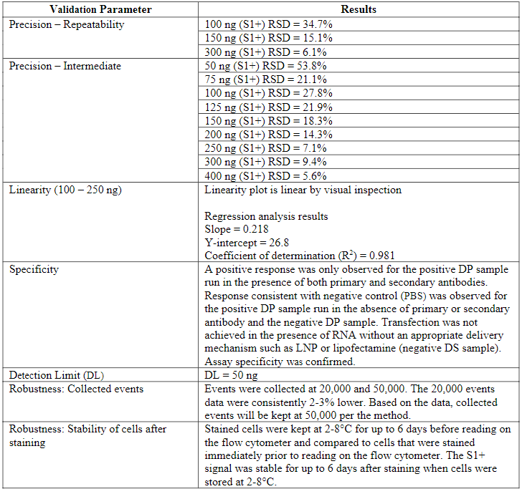
Abbreviations: S1+ = cells expressing the SARS-CoV-2 S1 antigen; DP = drug product; PBS =phosphate buffered saline; DS = drug substance; PE = phycoerythrin; LNP = lipid nanoparticle

Batch analyses (CTD section: P.5.4)
BNT162b2 drug product lots used for nonclinical toxicology studies, clinical trials, emergency supply, and stability are summarized in Table P.5-8. The lot analyses data for BNT162b2 drug product lots are listed, a typical example is given in Table P.5-9 for clinical drug product lots. A full drug product genealogy can be found in Section 3.2.P.2.3 Lot Genealogy. The analytical testing strategy applied to BNT162b2 drug product has evolved throughout the development history. All results met the acceptance criteria at the time of release.
Table P.5-8. Summary of BNT162b2 drug product lots.
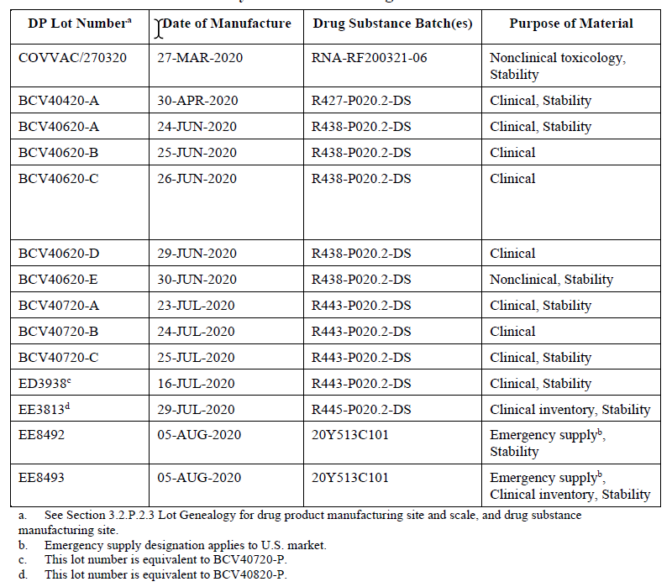
Table P.5-9. Batch analyses for clinical BNT162b2 drug product lots.
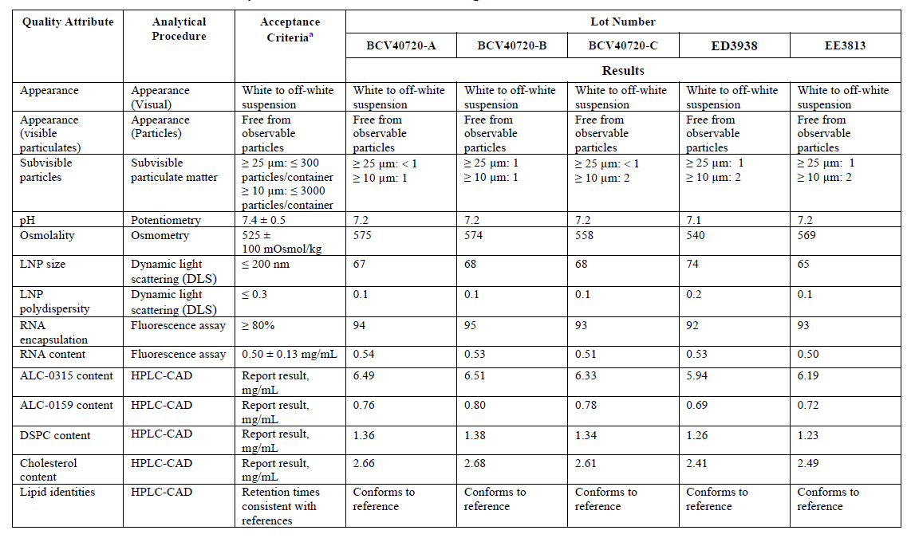
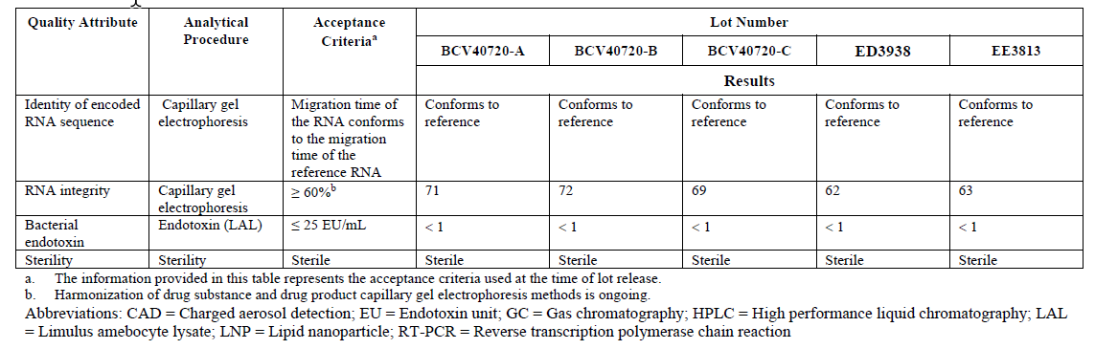

Characterisation of impurities (CTD section: P.5.5)
Data for this section is pending and will be updated once the data has been generated, analysed, and verified.
The impurity profile of the BNT162b2 drug product is based primarily on the impurity profile of the materials used for its manufacture.
The lipid impurities are controlled through the acceptance criteria used for their manufacture.
Impurities from the sucrose, phosphate and chloride salts used in the final drug product formulation are controlled through testing and specifications ensuring compliance to relevant compendial monographs.
There are four identified drug product manufacturing process-related impurities as shown in Table P.5-10.
Table P.5-10. Potential BNT162b2 drug product process related impurities.
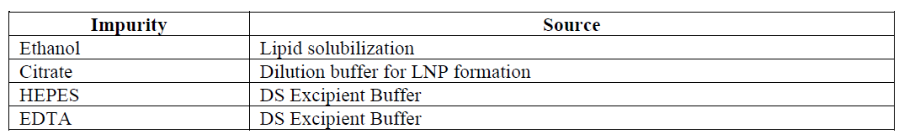
Residual ethanol and citrate are introduced during the drug product manufacturing process and HEPES (N-(2Hydroxyethyl)-piperazine-N-(2-ethanesulfonic acid)) and EDTA (ethylenediaminetetraacetic acid) enter the process as components of the drug substance excipient buffer.
The lipid impurities are controlled through the acceptance criteria used for their manufacture. Impurities from the final drug product formulation components are controlled through testing and specifications ensuring compliance to relevant compendial monographs.
Ethanol, EDTA, citrate and HEPES are the BNT162b2 drug product process related impurities. Removal of ethanol will be demonstrated during drug product manufacture and process validation and reported against the ICH Q3C (R6) limit of 5000 ppm.
EDTA, citrate and HEPES have been shown through a safety-based risk assessment to be significantly below established safety limits with no removal during tangential flow filtration and do not pose a safety concern. Therefore, these process related impurities from theBNT162b2 drug product manufacturing process will not require testing as part of BNT162b2 drug product release.

Justification of specification(s) (CTD section: P.5.6)
The specification for BNT162b2 drug product is based on an understanding of the control strategy and CQAs for the drug product. The attributes tested and associated acceptance criteria ensure the consistency of drug product and linkage to clinical experience. This preliminary specification was established to ensure the quality, purity, potency/biological activity and safety of the commercial drug product at release and during storage. The specification was informed by:
- Development experience (manufacture and analytical) with BNT162b2 drug product.
- Total BNT162b2 manufacturing experience, including drug product lots used in development, nonclinical and clinical studies.
- The ongoing release and stability data for drug product.
- Relevant BNT162b2 drug product development data and modRNA platform knowledge.
Specification setting strategy
A comprehensive panel of analytical procedures was implemented along with corresponding acceptance criteria to monitor and control BNT162b2 drug product quality at release and during shelf-life.
Appropriate analytical procedures were established to monitor and assess BNT162b2 drug product as detailed in Section 3.2.P.5.2 and Section 3.2.S.4.3. With the exception of osmometry (osmolality), volume of injections in containers (container content for injections), HPLC-CAD (lipid identities), and RT-PCR (identity of encoded RNA sequence) assays, which are conducted at drug product release only, all other procedures are conducted at release and during stability studies for drug product.
The approach to setting acceptance criteria for each quality attribute in the BNT162b2 drug product specification included understanding gained from:
- Data obtained for drug product lots used as nonclinical toxicology and clinical trial supplies.
- The relevant long-term stability data that were obtained for the BNT162b2 drug product at recommended storage conditions of -90°C to -60°C.
- Experience with the analytical procedure and knowledge of the method capabilities.
- The regulatory expectations for RNA-based products, where appropriate.
- Relevant BNT162b2 development data, including understanding of an impact to potency, safety and immunogenicity of the quality attribute evaluated, available literature, as well as the institutional experience with other mRNA products.
Testing results for each of the quality attributes obtained for drug product lots used as clinical trial supplies served as the basis for clinical justification of the specifications.
In vitro expression (Potency)
In vitro expression is a cell-based assay in which HEK293T cells are dosed with BNT162b2 drug product and the output is measured as expression of the SARS-CoV-2 S1 antigen flow cytometry. Because this assay was implemented recently, limited data are available for historical drug product lots. All available data from comparability measurements for drug product as well as release testing is shown in Table P.5-11.
Table P.5-11. BNT162b2 drug product in vitro expression comparability and release data.
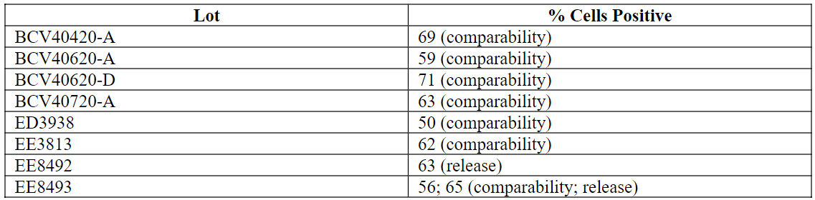
To set the acceptance criterion for in vitro expression, n=76 measurements obtained during assay validation, testing of controls during development as well as release and comparability analysis were included. The mean and standard deviation (SD) of this data set were calculated and correspond to 66.72% and 13.59%, respectively. The commercial acceptance criterion for in vitro expression tested at release and during stability studies corresponds to the mean –3 SD (26%), which is rounded up to 30%, and was established at ≥ 30% Cells Positive.
Because limited stability data are yet available for representative BNT162b2 drug product at the recommended storage condition of -90 to -60 C, the acceptance criteria used for stability during shelf-life will be the same as the acceptance criteria used for lot release. Finally, the Sponsor also acknowledges that limited data from drug product manufacture at the commercial scale using the commercial process is available at this time to inform the determination of acceptance criteria. When an adequate number of batches have been manufactured, the specification and all associated acceptance criteria will be reassessed.
Thus, the acceptance criteria in the drug product specification reflect the current understanding of criticality of quality attributes, their impact on product performance, and the quality of the product used in clinical trials to ensure consistent manufacture of drug product.
The lots included in the establishment of the commercial specification have been presented.
Descriptions of the analytical methodology used to set the BNT162b2 drug product specifications are contained in the respective analytical procedure sections, Section 3.2.P.5.2 and 3.2.S.4.3.
Method evolution and changes, with bridging information as appropriate, are described in detail Section 3.2.P.2.3.

Assessor’s comments on P.5 Control of Drug Product:
Specification and justification of specifications
The specifications document for drug product in section 3.2.P.5.1 includes a comprehensive panel of relevant tests along with corresponding acceptance criteria.
With the exception of osmometry, volume of injections in containers, HPLC-CAD (lipid identities) and RT-PCR (identity of encoded RNA sequence), which are performed only at DP release, all other analytical procedures are conducted at release and stability studies for drug product. It is stated by the applicant in section 3.2.P.5.6 that the acceptance criteria used for stability during shelf-life will be the same as the acceptance criteria used for lot release. This is found acceptable, however, the applicant should confirm that the same acceptance criteria are valid both at release and end-of-shelf-life for the drug product. The specifications document in 3.2.P.5.1 could preferably be updated to include a separate column for the end-of-shelf-life specifications. (OC)
Test method numbers are missing and should be given to all analytical procedures used in the specifications for release and end-of-shelf-life and should consequently be inserted in the drug product specifications document and to the descriptions and validations of analytical procedures. Sections 3.2.P.5.1, 3.2.P.5.2 and 3.2.P.5.3 should be updated accordingly. (OC)
LNP size for drug product is measured by dynamic light scattering (DLS) and the efficacy of the drug product depends on the size of the LNP. The proposed acceptance criteria of 40 to 180 nm seem wide compared to clinical batch data that is found in the range of 59-74 nm for the small scale clinical batches (“classical LNP process) and 68-71 nm for the emergency supply (“upscale” LNP process). The acceptance criteria should therefore be tightened to be in line with what has been qualified in the clinical studies or clinically qualified by other means and set such that a clinically qualified level is assured throughout the shelf-life of the drug product. (OC)
Potency: In-vitro expression is a cell-based flow cytometry assay. The assay was implemented recently and the proposed acceptance criteria of ≥30% cells positive seem wide compared to the limited batch release data available to date, i.e. emergency supply lots that is in the range of 63-65%. In addition, some data are presented for the small-scale clinical batches used in comparability testing, where data are found in the range of 50-71% (Table 3.2.P.2.3-5 in the dossier). The proposed acceptance criteria need to be thoroughly justified and tightened in line with the levels qualified in clinical studies or clinically qualified by other means. This justification should include the applicant’s total current knowledge of the drug product. (OC)
RNA encapsulation of drug product is measured by a fluorescence assay where free and total RNA are determined and the difference between the total and free RNA corresponds to RNA encapsulation. Encapsulation is used to ensure delivery of the RNA and improve the chances of transfection. The proposed acceptance criteria of ≥80% seem wide compared to clinical batch data that is found in the range of 92-94%. The proposed acceptance criteria for RNA encapsulation should therefore be tightened based on clinical qualification or clinically qualified by other means and set such that a clinically qualified level is assured throughout the shelf-life of the drug product. (OC)
The proposed acceptance criteria of ≥50% intact RNA for RNA integrity as measured by capillary gel electrophoresis seem wide compared to clinical batch data that is found in the range of 69-81%. The proposed acceptance criteria for RNA integrity should therefore be tightened based on clinical qualification or clinically qualified by other means and set such that a clinically qualified level is assured throughout the shelf-life of the drug product. Additionally, it should also be clarified if the emergency lots EE8492 and EE8493, both with results for RNA integrity of 55%, have actually been used in the clinical trials or not. In this context, it is also unclear whether there is a decrease in RNA integrity during the manufacturing of DP or not and a consequential need for a more stringent DS specification. The applicant should therefore discuss, and present comparative results for DS and DP, on RNA integrity. Sections S.4.1 and P.5.1 in the dossier should be aligned and updated accordingly. (OC)
The proposed acceptance criteria for LNP polydispersity as measured by DLS and RNA content as measured by fluorescence are found acceptable. In addition, the proposed acceptance criteria for appearance, subvisible particles, pH, osmolality, volume of injection in containers, identity of encoded RNA sequence, bacterial endotoxin, sterility and container closure integrity are all found acceptable.
Lipid content: Both safety and efficacy are dependent on the total amount of lipid relative to the RNA DS. A consistent molar ratio of lipid/RNA is expected in the DP vial, driven by the encapsulation process. Absolute lipid content may vary but composition (relative molar %) of the four lipids remains consistent. The acceptance criteria ranges have been calculated from worst-case low and high RNA content. No batches manufactured to date have exhibited results at or below the low RNA content estimate while the high RNA content level has been justified by development batches manufactured at worst-case high RNA contents. Although the absolute range of each lipid appears somewhat broad, the acceptance criteria are found acceptable. However, to further strengthen the control strategy given that a fixed molar ratio of cationic lipid and RNA is critical for LNP formation, acceptance criteria for the molar ratio N/P should be included in the specification unless further justified. (OC)
A separate test for in vitro release is not included in the specification. This is considered acceptable since test for potency is included by a cell-based method.
Analytical procedures
Some of the analytical procedures are common to both DS and DP and these are described, and the corresponding validation results presented and assessed, in sections 3.2.S.4.2 and 3.2.S.4.3, respectively. Several analytical procedures are specific to DP and are detailed and validation results presented in sections 3.2.P.5.2 and 3.2.P.5.3.
The compendial methods have been verified for use in accordance to the appropriate Ph. Eur. chapters.
It is claimed that all non-compendial methods were validated against the parameters given in ICH Q2. However, the validation summaries presented are far too brief to be able to conclude on the suitability of the analytical method. Therefore, the following issues needs to be addressed:
The information in the dossier does not support that any of the analytical procedures applied for drug substance and drug product has been properly validated, in line with ICH Q2. The quality of BNT162b cannot be properly assessed, if the reliability of the analytical methods cannot be guaranteed. The validation summaries provided in the dossier for both drug substance and drug product analytical procedures are far too brief and important details are missing. The Applicant should submit more comprehensive validation summaries of all non-compendial methods, for example in the form of short validation reports. The validation summaries should include all relevant calculations, acceptance criteria, description of and results obtained for individual samples. Chromatograms and dose response curves should be included, where applicable. The dossier should be updated accordingly. (OC)
Furthermore, in all of the in-house analytical methods used in the release of DP, method descriptions are based on “examples” of procedures, controls and standards as well as on “typical” system operating parameters. These terms raise uncertainties regarding the developmental stage, and the control of critical steps of these assays. The analytical methods used in the control of DP are expected to be finalized. The applicant is requested to confirm this and to update the relevant parts of the dossier with unequivocal method descriptions and additional details, if needed. The applicant should also confirm that any significant changes in analytical procedures will be applied for in a variation application. (OC)
In addition, it is stated in the dossier that a complete description of the rapid sterility test is pending. Therefore, method description and validation summary of the rapid sterility test should be provided during the procedure. (OC)
Potency: Cell based flow cytometry is used to confirm the in vitro expression of SARS-CoV-2 spike protein encoded by the RNA in BNT162b2 drug product (DP). Although the principle and method procedure is, in general, considered sufficiently described, additional details on critical reagents (such as antibodies), drug product control (DPC) samples and equipment are requested. In the assay acceptance criteria, a limit of >30% is established for the results obtained using DPC. The approach of using a lower limit instead of a determined target/interval for an assay acceptance criteria is not agreed upon. Furthermore this limit seems to be low to support the suitability of the method and should be further justified.
Representative cell population gates and flow cytometry plots are provided. However, it is stated that “the exact shapes and locations of gates are expected to be different between instruments. All gates should be properly shaped and sized to select for the relevant cell populations”. The gating strategy should be established, clearly defined and a description of the rationale for establishing the gating strategy should be provided. Possible changes observed between different equipment should be appropriately cross-validated.
HEK293T cells, thawed from an analytical working cell bank, are used for in vitro expression demonstration. It is stated that these cells can be continuously cultured and used in the assay from passage 3 to passage 15 (post-thaw). It is also recommended to passage cells between 2 and 4 days when seeded at 7,000 to 36,000 viable cells/cm². This possible variations in the method parameters are considered substantial and should be addressed in the validation exercise when investigating assay robustness.
With respect to the cell-based flow cytometry method used to confirm the in vitro expression of SARS-CoV-2 spike protein encoded by the RNA in BNT162b2 DP:
- Information regarding critical reagents (such as antibodies), drug product control samples and equipment used should be provided in the dossier. The robustness of the method should be appropriately demonstrated in the validation exercise, if different reagents, e.g. different clones or different vendors for the antibodies or different instruments, are envisaged.
- It is stated that exact shapes and locations of gates are expected to be different between instruments and that gates will be shaped and sized to select for the relevant cell populations. The gating strategy should be established, clearly defined and a description of the rationale for establishing the gating strategy should be provided. Possible changes observed between different equipment should be appropriately cross-validated.
- In the table defining assay acceptance criteria, a limit of >30% is established for results obtained using drug product control samples. In order to unequivocally demonstrate the suitability of this method, the lower limit strategy should be replaced by a target/interval value. A value of, or close to, 30% is considered too low for the demonstration of method suitability and should be updated based on relevant data.
- The relevance of the results obtained in the in vitro expression test using a HEK293 cell line for the in vivo intended targeted cell population should be further discussed and, ideally, substantiated with characterization data, unless otherwise justified. Additionally, information on characterisation of the HEK293 cell line used, including specifications should be provided.
- The cell culture and transfection steps included in the potency method should be appropriately considered in the method validation strategy. For example, substantial variation in the culture parameters (such as passage number and seeding densities) are allowed for HEK293 cells used in determining DP in vitro expression. Unless otherwise justified, these possible variations should be addressed in the validation exercise when investigating assay robustness (OC).
Batch analysis
Batch analysis data have been provided including DP batches used in toxicology studies, clinical trials, emergency supply and stability. All these batches have been manufactured with the “classical” LNP process (nonclinical, clinical supply lots) or the “upscale” LNP process (emergency supply) and comparability has been demonstrated and concluded between the clinical supply lots and the emergency supply lot. All DP batches manufactured and presented met the acceptance criteria in the DP specification. However, no DP batches at the intended full commercial scale have been manufactured to date. It is described in the dossier that four commercial PPQ-batches will be manufactured in November and December 2020. These batches will be used both to demonstrate the comparability of the commercial PPQ-batches versus the clinical supply batches as well as for process validation of the manufacturing process of the drug product. Therefore, no final conclusion on comparability or process validation can be drawn until all data for the PPQ-batches will be provided for assessment, see assessors’ comments in section 3.2.P.2.6 and section 3.2.P.3.5. In addition, section 3.2.P.5.4 should be updated with the release data for these four PPQ-batches.
Characterisation of impurities
The impurity profile of the DP is based on the impurity profile of the materials that are used for the manufacturing as well as the lipid impurities.
There are four process-related impurities identified for the DP; ethanol, citrate, HEPES and EDTA. Removal of ethanol will be demonstrated during process validation against the ICH Q3C limit (5000 ppm, class 3 solvents). Additional data on this issue is pending and will be provided for this section. EDTA, citrate and HEPES have been shown through safety risk assessment and theoretical worst-case calculations to be significantly below established safety limits. This is found acceptable.
The lipids are controlled via the acceptance criteria in their specifications. However, no information and discussion are provided on the lipid-related impurities originating from the degradation of the lipid nanoparticles and such data needs to be provided. (OC)
The applicant plans to update the dossier with further evaluations of lipid-related impurities and states that for section 3.2.P.5.5 “Data for this section is pending and will be updated once the data has been generated, analyzed, and verified”. Until these data are available for assessment, no final conclusions can be drawn on section 3.2.P.5.5.
A summary of risk assessment on elemental impurities in line with the ICH Q3D is missing. A risk assessment with respect to the potential presence of elemental impurities in the drug product based on the general principles outlined in Section 5.1 of ICH Q3D should be performed. A summary of this risk assessment should be submitted. The risk assessment should cover all relevant elements and sources in accordance with the guideline. The summary must enable a quantitative comparison of observed or predicted levels with the PDE:s given in the guideline. It should contain what is necessary to evaluate the appropriateness and completeness of the risk assessment, including any assumptions, calculations etc. made. The control strategy for elemental impurities should be justified based on the risk assessment. (OC)
In summary, no final conclusion on the section 3.2.P.5.5 can be drawn until all data on the characterization of impurities will be provided for assessment.

  - Reference standards or materials (CTD module 3.2.P.6)
A summary of the drug product reference materials is presented in Table P.6-1. The drug product clinical reference material (CRM) has been prepared for use as a reference material for the release and stability testing of drug product and this material may also be used as assay control material for release and stability testing of clinical and process validation materials, as well as initial commercial supply. Additionally, the drug substance reference material detailed in Section 3.2.S.5.1 Reference Standards or Materials and lipids being purchased from Avanti are also used as a reference material for the release and stability testing of drug product.
Table P.6-1. Summary of reference materials.
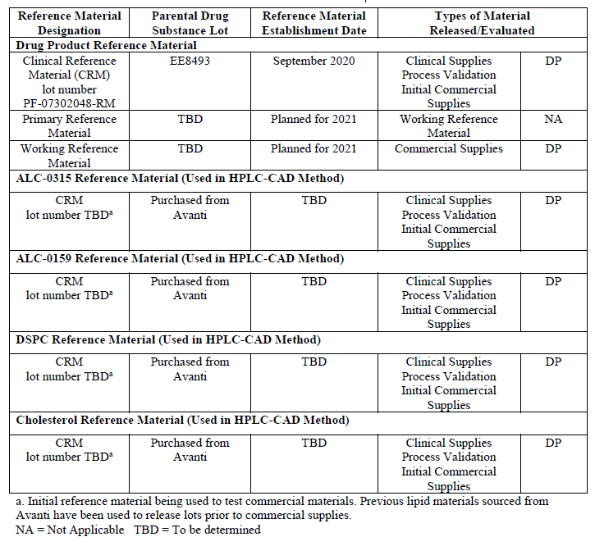

Assessor’s comments on P.6 Reference Standards or Materials:
A summary of the drug product reference materials has been provided.
A drug product clinical reference material (CRM) has been prepared for use as a reference material for the release and stability testing of drug product. The CRM was taken directly from the emergency supply lot EE8493. This CRM material may be used as assay control material for release and stability testing of clinical and process validation materials, as well as initial commercial supply. Additionally, the drug substance reference material detailed in Section 3.2.S.5.1 Reference Standards or Materials and lipids being purchased from Avanti are also used as a reference material for the release and stability testing of drug product.
The CRM has been tested and the batch-data is documented in section 3.2.P.5.4. The CRM is also followed during stability, according the stability protocol detailed in section 3.2.P.8.1, at the intended storage conditions of -90 to -60°C.
A two-tiered system will be implemented in the future (planned to 2021) to support the commercial product for in-house manufactured reference materials. After implementation, the primary reference materials (PRM) will be intended to last throughout the commercial product lifetime and will be used for qualification of future working reference materials (WRM). Initial WRMs will also be made and implemented in the future to support routine testing of commercial drug product until it is consumed and replaced.
Further information on the selection, preparation, qualification and stability of the PRM and WRMs will be provided in future amendments.
Avanti has implemented a two-tiered lipid reference material program and lipid reference materials will continue to be sourced from Avanti in the future to support commercial testing. Further information on the PRM and WRM for the lipids will be provided in future amendments.
This is at large found acceptable. However, it should be clarified for what release and stability testing methods the reference standard (including the CRM) is used today and will be used in the future. The function of the reference standard should be briefly stated for each assay, i.e. results of evaluation/normalisation, sample compliance, assay control etc. This information could be provided preferentially in a tabulated form. (OC)

  - Container closure system (CTD module 3.2.P.7)
The primary container closure system for the BNT162b2 vaccine consists of the vial components listed in Table P.7-1. Listed component dimensions are subject to standard industry tolerances.
Table P.7-1. List of components in container closure system.
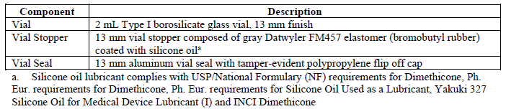
Primary container closure system
Vial
BNT162b2 drug product container consists of a clear and colourless Type I borosilicate glass vial with a 2 mL nominal fill volume and 13 mm finish (lip/flange) diameter. Vials are manufactured by both Schott Pharmaceuticals (Schott) and Ompi (part of Stevanato Group). Each manufacturer utilizes the same glass cane supply. Vials from both manufacturers have materials of construction and critical dimensions that are the same and the vials from both supplier are considered equivalent in terms of processability, container closure integrity and drug product interaction. The vial meets USP <660>, Ph. Eur. 3.2.1 and JP 7.01 requirements for Type I glass containers.
Vial stopper
The elastomeric closure is a vial stopper composed of Datwyler FM457 gray bromobutyl rubber that is not manufactured from dry natural rubber (latex). The vial stopper meets the requirements of USP <381>, Ph. Eur. 3.2.9, and JP 7.03. Vial stoppers are sterilized by steam.
Vial seal
The vial seal is a 13 mm flip-off design constructed of aluminium with a polypropylene tamper-evident flip-off vial seal that has no embossing.
Secondary packaging components
Drug product vials are placed into corrugated boxes with lids.

Assessor’s comments on P.7 Container Closure System:
The primary packaging material has been described and includes materials of construction, dimensions, schematic drawings and information with relation to quality control. The vials and rubber stoppers are in compliance with the requirements in Ph. Eur. monographs, Ph. Eur. 3.2.1 for Type I glass containers and Ph. Eur. 3.2.9 for closures.
Vials are manufactured by two manufacturers, Schott and Ompi. It is stated that vials from both manufacturers have materials of construction and critical dimensions that are the same and the vials from both suppliers are considered equivalent in terms of processability, container closure integrity and drug product interaction. This is acknowledged.
All equipment and primary packaging components used in the production of parenteral products are sterilized/ depyrogenated according to approved, validated cycles. The sterilization of the vials and stoppers are performed at standard conditions with dry heat for the glass vials and by steam sterilization for the rubber stoppers, information is provided in section 3.2.A.1 in the dossier.
This is found acceptable.

  - Stability (CTD module 3.2.P.8)

Stability summary and conclusion (CTD section: P.8.1)
Shelf-life at recommended storage temperature
The initial commercial shelf-life of the BNT162b2 drug product is 6 months when stored at the intended storage condition of -90 to -60°C. The initial shelf-life is based on the currently available data from stability studies utilizing material from two emergency supply lots, one clinical lot and one non-clinical lot of drug product. Additionally, supportive stability studies are also being presented for two clinical BNT162b1 lots.
Drug product stability lots have been enrolled in stability programs and are being monitored in accordance with the approved protocols. All testing to date has been performed using analytical methodology and phase appropriate specifications in place at time of testing. The analytical procedures used in the stability programs were developed to monitor the composition, strength, purity, safety and general quality attributes of the drug product.
A summary of all drug product lots on stability studies and current available stability data are shown in Table P.8-1. At this time, stability studies are on-going, or are scheduled to be initiated after manufacture of the drug product lot.
Table P.8-1. Summary of on-going stability studies.
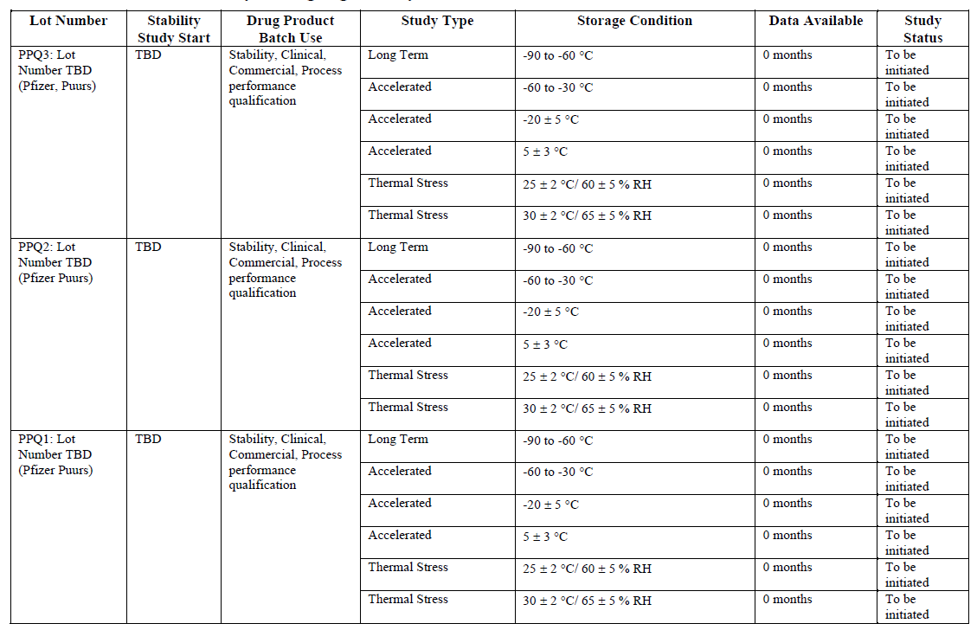
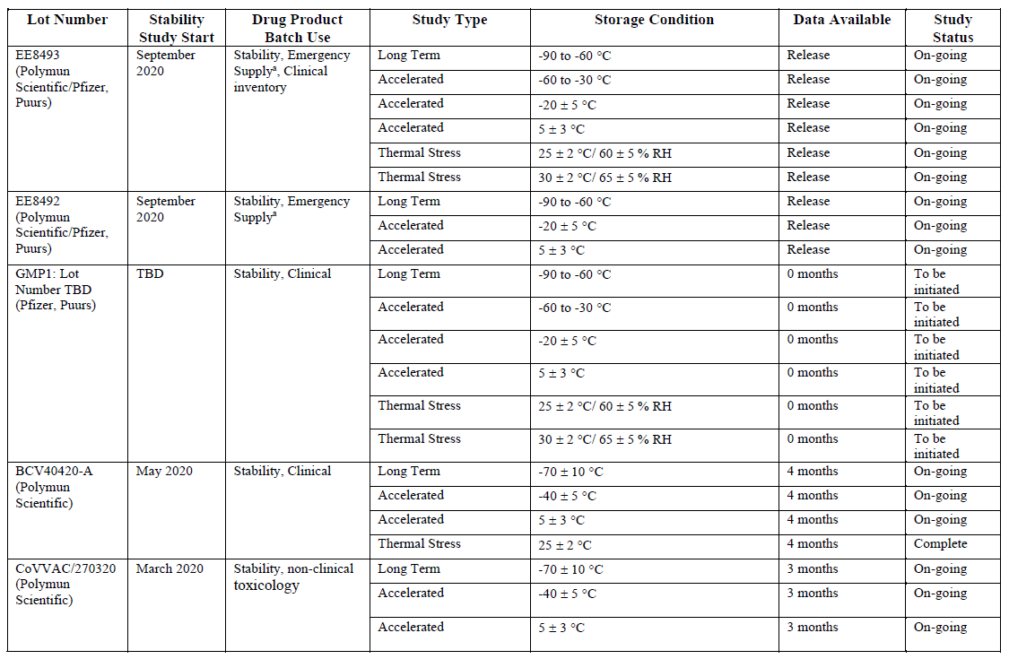
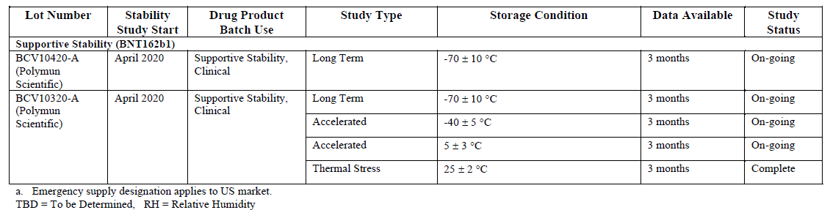
Protocol for testing at the long-term condition (-90 to -60°C)
Vials from drug product lots were stored at the recommended storage condition of -90 to -60°C. Testing is currently being performed on emergency supply lots according to the protocol indicated in Table P.8-2. The initial clinical lot and a minimum of three process validation lots will also be placed on formal stability according to the protocol indicated in Table P.8-2.
Additionally, testing at -70 ± 10°C is being performed on one clinical lot, one non-clinical lot and two supportive BNT162b1 lots according to the protocol indicated in Table P.8-3.
Table P.8-2. Protocol for BNT162b2 DP at the long-term condition of -90 to -60°C.
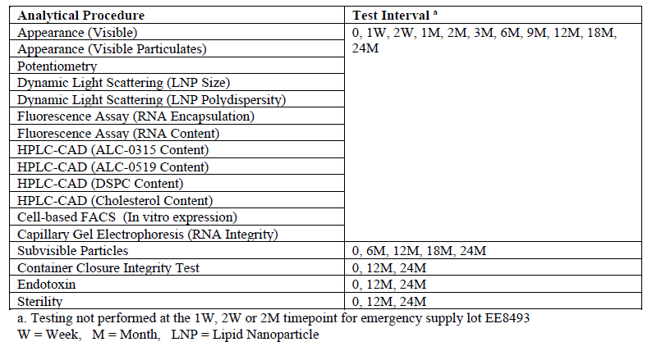
Table P.8-3. Protocol for BNT162b2 early clinical, non-clinical and supportive stability DP at the long-term condition of -70 ± 10 C.
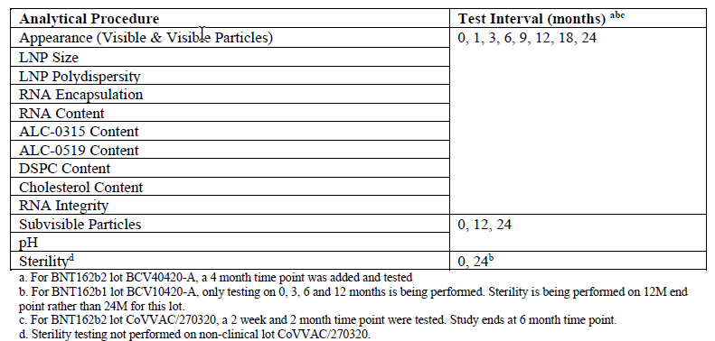
Protocol of testing at the accelerated condition
To study the effects of temporary excursions above the recommended storage temperature, drug product is being stored under the accelerated conditions of -60 to -30°C, -40°C, -20 ± 5°C and 5 ± 3°C. Protocols have been provided.
Protocol for testing at the thermal stress conditions
To study the effects of temporary excursions above the recommended storage temperature, drug product is being stored under thermal stress conditions at 25 ± 2°C/60 ± 5% RH and 30 ± 2°C/65 ± 5% RH and tested per the provided protocols.
Summary of stability data
Summary of stability data at the long-term storage condition (-90 to -60°C)
Results from stability studies on BNT162b2 DP stored at the long-term condition of -70 ± 10°C are currently available for one clinical lot, one non-clinical lot and two supportive clinical lots of BNT162b1 material and results have been provided.
Up to 4 months of data are currently available for the lots manufactured by Polymun Scientific. All data remained within the clinical acceptance criteria in place at the time of testing through the four month time point for lot BCV40420-A and the three month time point for lots CoVVAC/270320, BCV10420-A and BCV10320-A. Overall, the data indicate that there have been no significant changes in terms of quality, purity, or strength for the drug product.
Additionally, two lots of emergency supply have been placed on formal stability at the long-term condition of -90 to -60°C, with release data available at this time. Stability data will be provided in the future as it becomes available.
Summary of stability data at the accelerated storage condition
Results from stability studies on BNT162b2 DP stored at the accelerated condition of -40 ± 5°C are presented for one clinical lot, one non-clinical lot and one supportive BNT162b1 clinical lot.
Up to 4 months of data are currently available for lots manufactured by Polymun Scientific. All data remained within the clinical acceptance criteria in place at the time of testing through the four month time point for lot BCV40420-A and the three month time point for lots CoVVAC/270320 and BCV10320-A. The -40 ± 5°C accelerated condition provides additional supportive data for the long-term storage under recommended condition and supports temporary temperature excursions from the recommended storage condition for up to four months.
Additionally, one lot of emergency supply has been placed on formal stability at the long-term condition of -60 to -30°C, and both lots of emergency supply have been placed on formal stability at the -20 ± 5°C condition, with release data available at this time. Stability data will be provided in the future as it becomes available.
Results from stability studies on BNT162b2 DP stored at the accelerated condition of 5 ± 3°C are presented for one clinical lot, one non-clinical lot and one supportive BNT162b1 clinical lot.
Up to 4 months of data are currently available for lots manufactured by Polymun Scientific. All data remained within the clinical acceptance criteria in place at the time of testing through the two month time point. LNP polydispersity was out of specification at the 3 and 4 month time points for clinical drug product lot BCV40420-A. Additionally, the 3 month time point for clinical drug product lot BCV40420-A was also out of specification for RNA integrity. Changes can be expected at accelerated stability conditions and does not impact the overall stability strategy for this material. The 5°C accelerated condition provides additional supportive data for the long-term storage under recommended condition and supports temporary temperature excursions from the recommended storage condition for up to one month.
Additionally, two lots of emergency supply have been placed on formal stability at the accelerated condition of 5 ± 3°C with release data available at this time. Stability data will be provided in the future as it becomes available.
Summary of stability data at the thermal stress storage conditions
To support short term temperature excursions, drug product was exposed to the thermal stress condition of 25 ± 2°C. Results for one clinical lot and one supportive BNT162b1 clinical lot have been presented. There is currently up to four months of available data.
Up to 4 months of data are currently available for lots manufactured by Polymun Scientific. All data remained within the clinical acceptance criteria in place at the time of testing through the one month time point. At the 2 month time point and beyond, drug product lot BCV40420-A was out of specification for RNA integrity. Changes can be expected at stressed stability conditions and does not impact the overall stability strategy for this material.
Additionally, one lot of emergency supply has been placed on formal stability at both the stressed conditions of 25 C/60% RH and 30°C/65% RH with release data available at this time. Stability data will be provided in the future as it becomes available.
Shelf-life and conclusions
The initial shelf-life for the BNT162b2 DP is 6 months when stored at the recommended temperature of -90 to -60°C.
The initial shelf-life is based on:
- Up to 4 months of current available stability data on one lot of clinical drug product.
- Up to 3 months of current available stability data on one lot of non-clinical drug product.
- Up to 3 months of current available stability data on two clinical lots of BNT162b1 drug product.
- Comprehensive comparability assessments performed during development.
- Understanding of the mRNA platform to support the initial shelf-life.
The shelf-life will be extended beyond the 6 month initial shelf-life using real time stability data on a minimum of 3 batches of commercially representative material.
Additional drug product lots representative of the commercial process may be placed on stability in the future. Protocols and data will be submitted in the future and used as additional support of the drug product shelf-life.

Post-approval stability protocol and stability commitment (CTD section: P.8.2)
The commercial shelf-life of the drug product will be established based on the ICH stability studies that are being carried out per protocols detailed and provided in the dossier.
Post-approval, a minimum of one lot of BNT162b2 drug product will be enrolled in the commercial stability program at the long-term storage condition of -90 to -60°C each year that drug product is manufactured. The protocol is provided in Table P.8-4 for the long-term storage conditions of -90 to -60°C.
Table P.8-4. Post-approval commercial stability protocol for drug product stored at -90 to -60°C.
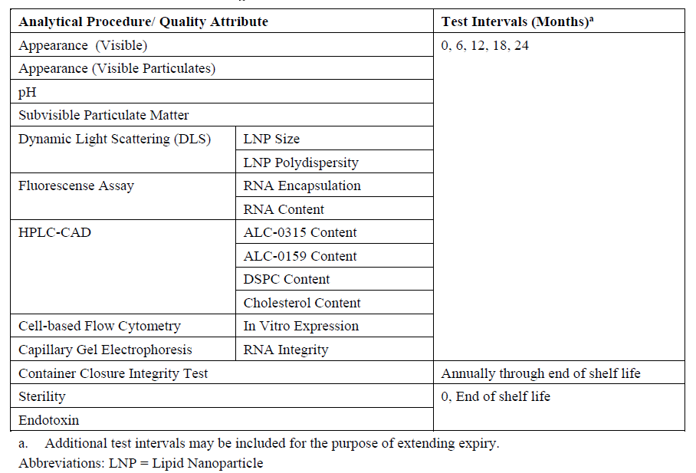

Stability data (CTD section: P.8.3)
The stability data on which the summary and conclusion in P.8.1 is based, is included in the dossier.

Assessor’s comments on P.8 Stability:
The proposed initial shelf-life for drug product is 6 months when stored at the recommended storage condition of -90 to -60°C.
The applicant has provided stability results up to 4 months at -80 to -60°C of one clinical batch and up to 3 months of a non-clinical batch of drug product. Additionally, up to 3 months results at -80 to -60°C are also provided for supportive stability studies for two clinical lots of drug product.
The applicant has also initiated stability studies on two emergency supply lots (only release data exists to date) and has plans to initiate stability studies on the future PPQ-batches.
In addition, stability data has also been provided at accelerated (-40°C to +5°C) and stressed (+25°C to +30°C) storage conditions.
The stability studies are performed in accordance with ICH Q5C (Quality of biotechnological products: Stability testing of biotechnological/biological products) and the same or representative container-closure system are used in these stability studies as will be used for commercial batches.
All stability results for the clinical and non-clinical batches as well as for the supportive stability studies stored at -80 to -60°C complies with the clinical acceptance criteria in place at the time of testing. Overall, the presented stability data indicate no signs of degradation, significant trends or changes in terms of quality.
At accelerated conditions of +5°C-storage and up to 4 months testing of a clinical batch of drug product, LNP polydispersity and RNA integrity were out of specification at the 3 and 4 month-points.
As discussed and concluded in section 3.2.P.2.3, it is agreed that comparability has been reasonable demonstrated between the clinical supply lots manufactured with the “classical” LNP process and the representative emergency supply lot manufactured with the “upscale” LNP process. However, the applicant has a plan for a comprehensive demonstration of comparability among clinical supplies and the full commercial scale product but data for this section is pending. Four commercial PPQ-batches will be manufactured in November and December 2020. In summary, no final conclusion on comparability can be drawn until all comparability data among clinical supplies and the commercial product (PPQ-batches) of drug product will be provided for assessment.
Photostability testing as well as temperature cycling studies are planned and results are pending to date.
Furthermore, it should be confirmed that future extensions of the assigned DP shelf-life will be applied for in formal variation applications. The following statement should be removed for Module 3.2.P.8.1 of the dossier; “The sponsor will extend the assigned shelf life without notification providing the real time stability data at the intended storage condition is acceptable and within commercial specifications.” (OC)
Post-approval stability protocol and stability commitment
A minimum of one batch of drug product will be added to the on-going post-approval stability program annually. The annual post-approval stability protocol has been provided and found acceptable although this protocol is part of GMP and therefore not assessed in this report. However, the applicant should confirm that they commit to continue all the ongoing stability studies at long-term conditions until completion. (OC)
Concluding remarks on the proposed shelf-life and storage conditions
The proposed initial shelf-life for the drug product is 6 months at the recommended storage temperature of -90 to -60°C. In order to support the suggested shelf-life for drug product, updated reports from the ongoing stability studies should be provided. (OC)
In addition, data on the full commercial scale PPQ-batches needs to be provided for assessment to reach a final conclusion regarding comparability among the clinical supplies manufactured at a lower scale compared to the full-scale commercial drug product (i.e. PPQ-batches).
Furthermore, results on photostability testing as well as temperature cycling studies are pending to date and needs to be provided for assessment. (OC)

- Appendices (CTD module 3.2.A)

A.1. Facilities and equipment
The facility and equipment section is covered by GMP, and thus not assessed in this AR.

A.2. Adventitious agents safety evaluation
Multiple mechanisms, procedures, and assays are used to minimize the entry of adventitious agents into the process stream and detect those agents that do enter the process stream. The adventitious agent control program includes the engineering systems of the facility and vessels, the control of the raw materials used in the process, various filtration steps to control microbial load in buffers and the process stream, and in-process and environmental testing to monitor the level of adventitious agents in and around the process stream.
Adventitious Agents Safety Evaluation [Andover]
Introduction
The main theoretical risk associated with these ingredients is contamination of the product by Transmissible Spongiform Encephalopathy (TSE) agents. A multifaceted program exists to ensure the viral safety of the drug substance, including development of a purification process and formulation that are devoid of human or animal derived components.
All raw materials used in the production of drug substance are evaluated as part of a comprehensive program to identify and manage TSE/BSE risks. The conclusion from the TSE/BSE risk evaluations performed for raw materials in the BNT162b2 process is that the risk of transmitting TSE/BSE via drug substance has been minimized.
Details of any starting material, reagent or component containing material of animal origin including its source and preparation are discussed in 3.2.A.2. Adventitious Agents Safety Evaluation [Andover].
Non-Viral Adventitious Agents
- Raw Material Sourcing and Testing
Raw material vendors are qualified to sourcing materials from them for use in the manufacturing process. Raw material information is provided in 3.2.S.2.3 Control of Materials used in Manufacturing. In particular, the human or animal-derived materials are provided in 3.2.A.2. Adventitious Agents Safety Evaluation [Andover]. All other materials are of synthetic and/or biological origin.
Table A.2-1. Materials of Animal Origin Used in the Manufacture of BNT162b2 Drug Substance
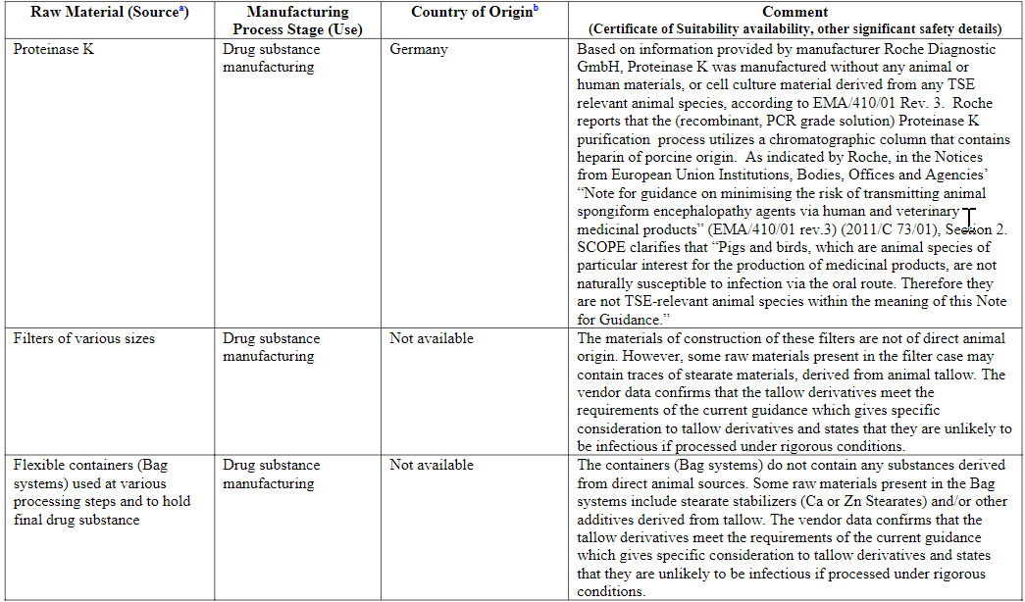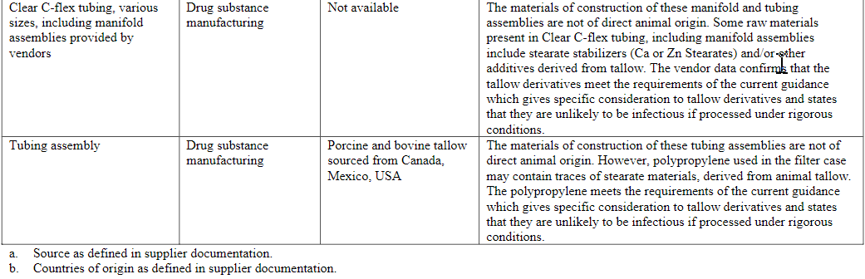

Adventitious Agents Safety Evaluation [Puurs]
Introduction
The main theoretical risk associated with these ingredients is a contamination of the product by Transmissible Spongiform Encephalopathy (TSE) agents. A multifaceted program has been established to ensure the viral safety of the drug product, including development of a formulation process that is devoid of human or animal proteins.
All raw materials used in the production of BNT162b2are evaluated as part of a comprehensive program to identify and manage TSE/BSE risks. The conclusion from the TSE/BSE risk evaluations performed for raw materials in the BNT162b2 process is that the risk of transmitting TSE/BSE via BNT162b2has been minimized.
Details of any material, reagent, or component containing material of animal origin including its source and preparationare discussed in 3.2.A.2. Adventitious Agents Safety Evaluation [Puurs]. These products are commercially available and are not specially produced for the applicant.
Non-Viral Adventitious Agents
- Raw Material Sourcing and Testing
Raw material vendors are qualified to sourcing materials from them for use in the manufacturing process. Raw material information is provided in 3.2.S.2.3 Control of Materials used in Manufacturing.
In particular, the human or animal-derived materials are provided in3.2.A.2. Adventitious Agents Safety Evaluation [Andover]. All other materials are of synthetic and/or biological origin.
In addition, sterility testing is performed on the final product, as described in 3.2.P.5.1 Specifications.
Table A.2-2. Materials of Animal Origin Used in the Manufacture of BNT162b2 Drug Product
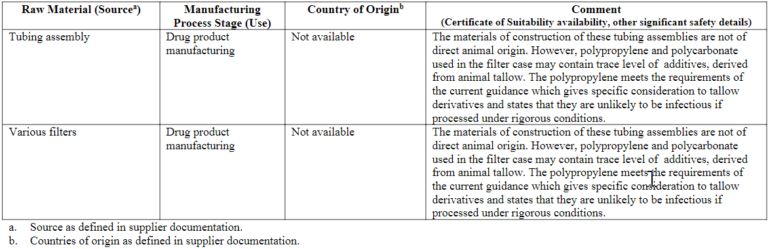

Adventitious Agents Safety Evaluation [BNT &Rentschler]
Section not provided

Assessor´s comments on A.2 Adventitious agents safety evaluation:
Adventitious agents safety evaluation has been provided for the DS manufacturing site [Andover] and for the DP manufacturing site [Puurs]. Information regarding the DP manufacturing site [BNT &Rentschler] is pending.
Proteinase K used in DS manufacturing and LB broth used in the establishment of the pST4-1525 MCB and WCB are the only materials of animal origin used in the manufacturing of BNT162b2. The applicant has identified contamination of the product by Transmissible Spongiform Encephalopathy (TSE) agents as the main theoretical risk associated with these ingredients.
Proteinase K was manufactured without any human or animal materials but in the purification process a chromatographic column containing heparin of porcine origin was utilized. The LB broth contains casein digest peptone derived from bovine milk fit for human consumption; the origin of the source animals is stated to be Australia and New Zeeland. The TSE/BSE risks for these materials has been discussed under A.2 Adventitious agents safety evaluation and under S.2.3 Control of materials, and is deemed minimal.
No information was provided for these materials regarding viral safety but considering the stringent conditions routinely used in the heparin production, the risk for viral contamination is considered negligible and this issue is not further pursued at this point.
No information is included in A.2 on the control of other non-viral adventitious agents and only sterility testing performed at the level of DP is named. Details on the aseptic validation filling and media fills have been provided in P.3 Manufacture and are considered adequate. Furthermore, testing for bioburden and endotoxin is performed at different stages of the manufacturing process, as described in section S.2.4 and the proposed strategy for microbial control is considered sufficient. No information regarding the microbiological control of raw and starting materials is given (OC).
Although the evaluation of the adventitious agents performed by the applicant in this section is relatively poor, based on the information existing in other parts of the dossier and pending new information regarding the BNT & Rentschler manufacturing site as well as new information requested on the control of materials, the overall risk for contamination is considered minimal at this point and no additional concerns are raised.

A.3. Novel excipients

A.3.1. Novel excipient – ALC-0315

A.3.1.1 General information

Nomenclature
International non-proprietary name (INN): | -
Company or laboratory code: | ALC-0315  Avanti product number – 770315  Croda product number – CM04017
Chemical names: | ((4-hydroxybutyl)azanediyl)bis(hexane-6,1-diyl)bis(2-hexyldecanoate)  6-[N-6-(2-hexyldecanoyloxy)hexyl-N-(4-hydroxybutyl)amino]hexyl 2-hexyldecanoate
CAS registry number: | 2036272-55-4
Molecular formula: | C₄₈H₉₅NO₅
Molecular weight: | 766.27 Da

Structural formula
The ALC-0315 novel excipient is a cationic lipid containing a tertiary amine and two ester moieties.
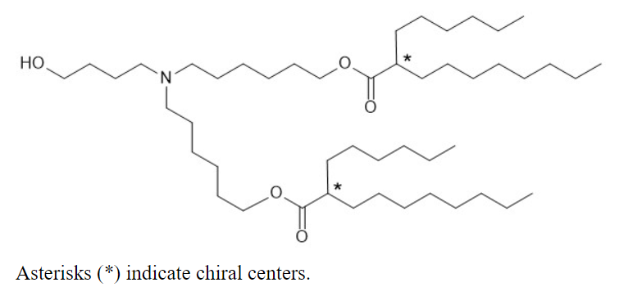

General properties
Physical characteristics: | Colourless to pale yellow oil
Solubility: | Soluble in chloroform (at 25 mg/mL and 20°C)  Insoluble in water (at 25 mg/mL and 20°C)
pH: | Not be performed, not sufficiently soluble in water
pKa | 6.09
Specific gravity: | 0.908 (at 25°C per USP <841>)
Hygroscopicity: | Non-hygroscopic (determined by DVS)
Stereochemistry: | Two chiral centers, a 1:1 racemic mixture of two diastereomers, not optically active
Polymorphism: | Amorphous and no thermal characteristics (determined by DSC)

Assessor’s comments on A.3.1.1 General Information:
The provided information is sufficient.

A.3.1.2 Manufacture

Manufacturer(s)
The facilities involved in the commercial manufacturing are listed below.
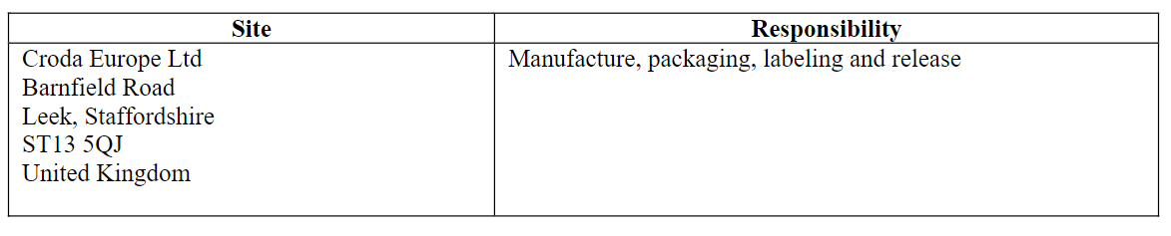

Description of manufacturing process and process controls
ALC-0315 is a synthetic diacyl lipid derived from the starting materials 2-hexyldecanoic acid, 1,6-hexanediol and 4-amino-1-butanol in a three-step process as shown in Figure A.3.1.2-1. The esterification of 2-hexyldecanoic acid and 1,6-hexanediol acid in step 1, results in 6-(2-hexyldecanoyloxy)-hexan-1-ol (6-HEX-OL). It is followed by an oxidation which gives 6-(2-hexyldecanoyloxy)-hexan-1-al (6-HEX-AL). The process is finalized in step 3 by two sequential reductive amination steps with 4-amino-1-butanol to yield ALC-0315.
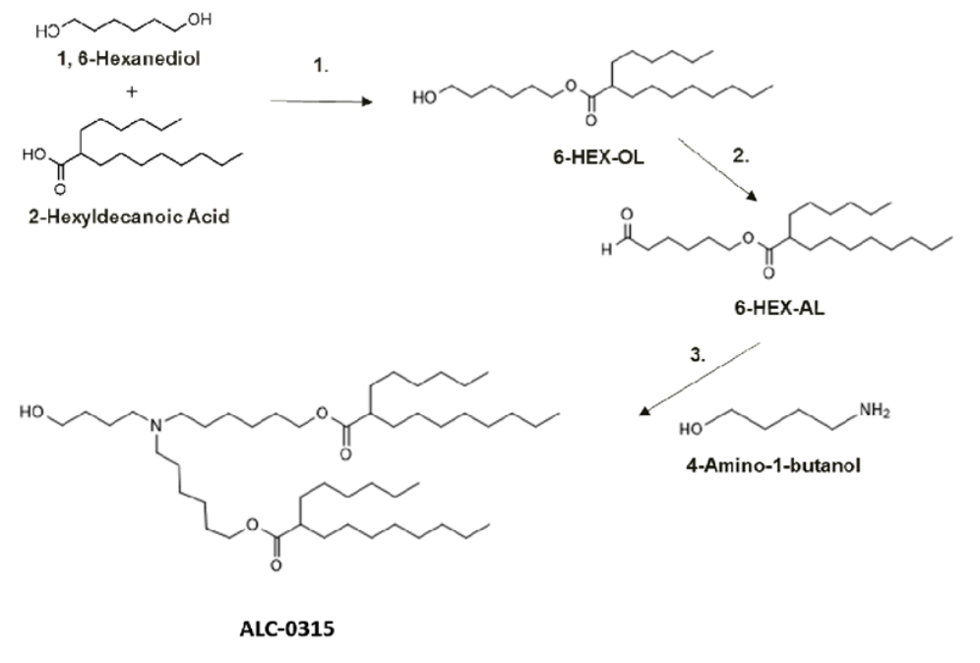
Figure A.3.1.2-1. Chemical synthesis steps for ALC-0315.
More details for each step will be provided in a future update.

Control of materials
No data available. Information on the control of materials used in the manufacture of ALC-0315 will be provided in a future update.

Control of critical steps and intermediates
No data available. Information on isolated intermediates and their specifications, critical in-process controls and their specifications will be provided in a future update.

Process validation and/or evaluation
Not applicable as there is no aseptic or sterilization processing.

Manufacturing process development
The same synthetic route was used throughout development of the BNT162b2 drug product. Nonclinical toxicology and clinical trials used Avanti Polar Lipids (Avanti)-produced ALC-0315 lipid for manufacture of the lipid nanoparticle (LNP) in the BNT162b2 drug product. The process was transferred to Croda Europe Ltd (Croda) and was scaled up for commercial production.
An analysis of a range of samples produced by both sites at varying scales (laboratory, pilot and GMP production) has showed that ALC-0315 produced by both manufacturing sites is similar in overall quality. Refer to Section 3.2.P.2.3 Process Development–Development History for information on comparability for ALC-0315 sourced from different vendors.
Initial batches of ALC-0315 sourced from Avanti for use in drug product manufactured for clinical and emergency supply use were accepted on the basis of Certificates of Analysis. As product development progressed, an assessment of analytical methodology was performed. It was determined that the HPLC-UV method for testing purity, recovery and impurities did not demonstrate sufficient specificity and sensitivity for impurity measurement due to insufficient impurity separation and lack of chromophores necessary for UV detection. A new HPLC method utilizing a gradient separation and a universal detection mode charged aerosol detector (CAD) was developed for measuring impurities. The same HPLC conditions have also been implemented as a test for assay by loading a lower amount of material on the column. These two new versions of the HPLC-CAD method, one for assay and the other one for impurities, have been qualified and implemented as a replacement for the HPLC-UV method. MS and NMR techniques were used for identity tests during development. These methods are not suitable for routine testing in a Quality Control (QC) laboratory. A QC friendly IR identity test was implemented.
More details will be provided in a future update.

Assessor’s comments on A.3.1.2 Manufacture:
A brief description of the chemical synthesis is provided as described in Figure A.3.1.2-1. The synthesis consists of three chemical transformation steps using the starting materials 2-hexyldecanoic acid (HDA), 1,6-hexanediol and 4-amino-1-butanol. The proposed starting materials could be acceptable provided that the control strategy of the synthetic process is appropriate. A detailed description of the chemical synthesis (e.g. information on reagents and process conditions), information on quality control of starting materials (e.g. general synthetic route, supplier and specifications), information on critical steps and intermediates will be provided for assessment during the procedure.
The supplier of ALC-0315 for commercial drug product will be Croda Europe Ltd, UK. During the clinical phase 1, 2 and 3 studies the supplier was Avanti Polar Lipids, US. Similar manufacturing process is used for ALC-0315 in clinical and commercial drug product batches.
GMP has not been evaluated during the assessment.
The commercial batch size should be provided. (OC)

A.3.1.3 Characterisation

Elucidation of structure and other characteristics
The molecular structure of ALC-0315 has been confirmed by ¹H-NMR, MS, FTIR and optical rotation.

Impurities
Analysis by LC-CAD and LC/MS/MS performed on lots of developmental material have identified a number of observed and potential impurities associated with the manufacture and storage of ALC-0315 (Table A.3.1.3-1). An acceptance criterion of NMT 5.0% has been set for total organic impurities. This equates to a maximum of 21.5 micrograms total impurities in a single dose of the vaccine, which poses minimal risk from a safety perspective.
Small amount of impurities in ALC-0315 can also be present relating to impurities in the starting material 2-hexyldecanoic acid. This is an expected observation considered to be a naturally occurring characteristic of most fatty acids.
All organic impurities are controlled with the design of the process, the multiple purge opportunities (reactivity, isolations, chromatography) and in-process controls.
Residual solvents are removed by vacuum drying, and their presence tested for in the final product by GC-FID.
Table A.3.1.3-1. Observed and potential organic impurities in ALC-0315.
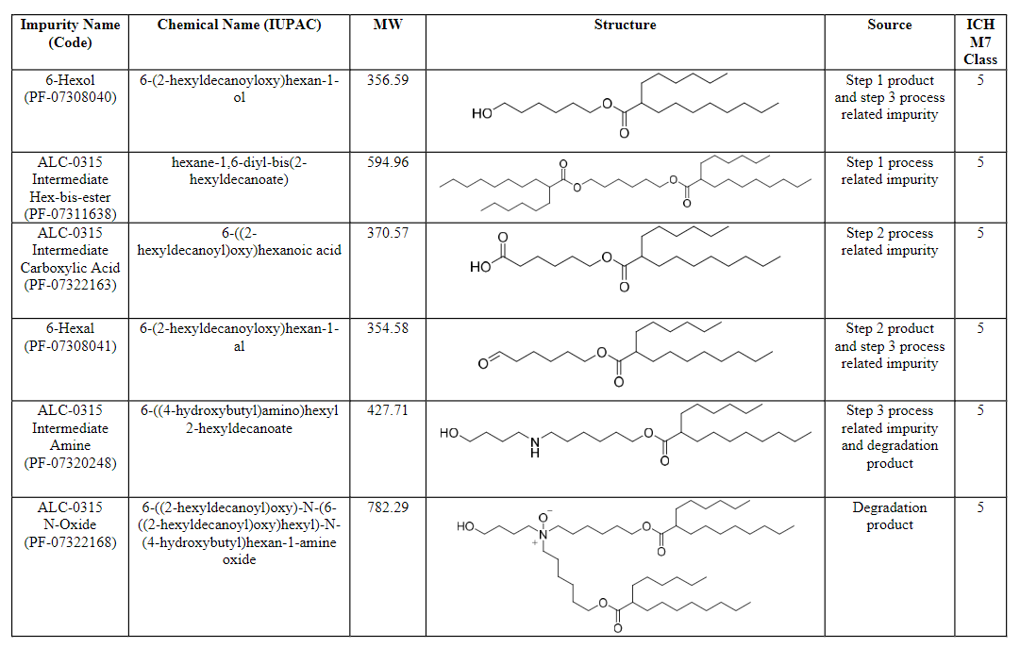
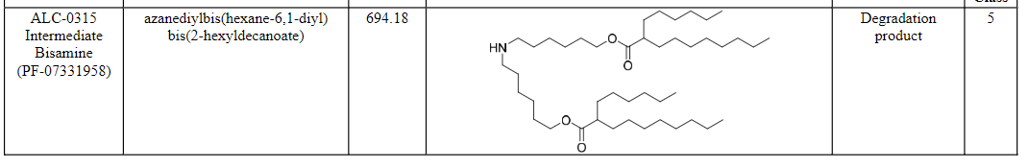

Assessor’s comments on A.3.1.3 Characterisation:
The structure of the excipient ALC-0315 has been satisfactorily established.
A general overall discussion on potential organic impurities is provided.
A specific discussion with regard to impurities with potential genotoxicity is missing. However, since the justification for the specification limit for total impurities in section A.3.1.4 indicate levels well below the ICH M7 limit for an individual mutagenic impurity, this is considered acceptable.
A discussion regarding risk of nitrosamine impurities is missing. An overall risk assessment of the final drug product is performed taking into account the lipid excipients, this is considered acceptable.
Elemental impurities are analysed by ICP-MS in batches supplied by Avanti and used for clinical studies. Results are provided in Table A.3.1.4-2 and demonstrates that the potential presence of elemental impurities in ALC-0315 is very low.

A.3.1.4 Control of excipient

Specification
Specifications for ALC-0315 is presented in Table A.3.1.4-1.
Information on acceptance criteria impurities is pending and will be updated once the information is available.
Table A.3.1.4-1. Specifications for ALC-0315.
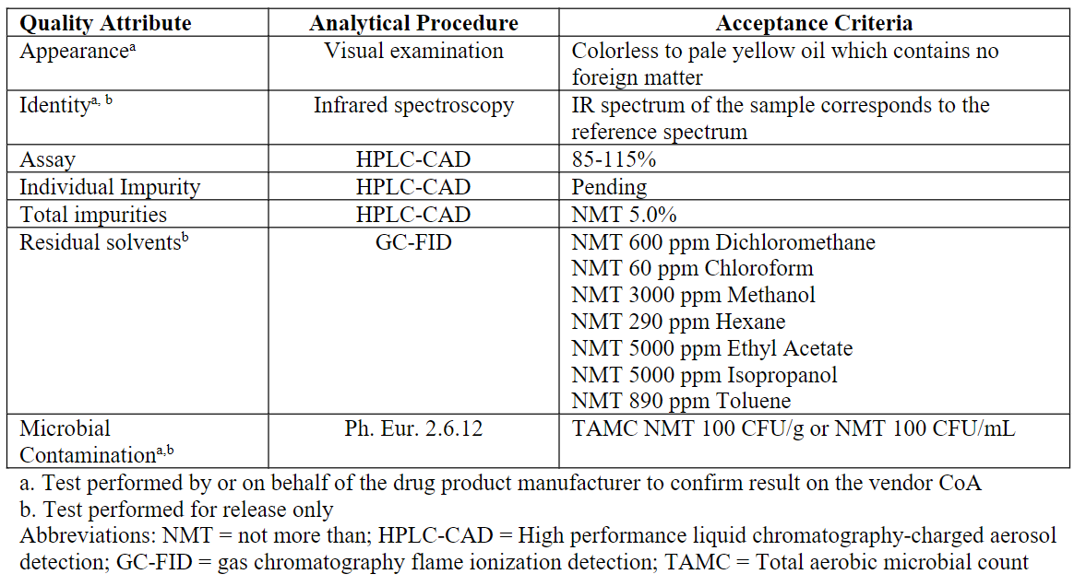

Analytical procedure
Identity is performed by IR according to USP <197A>.
Assay and impurities are determined by a gradient HPLC system with CAD detector.
Residual solvents are determined by GC-FID.

Validation of analytical procedure
Summaries of validation or qualification for the analytical methods are provided.
The GC method for residual solvents is validated with respect to specificity, accuracy, linearity, range, limit of detection and limit of quantitation.
The HPLC method for assay and impurities is validated with respect to specificity, repeatability, accuracy, linearity, limit of quantitation and robustness.

Batch analyses
Batch analysis results are provided for 4 batches manufactured by Avanti in 2017 or 2020, batch size 542.2 – 1117.9 gram. Some data are presented in Table A.3.1.4-2.
Table A.3.1.4-2. Batch analysis data for ALC-0315 manufactured by Avanti.
Analysis | Acceptance criteria | Detected level
Sum of all impurities | NMT 5.0% | 0.2 – 0.9%
Elemental impurities by ICP-MS
Cd | NMT 0.2 ppm | <0.05 ppm
Pb | NMT 0.5 ppm | <0.125 ppm
As | NMT 1.5 ppm | <0.375 ppm
Hg | NMT 0.3 ppm | <0.075 ppm
Co | NMT 0.5 ppm | <0.125 ppm
V | NMT 1 ppm | <0.25 ppm
Ni | NMT 2 ppm | <0.5 ppm
Li | NMT 25 ppm | <6.25 ppm
Sb | NMT 9 ppm | <2.25 ppm
Cu | NMT 30 ppm | <7.5 ppm
Endotoxins by USP <85> | NMT 0.015 EU/mg | <0.015 EU/mg
Batch analysis results are provided for 1 batch manufactured by Croda 19 August 2020 complying with the proposed specification limits.

Justification of specification
Appearance – The material is a colourless to pale yellow oil and should not have foreign matters.
Identity – A match of IR spectra of the sample and the standard confirms the identity of the sample.
Assay – The assay specification is based on limited manufacturing experience of ALC-0315 due to the unprecedented speed of development for the BNT162b2 drug product in the context of a global pandemic. In this context, setting specifications based on batch data is not appropriate and could lead to supply issues. The proposed limit guarantees the safety of the patient whilst also ensuring that supplies are available to meet the challenging global demand for this product.
Individual impurities – Information on acceptance criteria for individual impurities is pending and will be updated once the information is available.
Total impurities – An acceptance criterion of NMT 5.0% equates to a maximum of 21.5 micrograms total impurities in a single dose of the vaccine. This level poses minimal risk from a safety perspective as it is well below the identification threshold of 1.0 mg in ICH Q3A and well below the M7 limit for an individual mutagenic impurity of 120 micrograms per day based on a less than lifetime exposure of ≤1 month treatment duration. Furthermore, the unprecedented speed of development for the BNT162b2 drug product in the context of a global pandemic led to limited manufacturing experience for ALC-0315. In this context, setting specifications based on batch data is not appropriate and could lead to supply issues. The proposed limit guarantees the safety of the patient whilst also ensuring that supplies are available to meet the challenging global demand for this product.
Residual solvents – The limits for residual solvents were set according to ICH Q3C Option 1.
Microbiological contamination – The limit for microbiological contamination is based on the general limits defined in Ph. Eur. 5.1.4 for non-sterile substances for pharmaceutical use.
Tests considered but not included – Risk assessments were carried out for elemental impurities and endotoxin. Due to the low level of lipids in the dose of drug product and based on the historical batch data, these tests were deemed low risk and are not included in the commercial specification for ALC-0315.

Assessor’s comments on A.3.1.4 Control of Excipient:
The excipient ALC-0315 is in general sufficiently controlled by the proposed excipient specification with relevant parameters for parenteral administration. Acceptance criteria for individual impurities are pending and will be provided for assessment during the procedure.
The specification limit for assay (85-115%) is acceptable for this application based on the limited manufacturing experience of ALC-0315. However; it should be confirmed that the limit will be re-evaluated as more batch data are available and, if possible, tightened. (OC)
The analytical methods are sufficiently described.
A brief summary of validation of the GC method is provided. Extended information in form of a short validation report including relevant data, chromatograms and calculations should be submitted. (OC)
Batch analysis data are provided for ALC-0315 manufactured by both the former supplier Avanti used for clinical drug product batches and by the commercial supplier Croda. The specifications from the two suppliers are not identical but considered to provide comparable quality.

A.3.1.5 Reference standards of materials
The current reference standard (lot ALC0315-101D) was manufactured in March 2017. Certificate of Analysis (CoA) is provided.

Assessor’s comments on A.3.1.5 Reference Standards or Materials:
The provided information is sufficient.

A.3.1.6 Container closure system
ALC-0315 is packaged in Type III amber glass bottles with a polytetrafluoroethylene (PTFE) lined polypropylene screw capped lid.
Bottles are supplied pre-cleaned and assembled. All containers are rinsed three times with tap water, three times with ASTM Type-1 deionized water, baked at 288°C to dry and are assembled in an organic free environment. This washing procedure avoids the use of detergents or acids that may leave a residue following the preparation of the bottles.
Bottle composition, representative FTIR spectra for the polypropylene cap and PTFE liner are provided.
The Type III glass is suitable for pharmaceutical use and meets the requirements of USP <660>.

Assessor’s comments on A.3.1.6 Container Closure System:
The provided information is sufficient.

A.3.1.7 Stability

Stability summary and conclusion
Stability studies are carried out by Avanti on three historical batches and presented in Table A.3.1.7-1. These historical batches are representative of the commercial batches, as they were manufactured by the same synthetic route and similar process. Testing was performed using the vendor specification, methods, and protocol in place at the time of testing.
Additional stability studies will be carried out by Croda using the updated specification provided in Table A.3.1.4-1 and the stability data will be provided in future updates.
Table A.3.1.7-1. Stability studies of ALC-0315 manufactured by Avanti.
Storage conditions | Batches / storage time | Batch size | Package
Long-term  -20°C ± 5°C | 2 batches / 24 months | ALC0315-102D  ALC0315-103D | Amber glass
 | 1 batch / 18 months | ALC0315-104
Short-term excursion  25°C ± 5°C / 60% RH ± 5% RH | 3 batches / 7 days | ALC0315-102D  ALC0315-103D  ALC0315-104
Short-term excursion  40°C ± 5°C / 75% RH ± 5% RH | 3 batches / 7 days
The stability data generated thus far demonstrate that ALC-0315 is stable when stored at the recommended storage conditions (-20°C). In addition, ALC-0315 is stable at room temperature (25°C / 60% RH) for up to 7 days and elevated temperature (40°C / 75% RH) for up to 3 days indicating that the material is suitable for use when stored at room temperature and to support use in further manufacturing steps.
The retest period for ALC-0315 when stored at the recommended storage conditions (-20°C) will be provided in a future update.

Post-approval stability protocol and stability commitments
The first three commercial batches of ALC-0315 manufactured by Croda using the manufacturing process described in section A.3.1.2 and packaged in 2 oz amber glass containers will be placed on stability. A container from each of 3 batches is being stored at the ICH recommended conditions:
- Short-term excursion (40°C ± 2°C / 75% RH ± 5% RH) for up to 7 days
- Short-term excursion (25°C ± 2°C / 60% RH ± 5% RH) for up to 28 days
- Long-term (-20°C ± 5°C) for up to 60 months
Each batch will be tested according to the specification for appearance, assay and impurities presented in Table A.3.1.4-1.

Stability data
The stability data on which the summary and conclusion in A.3.1.7 is based, is included in the dossier.
Further stability data from Avanti and Croda are pending and this section will be updated with additional data once the data has been transferred from the manufacturers, analysed, and verified.

Assessor’s comments on A.3.1.7 Stability:
The provided stability data from the former supplier Avanti indicate that the excipient ALC-0315 is stable for up to 2 years stored at -20°C. Stability data also indicate that the excipient is stable for up to 7 days at room temperature, indicating that the excipient is suitable for use in the manufacturing process of the final drug product.
However, the conclusion for an appropriate retest period is pending. Additional stability data will be provided for assessment during the procedure.

A.3.2. Novel excipient – ALC-0159

A.3.2.1 General information

Nomenclature
International non-proprietary name (INN): | -
Company or laboratory code: | ALC-0159  Avanti product number – 770159
Chemical names: | 2-[(polyethylene glycol)-2000]-N,N-ditetradecylacetamide  2-[2-ω-methoxy(polyethyleneglycol-2000)-ethoxy]-N-N-ditetradecylacetamide  CAS: Poly(oxy-1,2-ethanediyl), α-[2-(ditetradecylamino)-2-oxoethyl]-ω-methoxy-polymer
CAS registry number: | 1849616-42-7
Molecular formula: | (C₂H₄O)_{n}C₃₁H₆₃NO₂, n=45-50
Molecular weight: | 2400-2600 Da  The range is due to the polydispersity of the PEG polymer moiety.

Structural formula
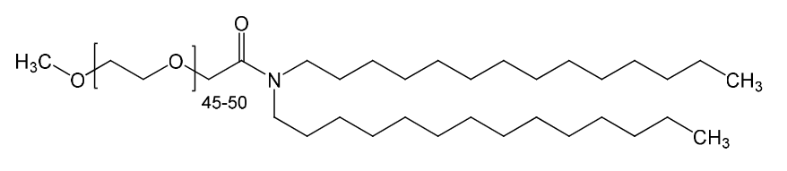

General properties
Physical characteristics: | White powder
Solubility: | Soluble in chloroform and water (at 25 mg/mL and 20°C)
pH: | 5.99 in water
Hygroscopicity: | Non-hygroscopic (determined by DVS)
Stereochemistry: | There are no chiral centers
Crystallinity: | 49.6°C (peak of endotherm determined by DSC)  Crystalline (determined by XRD)

Assessor’s comments on A.3.2.1 General Information:
The provided information is sufficient.

A.3.2.2 Manufacture

Manufacturer(s)
The manufacturers are listed below.
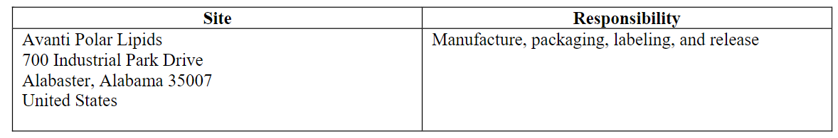

Description of manufacturing process and process controls
ALC-0159 is a synthetic lipid manufactured in a three-step process under GMP. In Step 1, process intermediate N-tetamide is generated via a CDI mediated amidation of myristic acid with 1-tetradecylamine. In Step 2, N-tetamide is reduced using lithium aluminium hydride to generate the amine N-tetamine. In Step 3, a CDI mediated amidation of N-tetamine with carboxy-MPEG produces ALC-0159. The synthesis steps for ALC-0159 are shown in Figure A.3.2.2-1
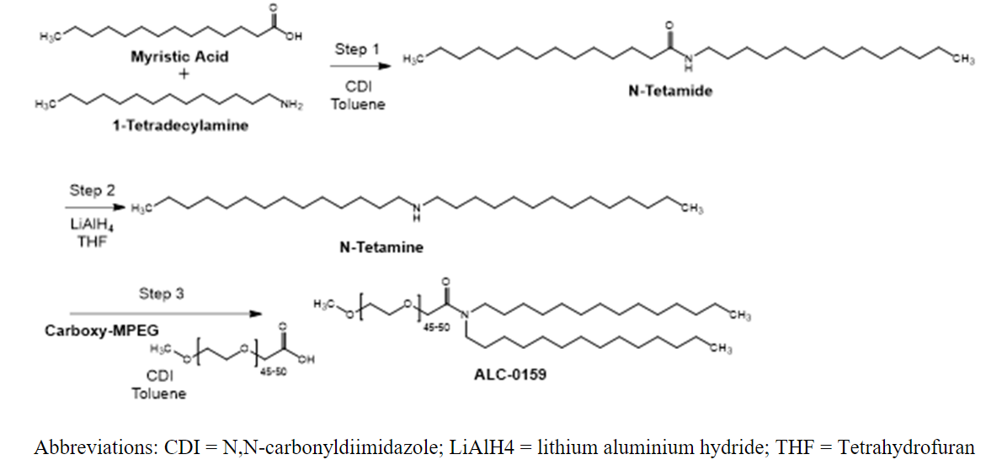
Figure A.3.2.2-1. Chemical synthesis steps for ALC-0159.
More details for each step will be provided in a future update.

Control of materials
No data available. Information on the control of materials used in the manufacture of ALC-0159 will be provided in a future update.

Control of critical steps and intermediates
No data available. Information on isolated intermediates and their specifications, critical in-process controls and their specifications will be provided in a future update.

Process validation and/or evaluation
Not applicable as there is no aseptic or sterilization processing.

Manufacturing process development
The same synthetic route was used for ALC-0159 throughout development of the BNT162b2 drug product. All materials used Avanti Polar Lipids (Avanti) produced ALC-0159 lipid for the manufacture of the lipid nanoparticle (LNP) in the BNT162b2 drug product. Avanti is the site of manufacture for commercial production.
Initial batches of ALC-0159 sourced from Avanti for use in drug product manufactured for clinical and emergency supply use were accepted on the basis of Certificates of Analysis issued by Avantis. As product development progressed, an assessment of analytical methodology was performed. It was determined that the high performance liquid chromatography (HPLC) ultraviolet (UV) method for testing purity, recovery and impurities did not demonstrate sufficient specificity and sensitivity for impurity measurement due to insufficient impurity separation and lack of chromophores necessary for UV detection. As a result, a new HPLC method utilizing a gradient separation and a universal detection mode charged aerosol detector (CAD) was developed and is in the process of being qualified and implemented for measuring impurities in ALC-0159 materials. The same HPLC conditions will also be qualified and implemented as a test for assay by loading a lower amount of material on the column. These two new versions of the HPLC CAD method, one for assay and the other one for impurities, once qualified, will be implemented as a replacement for the HPLC UV method. The HPLC CAD method details will be added to Section 3.2.A.4.2 once method qualification is complete.
Mass spectrometry (MS) and nuclear magnetic resonance (NMR) techniques were used for identity tests during development. However, these methods are not suitable for routine testing in a Quality Control (QC) laboratory environment. To that end, a QC friendly infrared (IR) identity test has been implemented at the ALC-0159 manufacturer and the drug product manufacturing sites.

Assessor’s comments on A.3.2.2 Manufacture:
A brief description of the chemical synthesis is provided as described in Figure A.3.2.2-1. The synthesis consists of three chemical transformation steps using the starting materials myristic acid, 1-tetradecylamine and carboxy-MPEG. The proposed starting materials could be acceptable provided that the control strategy of the synthetic process is appropriate. A detailed description of the chemical synthesis (e.g. information on reagents and process conditions), information on quality control of starting materials (e.g. general synthetic route, supplier and specifications), information on critical steps and intermediates will be provided for assessment during the procedure.
The supplier of ALC-0315 for commercial drug product is Avanti Polar Lipids, US. The same supplier was used during development for clinical phase 1, 2 and 3 studies.
GMP has not been evaluated during the assessment.
The commercial batch size should be provided. (OC)

A.3.2.3 Characterisation

Elucidation of structure and other characteristics
The molecular structure of ALC-0159 has been confirmed by ¹H-NMR, TOF MS and FTIR.

Impurities
Starting materials and intermediates in the ALC-0159 synthesis are potential impurities associated with the manufacture and storage of ALC-0159 (Table A.3.2.3-1). These potential impurities are all ICH M7 class 5. More detailed information on actual and potential impurities including impurity control strategy will be included in a future update.
Solvents are removed by vacuum drying, and their presence is tested for in the final product by GC-FID.
Residual lithium may be present due to the use of lithium aluminum hydride in the N-tetamine reaction. Lithium is removed by filtration and its clearance was demonstrated by ICP/MS results in three batches. The lithium levels in the batches were either <10 ppm or <8 ppm.
Table A.3.2.3-1. Potential organic impurities in ALC-0159.
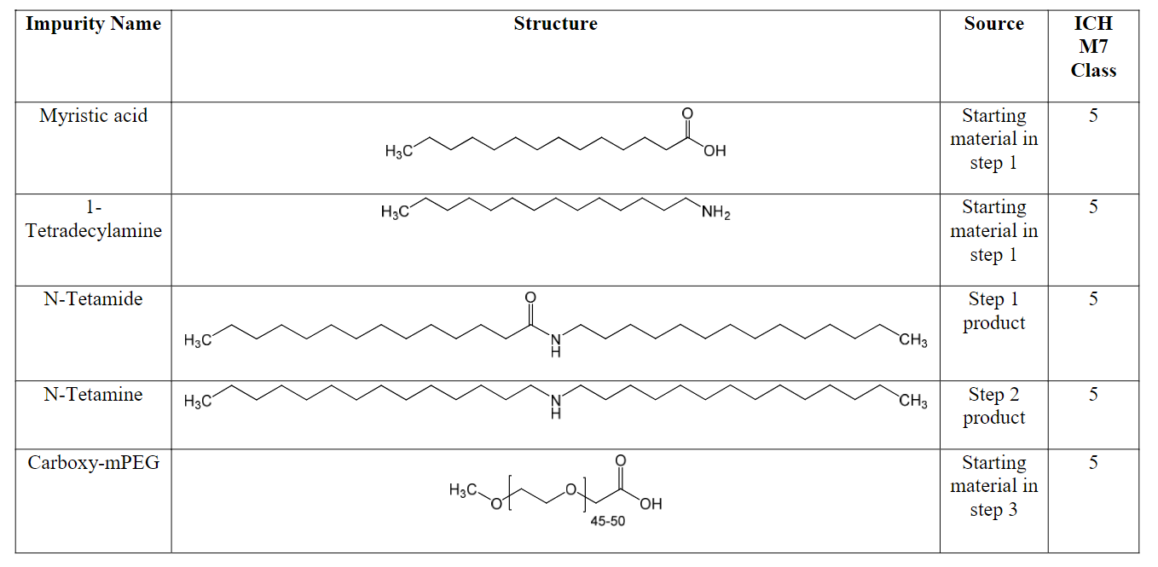

Assessor’s comments on A.3.2.3 Characterisation:
The structure of the excipient ALC-0159 has been satisfactorily established.
An overall discussion on potential organic impurities is provided and additional data will be provided for assessment during the procedure.
Lithium is used in the synthesis and batch analysis data are provided for three batches demonstrating that residual lithium is sufficiently removed.
Specific discussion with regard to impurities with potential genotoxicity and the risk of nitrosamine impurities should also be provided.
A specific discussion with regard to impurities with potential genotoxicity is missing. This conclusion is still pending but may be acceptable depending on the discussion and justification for specification limits for impurities that will be provided for assessment during the procedure.
A discussion regarding risk of nitrosamine impurities is missing. An overall risk assessment of the final drug product is performed taking into account the lipid excipients, this is considered acceptable.

A.3.2.4 Control of excipient

Specification
Specifications for ALC-0159 is presented in Table A.3.2.4-1.
Information on acceptance criteria impurities is pending and will be updated once the information is available.
Table A.3.2.4-1. Specifications for ALC-0159.
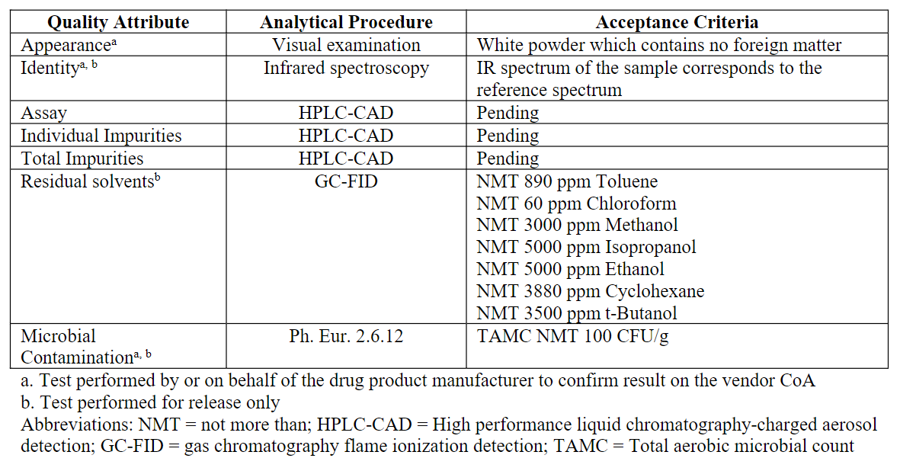

Analytical procedure
Residual solvents are determined by GC-FID.
Identity is determined by IR according to USP <197A>.
Information on the HPLC method for assay and impurities is pending and will be updated once the information has been generated, analysed, and verified.

Validation of analytical procedure
A summary of validation procedure for the GC method for residual solvents are provided. The method is validated with respect to specificity, accuracy, linearity, range, limit of detection and limit of quantitation.
Validation of the HPLC method is pending and will be updated once the information has been generated, analysed, and verified.

Batch analyses
Batch analysis results are provided for 3 batches manufactured by Avanti in 2019 or 2020 tested according to an earlier specification included extended test parameters compared to the specification presented in Table A.3.2.4-1. Some data are presented in Table A.3.2.4-2.
Table A.3.2.4-2. Batch analysis data for ALC-0159 manufactured by Avanti.
Analysis | Acceptance criteria | Detected level
Purity by HPLC-UV | NLT 95.0% AUC  85-115% recovery | 99.3 – 99.5%  99-103% recovery
Sum of all impurities | NMT 5.0% | 0.5 – 0.7%
Elemental impurities by ICP-MS
Pb | NMT 1 ppm / 0.5 ppm | <1 ppm / <0.16 ppm
Hg | NMT 1 ppm / 0.3 ppm | <1 ppm / <0.10 ppm
As | NMT 1 ppm / 1.5 ppm | <1 ppm / <0.48 ppm
Cd | NMT 1 ppm / 0.2 ppm | <1 ppm / <0.06 ppm
Sb | NMT 10 ppm / 9 ppm | <10 ppm / <2.88 ppm
Cu | NMT 10 ppm / 30 ppm | <10 ppm / <9.60 ppm
Bi | NMT 10 ppm / - | <10 ppm / -
Mo | NMT 10 ppm / - | <10 ppm / -
Ag | NMT 10 ppm / - | <10 ppm / -
Sn | NMT 10 ppm / - | <10 ppm / -
Co | - / NMT 0.5 ppm | - / <0.16 ppm
V | - / NMT 1 ppm | - / <0.32 ppm
Ni | - / NMT 2 ppm | - / <0.64 ppm
Li | NMT 10 ppm / 25 ppm | <10 ppm / <8.00 ppm
Total | NMT 10 ppm / - | <10 ppm / -
Endotoxins by USP <85> | NMT 0.015 EU/mg | <0.015 EU/mg

Justification of specification
Appearance – The material is a white powder and should not have foreign matters.
Identity – A match of IR spectra of the sample and the standard confirms the identity of the sample.
Assay, individual and total impurities – Information is pending and will be updated once the information has been generated, analysed, and verified.
Residual solvents – The limits were set according to the ICH Q3C Option 1.
Microbiological contamination – The limit is based on the general limits defined in Ph. Eur. 5.1.4 for non-sterile substances for pharmaceutical use.
Tests considered but not included – Risk assessments were carried out for elemental impurities and endotoxin. Due to the low level of lipids in dose of drug product, and based on the historical batch data, these tests were deemed low risk and they are not included in the commercial specification for ALC-0159.

Assessor’s comments on A.3.2.4 Control of Excipient:
The excipient ALC-0159 is in general sufficiently controlled by the proposed excipient specification with relevant parameters for parenteral administration. Acceptance criteria for assay, individual impurities and total impurities are pending and will be provided for assessment during the procedure.
The analytical methods for appearance, identity, residual solvent and microbial contamination are sufficiently described. Information on the HPLC method for assay and impurities is pending and the description and validation will be provided for assessment during the procedure.
A brief summary of validation of the GC method is provided. Extended information in form of a short validation report including relevant data, chromatograms and calculations should be submitted. (OC)

A.3.2.5 Reference standards of materials
The current reference standard (lot ALC0159-102), was manufactured in December 2019. Certificate of Analysis (CoA) is provided.

Assessor’s comments on A.3.2.5 Reference Standards or Materials:
The provided information is sufficient.

A.3.2.6 Container closure system
ALC-0159 is packaged in wide mouth amber glass Type III bottles with a screw cap.
Bottles are supplied pre-cleaned and assembled. All containers are rinsed three times with tap water, three times with ASTM Type-1 deionized water, baked at 288°C to dry and are assembled in an organic free environment. This washing procedure avoids the use of detergents or acids that may leave a residue following the preparation of the bottles. Prior to use, all bottles are inspected for visible cleanliness and structural integrity.
Bottle and cap description, bottle composition, representative FTIR spectra for the polypropylene cap and PTFE liner are provided.

Assessor’s comments on A.3.2.6 Container Closure System:
The provided information is sufficient.

A.3.2.7 Stability

Stability summary and conclusion
The stability studies are carried out by Avanti and presented in Table A.3.2.7-1. The stability batches are representative of the commercial batches, as they were made by the same synthetic route and similar process. Testing was performed using the vendor specification, methods, and protocol in place at the time of testing.
Confirmatory stability studies will be carried out on future batches of Avanti using specifications provided in Table A.3.2.4-1 and the stability data will be provided in future updates.
Table A.3.2.7-1. Stability studies of ALC-0159 manufactured by Avanti.
Storage conditions | Batches / storage time | Batch size | Package
Long-term  -20°C ± 5°C | 2 batches / 36 months | ALC0159-100D  ALC0159-101 | Amber glass
 | 1 batch / 6 months | ALC0159-102
Short-term excursion  25°C ± 5°C / 60% RH ± 5% RH | 2 batches / 7 days | ALC0159-100D  ALC0159-101
Short-term excursion  40°C ± 5°C / 75% RH ± 5% RH | 2 batches / 7 days
The stability data generated thus far demonstrate that ALC-0159 is stable when stored at the recommended storage conditions (-20°C). In addition, ALC-0159 is stable at room temperature (25°C / 60% RH) and elevated temperature (40°C / 75% RH) for up to 7 days indicating the material is suitable for use when stored at room temperature to support use in further manufacturing steps.
The retest period for ALC-0159 when stored at the recommended storage conditions (-20°C) will be provided in a future update.

Post-approval stability protocol and stability commitments
Data for three batches of ALC-0159 manufactured by Avanti using a process representative of the commercial process and stored at the recommended storage conditions (-20°C) is ongoing. The stability study will continue through 60 months.
Confirmatory stability studies will be conducted on future batches of ALC-0159 for up to 60 months using the proposed specification for appearance, assay and impurities presented in Table A.3.2.7-1.

Stability data
The stability data on which the summary and conclusion in A.3.2.7 is based, is included in the dossier.
Further stability data is pending and this section will be updated with additional data once the data has been transferred from the manufacturers, analysed, and verified.

Assessor’s comments on A.3.2.7 Stability:
The provided stability data indicate that the excipient ALC-0159 is stable for up to 3 years when stored at -20°C. Stability data also indicate that the excipient is stable for up to 7 days at room temperature, indicating that the excipient is suitable for use in the manufacturing process of the final drug product.
However, the conclusion for an appropriate retest period is pending. Additional stability data will be provided for assessment during the procedure.

- Regional information

Post approval change management protocols
A post-approval change management protocol (PACMP) is planned to be included in subsequent CMC rolls in support of anticipated additional manufacturing facilities to support additional supply.

Process validation scheme for the drug product
Process Validation Data at commercial scale are provided for the Drug Substance and for the Drug Product with the Application. Consequently, submission of a Process Validation Scheme is not required.

Assessor´s comments on Post approval change management protocols and Process validation scheme for the drug product:
The information provided on Post approval change management protocols and Process validation scheme for the drug product are noted.

Medical device issues
Not applicable.

TSE issues
See assessors’ comments on A.2 Adventitious agents safety evaluation.

N-Nitrosamines risk assessment
Pfizer has assessed their COVID-19 (BNT162b2) vaccine drug product and manufacturing process for nitrosamine risks. Pfizer has conducted a comprehensive assessment of the potential nitrosamine risk factors associated with the active substance, drug product and primary packaging components.
In general, for large biotherapeutic products, nitrosamines that could be potentially be derived are considered very unlikely to be associated with the potent toxicity that has been seen with some small molecule nitrosamines due to a lack of cytochrome P450 (CYP) metabolic activation required for formation of a reactive diazonium species. The active site of CYP enzymes are buried within the CYP protein, and access to the active site is restricted to small molecules, with substrate specificity of different CYP enzymes driven by physical chemical properties and size of the molecules. The BNT162b2 active substance is a mRNA that contains over 4 000 bases and has a molecular weight of over 1 000 000 g/mol. The inability of BNT162b2 active ingredient to undergo metabolic activation supports the conclusion that BNT162b2 active ingredient is not susceptible to the formation of a nitrosamine that would need cohort of concern control.
- SARS-CoV-2 mRNA vaccine active substance
BNT162b2 drug substance is a single-stranded, 5'-capped mRNA. The manufacturing process for the active substance involves using plasmid DNA from transfected DH10B Escherichia coli cells, linearizing this DNA, followed by in-vitro translation to mRNA. As there is no nitrite source or small molecule amine compounds used in the active substance manufacturing process, there is no nitrosamine risk associated with the manufacture of BNT162b2.
- COVID-19 vaccine drug product
The BNT162b2 drug product has also been assessed for potential nitrosamine risks associated with small molecule amines, and the amine functionality within the active substance molecule itself. The formation of a nitrosamine requires the presence of both a vulnerable (reactive) amine and a nitrosating agent. The solvents and excipients used to manufacture the drug product have been assessed. The only source of amines come from the distearoylphosphatidylcholineused in the formulation, which is a quaternary ammonium salt. Quaternary ammonium salts are unlikely to form nitrosamines as de-alkylation would need to occur first to produce the tertiary amine. In this assessment, quaternary ammonium salts are considered unreactive unless stoichiometric amounts of nitrite are present which is not the case. ALC-0315 (a component of the lipid nanoparticle) has a tertiary amine present in the structure. Tertiary amines are significantly less reactive than secondary amines as potential vulnerable amine species. Sugars can contain low levels (sub-ppm) of nitrate and there is sucrose in the formulation. Some phosphate salts are also known to contain low levels of nitrate (up to 1-2 ppm). It has been shown that traces of nitrite in a liquid formulation do not constitute a risk for tertiary amines and even less for quaternary ammonium salts. In addition, nitrosamine formation occurs in an acidic environment whereas the COVID-19vaccine is formulated at 6.9-7.9. Thus, the drug product has been assessed and considered to be at low risk for nitrosamine formation.
- Primary packaging
The drug product is provided in a vial configuration (with a stopper composed of gray Datwyler FM457 elastomer (bromobutyl rubber) coated with silicone oil). Neither glass nor the stopper are at risk of nitrosamine presence. The stopper components have been assessed and do not contain compounds associated with nitrosamine presence.

- Overall risk assessment conclusion
The comprehensive risk assessment to identify potential risk factors for nitrosamine formation in the active substance, drug product and primary packaging processes, identified no risk for small molecule nitrosamine (cohort of concern) formation. Additionally, from a toxicological perspective, there is no risk of the BNT162b2 vaccine molecule itself forming a nitrosamine requiring cohort of concern control.

Assessor’s comments on Nitrosamines risk assessment:
A risk evaluation regarding nitrosamines are provided concluding that there is no risk of presence of nitrosamines in the final drug product taking into account the active substance, the drug product formulation and primary package. The risk assessment is considered acceptable.
- Assessor’s comments on the SmPC, labels and package leaflet
Not applicable, no SmPC provided.
- Assessor’s overall conclusions on quality
See overview report.
- ASSESSMENT OF THE RESPONSES TO THE REQUEST FOR SUPPLEMENTARY INFORMATION RAISED IN PREVIOUS CYCLES, <CYCLE X, Y>

Please copy/paste any of the relevant section headings detailed above, in this section. Please provide a list of any outstanding questions on the response submission (indicating the cycle number).

Example:

  - Cycle X

Question 1

Summary of the MAH’s response
Assessment of the MAH’s response
Conclusion

Question 2

Summary of the MAH’s response
Assessment of the MAH’s response
Conclusion

  - Cycle Y

Question 1

Summary of the MAH’s response
Assessment of the MAH’s response
Conclusion

Question 2

Summary of the MAH’s response
Assessment of the MAH’s response
Conclusion

  - Conclusion and any outstanding questions from Cycle X and Y

- List of questions as proposed by the Rapporteur
See overview report.
- Annex 1 (as appropriate)
Not applicable.
- Annex 2 (For centrally – submitted product)

Proposals for post-authorisation Sampling and Testing
Selection of parameters for testing during post authorisation surveillance for centrally authorised products
EMA manages annual sampling and testing programmes for centrally authorised products in accordance with Art. 57r of Regulation (EC) 2004/726 in conjunction with the European Directorate for the Quality of Medicines & HealthCare (EDQM) and the Official Medicines Control Laboratories of the EU/EEA Member States.
The (co)rapporteur’s recommendations for the parameters to be tested should be included on the attached form. Recommendations should be focused on the finished product and should be as precise as possible. Whenever several methods are applicable to a parameter, the method(s) used should be clearly specified. Assessors are recommended to discuss the selection of parameters to be tested with colleagues from the OMCL of the (Co)rapporteur’s country.
Parameters indicative of the overall quality of the product such as appearance, weight or volume, dissolution, pH, moisture content particle counts, osmolality and disintegration are readily performed by OMCLs.
Usually active-specific assays and impurity tests provide sufficient information on the identity of the active substance and the need for additional specific identity testing should be justified.
When bioassays are requested it should be noted that these are often very challenging for OMCLs to repeat in a proficient manner but should normally be requested when it is the only means to verify the concentration of the active, or where there is other justification.
It should also be noted that occasionally the use of laboratory animals is required.
Owing to the limitations of the test itself and the non-availability of appropriate samples, requests for sterility testing is not recommended as part of routine post-authorisation surveillance.
The form allows you to record also recommendations for the testing of the active substance. However, testing of active substances should only be requested where justified e.g.:
potential safety problems with impurities arising from the process;
stability problems (if this cannot be covered adequately by the testing of the finished medicinal product);
the active ingredient is too diluted in the finished medicinal product so that an important parameter cannot be tested;
matrix problems that prevent testing an important parameter in the finished medicinal product.
The selection of products for inclusion in any annual sampling and testing programme is largely driven through a risk based approach as agreed by CHMP in January 2008 (EMEA/INS/S&T/81176/2007). The second page of the attached form allows the assessor to assign weightings based on his/her detailed assessment of the quality part of the dossier which will then be used by EMA in the risk ranking model used for the selection of products for testing in any one annual programme.
It is understood that if any of these risk factors are deemed to apply that the assessor will nevertheless have satisfied himself, if necessary by seeking further information from the applicant, that the product meets the necessary quality standards for the grant of a marketing authorisation. The intention is simply to give the assessor the opportunity to influence the weighting assigned to the product in the context of the sampling and testing scheme should it be felt appropriate. Each box checked will assign a weighting value. Any number of boxes can be checked as appropriate.

Doc. Ref: EMEA/INS/3924/02 Proposals from the Rapporteur / Co-Rapporteur on “Essential Quality Parameters to be tested for the Control of Marketed Centrally Authorised Product”
NAME OF MEDICINAL PRODUCT  - - - - - - - - - - - - - - - - - - - - - |  | Application number:  EMEA/ / /
Authorisation number:

EU/ /
Active substance  - - - - - - - - - - - - - - - - - - - - - |  | NCE  Other
Active substance  (please see guidance given above)  No control  Identity  Assay / activity  Purity (Main impurities - Manufacturing)  Other parameters | Rationale for testing  (specification and test method, when appropriate)  ……………………………………………………………  ……………………………………………………………  ……………………………………………………………  ……………………………………………………………  ……………………………………………………………

Following a critical review the following quality test parameters have been selected for testing by OMCLs during post-authorisation surveillance
Medicinal Product  Identity  Assay / activity  Purity (main impurities - stability)  Dissolution  Uniformity of dosage units  Moisture Content  Other parameters | Comments  (specification and test method, if several methods are possible for a parameter please specify which method(s) should be applied)  ……………………………………………………………  ……………………………………………………………  ……………………………………………………………  ……………………………………………………………  ……………………………………………………………  ……………………………………………………………  ……………………………………………………………  ……………………………………………………………  ……………………………………………………………
Recommendation, when applicable, on pharmaceutical form / strength / presentation to be tested

Please record below the name, organisation and telephone number of a contact person
Name:
Organisation:
Telephone Nr.:

Assessor-identified weighting factors to be taken into account in the risk-based selection of products for testing

An inherent variability in the production process

Inherent difficulties foreseen with the testing methodology

Novel manufacturing or control technology

Potential presence of toxic impurities

A particular risk of bioavailability problems

A particular risk inherent in the manufacturing or control methodology not covered by any of the above (explanatory comments may be made below).

…………………………………………………………………………………….
…………………………………………………………………………………….

None of the above weighting factors apply

- Annex 3
The purpose of this Annex is to highlight issues that should be reflected in the assessment report concerning the evaluation of risk assessment methodologies and statistical tools that are used in the context of ICH Q8, ICH Q9 and Q11 (draft) Guidelines. Assessors are encouraged to read this annex in conjunction with any related Guidelines.
1. Risk assessment methodologies
Risk assessment tools can be used in many situations. For instance it may be used to rank and select material quality attributes and /or process parameters that should be within appropriate ranges to ensure the desired product quality. Such tools could also be used to select process parameters that may potentially impact product quality based on prior knowledge and experimental data. Issues that need to be taken into account in the evaluation include:
• Has a summary of all material quality attributes and process parameters that based on previous knowledge and/or experimental data may have an impact on product quality been presented?
For FMEA analyses:
• Have all the relevant known risk factors been included? e.g. known risk factors of the finished product (e.g. degradation, solubility etc)
• Has the effect of unit operations and material properties been included?
• Has the applicant explained how the risk ranking and scoring has been performed?
• Has the applicant justified how the threshold has been set in order to select, which parameters will be further studied?
• Do you agree with the proposed risk ranking?
• Is the result of the FMEA in accordance with existing scientific knowledge? If not has it been justified?
• Are the identified risks managed by the Design Space or the proposed control strategy?
2. Design of Experiments
Design of Experiments (DoEs) is a strategy for experimentation, whereby all factors under study are varied at the same time in accordance to rigorously formulated mathematical protocols. The goal is to generate representative and informative experiments that maximise the information provided with the minimum number of experiments. The factors to be studied in a DoE should come out of the risk assessment
exercise. A full statistical evaluation of DoEs performed at early development stages (e.g. for screening) is not necessary. A narrative description of the factors and levels studied and the conclusions reached is adequate.
However for DoEs used for the establishment of CQAs, CPPs and / or a
Design Space:
The following data should be considered:
• Type of experimental design used and justification of its appropriateness (e.g. some screening designs are not appropriate since they cannot identify interactions). The power of the design should be stated. (Experimental error compared to the differences in the responses that have to be shown)
• Factors under study and their ranges (in a tabular format if possible)
• The list of design runs clearly stating the batch or study number and the scale of the batch involved in each run. The number of replicated runs should be mentioned.
• Reference to the analytical methods used for the evaluation of the data and demonstration of their suitability for their intended use.
• Statistical results (e.g. Pareto diagrams or a simple list of the sizes of effects and interactions) showing the relative significance of the factors under study as well as of the interactions between them (where applicable) should be provided
• Ensure that the predictions made from a DoE study are appropriate for the ranges studied and scale/equipment differences.
3. Multivariate Data Analysis (MVDA) for Multivariate Statistical Process Control (MSPC)
Multivariate data analysis (MVDA) including Principal Components Analysis (PCA) and Partial Least Squares (PLS) can be used to model pharmaceutical processes. PCA is often used for data overview e.g. for detecting groups and trends among observations, for evaluating relationships between variables and between observations and variables. While PLS is used for linking input and response variables together with the aim of predicting one or more components. Issues that need to be taken into account, when MVDA models are used for MSPC include:
• Are the spectral sample preparation and the reference analytical method used to analyse the sample fit for purpose? For online or in- line control where there is no sampling: what is the repeatability and the reproducibility of the sampling in combination with the analytical method?
• Are the validation (training) and calibration (test) datasets representative of the expected process variability? Has the applicability of the model been demonstrated across all the variation allowed by the Design Space? In the cases that this is difficult to show, the results of the risk assessment could be used. The influence of all important risk factors should be checked and included in the calibration, validation and test set.
• Does the variability of the calibration (test) set adequately represent most of the variability of the validation (training) set?
• Have outliers been identified in the original dataset and if yes, is the justification for (non)- omission of data valid? Please note that if the dataset used to develop the model is generated from a DoE, the omission of data may have a greater impact on the predictive power of the model compared to historical datasets.
• Is the information concerning the pre-treatment of data (if any) adequately described and consistently applied for all datasets used for creation, optimization and validation of the model?
• Are the MVDA modelling techniques adequately described including a brief justification for the selection of the selected algorithm?
• Do you agree with the selection of the variables that have been included in the model? Compare with the results of the risk assessment. Are there any relevant sources of variation not included in the model and if yes, is this justified?
• For PLS models, is the model fit for purpose? Is the complexity of the model optimal? Note: the PLS model complexity usually corresponds to the number of PLS (latent) factors resulting in the lowest RMSECV. The model complexity (number of PLS factors used to build the model) should be presented in a graph showing the regression coefficients for each variable
• Can the weightings (high/ low) of the variables in the model be explained with the existing scientific knowledge or rational concerning that variable and/or manufacturing process?
• Is the MVDA model statistically evaluated for fitting and predictive ability? The standard error for prediction should be discussed against the precision of the reference analytical method precision.
• Has a model verification scheme been proposed for the product lifecycle? Has it been defined which criteria would trigger an update of the model and are they adequate?
4. Design Space (DS)
Aspects that may be considered when a DS has been proposed include:• Has the applicant provided adequate data to support the DS applied for? (Risk assessment, experimental data, models that have been statistically evaluated and verified at full scale)
• In case that the Design Space has been developed at lab or pilot scale, has the applicant demonstrated its validity at production scale through the use of scaling factors or independent experiments, or otherwise has it been demonstrated that the parameters are scale independent? Scaling factors might be supported by literature or prior knowledge. Has the applicant discussed the potential risks in the scale-up operation and is there an appropriate control strategy in place to manage these risks?
• Has the applicant considered all CQAs, when developing a DS? (See risk assessment and DoE results)
• Does the control strategy support the DS?
• Are all critical parameters identified in the unit operation part of the Design Space? If not, is there an appropriate justification?

Design space and change management protocols (if applicable)
[This Annex is an extract of the main body of the AR and its purpose is to summarise all aspects agreed upon in the dossier that result to post approval regulatory flexibility. This annex may be used by Inspectors and could be a basis for the evaluation of post-approval variation applications.]

1. Active substance

1.1. Design space for the active substance
[Presentation of the Design Space (attributes and their ranges) in a tabular format]

1.2. Change management protocols for the active substance
[Description of the changes included in the agreed protocol as well as the agreed variation category for reporting the implementation of the change]

2. Finished product

1.3. Design space for the finished product
[Presentation of the Design Space (attributes and their ranges) in a tabular format]

1.4. Change management protocols for the finished product
[Description of the changes included in the agreed protocol as well as the agreed variation category for reporting the implementation of the change]

Delete as appropriate
A (short) rationale should be provided for each test selected for the active substance.
Note: PAT or new ICH approaches to quality are expected to lead to enhanced product and process knowledge and improved quality assurance rather than increased risk but it is accepted that assessors may wish to express caution in some cases until there is greater experience and confidence.

